LAB EXPERIMENT RECORD
Field | Details
Course Code / Course Name | DSA0601 / Data Handling and Visualization
Experiment | Data Visualization using R
Name | Lakshna Sree T S
Register Number | 192524059
Date | 29 September 2026
SET 2: CUSTOMER FEEDBACK ANALYSIS
Aim
To analyse customer satisfaction data using a histogram, pie chart and stacked bar chart, and to identify prevalent customer sentiments using a word cloud in R.
Dataset: Customer Satisfaction
Customer ID | Age | Satisfaction Score
1 | 25 | 4
2 | 30 | 5
3 | 35 | 3
4 | 28 | 4
5 | 40 | 5
Procedure
1. Create the customer age and satisfaction score vectors.
2. Use hist() to visualize the distribution of customer ages.
3. Use table() and pie() to show the satisfaction score distribution with percentage labels.
4. Divide customers into age groups using cut(), build a table with table(), and use barplot() and legend() for the stacked bar chart.
5. Load the wordcloud and RColorBrewer packages, split the feedback into words and count their frequency.
6. Generate the word cloud using wordcloud().
Key R Functions Used
Function | Purpose
hist() | Creates a histogram.
table() | Counts frequencies / builds contingency tables.
pie() | Creates a pie chart.
cut() | Creates age groups.
barplot() / legend() | Creates the stacked bar chart and its legend.
strsplit() / tolower() | Splits feedback into lowercase words.
wordcloud() / brewer.pal() | Draws the word cloud with a colour palette.
PROGRAM 1: Histogram of Customer Ages
Create a histogram to represent the distribution of customer ages. Label the axes and title the chart.
# Dataset
age <- c(25, 30, 35, 28, 40)
# Histogram
hist(age,
main = "Distribution of Customer Ages",
xlab = "Age",
ylab = "Frequency",
col = "lightblue")
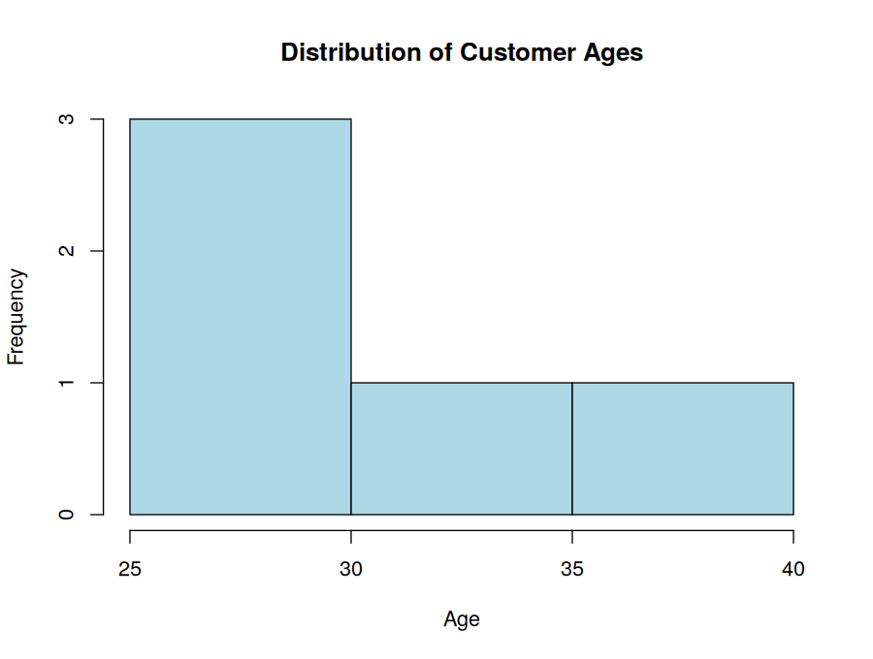
Output 1: Distribution of Customer Ages (Histogram)
Observation: Three of the five customers (ages 25, 28 and 30) fall in the 25–30 range, and one customer each falls in the 30–35 and 35–40 ranges. Most customers are in the younger age range.
PROGRAM 2: Pie Chart of Satisfaction Scores
Generate a pie chart to display the overall distribution of customer satisfaction scores. Include labels.
# Dataset
satisfaction <- c(4, 5, 3, 4, 5)
# Count satisfaction scores
score_count <- table(satisfaction)
percent <- round(100 * score_count / sum(score_count))
# Pie Chart
pie(score_count,
labels = paste0("Score ", names(score_count), " (", percent, "%)"),
col = c("tomato", "gold", "mediumseagreen"),
main = "Customer Satisfaction Scores")
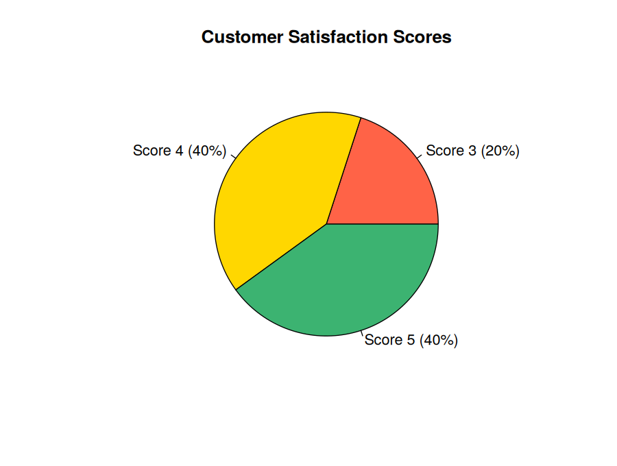
Output 2: Customer Satisfaction Scores (Pie Chart)
Observation: Scores 4 and 5 each make up 40% of responses and score 3 makes up 20%. So 80% of customers rated 4 or above, showing high overall satisfaction.
PROGRAM 3: Stacked Bar Chart of Satisfaction by Age Group
Build a stacked bar chart to visualize the distribution of customer satisfaction scores by age group.
# Dataset
age <- c(25, 30, 35, 28, 40)
satisfaction <- c(4, 5, 3, 4, 5)
# Create age groups
age_group <- cut(age,
breaks = c(20, 29, 39, 49),
labels = c("20-29", "30-39", "40-49"))
# Create table
data <- table(age_group, satisfaction)
colours <- c("skyblue", "orange", "mediumseagreen")
# Stacked Bar Chart
barplot(data,
col = colours,
ylim = c(0, 2.5),
main = "Satisfaction Scores by Age Group",
xlab = "Satisfaction Score",
ylab = "Number of Customers")
legend("topleft", legend = rownames(data), fill = colours,
title = "Age Group", bty = "n")
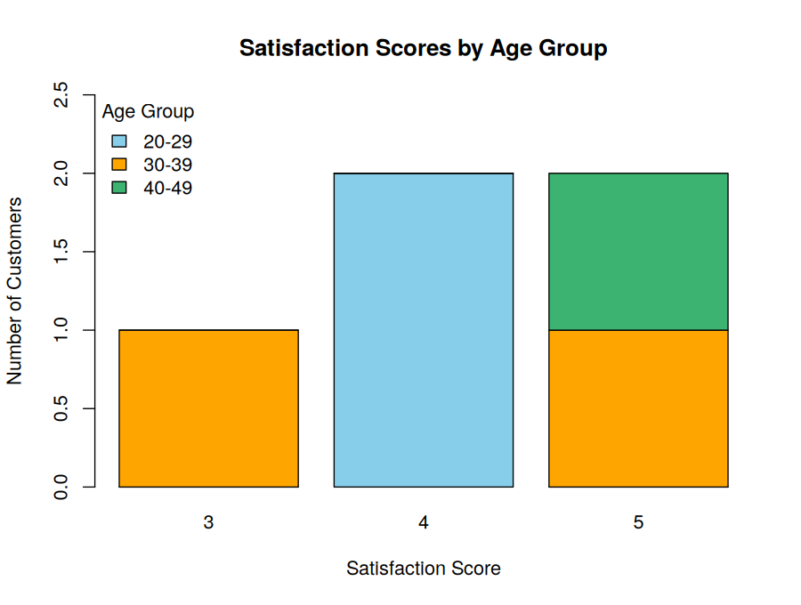
Output 3: Satisfaction Scores by Age Group (Stacked Bar Chart)
Observation: Both customers aged 20–29 gave a score of 4. The 30–39 group gave one 3 and one 5, and the 40–49 customer gave a 5. The only low score (3) comes from the 30–39 group, while score 5 comes from the older groups.
PROGRAM 4: Word Cloud of Customer Feedback
Develop a word cloud from open-ended customer feedback to identify prevalent customer sentiments.
# Install packages if required
# install.packages(c("wordcloud", "RColorBrewer"))
library(wordcloud)
library(RColorBrewer)
# Customer feedback
feedback <- c("good service", "excellent service", "good experience",
"friendly staff", "excellent service")
# Split into words and count frequency
words <- unlist(strsplit(tolower(feedback), " "))
word_count <- table(words)
# Word Cloud
wordcloud(words = names(word_count),
freq = as.numeric(word_count),
min.freq = 1,
scale = c(4, 1),
colors = brewer.pal(8, "Dark2"),
random.order = FALSE)
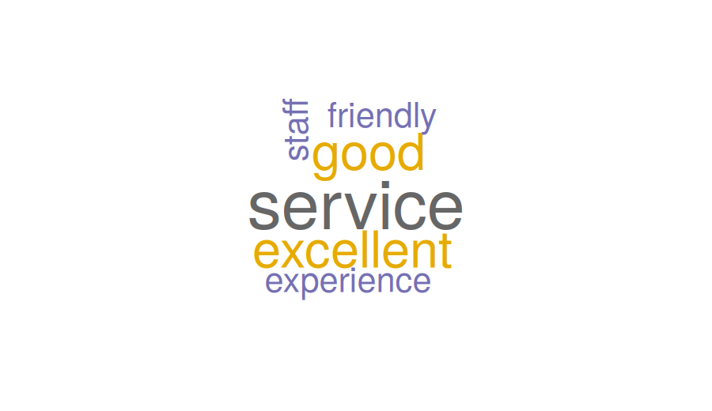
Output 4: Customer Feedback Word Cloud
Observation: "Service" is the most frequent word (3 times), followed by "excellent" and "good" (2 times each). The feedback is clearly positive and mostly about service quality, with "friendly staff" and "experience" also mentioned.
Note: The dataset has no feedback text, so sample open-ended feedback comments were used.
Result
The customer feedback data was successfully visualized in R using a histogram, pie chart, stacked bar chart and word cloud, and the prevalent customer sentiment was found to be positive.

