DSA0601 • DATA HANDLING AND VISUALIZATION
LAB EXPERIMENT RECORD
Set 7: Customer Demographics Analysis
Department | AIML
Course Code / Course Name | DSA0601 / Data Handling and Visualization
Experiment | Data Visualization using R
Name | Lakshna Sree T S
Register Number | 192524059
Aim
To visualize customer demographic data using a bar chart, pie chart, and data table, and to build an interactive dashboard using R and Shiny.
Dataset: Customer Demographics
Customer ID | Age | Gender | Income (in $)
1 | 28 | Female | 50000
2 | 35 | Male | 60000
3 | 42 | Female | 75000
PROGRAM 1: Bar Chart of Customer Ages
Create a bar chart to visualize the distribution of customer ages. Label the axes and title the chart.
# Dataset
customer <- c("Customer 1", "Customer 2", "Customer 3")
age <- c(28, 35, 42)

# Bar Chart
barplot(age,
names.arg = customer,
xlab = "Customer",
ylab = "Age (years)",
main = "Distribution of Customer Ages",
col = "steelblue",
ylim = c(0, 50))

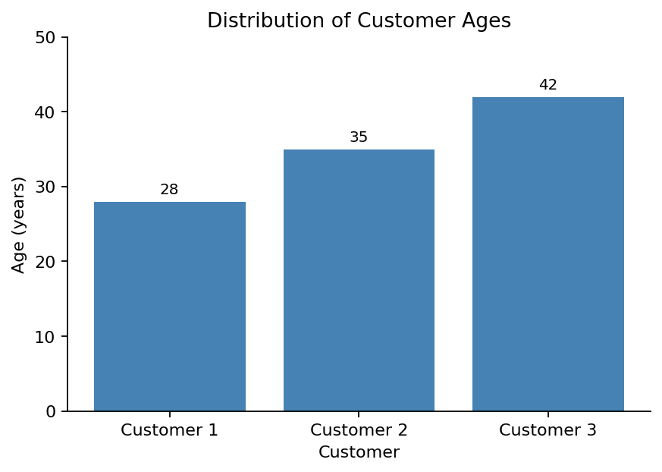
Output 1: Customer Age Bar Chart
Observation: The customers are aged 28, 35 and 42. Customer 3 is the oldest and Customer 1 the youngest, and the ages are spread evenly about 7 years apart.
PROGRAM 2: Pie Chart of Customers by Gender
Generate a pie chart to represent the distribution of customers by gender.
# Dataset
gender <- c("Female", "Male", "Female")

# Count customers by gender
gender_count <- table(gender)
percent <- round(100 * gender_count / sum(gender_count), 1)

# Pie Chart
pie(gender_count,
labels = paste0(names(gender_count), " (", percent, "%)"),
main = "Customers by Gender",
col = c("pink", "steelblue"))

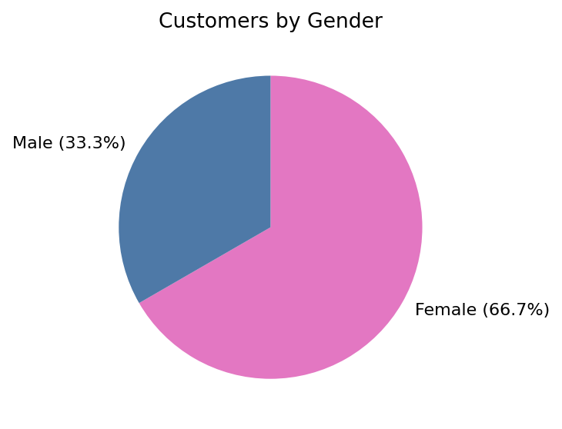
Output 2: Customers by Gender Pie Chart
Observation: Two of the three customers (66.7%) are female and one (33.3%) is male, so female customers form the majority.
PROGRAM 3: Table of Customer Demographics
Build a table to show the demographic information for each customer. Label the table elements.
# Dataset
customers <- data.frame(
"Customer ID" = c(1, 2, 3),
"Age" = c(28, 35, 42),
"Gender" = c("Female", "Male", "Female"),
"Income (in $)" = c(50000, 60000, 75000),
check.names = FALSE
)

# Display the table
print(customers)

Observation: The table gives the age, gender and income of each customer. Income increases with age: $50,000 at age 28, $60,000 at 35 and $75,000 at 42.
Output 3: Customer Demographics Table
Customer ID | Age | Gender | Income (in $)
1 | 28 | Female | 50000
2 | 35 | Male | 60000
3 | 42 | Female | 75000
PROGRAM 4: Interactive Customer Demographics Dashboard
Develop an interactive dashboard combining the bar chart, pie chart and table using the Shiny package.
library(shiny)

customers <- data.frame(
id = c(1, 2, 3),
age = c(28, 35, 42),
gender = c("Female", "Male", "Female"),
income = c(50000, 60000, 75000)
)

ui <- fluidPage(
titlePanel("Customer Demographics Dashboard"),
sidebarLayout(
sidebarPanel(
selectInput("gender", "Select Gender:",
choices = c("All", "Female", "Male"))
),
mainPanel(
plotOutput("agePlot"),
plotOutput("genderPlot"),
tableOutput("custTable")
)
)
)

server <- function(input, output) {
filtered <- reactive({
if (input$gender == "All") customers
else subset(customers, gender == input$gender)
})

output$agePlot <- renderPlot({
d <- filtered()
barplot(d$age, names.arg = paste("Customer", d$id),
xlab = "Customer", ylab = "Age (years)",
main = "Distribution of Customer Ages", col = "steelblue")
})

output$genderPlot <- renderPlot({
g <- table(filtered()$gender)
pie(g, labels = names(g), main = "Customers by Gender",
col = c("pink", "steelblue")[seq_along(g)])
})

output$custTable <- renderTable({
d <- filtered()
names(d) <- c("Customer ID", "Age", "Gender", "Income (in $)")
d
})
}

shinyApp(ui = ui, server = server)

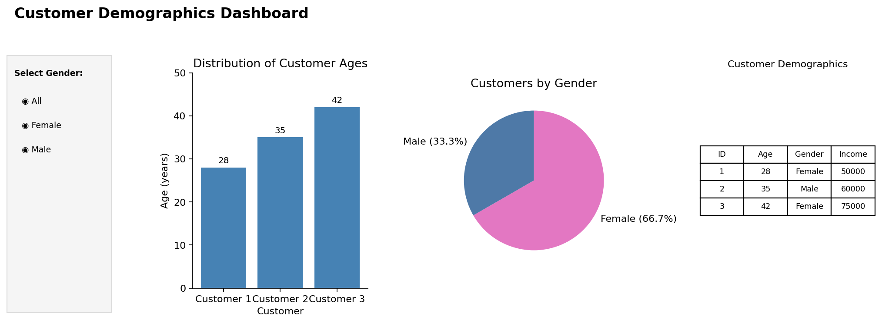
Output 4: Interactive Customer Demographics Dashboard
Observation: The dashboard combines the age bar chart, gender pie chart and demographics table. Choosing All, Female or Male in the selection box updates all three views together.
Procedure
1. Create the customer ID, age, gender and income data in R.
2. Use barplot() to draw the bar chart of customer ages.
3. Use table() to count customers by gender and pie() to draw the pie chart with labels.
4. Create a data.frame() with the demographic information and display it as a table.
5. Install and load the Shiny package, then create the UI and server components for the dashboard.
6. Run the Shiny application and choose a gender to update the charts and table.
Result
The customer demographic data was successfully visualized using a bar chart, a pie chart and a data table. An interactive Shiny dashboard combining all three was also created.
Key R Functions Used
Function | Purpose
barplot() | Creates the bar chart.
table() | Counts customers in each gender group.
pie() | Creates the pie chart.
data.frame() | Creates the demographic table.
selectInput() | Provides the gender selection control.
reactive() | Filters the data when the selection changes.
renderPlot() / renderTable() | Generate plots and tables dynamically in Shiny.
shinyApp() | Runs the interactive Shiny application.

