DSA0601 • DATA HANDLING AND VISUALIZATION
LAB EXPERIMENT RECORD
Set 8: Employee Performance Analysis
Department | AIML
Course Code / Course Name | DSA0601 / Data Handling and Visualization
Experiment | Data Visualization using R
Name | Lakshna Sree T S
Register Number | 192524059
Aim
To analyze employee performance data using a line chart, bar chart, and data table, and to build an interactive dashboard using R and Shiny.
Dataset: Employee Performance
Employee ID | Department | Years of Service | Performance Score
1 | Sales | 5 | 85
2 | HR | 3 | 92
3 | Marketing | 7 | 78
Note: The dataset has no date column, so "performance over time" is shown against Years of Service, with the employees arranged from the shortest to the longest service.
PROGRAM 1: Line Chart of Performance Trend
Create a line chart to visualize the performance trend of employees over time. Label the axes and title the chart.
# Dataset
years <- c(5, 3, 7)
score <- c(85, 92, 78)

# Arrange by years of service
ord <- order(years)

# Line Chart
plot(years[ord], score[ord],
type = "o",
xaxt = "n",
xlab = "Years of Service",
ylab = "Performance Score",
main = "Employee Performance Trend",
col = "blue",
ylim = c(70, 100))

axis(1, at = years[ord])

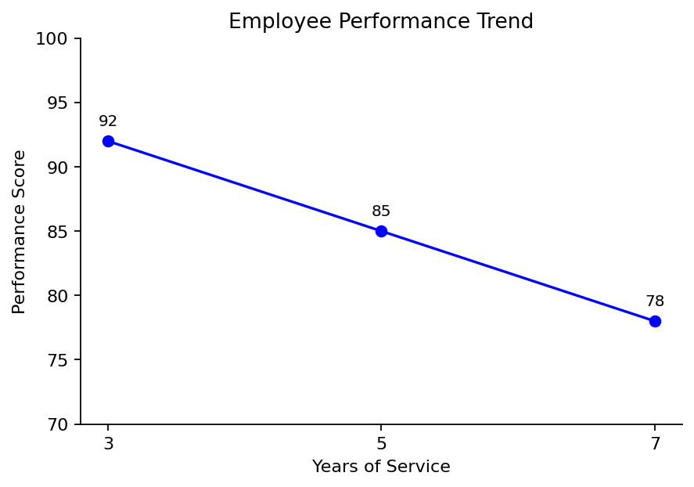
Output 1: Employee Performance Trend Line Chart
Observation: The performance score falls as years of service increase: 92 at 3 years, 85 at 5 years and 78 at 7 years. With only three employees this is a pattern in the sample, not a general rule.
PROGRAM 2: Bar Chart of Employees by Department
Generate a bar chart showing the distribution of employees across different departments. Label the chart elements.
# Dataset
department <- c("Sales", "HR", "Marketing")

# Count employees in each department
dept_count <- table(department)

# Bar Chart
barplot(dept_count,
xlab = "Department",
ylab = "Number of Employees",
main = "Employees by Department",
col = "orange",
ylim = c(0, 2))

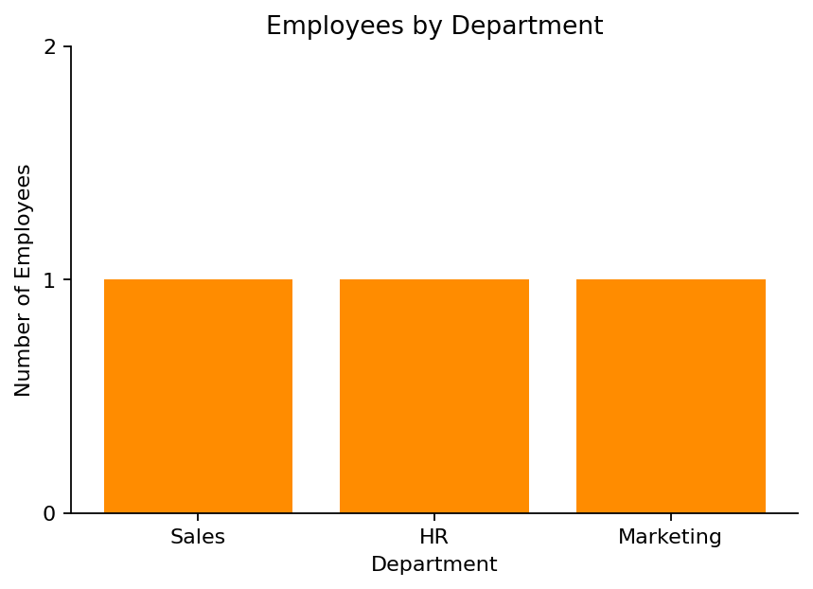
Output 2: Employees by Department Bar Chart
Observation: Each of the three departments (Sales, HR and Marketing) has exactly one employee, so the employees are evenly distributed.
PROGRAM 3: Table of Employee Performance Data
Build a table to display the performance data for each employee. Label the table elements.
# Dataset
employees <- data.frame(
"Employee ID" = c(1, 2, 3),
"Department" = c("Sales", "HR", "Marketing"),
"Years of Service" = c(5, 3, 7),
"Performance Score" = c(85, 92, 78),
check.names = FALSE
)

# Display the table
print(employees)

Observation: The table lists the department, years of service and performance score of each employee. The HR employee has the highest score (92) and the Marketing employee the lowest (78).
Output 3: Employee Performance Table
Employee ID | Department | Years of Service | Performance Score
1 | Sales | 5 | 85
2 | HR | 3 | 92
3 | Marketing | 7 | 78
PROGRAM 4: Interactive Employee Performance Dashboard
Develop an interactive dashboard combining the line chart, bar chart and table using the Shiny package.
library(shiny)

employees <- data.frame(
id = c(1, 2, 3),
department = c("Sales", "HR", "Marketing"),
years = c(5, 3, 7),
score = c(85, 92, 78)
)

ui <- fluidPage(
titlePanel("Employee Performance Dashboard"),
sidebarLayout(
sidebarPanel(
checkboxGroupInput("dept", "Select Department:",
choices = c("Sales", "HR", "Marketing"),
selected = c("Sales", "HR", "Marketing"))
),
mainPanel(
plotOutput("linePlot"),
plotOutput("barPlot"),
tableOutput("empTable")
)
)
)

server <- function(input, output) {
filtered <- reactive({
d <- subset(employees, department %in% input$dept)
d[order(d$years), ]
})

output$linePlot <- renderPlot({
d <- filtered()
req(nrow(d) > 0)
plot(d$years, d$score, type = "o", xlab = "Years of Service",
ylab = "Performance Score", main = "Employee Performance Trend",
col = "blue", ylim = c(70, 100))
})

output$barPlot <- renderPlot({
d <- filtered()
req(nrow(d) > 0)
barplot(table(d$department), xlab = "Department",
ylab = "Number of Employees", main = "Employees by Department",
col = "orange")
})

output$empTable <- renderTable({
d <- filtered()
names(d) <- c("Employee ID", "Department", "Years of Service", "Performance Score")
d
})
}

shinyApp(ui = ui, server = server)

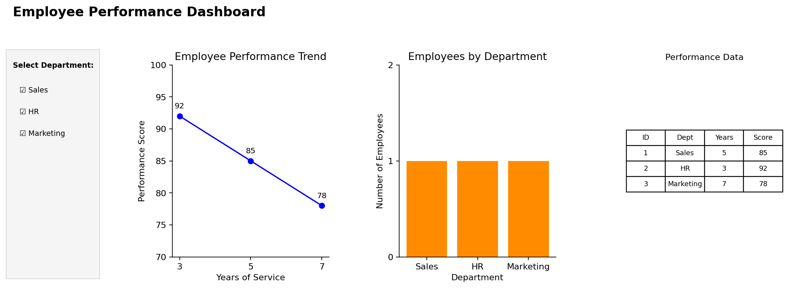
Output 4: Interactive Employee Performance Dashboard
Observation: The dashboard shows the performance trend, department distribution and data table together. Selecting or clearing departments in the sidebar updates all three views at once.
Procedure
1. Create the employee ID, department, years of service and performance score data in R.
2. Sort the employees by years of service with order() and use plot() with type = "o" for the line chart.
3. Use table() to count employees per department and barplot() to draw the bar chart.
4. Create a data.frame() with the performance data and display it as a table.
5. Install and load the Shiny package, then create the UI and server components for the dashboard.
6. Run the Shiny application and select departments to update the charts and table.
Result
The employee performance data was successfully visualized using a line chart, a bar chart and a data table. An interactive Shiny dashboard combining all three was also created.
Key R Functions Used
Function | Purpose
order() | Arranges employees by years of service.
plot() | Creates the line chart.
table() | Counts employees in each department.
barplot() | Creates the bar chart.
data.frame() | Creates the performance table.
checkboxGroupInput() | Provides the department selection control.
reactive() | Filters the data when the selection changes.
renderPlot() / renderTable() | Generate plots and tables dynamically in Shiny.
shinyApp() | Runs the interactive Shiny application.

