DSA0601 • DATA HANDLING AND VISUALIZATION
LAB EXPERIMENT RECORD
Set 9: Online Learning Activity Analysis
Department | AIML
Course Code / Course Name | DSA0601 / Data Handling and Visualization
Experiment | Data Visualization using R
Name | Lakshna Sree T S
Register Number | 192524059
Aim
To import the Online_Learning_Activity.csv dataset in R, visualize student performance using a histogram, boxplot, bubble scatter plot and smoothed line chart, and to build an interactive dashboard with filters.
Dataset: Online_Learning_Activity.csv
Student_ID | Gender | Age | Course | Study_Time (hrs) | Videos_Watched | Quiz_Score | Login_Date
L01 | Male | 20 | R | 3.5 | 12 | 78 | 2025-01-05
L02 | Female | 22 | R | 4.2 | 15 | 85 | 2025-01-05
L03 | Male | 19 | SQL | 2.0 | 8 | 65 | 2025-02-08
L04 | Female | 21 | R | 5.0 | 18 | 92 | 2025-02-08
L05 | Male | 23 | R | 2.5 | 9 | 70 | 2025-03-12
L06 | Female | 20 | SQL | 4.0 | 14 | 88 | 2025-03-12
Note: Save the table above as Online_Learning_Activity.csv in the R working directory (use setwd() or the full file path) before running the programs.
PROGRAM 1: Histogram and Boxplot of Quiz Score
Import the dataset in R. Plot a histogram for Quiz_Score. Draw a boxplot of Quiz_Score by Course. Add title and labels. Interpret student performance.
# Import the dataset
data <- read.csv("Online_Learning_Activity.csv")
head(data)

# Histogram of Quiz_Score
hist(data$Quiz_Score,
breaks = seq(60, 100, by = 10),
xlab = "Quiz Score",
ylab = "Frequency",
main = "Histogram of Quiz Scores",
col = "skyblue")

# Boxplot of Quiz_Score by Course
boxplot(Quiz_Score ~ Course, data = data,
xlab = "Course",
ylab = "Quiz Score",
main = "Quiz Score by Course",
col = "lightgreen")

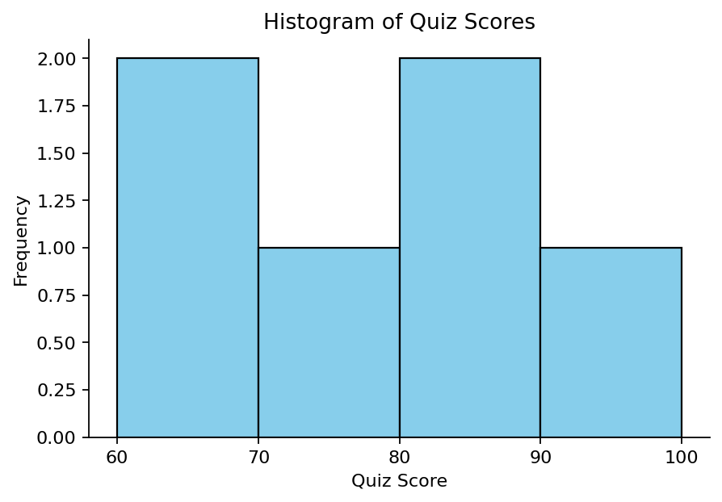
Output 1(a): Histogram of Quiz Scores
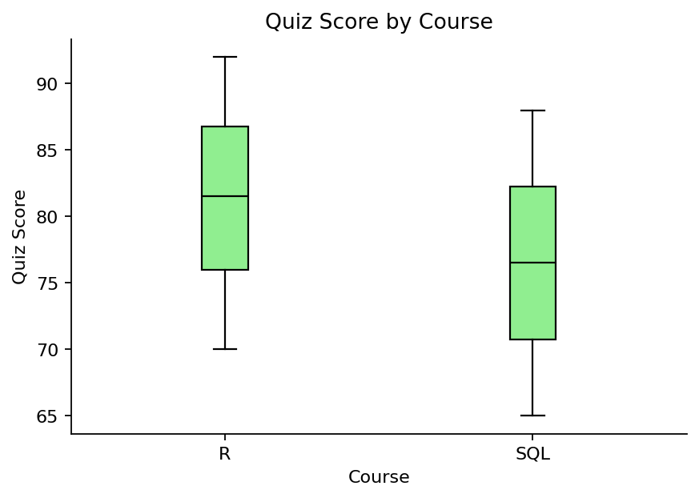
Output 1(b): Boxplot of Quiz Score by Course
Interpretation: Quiz scores range from 65 to 92 and are spread fairly evenly, with four of the six students scoring between 70 and 88. R students (median 81.5) scored higher than SQL students (median 76.5), and the R group also has the highest score (92). The SQL boxplot is based on only two students, so it should be read with caution.
PROGRAM 2: Bubble Scatter Plot: Study Time vs Quiz Score
Create a scatter plot between Study_Time and Quiz_Score. Represent Videos_Watched using bubble size. Apply transparency. Explain the learning pattern.
data <- read.csv("Online_Learning_Activity.csv")

# Bubble size = Videos_Watched, transparency = 0.5
plot(data$Study_Time..hrs., data$Quiz_Score,
cex = data$Videos_Watched / 5,
pch = 19,
col = rgb(0, 0, 1, alpha = 0.5),
xlab = "Study Time (hrs)",
ylab = "Quiz Score",
main = "Study Time vs Quiz Score")

# Correlation
cor(data$Study_Time..hrs., data$Quiz_Score)

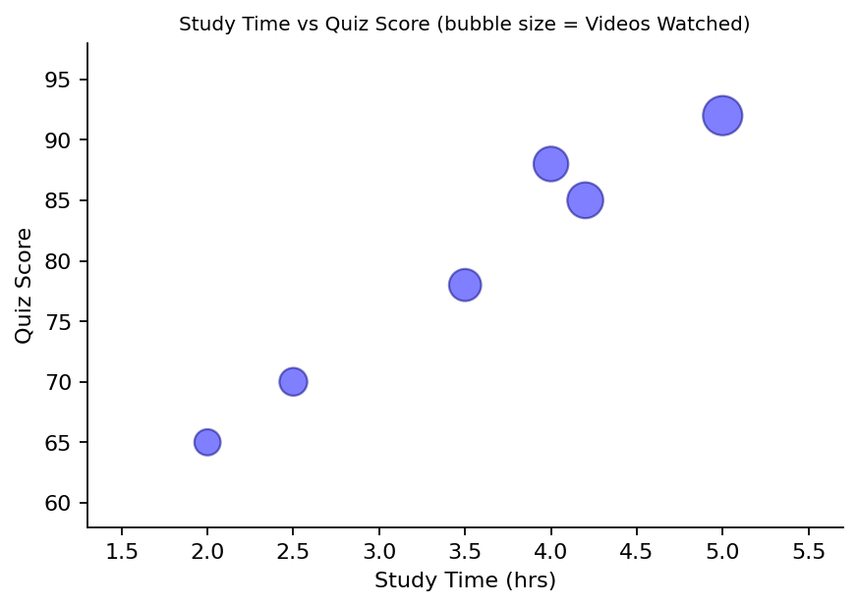
Output 2: Bubble Plot of Study Time vs Quiz Score
Learning Pattern: The points rise from the lower left to the upper right and the correlation is about 0.98, a very strong positive relationship. Students who studied longer also scored higher, and those students also watched more videos (the largest bubbles are at the top right). The overlapping transparent bubbles make this pattern easy to see. This is a small sample, and it shows association, not cause.
PROGRAM 3: Monthly Average Quiz Score with Moving Average
Convert Login_Date into Date format. Calculate average quiz score per month. Plot a line chart. Apply moving average smoothing. Identify the trend.
data <- read.csv("Online_Learning_Activity.csv")

# Convert Login_Date to Date format
data$Login_Date <- as.Date(data$Login_Date)
data$Month <- format(data$Login_Date, "%Y-%m")

# Average quiz score per month
monthly <- aggregate(Quiz_Score ~ Month, data = data, FUN = mean)
print(monthly)

# Moving average (window = 2)
monthly$MA <- stats::filter(monthly$Quiz_Score, rep(1/2, 2), sides = 1)

# Line chart
plot(monthly$Quiz_Score, type = "o", col = "blue", xaxt = "n",
ylim = c(76, 84),
xlab = "Month", ylab = "Average Quiz Score",
main = "Average Quiz Score per Month")
axis(1, at = 1:3, labels = monthly$Month)
lines(monthly$MA, type = "o", col = "red", lty = 2)
legend("topright", legend = c("Monthly average", "Moving average"),
col = c("blue", "red"), lty = c(1, 2), pch = 1)

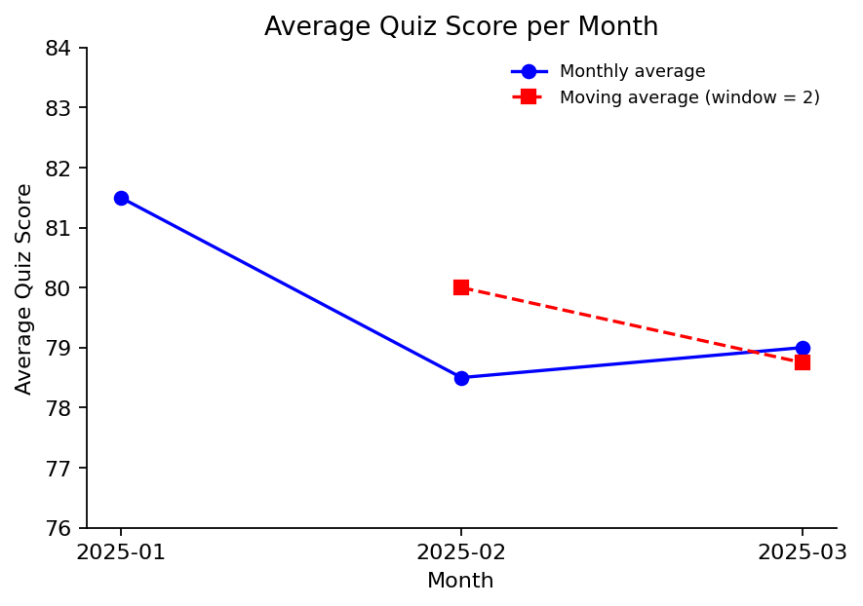
Output 3: Monthly Average Quiz Score with Moving Average
Trend: The monthly averages are 81.5 (January), 78.5 (February) and 79.0 (March). The moving average is 80.0 for February and 78.75 for March (the first month has no value because it has no earlier month). The trend is a small drop from January to February, then a flat level, so overall scores are slightly lower after January.
Monthly Average Table
Month | Average Quiz Score | Moving Average (window = 2)
2025-01 | 81.5 | NA
2025-02 | 78.5 | 80.0
2025-03 | 79.0 | 78.75
PROGRAM 4: Interactive Learning Dashboard
Import Online_Learning_Activity.csv and create a bar chart of average quiz score by Course, a scatter plot of Study Time vs Quiz Score, and filters for Gender and Course. Design a mini interactive dashboard.
library(shiny)

data <- read.csv("Online_Learning_Activity.csv")

ui <- fluidPage(
titlePanel("Online Learning Dashboard"),
sidebarLayout(
sidebarPanel(
selectInput("gender", "Gender:",
choices = c("All", unique(data$Gender))),
selectInput("course", "Course:",
choices = c("All", unique(data$Course)))
),
mainPanel(
plotOutput("barPlot"),
plotOutput("scatterPlot")
)
)
)

server <- function(input, output) {
filtered <- reactive({
d <- data
if (input$gender != "All") d <- subset(d, Gender == input$gender)
if (input$course != "All") d <- subset(d, Course == input$course)
d
})

output$barPlot <- renderPlot({
d <- filtered()
req(nrow(d) > 0)
avg <- aggregate(Quiz_Score ~ Course, data = d, FUN = mean)
barplot(avg$Quiz_Score, names.arg = avg$Course, xlab = "Course",
ylab = "Average Quiz Score",
main = "Average Quiz Score by Course", col = "steelblue")
})

output$scatterPlot <- renderPlot({
d <- filtered()
req(nrow(d) > 0)
plot(d$Study_Time..hrs., d$Quiz_Score, pch = 19, col = "blue",
xlab = "Study Time (hrs)", ylab = "Quiz Score",
main = "Study Time vs Quiz Score")
})
}

shinyApp(ui = ui, server = server)

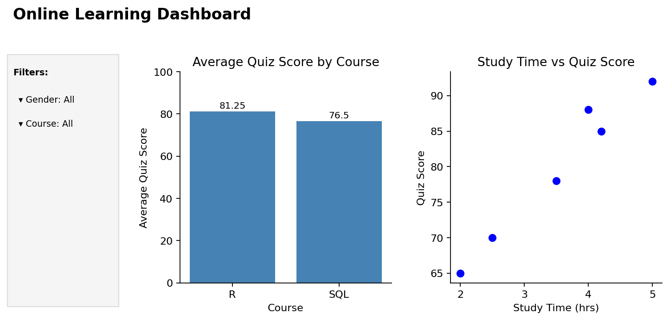
Output 4: Interactive Online Learning Dashboard
Observation: The dashboard has Gender and Course filters in the sidebar. Changing either filter updates the average-score bar chart (R: 81.25, SQL: 76.5 with no filter) and the study-time scatter plot together.
Procedure
1. Save the dataset as Online_Learning_Activity.csv and import it with read.csv().
2. Use hist() for the quiz-score histogram and boxplot() with a formula to compare courses.
3. Use plot() with cex (bubble size) and rgb(..., alpha) (transparency) to draw the bubble plot.
4. Convert Login_Date with as.Date(), extract the month with format(), and find the monthly average with aggregate().
5. Apply moving-average smoothing with stats::filter() and draw both lines on one line chart.
6. Create the Shiny UI with Gender and Course filters and the server code with a reactive filtered dataset, then run the application.
Result
The online learning data was successfully imported and visualized using a histogram, boxplot, bubble scatter plot and moving-average line chart. A strong positive relationship between study time and quiz score was found, and an interactive Shiny dashboard with Gender and Course filters was created.
Key R Functions Used
Function | Purpose
read.csv() | Imports the CSV dataset into R.
hist() | Creates the histogram.
boxplot() | Creates the boxplot by group.
plot() with cex / rgb() | Creates the bubble plot with transparency.
as.Date() / format() | Converts the login date and extracts the month.
aggregate() | Calculates the average score per group.
stats::filter() | Applies moving-average smoothing.
selectInput() | Provides the Gender and Course filters.
reactive() | Filters the data when a selection changes.
shinyApp() | Runs the interactive Shiny application.

