DSA0601 • DATA HANDLING AND VISUALIZATION
LAB EXPERIMENT RECORD
Set 5: Website Analytics
Department | AIML
Course Code / Course Name | DSA0601 / Data Handling and Visualization
Experiment | Data Visualization using R
Name | Lakshna Sree T S
Register Number | 192524059
Date | 01 October 2026
Aim
To visualize website traffic data using a line chart, bar chart, and stacked area chart, and to build an interactive dashboard using R and Shiny.
Dataset: Website Traffic
Date | Page Views | Click-through Rate
2023-01-01 | 1500 | 2.3%
2023-01-02 | 1600 | 2.7%
2023-01-03 | 1400 | 2.0%
2023-01-04 | 1650 | 2.4%
2023-01-05 | 1800 | 2.6%
Note: The assignment table does not include likes, shares and comments. For Program 3, the following sample values were assumed (Jan 1 to Jan 5) – Likes: 320, 350, 300, 380, 410; Shares: 80, 95, 70, 100, 120; Comments: 45, 55, 40, 60, 70.
PROGRAM 1: Line Chart of Daily Page Views
Create a line chart to visualize the trend in daily page views over time. Label the axes and title the chart.
# Dataset
date <- as.Date(c("2023-01-01", "2023-01-02", "2023-01-03",
"2023-01-04", "2023-01-05"))
page_views <- c(1500, 1600, 1400, 1650, 1800)

# Line Chart
plot(date, page_views,
type = "o",
xlab = "Date",
ylab = "Page Views",
main = "Daily Page Views",
col = "blue")

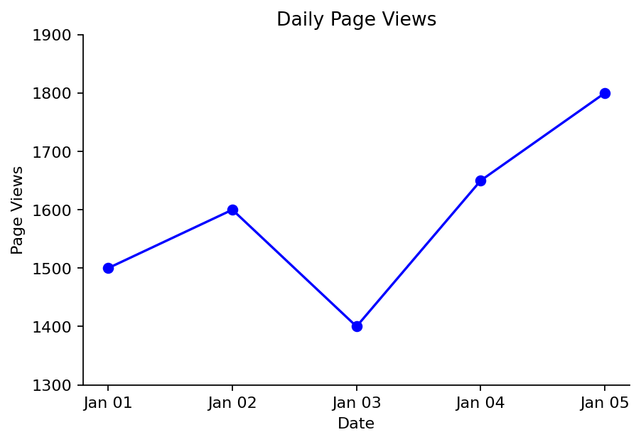
Output 1: Daily Page Views Line Chart
Observation: Page views rise from 1500 to 1600, drop to 1400 on 3 January, and then climb steadily to 1650 and finally 1800 on 5 January. Overall the trend is upward.
PROGRAM 2: Bar Chart of Top N Days by Click-through Rate
Generate a bar chart showing the top N days with the highest click-through rates. Label the chart elements.
# Dataset
date <- c("2023-01-01", "2023-01-02", "2023-01-03", "2023-01-04", "2023-01-05")
ctr <- c(2.3, 2.7, 2.0, 2.4, 2.6)

# Select the top N days
N <- 3
top <- order(ctr, decreasing = TRUE)[1:N]

# Bar Chart
barplot(ctr[top],
names.arg = date[top],
xlab = "Date",
ylab = "Click-through Rate (%)",
main = paste("Top", N, "Days by Click-through Rate"),
col = "darkgreen")

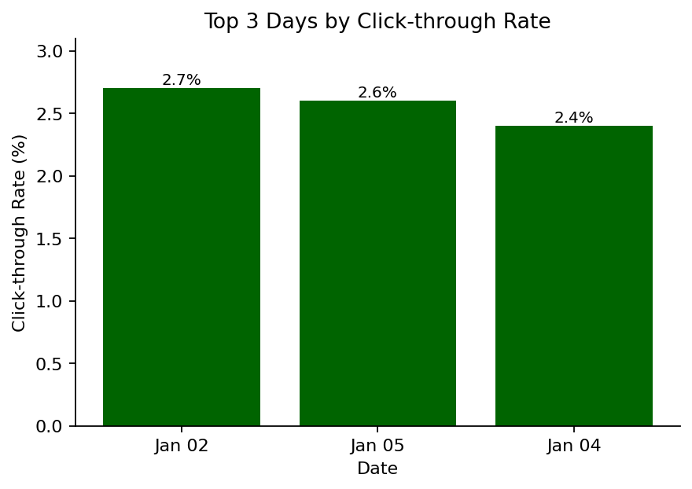
Output 2: Top 3 Days by Click-through Rate
Observation: The three best days are 2 January (2.7%), 5 January (2.6%) and 4 January (2.4%). 3 January had the lowest click-through rate (2.0%) and is not in the top 3.
PROGRAM 3: Stacked Area Chart of User Interactions
Develop a stacked area chart to display the distribution of user interactions (likes, shares, comments) on a website.
library(ggplot2)

# Dataset (sample interaction values)
interactions <- data.frame(
date = rep(as.Date(c("2023-01-01", "2023-01-02", "2023-01-03",
"2023-01-04", "2023-01-05")), times = 3),
type = rep(c("Likes", "Shares", "Comments"), each = 5),
count = c(320, 350, 300, 380, 410, # Likes
80, 95, 70, 100, 120, # Shares
45, 55, 40, 60, 70) # Comments
)

# Stacked Area Chart
ggplot(interactions, aes(x = date, y = count, fill = type)) +
geom_area() +
labs(title = "Distribution of User Interactions",
x = "Date", y = "Number of Interactions", fill = "Interaction")

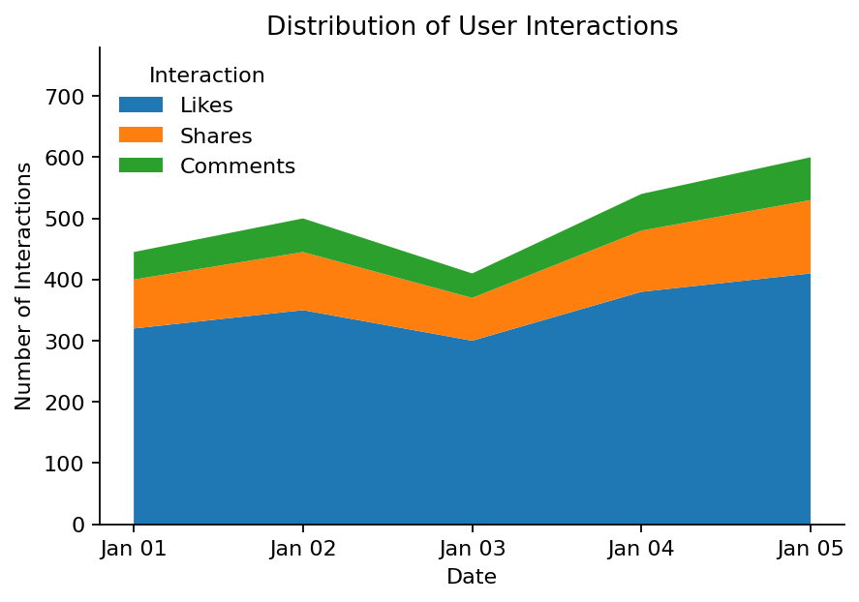
Output 3: Stacked Area Chart of User Interactions
Observation: Likes make up the largest share of interactions every day, followed by shares and comments. Total interactions dip on 3 January and reach their peak on 5 January, matching the page-view trend.
PROGRAM 4: Interactive Website Traffic Dashboard
Build an interactive dashboard with the line chart and bar chart using the Shiny package.
library(shiny)

date <- as.Date(c("2023-01-01", "2023-01-02", "2023-01-03",
"2023-01-04", "2023-01-05"))
page_views <- c(1500, 1600, 1400, 1650, 1800)
ctr <- c(2.3, 2.7, 2.0, 2.4, 2.6)

ui <- fluidPage(
titlePanel("Website Traffic Dashboard"),
sidebarLayout(
sidebarPanel(
sliderInput("n", "Top N days (by CTR):",
min = 1, max = 5, value = 3, step = 1)
),
mainPanel(
plotOutput("linePlot"),
plotOutput("barPlot")
)
)
)

server <- function(input, output) {
output$linePlot <- renderPlot({
plot(date, page_views, type = "o", xlab = "Date",
ylab = "Page Views", main = "Daily Page Views", col = "blue")
})
output$barPlot <- renderPlot({
top <- order(ctr, decreasing = TRUE)[1:input$n]
barplot(ctr[top], names.arg = format(date[top]),
xlab = "Date", ylab = "Click-through Rate (%)",
main = paste("Top", input$n, "Days by Click-through Rate"),
col = "darkgreen")
})
}

shinyApp(ui = ui, server = server)

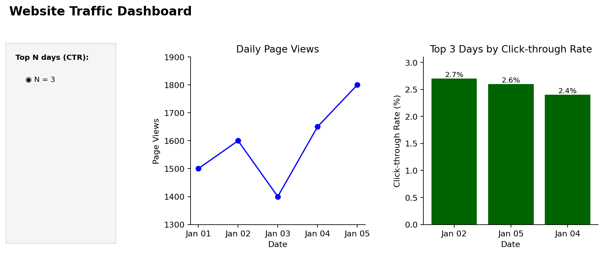
Output 4: Interactive Website Traffic Dashboard
Observation: The dashboard shows the page-view trend and the click-through-rate chart together. Moving the slider changes N, so the bar chart updates to show the top 1 to 5 days.
Procedure
1. Create the date, page-view and click-through-rate vectors in R.
2. Use plot() with type = "o" to create the line chart of daily page views.
3. Use order() to find the top N click-through rates and barplot() to display them.
4. Create a data frame of likes, shares and comments, and use ggplot2 with geom_area() to draw the stacked area chart.
5. Install and load the Shiny package, then create the UI and server components for the dashboard.
6. Run the Shiny application and change the slider to explore the top N days.
Result
The website traffic data was successfully visualized using a line chart, a bar chart of the top N click-through days, and a stacked area chart of user interactions. An interactive Shiny dashboard combining the line chart and bar chart was also created.
Key R Functions Used
Function | Purpose
as.Date() | Converts text into date values.
plot() | Creates the line chart.
order() | Ranks the days by click-through rate.
barplot() | Creates the bar chart.
ggplot() / geom_area() | Creates the stacked area chart (ggplot2 package).
sliderInput() | Provides the control for choosing N in Shiny.
renderPlot() | Generates plots dynamically in Shiny.
shinyApp() | Runs the interactive Shiny application.

