DSA0601 • DATA HANDLING AND VISUALIZATION
LAB EXPERIMENT RECORD
Set 6: Product Sales Analysis
Department | AIML
Course Code / Course Name | DSA0601 / Data Handling and Visualization
Experiment | Data Visualization using R
Name | Lakshna Sree T S
Register Number | 192524059
Date | 01 October 2026
Aim
To analyze monthly product sales using a grouped bar chart, stacked area chart, and data table, and to build an interactive dashboard using R and Shiny.
Dataset: Monthly Product Sales
Product ID | Product Name | January Sales | February Sales | March Sales
1 | Product A | 2000 | 2200 | 2400
2 | Product B | 1500 | 1800 | 1600
3 | Product C | 1200 | 1400 | 1100
PROGRAM 1: Grouped Bar Chart of Q1 Sales
Create a grouped bar chart to visualize the sales of each product for the first quarter. Label the chart elements.
# Dataset (rows = months, columns = products)
product <- c("Product A", "Product B", "Product C")
sales <- matrix(c(2000, 1500, 1200, # January
2200, 1800, 1400, # February
2400, 1600, 1100), # March
nrow = 3, byrow = TRUE)
rownames(sales) <- c("January", "February", "March")

# Grouped Bar Chart
barplot(sales,
beside = TRUE,
names.arg = product,
xlab = "Product",
ylab = "Sales ($)",
main = "Q1 Sales by Product",
col = c("steelblue", "orange", "darkgreen"),
legend.text = rownames(sales))

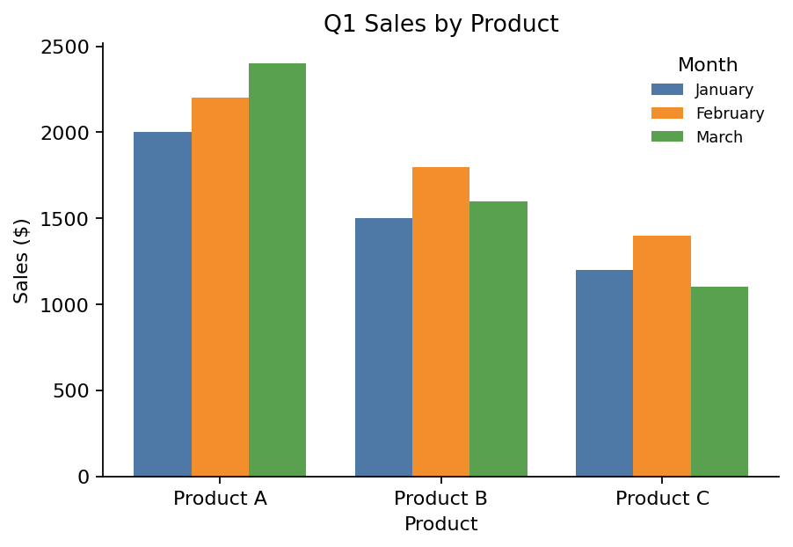
Output 1: Grouped Bar Chart of Q1 Sales
Observation: Product A has the highest sales in every month and grows steadily from 2000 to 2400. Product B peaks in February and falls in March, and Product C peaks in February and drops to its lowest value in March.
PROGRAM 2: Stacked Area Chart of Overall Sales Trend
Generate a stacked area chart to represent the overall sales trend for all products over the three months.
library(ggplot2)

# Dataset
sales_data <- data.frame(
month = factor(rep(c("January", "February", "March"), times = 3),
levels = c("January", "February", "March")),
product = rep(c("Product A", "Product B", "Product C"), each = 3),
sales = c(2000, 2200, 2400, # Product A
1500, 1800, 1600, # Product B
1200, 1400, 1100) # Product C
)

# Stacked Area Chart
ggplot(sales_data, aes(x = month, y = sales, fill = product, group = product)) +
geom_area() +
labs(title = "Overall Sales Trend",
x = "Month", y = "Total Sales ($)", fill = "Product")

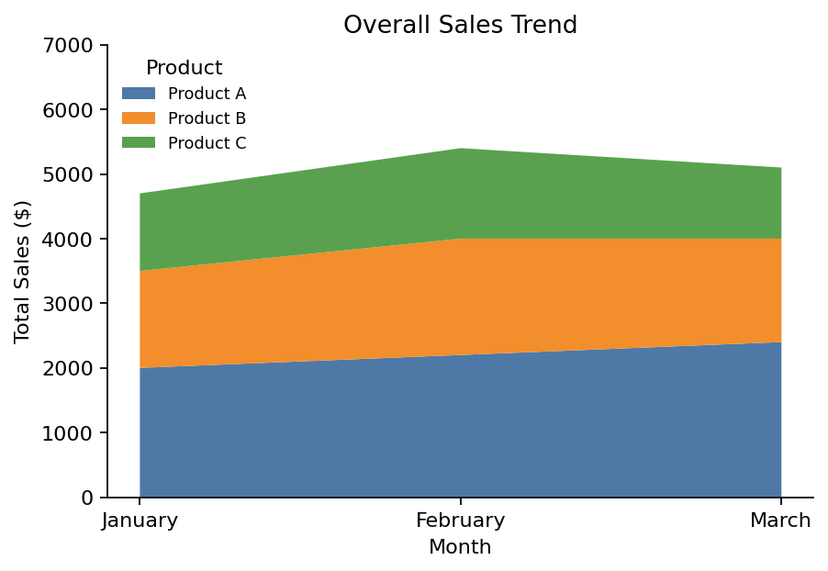
Output 2: Stacked Area Chart of Overall Sales Trend
Observation: Total sales rise from 4700 in January to 5400 in February and then fall to 5100 in March. Product A forms the biggest part of the total in every month.
PROGRAM 3: Table of Monthly Sales Data
Build a table to show the monthly sales data for each product. Label the table elements.
# Dataset
sales_table <- data.frame(
"Product ID" = c(1, 2, 3),
"Product Name" = c("Product A", "Product B", "Product C"),
"January Sales" = c(2000, 1500, 1200),
"February Sales" = c(2200, 1800, 1400),
"March Sales" = c(2400, 1600, 1100),
check.names = FALSE
)

# Display the table
print(sales_table)

Observation: The table lists the exact sales value of every product for each month, which complements the charts.
Output 3: Monthly Sales Table
Product ID | Product Name | January Sales | February Sales | March Sales
1 | Product A | 2000 | 2200 | 2400
2 | Product B | 1500 | 1800 | 1600
3 | Product C | 1200 | 1400 | 1100
PROGRAM 4: Interactive Sales Dashboard
Develop an interactive dashboard combining the grouped bar chart, stacked area chart and table using the Shiny package.
library(shiny)
library(ggplot2)

sales_data <- data.frame(
product_id = rep(1:3, times = 3),
product = rep(c("Product A", "Product B", "Product C"), times = 3),
month = factor(rep(c("January", "February", "March"), each = 3),
levels = c("January", "February", "March")),
sales = c(2000, 1500, 1200,
2200, 1800, 1400,
2400, 1600, 1100)
)

ui <- fluidPage(
titlePanel("Product Sales Dashboard"),
sidebarLayout(
sidebarPanel(
checkboxGroupInput("products", "Select Products:",
choices = c("Product A", "Product B", "Product C"),
selected = c("Product A", "Product B", "Product C"))
),
mainPanel(
plotOutput("groupPlot"),
plotOutput("areaPlot"),
tableOutput("salesTable")
)
)
)

server <- function(input, output) {
filtered <- reactive({ subset(sales_data, product %in% input$products) })

output$groupPlot <- renderPlot({
ggplot(filtered(), aes(x = product, y = sales, fill = month)) +
geom_col(position = "dodge") +
labs(title = "Q1 Sales by Product", x = "Product", y = "Sales ($)", fill = "Month")
})

output$areaPlot <- renderPlot({
ggplot(filtered(), aes(x = month, y = sales, fill = product, group = product)) +
geom_area() +
labs(title = "Overall Sales Trend", x = "Month", y = "Total Sales ($)", fill = "Product")
})

output$salesTable <- renderTable({
wide <- reshape(filtered()[, c("product_id", "product", "month", "sales")],
idvar = c("product_id", "product"),
timevar = "month", direction = "wide")
names(wide) <- c("Product ID", "Product Name", "January Sales",
"February Sales", "March Sales")
wide
})
}

shinyApp(ui = ui, server = server)

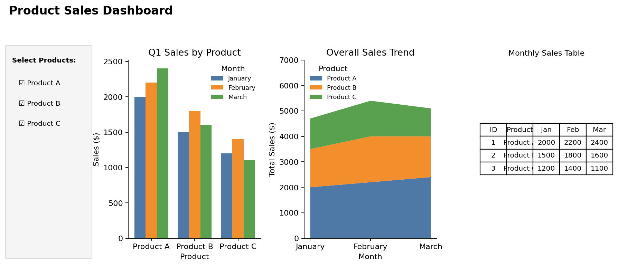
Output 4: Interactive Product Sales Dashboard
Observation: The dashboard combines the grouped bar chart, stacked area chart and sales table. Selecting or clearing products in the sidebar updates all three views at the same time.
Procedure
1. Create the product and monthly sales data in R.
2. Build a month-by-product matrix and use barplot() with beside = TRUE to create the grouped bar chart.
3. Create a long-format data frame and use ggplot2 with geom_area() to draw the stacked area chart.
4. Create a data.frame() with the monthly sales of each product and display it as a table.
5. Install and load the Shiny and ggplot2 packages, then create the UI and server components for the dashboard.
6. Run the Shiny application and select products to update the charts and table.
Result
The monthly product sales data was successfully visualized using a grouped bar chart, a stacked area chart and a data table. An interactive Shiny dashboard combining all three was also created.
Key R Functions Used
Function | Purpose
matrix() | Builds the month-by-product sales data.
barplot(beside = TRUE) | Creates the grouped bar chart.
ggplot() / geom_area() | Creates the stacked area chart (ggplot2 package).
data.frame() | Creates the sales table.
checkboxGroupInput() | Provides the product selection control.
reactive() | Filters the data when the selection changes.
renderPlot() / renderTable() | Generate plots and tables dynamically in Shiny.
shinyApp() | Runs the interactive Shiny application.

