DSA0601 Data Handling and Visualization
Name: Lakshna Sree T S
Regno: 192524059
SET 19 — SURVEY RESPONSES ANALYSIS
Dataset
Survey ID | Question 1 | Question 2 | Question 3
1 | A | B | C
2 | B | A | D
3 | C | A | B

PROGRAM 1 — Grouped Bar Chart for Question 1
# Dataset
q1 <- c("A", "B", "C")
options <- c("A", "B", "C", "D")
# Rows = surveys, columns = answer options (1 if chosen)
q1_matrix <- sapply(options, function(o) as.numeric(q1 == o))
rownames(q1_matrix) <- c("Survey 1", "Survey 2", "Survey 3")
# Grouped Bar Chart
barplot(q1_matrix,
beside = TRUE,
xlab = "Answer Option (Question 1)",
ylab = "Number of Responses",
main = "Distribution of Answers: Question 1",
col = gray.colors(3),
legend.text = rownames(q1_matrix),
ylim = c(0, 1.5))

Output: Grouped bar chart showing which answer each survey chose for Question 1.
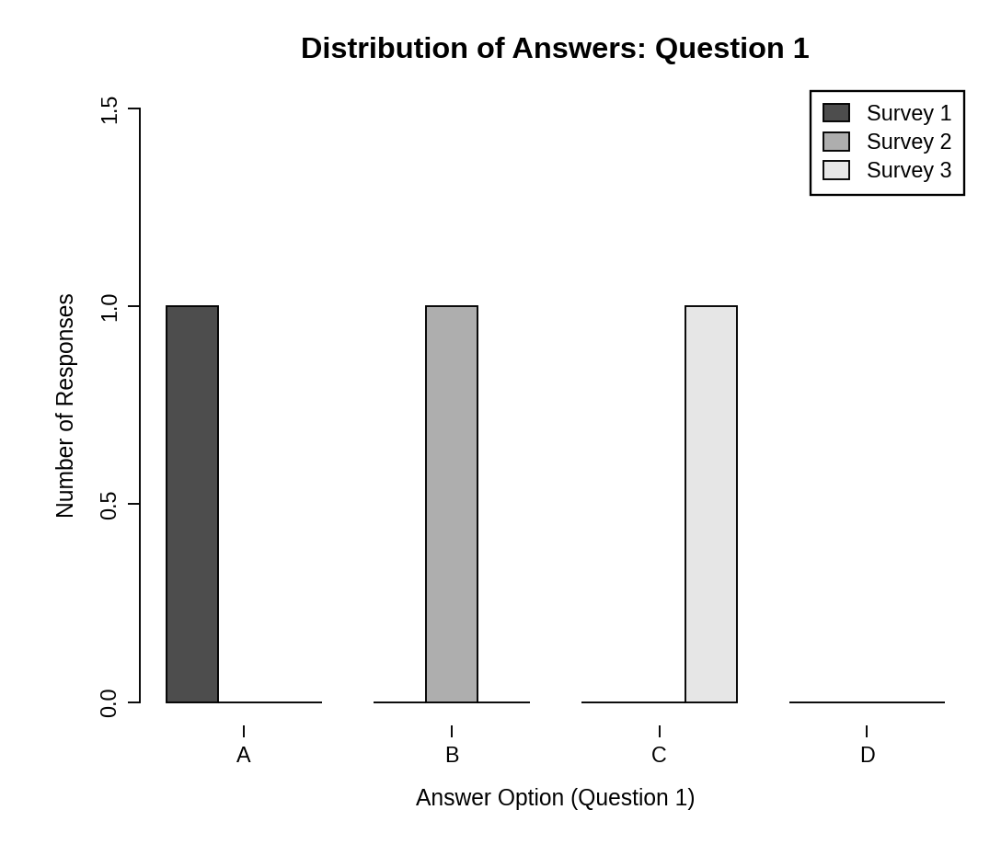
Observation: Options A, B and C were each chosen by exactly one survey (Survey 1, 2 and 3) and option D was not chosen, so the answers to Question 1 are evenly split.
PROGRAM 2 — Stacked Bar Chart for All Questions
# Dataset
survey <- data.frame(
Q1 = c("A", "B", "C"),
Q2 = c("B", "A", "A"),
Q3 = c("C", "D", "B")
)
# Count answers for each question (rows = answers, columns = questions)
levels <- c("A", "B", "C", "D")
counts <- sapply(survey, function(x) table(factor(x, levels = levels)))
colnames(counts) <- c("Question 1", "Question 2", "Question 3")
# Stacked Bar Chart
barplot(counts,
xlab = "Question",
ylab = "Number of Responses",
main = "Overall Distribution of Responses",
col = gray.colors(4),
legend.text = rownames(counts),
args.legend = list(title = "Answer"),
ylim = c(0, 5))

Output: Stacked bar chart showing the distribution of answers for all three questions.
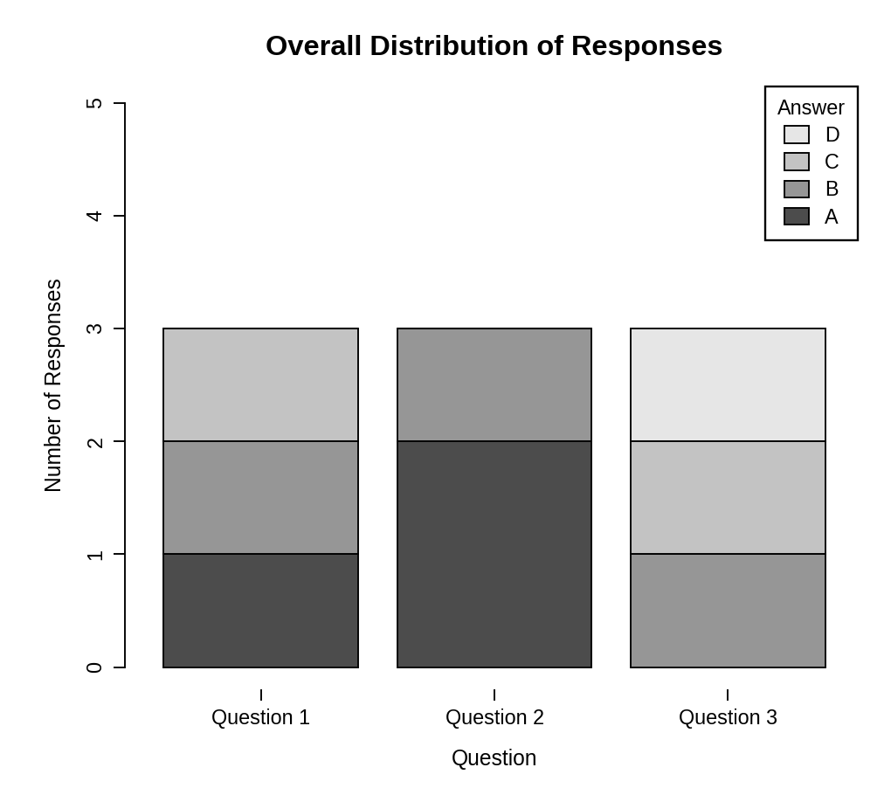
Observation: Every bar totals 3 responses. Option A was the most common answer to Question 2 (2 of 3), while Questions 1 and 3 received a different answer from each respondent. Option D appears only once, in Question 3.
PROGRAM 3 — Table of Survey Responses
# Dataset
survey_table <- data.frame(
"Survey ID" = c(1, 2, 3),
"Question 1" = c("A", "B", "C"),
"Question 2" = c("B", "A", "A"),
"Question 3" = c("C", "D", "B"),
check.names = FALSE
)
# Display the table
print(survey_table)

Output: Table showing the answers given by each survey.
> print(survey_table)
Survey ID Question 1 Question 2 Question 3
1 1 A B C
2 2 B A D
3 3 C A B

Observation: The table shows the answer given by each survey to every question, which can be compared with the counts in the charts.
PROGRAM 4 — Tableau Dashboard for Survey Responses
Dashboard steps:
- Open Tableau and connect to the data (Connect > Text file / Microsoft Excel) containing the survey responses.
- Sheet 1: Grouped bar chart: drag Question 1 to Columns, Survey ID to Color and Number of Records to Rows (Show Me > Side-by-side bars).
- Sheet 2: Stacked bar chart: use Pivot to combine the three question columns into one Question field, then drag Question to Columns, Number of Records to Rows and the Answer field to Color.
- Sheet 3: Table: drag Survey ID and the three question fields to the Text shelf.
- Create a new dashboard (Dashboard > New Dashboard) and drag the sheets onto the canvas.
- Add the filters: Survey ID. For each filter choose Show Filter and set Apply to Worksheets > All Using This Data Source.
- Select each chart and enable Use as Filter, so that clicking a mark updates the other views and the table.

Output: An interactive Tableau dashboard combining the grouped bar chart, the stacked bar chart and the response table, with a Survey ID filter.
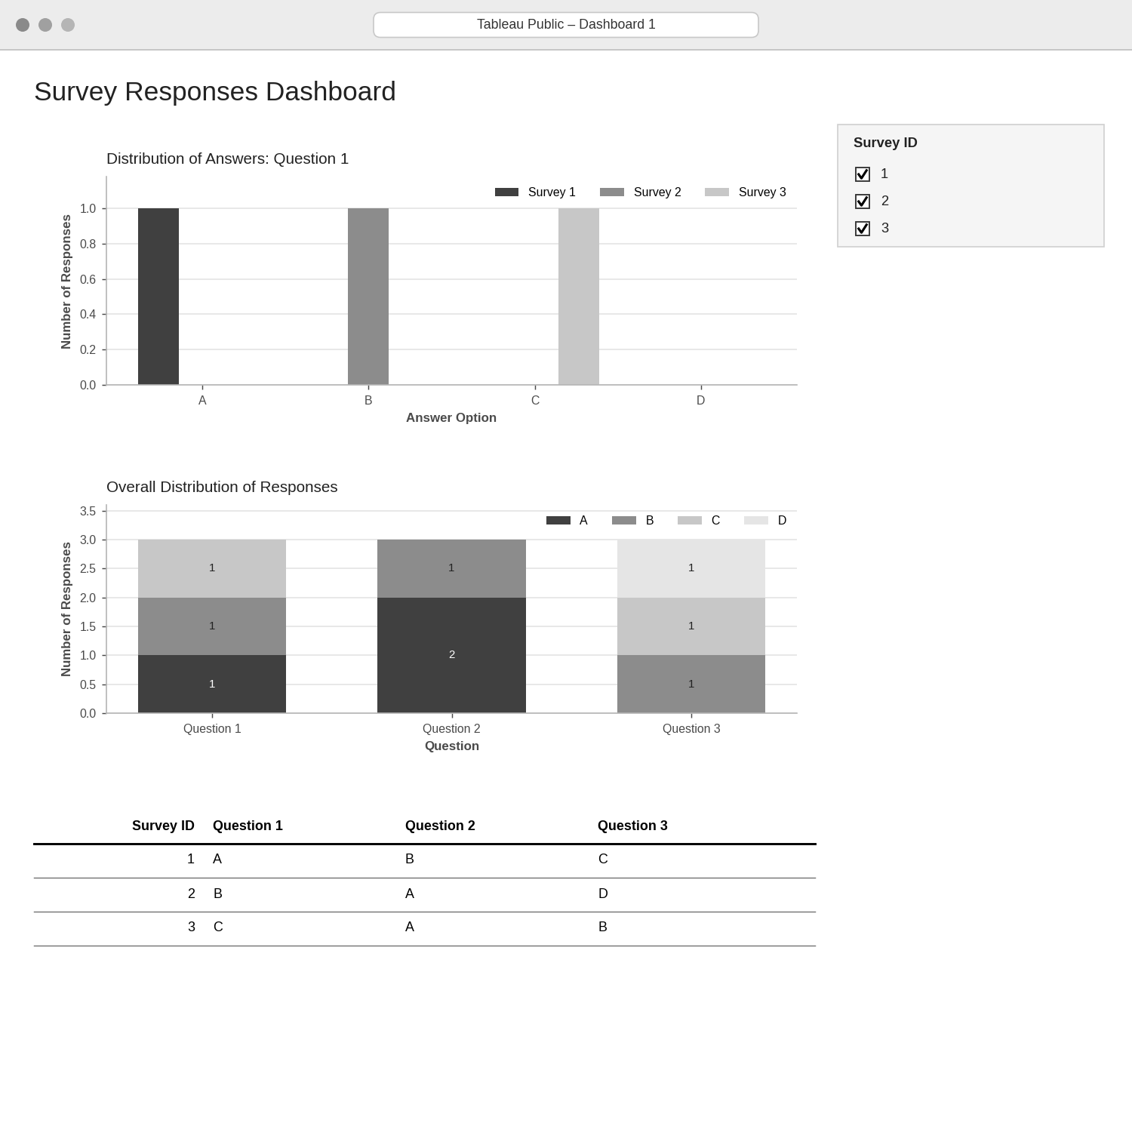
Observation: Selecting or clearing surveys updates both charts and the table together, so the responses of individual surveys can be compared with the overall distribution.
PROCEDURE
- Create the survey ID and the Question 1, 2 and 3 answers in R.
- Build a survey-by-option matrix for Question 1 and draw the grouped bar chart with barplot(beside = TRUE).
- Count the answers to each question with table() and draw the stacked bar chart.
- Create a data.frame() with the survey responses and display it as a table.
- Connect the data in Tableau, pivot the question columns, and build the three sheets.
- Combine the sheets into a dashboard and add a Survey ID filter.
RESULT
The survey response data was successfully visualized using a grouped bar chart, a stacked bar chart and a data table. An interactive Tableau dashboard combining all three was designed.
KEY FUNCTIONS / TOOLS USED
- sapply() – Builds the answer-count matrices.
- table() / factor() – Count how many times each answer was chosen.
- barplot(beside = TRUE) – Creates the grouped bar chart.
- barplot() – Creates the stacked bar chart.
- data.frame() – Creates the response table.
- Tableau Sheets – One worksheet for each chart or table.
- Tableau Dashboard – Combines the sheets with filters for interactive exploration.

