DSA0601 Data Handling and Visualization
Name: Lakshna Sree T S
Regno: 192524059
SET 20 — STOCK ANALYSIS
Dataset
Date | Stock A | Stock B | Stock C
2023-01-01 | 100 | 150 | 120
2023-01-02 | 105 | 152 | 118
2023-01-03 | 110 | 148 | 122

PROGRAM 1 — Line Chart of Stock Prices
# Dataset
date <- as.Date(c("2023-01-01", "2023-01-02", "2023-01-03"))
stock_a <- c(100, 105, 110)
stock_b <- c(150, 152, 148)
stock_c <- c(120, 118, 122)
# Line Chart (one line per stock)
matplot(date, cbind(stock_a, stock_b, stock_c),
type = "o", lty = 1:3, pch = 1:3, col = "black",
xlab = "Date",
ylab = "Price",
main = "Stock Prices",
ylim = c(100, 175))
legend("topleft", legend = c("Stock A", "Stock B", "Stock C"),
lty = 1:3, pch = 1:3)

Output: Line chart comparing the prices of the three stocks over the three days.
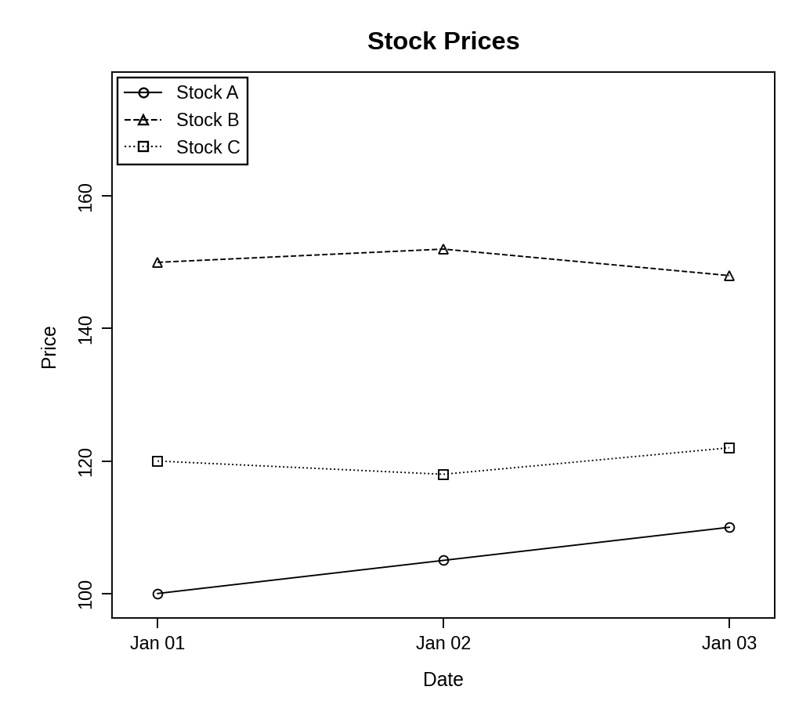
Observation: Stock A rises steadily from 100 to 110. Stock B is the highest-priced stock (148–152) and peaks on 2 January. Stock C is almost flat, falling to 118 on 2 January and recovering to 122.
PROGRAM 2 — Bar Chart of Daily Percentage Change for Stock A
# Dataset
date <- c("2023-01-01", "2023-01-02", "2023-01-03")
stock_a <- c(100, 105, 110)
# Daily percentage change
pct_change <- diff(stock_a) / head(stock_a, -1) * 100
# Bar Chart
bp <- barplot(pct_change,
names.arg = date[-1],
xlab = "Date",
ylab = "Percentage Change (%)",
main = "Daily % Change in Stock A",
ylim = c(0, 6))
text(bp, pct_change, labels = round(pct_change, 2), pos = 3)

Output: Bar chart showing the daily percentage change in the price of Stock A.
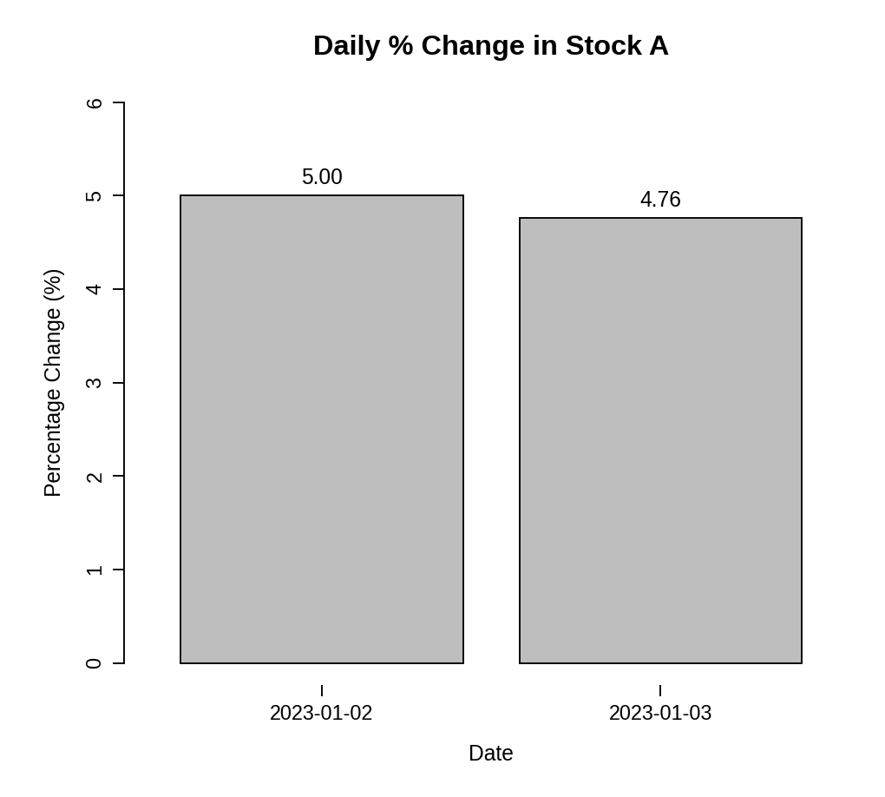
Observation: Stock A gained 5.00% on 2 January and 4.76% on 3 January. The percentage gain is slightly smaller on the second day because the price is higher while the rise is the same $5.
PROGRAM 3 — Table of Stock Prices
# Dataset
stock_table <- data.frame(
"Date" = c("2023-01-01", "2023-01-02", "2023-01-03"),
"Stock A" = c(100, 105, 110),
"Stock B" = c(150, 152, 148),
"Stock C" = c(120, 118, 122),
check.names = FALSE
)
# Display the table
print(stock_table)

Output: Table showing the stock prices of each company.
> print(stock_table)
Date Stock A Stock B Stock C
1 2023-01-01 100 150 120
2 2023-01-02 105 152 118
3 2023-01-03 110 148 122

Observation: The table lists the closing price of each stock on every date. Only Stock A increased on both days.
PROGRAM 4 — Tableau Dashboard for Stock Prices
Dashboard steps:
- Open Tableau and connect to the data (Connect > Text file / Microsoft Excel) containing the stock price data.
- Sheet 1: Line chart: use Pivot to turn Stock A, Stock B and Stock C into Stock and Price fields, then drag Date to Columns, Price to Rows and Stock to Color.
- Sheet 2: Bar chart: create a calculated field Pct Change = (SUM([Stock A]) - LOOKUP(SUM([Stock A]), -1)) / LOOKUP(SUM([Stock A]), -1) and place it on Rows with Date on Columns.
- Sheet 3: Table: drag Date, Stock A, Stock B and Stock C to the Text shelf.
- Create a new dashboard (Dashboard > New Dashboard) and drag the sheets onto the canvas.
- Add the filters: Stock and Date (range). For each filter choose Show Filter and set Apply to Worksheets > All Using This Data Source.
- Select each chart and enable Use as Filter, so that clicking a mark updates the other views and the table.

Output: An interactive Tableau dashboard combining the stock price line chart, the percentage-change bar chart and the price table, with Stock and Date filters.
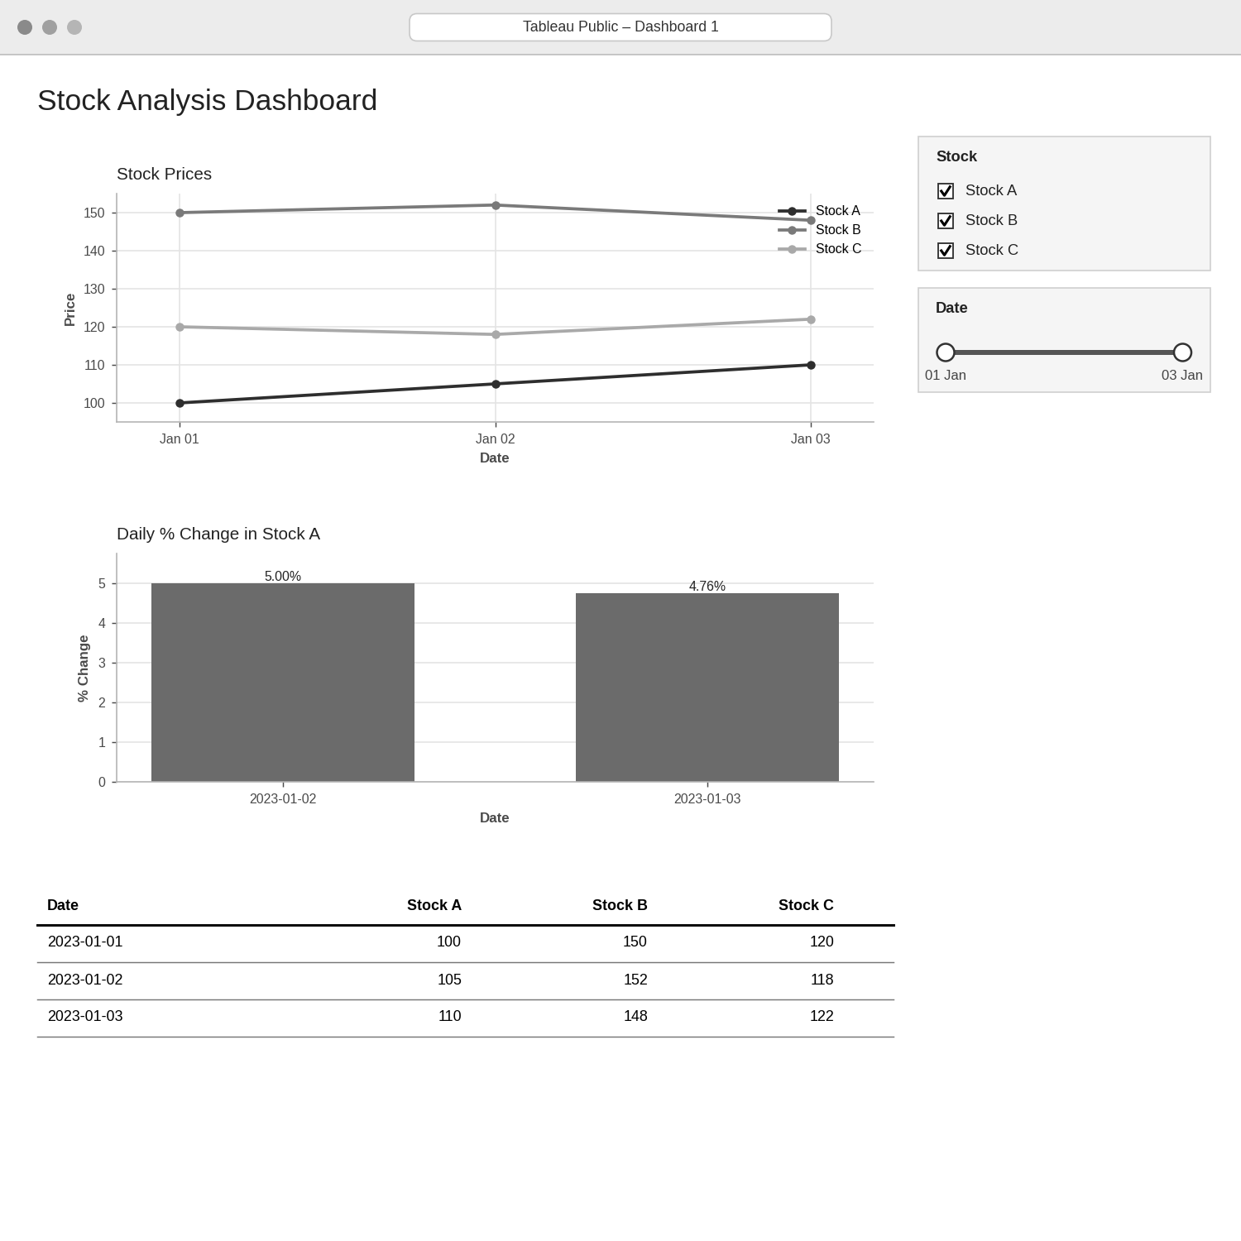
Observation: The Stock filter shows or hides the lines and the Date filter limits all views to the chosen days, making it easy to compare the stocks over any period.
PROCEDURE
- Create the date and the three stock price vectors in R.
- Use matplot() to draw one line per stock and add a legend.
- Calculate the daily percentage change of Stock A with diff() and draw the bar chart with barplot().
- Create a data.frame() with the stock prices and display it as a table.
- Connect the data in Tableau, pivot the stock columns, and build the three sheets.
- Combine the sheets into a dashboard and add Stock and Date filters.
RESULT
The stock price data was successfully visualized using a line chart, a percentage-change bar chart and a data table. An interactive Tableau dashboard combining all three was designed.
KEY FUNCTIONS / TOOLS USED
- as.Date() – Converts text into date values.
- matplot() – Draws several lines in one chart.
- diff() – Calculates the day-to-day difference.
- barplot() / text() – Draw the bar chart and its value labels.
- data.frame() – Creates the price table.
- Tableau Sheets – One worksheet for each chart or table.
- Tableau Dashboard – Combines the sheets with filters for interactive exploration.

