DSA0601 Data Handling and Visualization
Name: Lakshna Sree T S
Regno: 192524059
SET 21 — ENERGY CONSUMPTION ANALYSIS
Dataset: Energy_Consumption_Data.csv
Sector | Region | Month | Temperature | Units_Consumed | Cost | Renewable_Usage | Peak_Hours
Residential | North | Jan | 15 | 320 | 2100 | 22 | 4
Commercial | South | Jan | 24 | 540 | 3600 | 18 | 6
Industrial | West | Feb | 20 | 880 | 5900 | 12 | 8
Residential | East | Feb | 18 | 350 | 2300 | 25 | 5
Commercial | North | Mar | 28 | 610 | 4100 | 20 | 7
Industrial | South | Mar | 30 | 920 | 6200 | 15 | 9

Note: The table above was saved as Energy_Consumption_Data.csv in the R working directory. Column names were simplified when saving the file (units dropped): Temperature is in °C, Units_Consumed in kWh, Cost in ₹ and Renewable_Usage in %.
PROGRAM 1 — Histogram and Density Plot of Units Consumed
# Import the dataset
data <- read.csv("Energy_Consumption_Data.csv")
head(data)

# Histogram with density curve
hist(data$Units_Consumed,
freq = FALSE,
breaks = seq(200, 1000, by = 200),
xlab = "Units Consumed (kWh)",
main = "Histogram and Density of Units Consumed")
lines(density(data$Units_Consumed), lwd = 2)

Output: Dataset imported with read.csv(), followed by the histogram with the density curve of Units_Consumed.
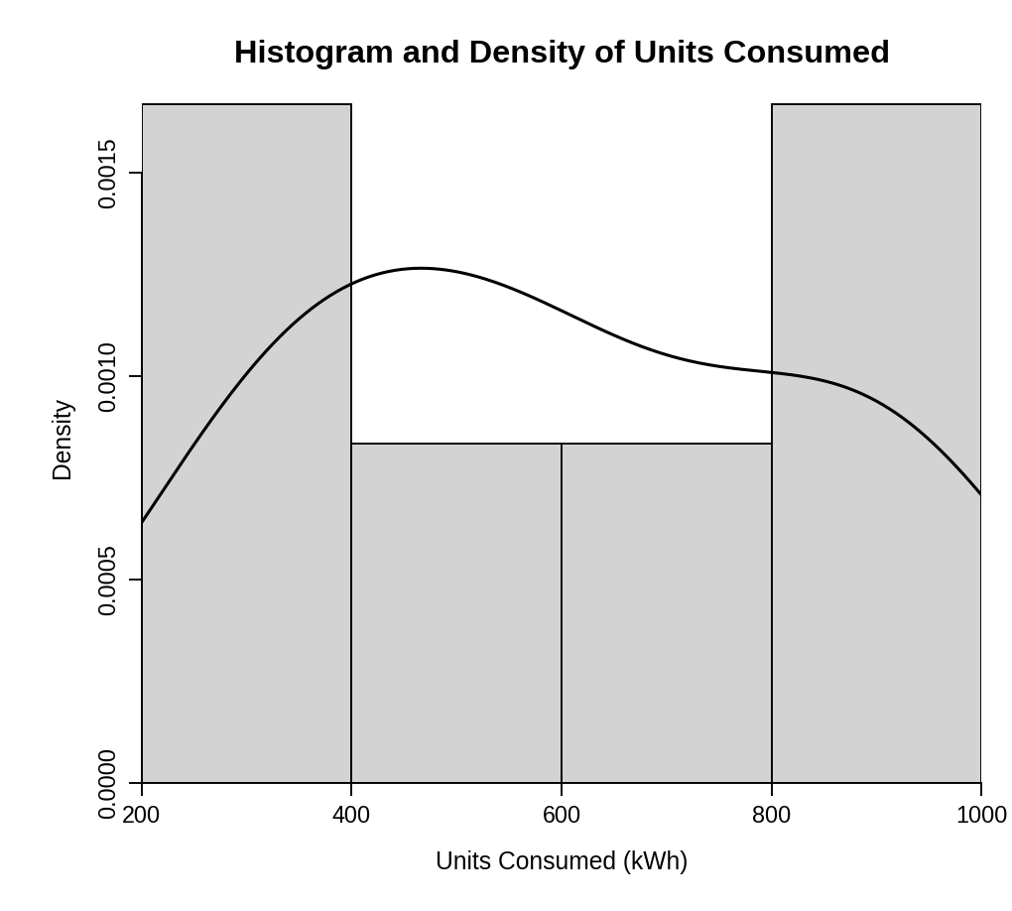
> head(data)
Sector Region Month Temperature Units_Consumed Cost Renewable_Usage
1 Residential North Jan 15 320 2100 22
2 Commercial South Jan 24 540 3600 18
3 Industrial West Feb 20 880 5900 12
4 Residential East Feb 18 350 2300 25
5 Commercial North Mar 28 610 4100 20
6 Industrial South Mar 30 920 6200 15
Peak_Hours
1 4
2 6
3 8
4 5
5 7
6 9

Comparison of consumption patterns: Units consumed range from 320 to 920 kWh (mean 603, median 575). The histogram has tall bars at both ends (200–400 and 800–1000 kWh) and lower bars in the middle, and the density curve is wide and flat, with its main peak near 470 kWh and a long shoulder out to about 900 kWh. This shows two groups: low consumers (Residential, 320–350 kWh) and high consumers (Industrial, 880–920 kWh), with Commercial sites in between (540–610 kWh).
PROGRAM 2 — Scatter Plot of Temperature vs Units Consumed with Bubble Size
data <- read.csv("Energy_Consumption_Data.csv")

# Bubble size = Peak_Hours, transparency = 0.5
plot(data$Temperature, data$Units_Consumed,
cex = data$Peak_Hours / 3,
pch = 19,
col = rgb(0, 0, 0, alpha = 0.5),
xlab = "Temperature (°C)",
ylab = "Units Consumed (kWh)",
main = "Temperature vs Units Consumed")

# Correlations
cor(data$Temperature, data$Units_Consumed)
cor(data$Peak_Hours, data$Units_Consumed)

Output: Bubble plot of temperature against units consumed, with bubble size showing peak hours.
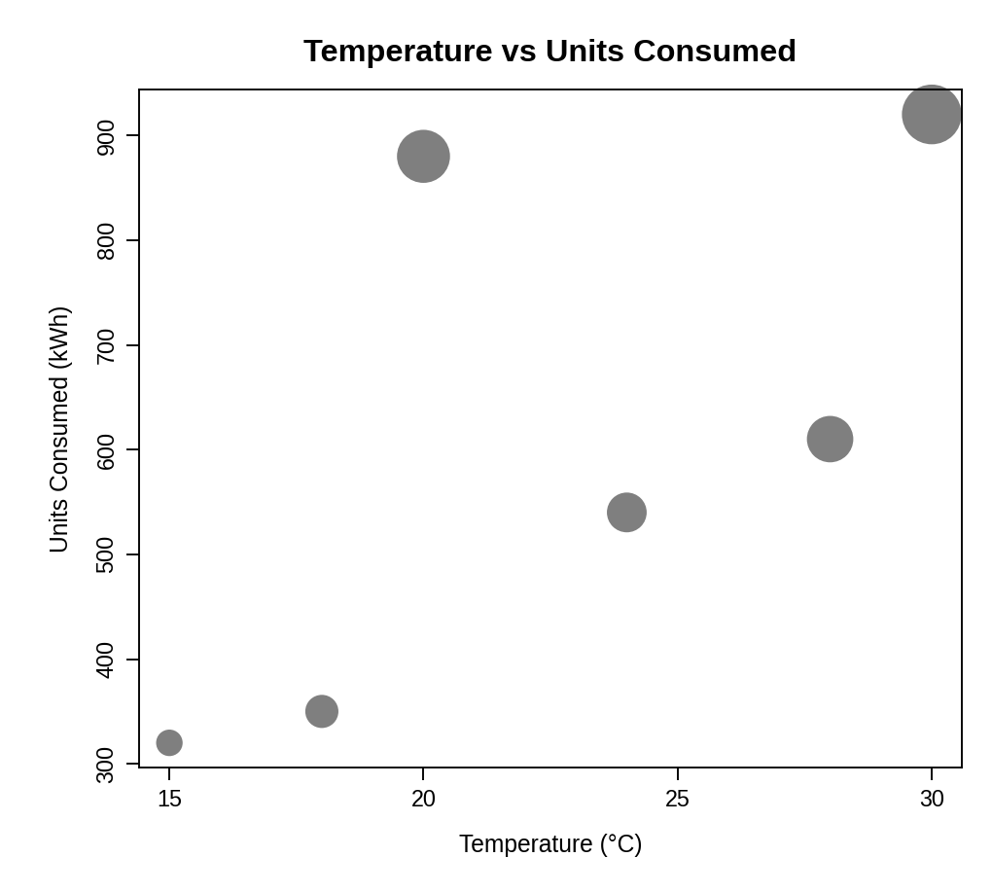
> cor(data$Temperature, data$Units_Consumed)
[1] 0.654655
> cor(data$Peak_Hours, data$Units_Consumed)
[1] 0.9765008

Observation: Consumption generally rises with temperature (correlation 0.65, moderate), but the bubbles show a stronger link with peak hours: the largest bubbles (8–9 peak hours) are the highest points, and peak hours and units consumed have a correlation of 0.98. The two industrial sites (880 and 920 kWh) have the longest peak periods. The transparency lets overlapping bubbles remain visible.
PROGRAM 3 — Average Renewable Usage by Sector
data <- read.csv("Energy_Consumption_Data.csv")

# Average renewable usage for each sector
avg_renew <- aggregate(Renewable_Usage ~ Sector, data = data, FUN = mean)
print(avg_renew)

# Bar Chart
barplot(avg_renew$Renewable_Usage,
names.arg = avg_renew$Sector,
xlab = "Sector",
ylab = "Average Renewable Usage (%)",
main = "Average Renewable Usage by Sector")

Output: Bar chart showing the average renewable energy usage of each sector.
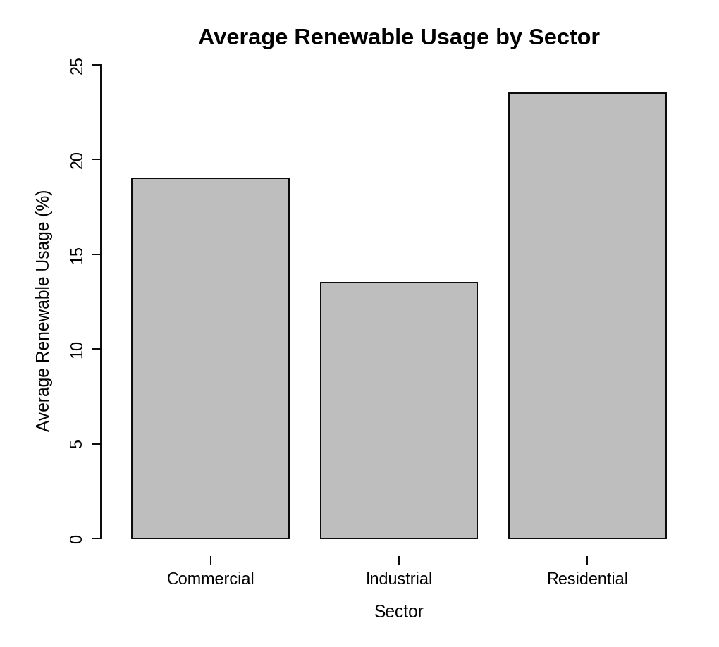
> print(avg_renew)
Sector Renewable_Usage
1 Commercial 19.0
2 Industrial 13.5
3 Residential 23.5

Interpretation: Residential users have the highest renewable adoption (23.5%), followed by Commercial (19.0%), while Industrial users have the lowest (13.5%). The sector that consumes the most energy therefore uses the least renewable energy, so Industrial users offer the greatest scope to increase renewable adoption.
PROGRAM 4 — Tableau Dashboard for Energy Consumption
Dashboard steps:
- Open Tableau and import Energy_Consumption_Data.csv (Connect > Text file).
- Line chart: drag Month to Columns (sort it Jan, Feb, Mar), drag Units_Consumed to Rows as SUM, and set the mark type to Line.
- Heatmap: drag Region to Columns and Sector to Rows, drag SUM(Units_Consumed) to Color and to Label, and set the mark type to Square.
- Right-click Month and Sector and choose Show Filter, then set each filter to Apply to Worksheets > All Using This Data Source.
- Create a new dashboard, drag the line chart and the heatmap onto it and place the two filters on the right.
- Select both charts and enable Use as Filter, so that clicking a month, sector or region updates every view.

Output: An interactive Tableau dashboard with the monthly usage line chart, the Sector vs Region heatmap and Month and Sector filters.
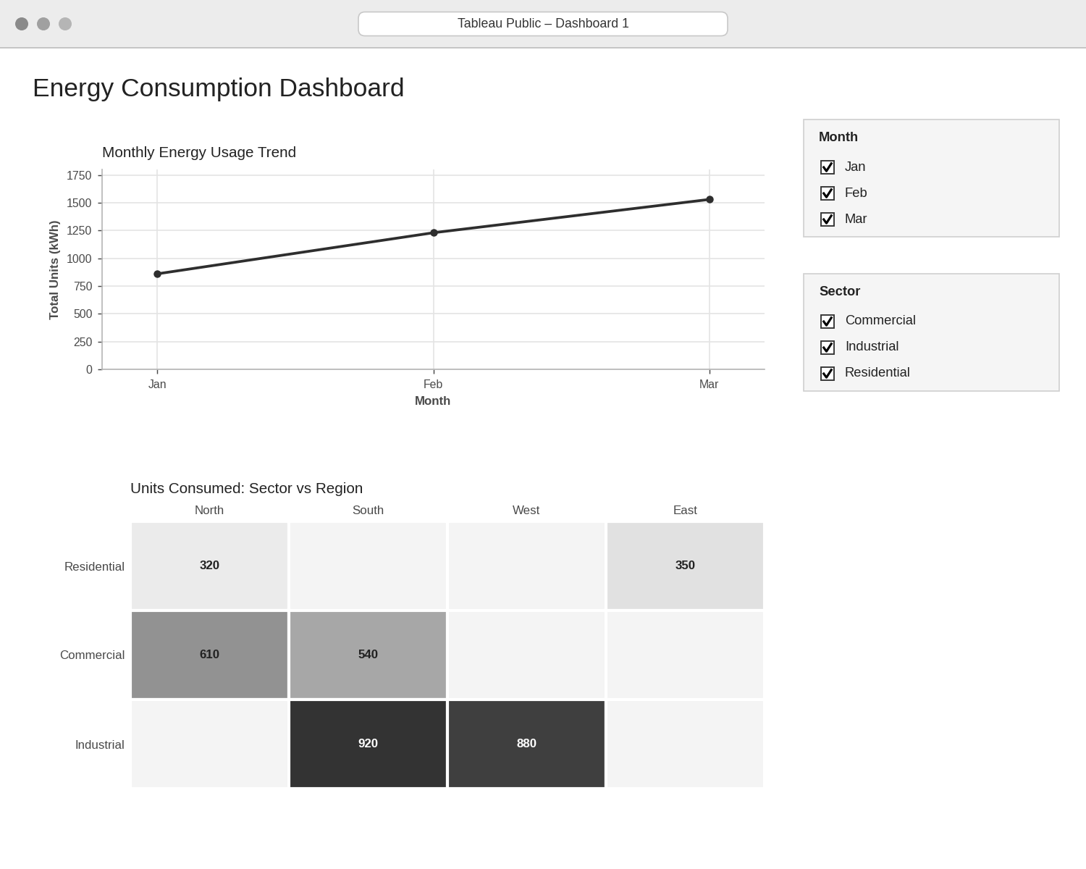
Observation: Total energy use rises each month: 860 kWh in January, 1230 in February and 1530 in March. The darkest heatmap cells are the Industrial sites (South 920 kWh, West 880 kWh). Selecting a month or sector instantly updates both views.
PROCEDURE
- Save the dataset as Energy_Consumption_Data.csv and import it with read.csv().
- Draw the histogram with hist(freq = FALSE) and add the density curve with lines(density()).
- Use plot() with cex (bubble size) and rgb(..., alpha) (transparency) to draw the bubble plot, and calculate the correlations with cor().
- Calculate the average renewable usage per sector with aggregate() and draw the bar chart.
- Import the CSV into Tableau and build the line chart and the Sector–Region heatmap.
- Add the Month and Sector filters and design the interactive dashboard.
RESULT
The energy consumption data was successfully imported and visualized using a histogram with density curve, a bubble scatter plot and a bar chart. Industrial users consume the most energy but have the lowest renewable usage, and an interactive Tableau dashboard with Month and Sector filters was designed.
KEY FUNCTIONS / TOOLS USED
- read.csv() – Imports the CSV dataset.
- hist() / density() – Draw the histogram and the density curve.
- plot() with cex / rgb() – Creates the bubble plot with transparency.
- cor() – Calculates correlations.
- aggregate() – Calculates the average per group.
- barplot() – Creates the bar chart.
- Tableau Sheets – One worksheet for each chart or table.
- Tableau Dashboard – Combines the sheets with filters for interactive exploration.

