Low Level Design

Project Code | Group 1
Project Name | Employee Maintenance System

Prepared / Modified by | Role | Date of preparation/ Modification
Lakshmi Priya N | Software Engineer | 14-Jul-18
Reviewed by | Role | Date of review
Tanmaya K Acharya | Mentor
Approved by | Role | Date of Approval
Tanmaya K Acharya | Mentor
Circulation List |  | Version Number : 1.0
Version number of the work product | Version 1.0

Table of Contents

1. Description Of The Unit 3
2. References 4
3. Dependencies / Assumptions 5
4. Class Diagrams 6
5. Sequence Diagrams 7
6. Design Components 8
6.1 List of UI Components…….………………………………………….…………………………………8
6.2 List of Design Classes…………………………………………………………………………………….10

7. Reusable Routines/Components……………………………………………………. 11
8. Messages 12
9. Configuration Files 13
10. Crud Matrix Table 14
11. Data Mapping Matrix 15
12. Action Flow Matrix 16
13. Stored Procedures 17
14. Program Specification / Pseudo Code 18
REVISION HISTORY OF THE WORK PRODUCT 21
Description Of The Unit

This project is aimed at developing an Employee Maintenance System for maintaining employee details easily. This is a web-based application that can be accessed over the web. This system can be used for adding employee details, modifying employee details, searching and displaying employee details. This is an integrated system that contains two user components, Admin component, Employee component.

There are two categories of people who would access the system viz. Admin/Manager, Employee/User. Each one of them would have some exclusive privileges (for e.g. Employee can search for existing employee details and apply for leave, but the admin has the right to add employee details and modify employee details)

- User should be able to
  - Login to the system using his/her credentials
  - Search employee details
  - Apply for leave
  - Logout

- Airline Administrator should be able to

  - Login to the system using his/her credentials
  - Add employee details
  - Modify employee details
  - Display employee details
  - Approve or reject leave
  - Logout

References

Reference | Description
Repository reference
Class Diagram
URS
UTP
DB Design

Dependencies / Assumptions
Dependencies:
The Admin should be logged in.
All fields in modifyEmployeepage are filled correctly.

Assumptions:
The Admin details are stored in the database.
The Employee details will get store in the database.

Class Diagrams
Class Diagram

Sequence Diagrams

Sequence Diagram-Admin

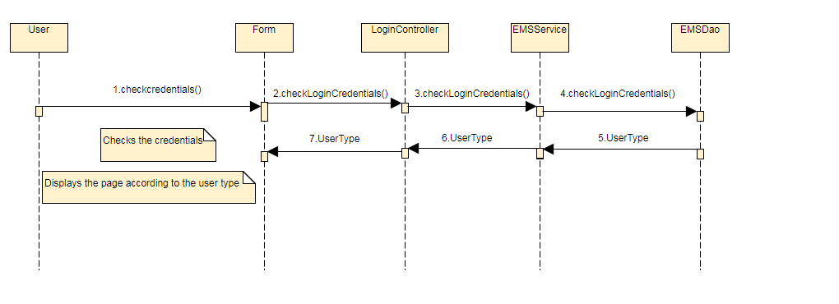

Sequence Diagram-Login

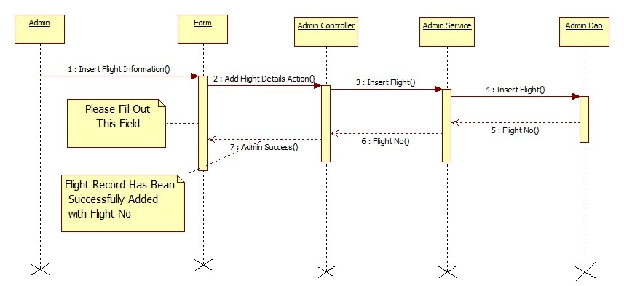

Design Components

List Of UI Components

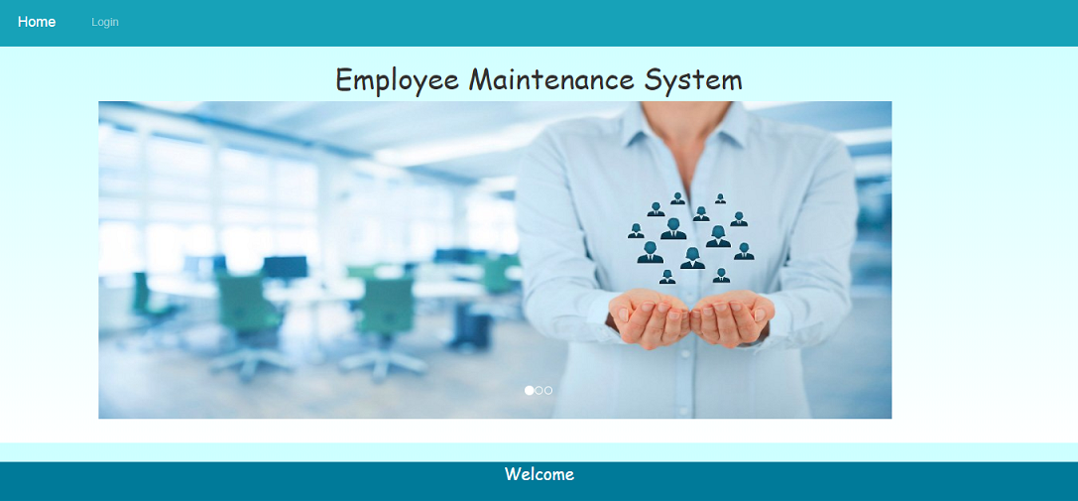

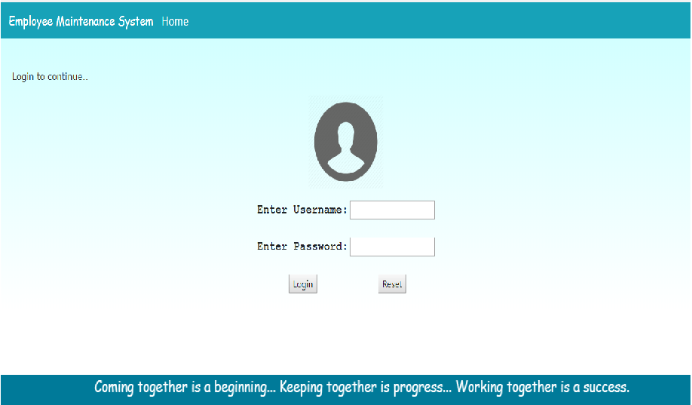

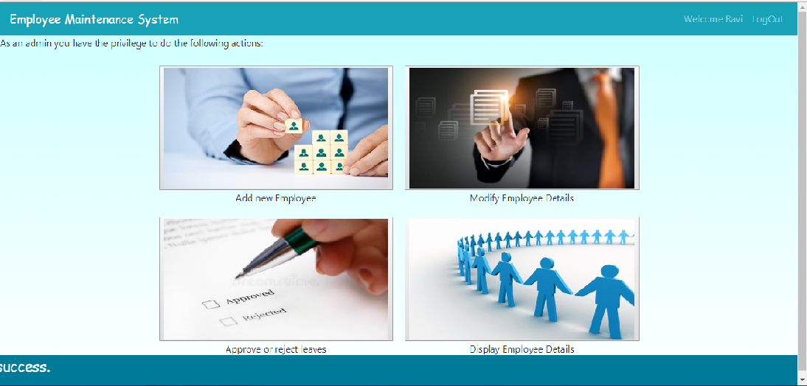

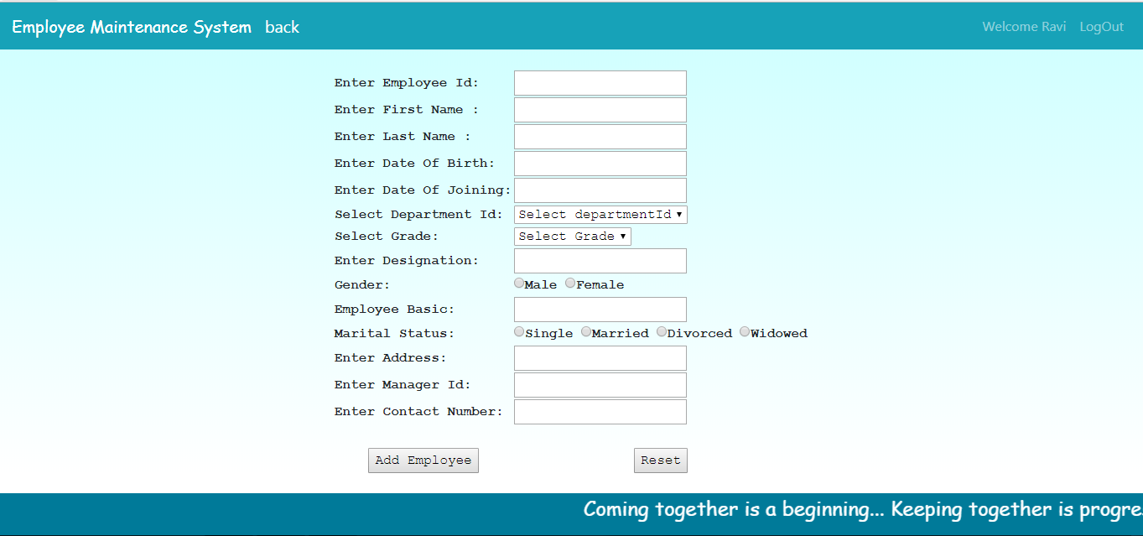

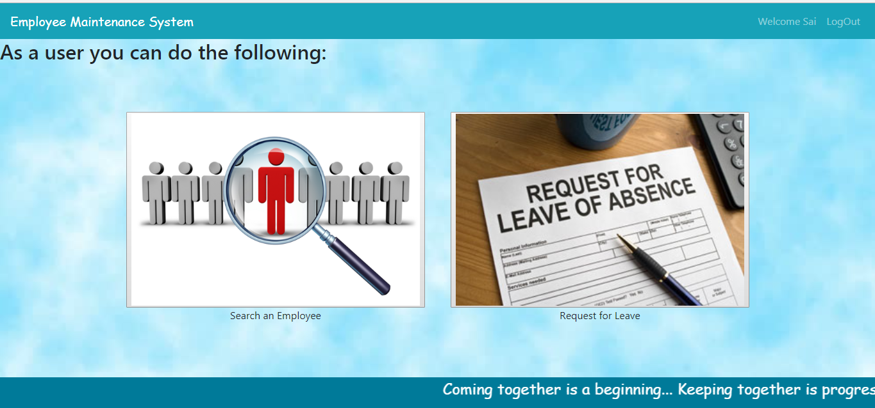

Sr. No. | LLD Name | Class Name | Method Name | Method Description
1 | Insert Flight Information`Module | FlightInformationBean | Appropriate getters and setters methods | Getters retrieve the property values and setters set the property values
2 | Insert Flight Information Module | AdminController | private void addFlightDetailsAction(HttpServletRequest request,HttpServletResponse response) throws ServletException, IOException, AirlineException | Sets the model attribute.  Calls the Service layer method to insert the Flight details in to the database
3 | Insert Flight Information Module | AdminServiceImpl | public boolean insertFlight(FlightInformationBean flightInfo)throws AirlineException | Calls the DAO layer method to insert the flight details in to the database
4 | Insert Flight Information Module | AirlineDaoImpl | public boolean insertFlight(FlightInformationBean flightInfo) throws AirlineException ) | Inserts the flight information into the database and returns the result to AdminServiceImpl

List Of Design Classes

Re-Usable Routines/Components
Re-Usable Routines/Components

- CSS files
- DataAccessException class

Messages

#. | Type | Message Text
M1 | Error | Please fill out this field
M2 | Error | Must be in characters only in range of 5 to 30!!
M3 | Error | Please select an item in the list!!
M4 | Error | Must be a valid future date!!
M5 | Error | Must be entered in format: HHMM!!
M6 | Error | Must be in 2 digits only!!
M7 | Error | Must be in digits in range of 3 to 6!!

Configuration Files

File Name | Path | Description
oracle.properties | /Development/Source | To configure database connection.
Web.xml | /Development/Source | To configure the bean properties.
Dispatcher-servlet.xml | /Development/Source | To configure the request mapping and view resolver.

Crud Matrix Table

# | Table Name | Create | Read | Update | Delete
1 | Employee | Y | Y | Y | N

Data Mapping Matrix

Sr. No. | Screen Label | Field Source | Field Type | Data Type | Max Length | Data Flow | Mandatory
1 | Airline | FlightInformationBean.airline | Text Box | String | 30 | UI→D | Yes
2 | Departure City | FlightInformationBean.deptCity | Combo Box | String | NA | UI→D | Yes
3 | Arrival City | FlightInformationBean.arrCity | Combo Box | String | NA | UI→D | Yes
4 | Departure Date | FlightInformationBean.deptDate | Text Box | Local Date | NA | UI→D | Yes
5 | Arrival Date | FlightInformationBean.arrDate | Text Box | Local  Date | NA | UI→D | Yes
6 | Departure Time | FlightInformationBean.deptTime | Text Box | String | 4 | UI→D | Yes
7 | Arrival Time | FlightInformationBean.arrTime | Text Box | String | 4 | UI→D | Yes
8 | First Class Seats | FlightInformationBean.firstSeats | Text Box | int | 2 | UI→D | Yes
9 | First Class Seat Fare | FlightInformationBean.firstSeatsFare | Text Box | double | 6 | UI→D | Yes
10 | Business Class Seats | FlightInformationBean.bussSeats | Text Box | int | 2 | UI→D | Yes
11 | Business Class Seat Fare | FlightInformationBean.bussSeatsFare | Text Box | double | 6 | UI→D | Yes

Legend

UI (User Interface Only)
UI → D (User Interface to Database)

Action Flow Matrix

Sr. No. | Action | Description | Process
1 | On click Insert Flight Information in Admin Home page | Redirected to the Insert Flight Home form | The Admin clicks on the Add in the Admin Home page and gets redirected to the Insert Flight Home form.
2 | On click of Submit button in Insert Flight Home Form | The flight information is inserted into the database. | Data is entered in the fields by the Admin which gets inserted into the database when Submit button is pressed.
3 | On click Reset button in Insert Flight Home form | Redirected to Insert Flight Home page | On click reset button by the Admin in register form redirected to Insert Flight Home page

Stored Procedures

# | Stored Procedure Name  (with Description) | Input/Out Parameters | Type | Size
1. | NA

Program Specification / Pseudo Code

<ACTION: MODIFY_EMPLOYEE_DETAILS>

Pseudo Code:
- Client-Side Scripting:
None

- Server-Side Scripting:
BEGIN
Call the Service Layer for modifying the employee details into the database.
END

Pseudo Code:
- Server Side Scripting:
BEGIN
Call addFlightDetailsActi (@ModelAttribute (“insertFlight") @Valid FlightInformationBean insertFlight, BindingResult result, Model model) in Controller class in Presentation Layer
BEGIN
Call insertFlight (FlightInformationBean insertFlight) in AdminServicempl class in Service Layer
BEGIN
Call insertFlight (FlightInformationBean insertFlight) in class AirlineDaoImpl in Data Access Layer
BEGIN
Create query for inserting flight details into FlightInformation table
Return String value.
END
Return String value to Service Layer
END
Return String value to Presentation Layer

END
IF successful then navigate to AdminSuccess page and show success message.
Else navigate to Error page and show error.
END

REVISION HISTORY OF THE WORK PRODUCT
<To be maintained by projects>

# | Date | Version # | Section Changed | Details of changes made | Approved By
1
2

