Progressive Education Society's

**Modern College of Engineering**

**MCA Department**

**A.Y. 2024-25**

**Subject Code: 410908: Data Science Laboratory**

********************************************************************************************

Class: SY MCA Div: A Batch: S3 Roll Number: 52062

Name: Laxman Shinde Assignment No: 4 Date of Implementation: 25/09/2024

********************************************************************************************

**1. Use the Apriori algorithm on the grocery dataset with minimum support to 0.001 and**

**minimum confidence of 0.8 indicate the top 5 association rules that are generated and**

**highlight the strong ones, sort them by confidence.**

install.packages("arules")

library("arules")

data("Groceries")

summary(Groceries)

rules <- apriori(Groceries, parameter = list(supp = 0.001, conf = 0.8))

rules_sorted <- sort(rules, by = "confidence", decreasing = TRUE)

inspect(head(rules_sorted, 5))

o/p:

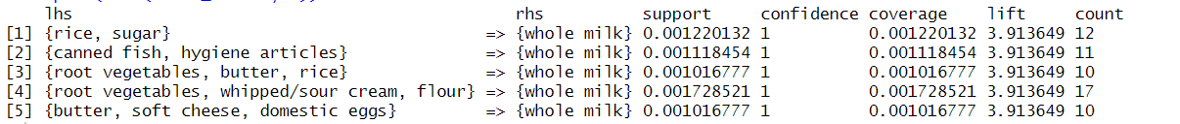

**2. Use the Eclat algorithm on given Market Basket Dataset and predict the items which are**

**bought frequently.**

**Code :**

data("Groceries")

summary(Groceries)

frequent_itemsets <- eclat(Groceries, parameter = list(supp = 0.05)) # Adjust support as needed

inspect(frequent_itemsets)

o/p:

