Progressive Education Society's

**Modern College of Engineering**

**MCA Department**

**A.Y. 2024-25**

**Subject Code: 410908: Data Science Laboratory**

********************************************************************************************

Class: SY MCA Div: A Batch: S3 Roll Number: 52062

Name: Laxman Shinde Assignment No: 2 Date of Implementation: 20/08/2024

********************************************************************************************

1 Write a R program to create three vectors a,b,c with 3 integers. Combine the three vectors to

become a 3×3 matrix where each column represents a vector. Print the content of the matrix.

Code:

t1<-c(1,2,3)

t2<-c(4,5,6)

t3<-c(7,8,9)

vec<-c(t1,t2,t3)

thismatrix <- matrix(c(vec), nrow = 3, ncol = 3)

colnames(thismatrix)<- c("c1","c2","c3")

rownames(thismatrix)<-c("r1","r2","r3")

print(thismatrix)

o/p:

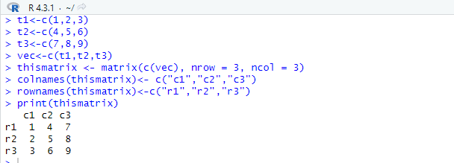

2 Write a R program to create a list containing a vector, a matrix and a list and give names to

the elements in the list. Access the first and second element of the list.

Code:

li<-list(c("a","b","c"),matrix(c(1,2,3,4,5,6,7,8,9),nrow=3,ncol=3),list(10,20,30))

names(li)<-c("vector","matrix","inner list")

print(li[1:2])

o/p:

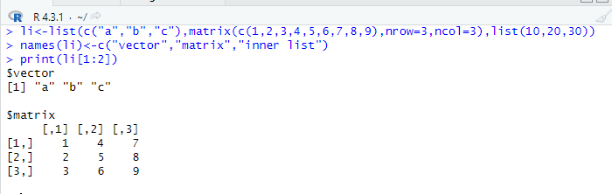

3 Write a R program to create an array with three columns, three rows, and two “tables”, taking

two vectors as input to the array. Print the array.

Code:

combined_matrix <- matrix(c(vector1, vector2), nrow = 3, ncol = 3, byrow = TRUE)

my_array <- array(combined_matrix, dim = c(3, 3, 3))

print(my_array)

o/p:

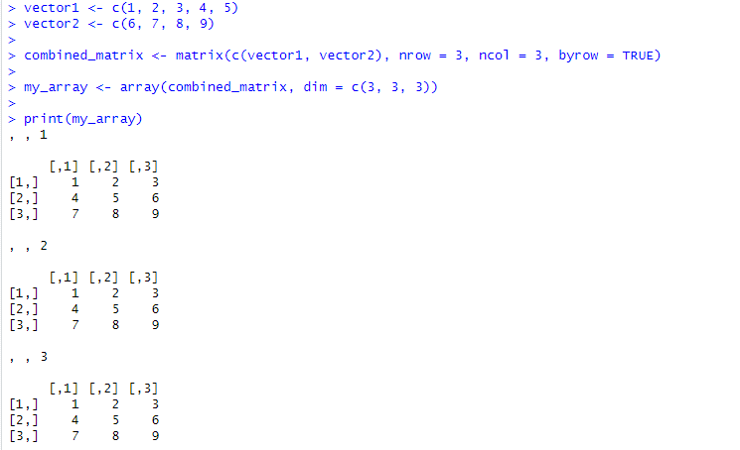

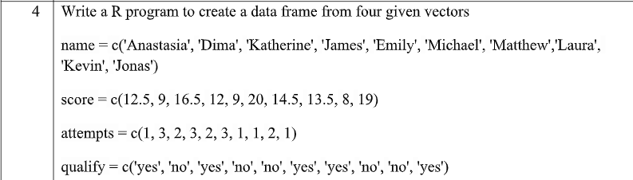

Code:

four.data <- data.frame(

  name=c('Anastesia','Dima','Katherine','James','Emily','Michael','Matthew','Laura','Kevin','Jones'),

  score =c(12.5, 9, 16.5, 12, 9, 20, 14.5, 13.5, 8, 19),

  attempts = c(1, 3, 2, 3, 2, 3, 1, 1, 2, 1),

  qualify = c('yes','no','yes','no','no','yes','yes','no','no','yes'),

  stringsAsFactors = FALSE

)

print(four.data)

o/p:

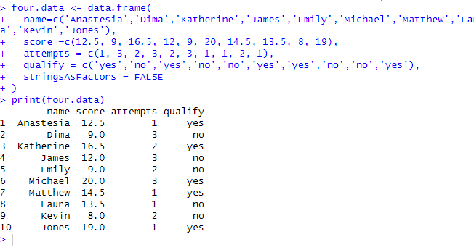

5 Write a R program to create a factor corresponding to height of women data set, which

contains height and weights for a sample of women

Code:

mat1 <- matrix(c(7,9,12,2,4,13), nrow= 2 , ncol=3, byrow= TRUE)

mat2 <- matrix(c(1,7,12,19, 2,8,13,20,3,9,14,21), nrow=3 , ncol = 4, byrow = TRUE)

print(mat1)

print(mat2)

print(mat1%*%mat2)

mat3 <- c(mat1%*%mat2)

print(mat3)

o/p:

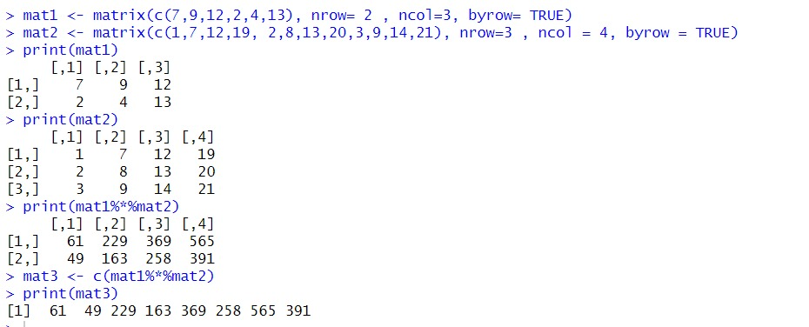

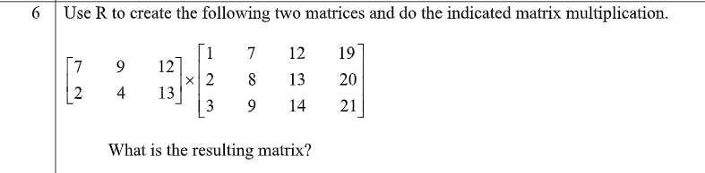

Code:

mat1<-matrix(c(7,9,12,2,4,13),nrow=2,ncol=3,byrow = TRUE)

mat2<-matrix(c(1,7,12,19,2,8,13,20,3,9,14,21),nrow=3,ncol=4,byrow = TRUE)

print(mat1%*%mat2)

o/p:

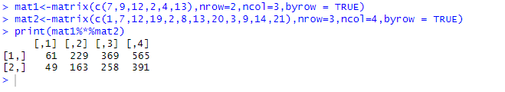

7 WAP to Print the Fibonacci Sequence.

Code:

a=0

b=1

for (i in 1:6)

  {

  cat(a," ",b," ")

  a=a+b

  b=a+b

}

o/p:

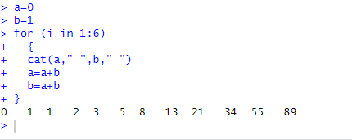

8 WAP to import data in R from csv, excel, txt file.

x1<-read.csv("D:/laxman /csv123.csv")

print(x1)

x2<-read_excel("D:/laxman /excel23.xlsx")

print(x2)

x3<-read.table("D:/laxman /text123.txt")

print(x3)

o/p:

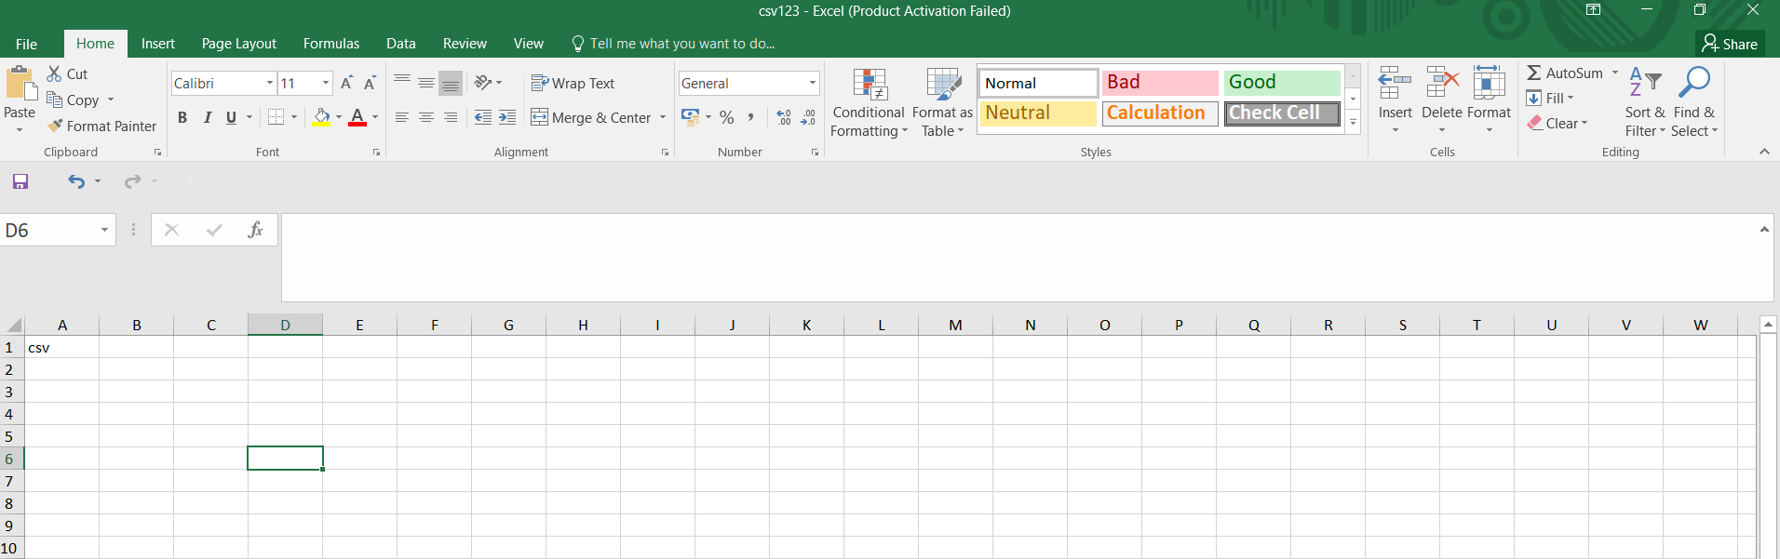

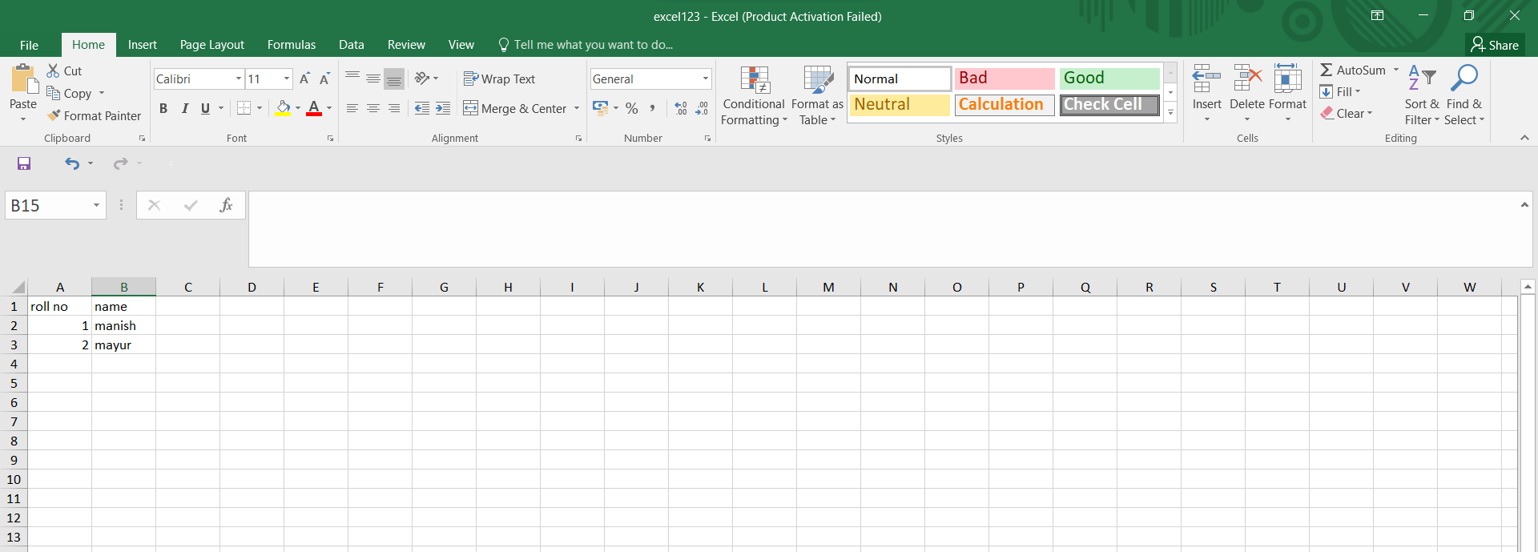

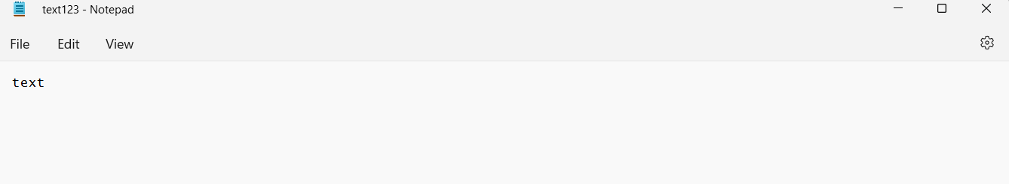

9 WAP to export data from R to CSV, Excel, Text File and Google drive.

Rollno <- c("5", "6", "7")

Name <- c("man","may", "adi")

Marks <- c("80", "75", "95")

Age <- c("23", "23", "21")

df <- data.frame(Rollno,Name,Marks,Age)

write.csv(df,"D:\\man\\agedata.csv", row.names = FALSE)

print ('CSV created Successfully :)')

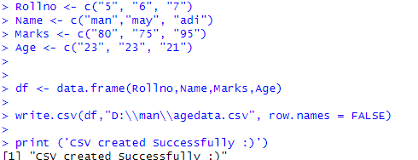

Rollno <- c("5", "6", "7")

Name <- c("man","may", "adi")

Marks <- c("80", "75", "95")

Age <- c("23", "23", "21")

df <- data.frame(Rollno,Name,Marks,Age)

write_xlsx(df,"D:\\man\\agedataexcel.xlsx")

print ('excel created Successfully :)')

o/p:

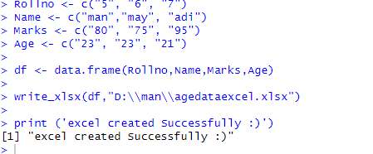

Rollno <- c("5", "6", "7")

Name <- c("man","may", "adi")

Marks <- c("80", "75", "95")

Age <- c("23", "23", "21")

df <- data.frame(Rollno,Name,Marks,Age)

write.table(df,"D:\\man\\agetext.txt")

print ('text created Successfully :)')

o/p:

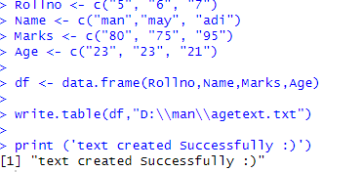

drive_upload('D://man//agedata.csv',type='spreadsheet')

o/p:

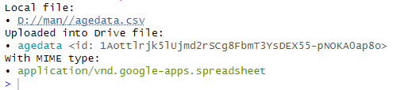

10 Write a R program to create an array of two 3x3 matrices each with 3 rows and 3 columns

from two vectors. Print the second row of the second matrix of the array and the element in

the 3rd row and 3rd column of the 1st matrix.

Code:

mat1<-matrix(c(1,2,3,4,5,6,7,8,9),nrow=3,ncol=3,byrow = TRUE)

mat2<-matrix(c(11,12,13,14,15,16,17,18,19),nrow=3,ncol=3,byrow = TRUE)

print(mat1)

print(mat2)

arr<-array(c(mat1,mat2),dim = c(3,3,2))

print(arr[2,,2])

print(arr[3,3,1])

o/p:

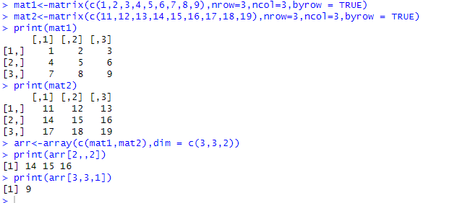



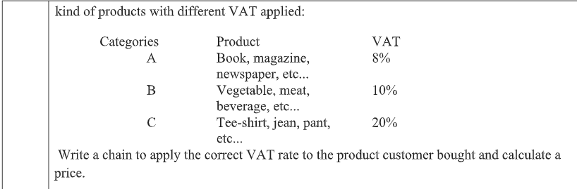

Code:

cate<-readline("Enter your category : ");

price<-as.integer(readline("Enter Price : "));

if (cate=="A") {

  print(price*1.08)

} else if (cate=="B") {

  print(price*1.1)

} else if (cate=="C") {

  print(price*1.2)

}

o/p:

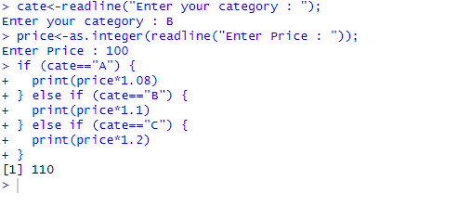

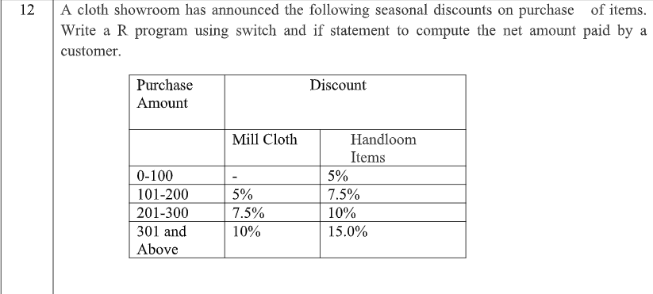

Code:

pur<-as.integer(readline("Enter purchase amount : "))

dis<-as.integer(readline("Enter 1 for  Mill Cloth. 2 for Handloom items : "))

var<-""

if(pur<=100)

{

  var="a"

}else if(pur<=200){

  var="b"

}else if(pur<=300){

  var="c"

}else{

  var="d"

}

if(dis==1)

{

  switch(

   var,

   "a"=cat("Final price ",pur),

   "b"=cat("Final price ",pur-pur*.05),

   "c"=cat("Final price ",pur-pur*0.075),

   "d"=cat("Final price ",pur-pur*0.1),

  )

  }else{

    switch(

      var,

      "a"=cat("Final price ",pur-pur*.05),

      "b"=cat("Final price ",pur-pur*.075),

      "c"=cat("Final price ",pur-pur*0.1),

      "d"=cat("Final price ",pur-pur*0.15),

    )

  }

o/p:

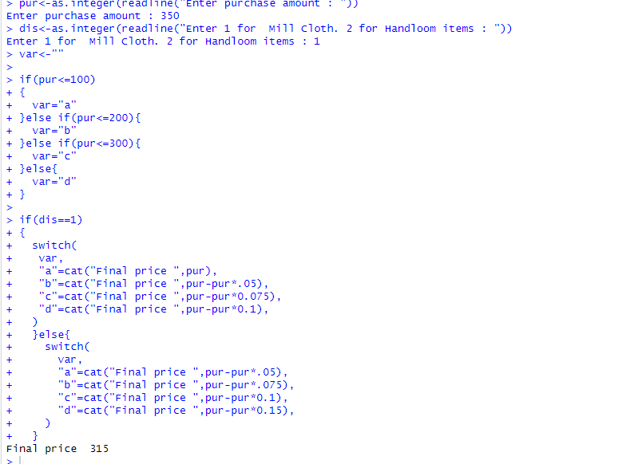

13 Find Sum of Series 1²+2²+3²+…..+n².

Code:

inp<-as.integer(readline("Enter a number : "))

print(Sum_Square(inp))

Sum_Square<-function(inp){

  res<-0

  for(i in 1:inp){

    res=res+(i*i)

  }

  return(res)

}

o/p:

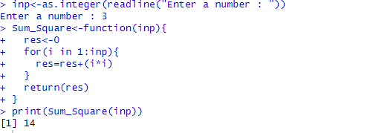

14 Write a R program to print the numbers from 1 to 100 and print “Fizz” for multiples of 3, print “Buzz” for multiples of 5, and print “FizzBuzz” for multiples of both.

Code:

for(i in 1:100){

  if(i%%3==0 & i%%5==0){

    cat(i," is a FizzBuzz number\n")

  }else if(i%%3==0){

    cat(i," is a Fizz number\n")

  }else if(i%%5==0){

    cat(i," is a Buzz number\n")

  }

}

o/p:

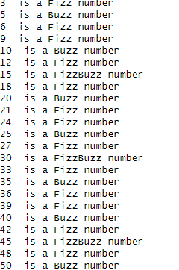

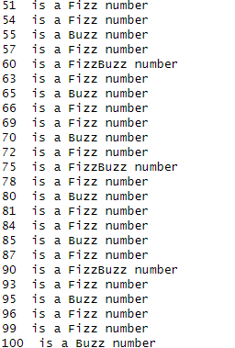

15 Write a R Program to find the sum of digits of a number reducing it to one digit using repeat loop.

Code:

num<-as.integer(readline("Enter a number : "))

repeat{

  sum<-0

  while(num>0){

    sum=sum+num%%10

    num=num%/%10

  }

  num=sum

  if(num<10){

    print(num)

    break

  }

}

o/p:

