Progressive Education Society's

**Modern College of Engineering, Pune**

**MCA Department**

**A.Y.2024-25**

**(410907) Software Testing Laboratory**

******************************************************************************************

**Class:** SY-MCA **Shift / Div:** A **Batch:** S3 **Roll Number:5 2062**

**Name:** Laxman Shinde **Assignment No:** 4 **Date of Implementation:** 10/10/2024

******************************************************************************************

**Q1. Install Selenium IDE in Mozilla Firefox/ Google Chrome**

**Using “https://accounts.google.com” Test Gmail Login Logout functionality in IDE (Record and Replay)**

* **Test Gmail login functionality with incorrect username and correct password.**
* **Test Gmail login functionality with incorrect username and incorrect password.**
* **Test Gmail login functionality with correct username and correct password.**

**Output:**

Test Gmail login functionality with incorrect username and correct password.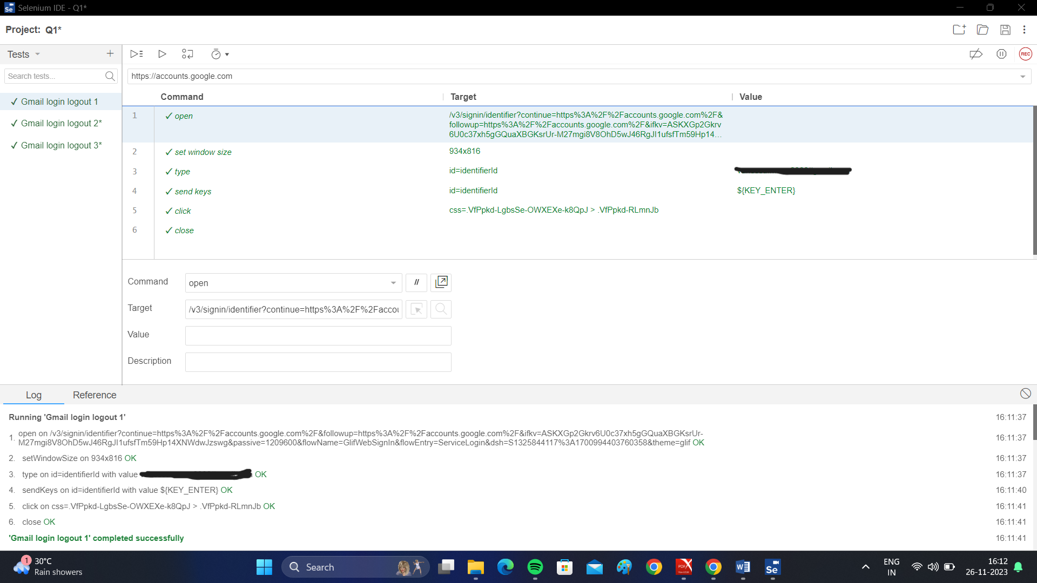

Test Gmail login functionality with incorrect username and incorrect password.

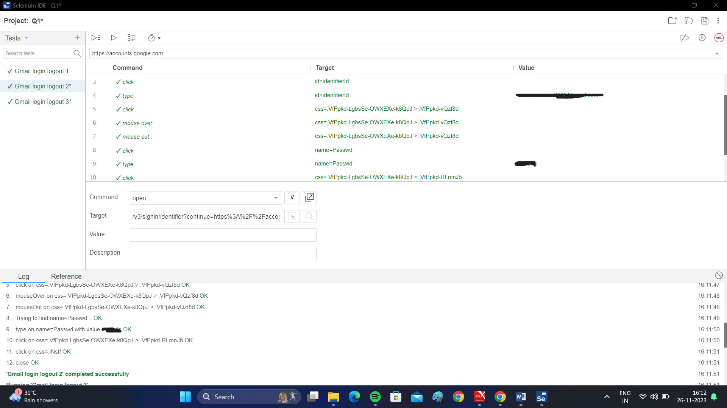

Test Gmail login functionality with correct username and correct password.

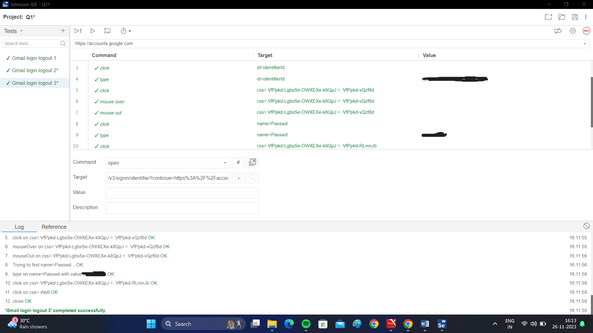

**Q2. Test following scenario in Selenium IDE using record and replay**

**Invoke Google Chrome browser.**

**● Open URL: www.google.com**

**● Click on the Google Search text box.**

**● Type the value "java tutorials"**

**● Click on any of java tutorial link**

**Output:**

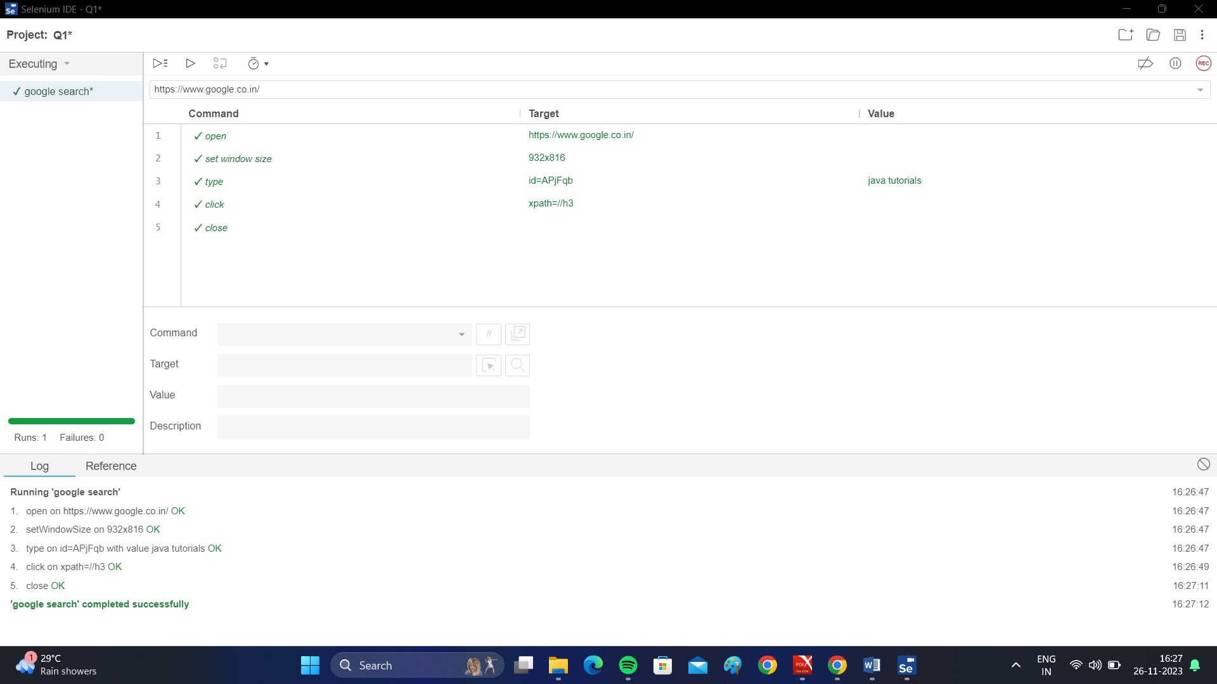

**Q.3 Automate Gmail/Rediffmail/Hotmail login flow using Selenium Web Driver**

**Code:**

import org.openqa.selenium.By;

import org.openqa.selenium.WebDriver;

import org.openqa.selenium.chrome.ChromeDriver;

public class login {

public static void main(String[] args) {

// TODO Auto-generated method stub

System.setProperty("webdriver.chrome.driver", "E:\\softwares\\chromedriver-win64\\chromedriver-win64\\chromedriver.exe");

WebDriver driver = new ChromeDriver();

driver.get("https://accounts.google.com");

driver.findElement(By.id("identifierId"));

driver.findElement(By.id("identifierId")).sendKeys("****************");

driver.findElement(By.xpath("//*[@id='identifierNext']")).click();

driver.findElement(By.name("password")).sendKeys("********");

driver.findElement(By.xpath("//*[@id='passwordNext']")).click();

}

}

**Q.4. Handle multiple windows using Selenium. (use site naukri.com) using SeleniumWeb Driver.**

**Code:**

import java.util.Iterator;

import java.util.Set;

import org.openqa.selenium.WebDriver;

import org.openqa.selenium.chrome.ChromeDriver;

public class multipleWindow {

public static void main(String[] args) throws Exception {

System.setProperty("webdriver.chrome.driver", "E:\\softwares\\chromedriver-win64\\chromedriver-win64\\chromedriver.exe");

WebDriver driver = new ChromeDriver();

driver.manage().window().maximize();

// To open Naukri.com with multiple windows

driver.get("https://www.naukri.com/");

Thread.sleep(2000);

// It will return the parent window name as a String

String parentWinID = driver.getWindowHandle();

System.out.println("Parent Win ID is: " + parentWinID);

// It returns no. of windows opened by WebDriver and will return Set of Strings

Set<String> allWinID = driver.getWindowHandles();

System.out.println("Total Window size:" +allWinID.size());

System.out.println("All win IDs are:");

for (String allIDs : allWinID) {

System.out.println(allIDs);

}

// Using Iterator to iterate with in windows

Iterator<String> itr = allWinID.iterator();

while (itr.hasNext()) {

String childWinID = itr.next();

// Compare whether the main window is not equal to child window. If not equal, we will close child windows.

if(!parentWinID.equalsIgnoreCase(childWinID)) {

driver.switchTo().window(childWinID);

System.out.println("Child URL is:"+driver.getCurrentUrl());

System.out.println("Child Win Title is:"+driver.getTitle());

Thread.sleep(2000);

driver.close();

}

}

// This is to switch to the main window

driver.switchTo().window(parentWinID);

driver.quit();

}

}

**Output:**

Parent Win ID is: 0D692EF85935CBBC19273CD7F1913210

Total Window size:1

All win IDs are:

0D692EF85935CBBC19273CD7F1913210

------------------------------------------------------------------------------------------------------------------------------------------