Progressive Education Society's

**Modern College of Engineering, Pune**

**MCA Department**

**A.Y.2024-25**

**Software Testing Laboratory(410907)**

******************************************************************************************

Class :- SYMCA Shift / Div :- S3/A Roll Number :- 52062

Name :- Laxman Shinde Assignment No :- 3 Date of Implementation :-25/09/2024

******************************************************************************************

**Q1: Write black box test cases using ECP &amp; BVA to test the requirement –**

**Bank has different charges depending on the transaction done**

**5% of the amount for transaction less than or equal to 1000**

**6% of the amount for transaction more than 1000 and less than or equal to 2000**

**7% of the amount for transaction more than 2000**

**ANSWER:**

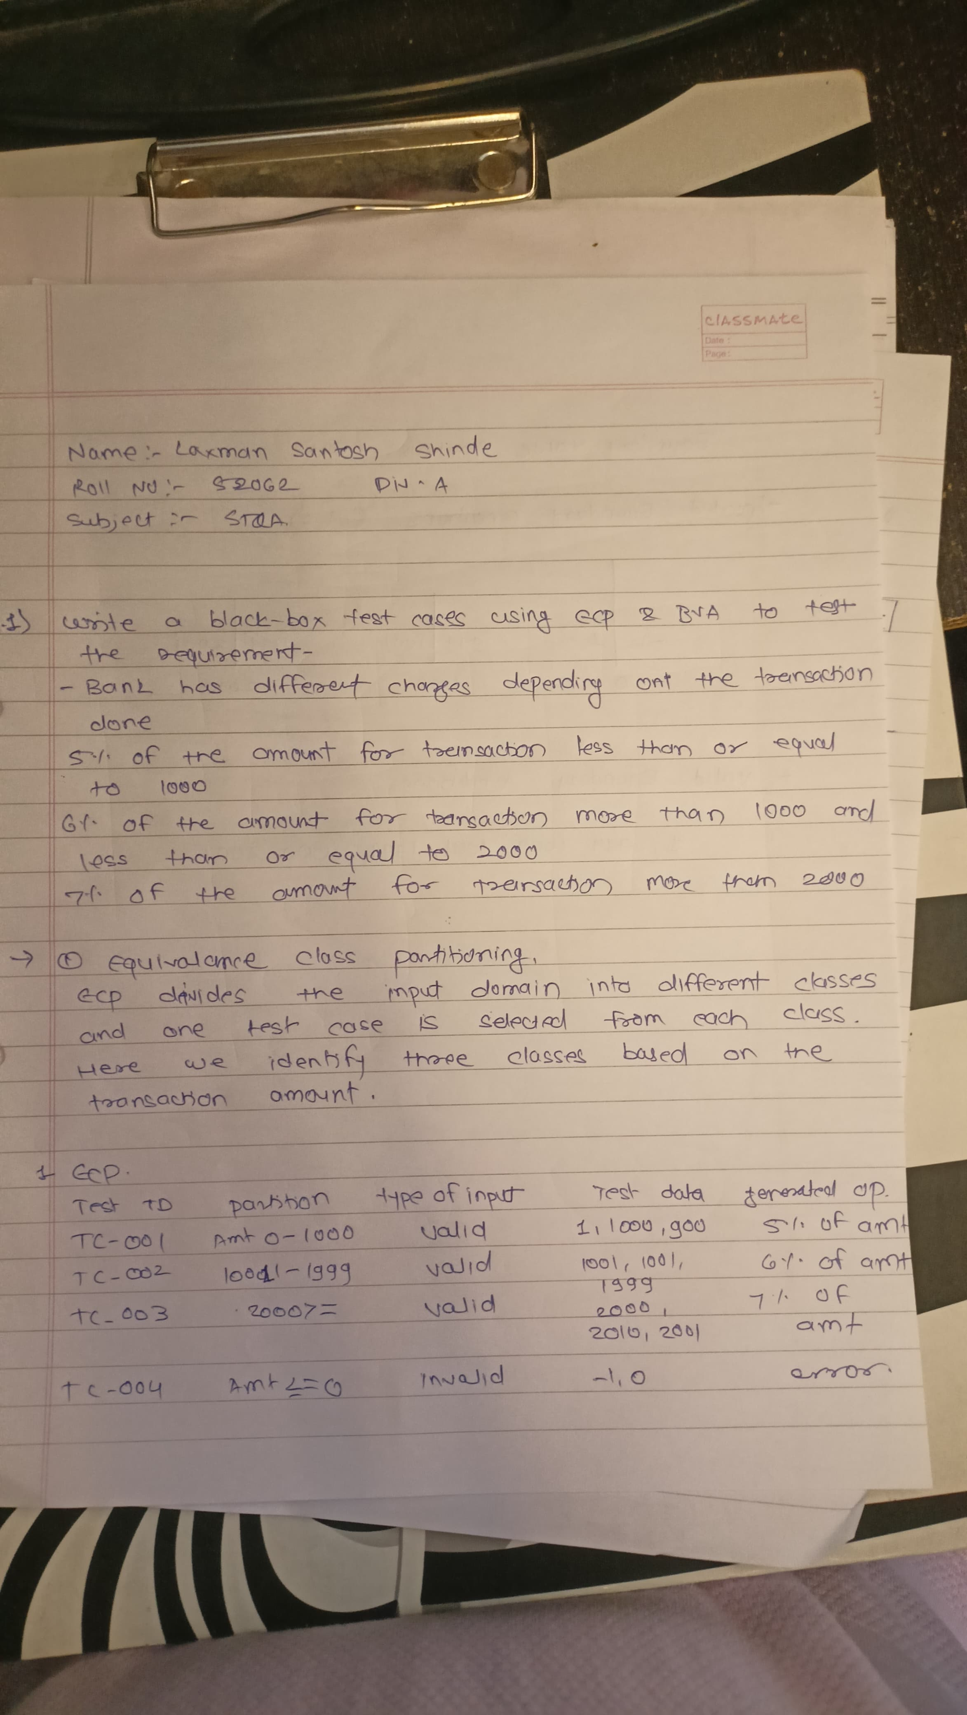

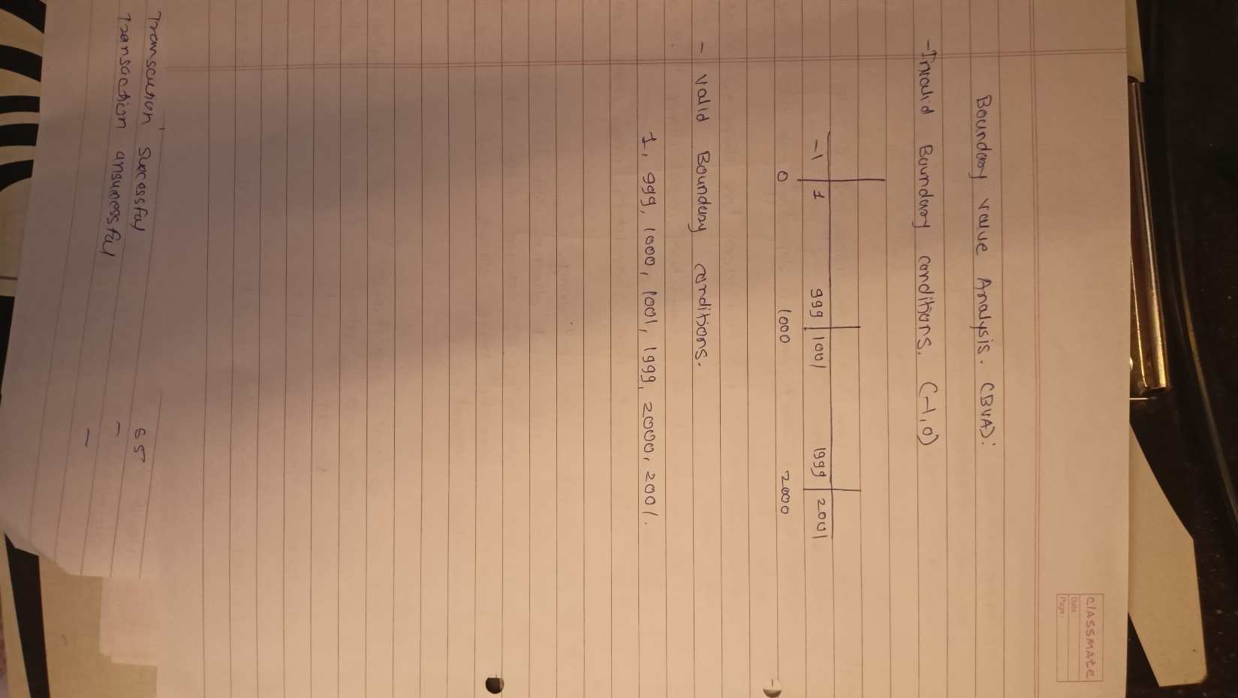

**TEST CASE:**

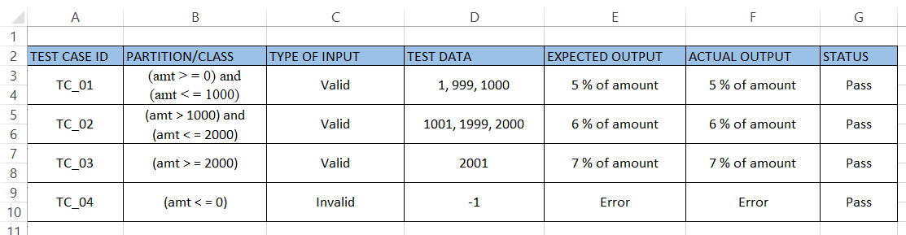

**Q2: Write black box test cases using state based(state transition) technique to test the requirement –**

**Withdrawal of money from ATM. ‘User A’ wants to withdraw 30,000**

**from ATM. Imagine he could take 10,000 per transaction and total balance**

**available in the account is 25,000. In the first two attempts, he could withdraw**

**money. Whereas in the third attempt, ATM shows a message as “Insufficient**

**balance, contact Bank”. Same Action but due to change in the state, he couldn’t**

**withdraw the money in the third transaction.**

**ANSWER:**

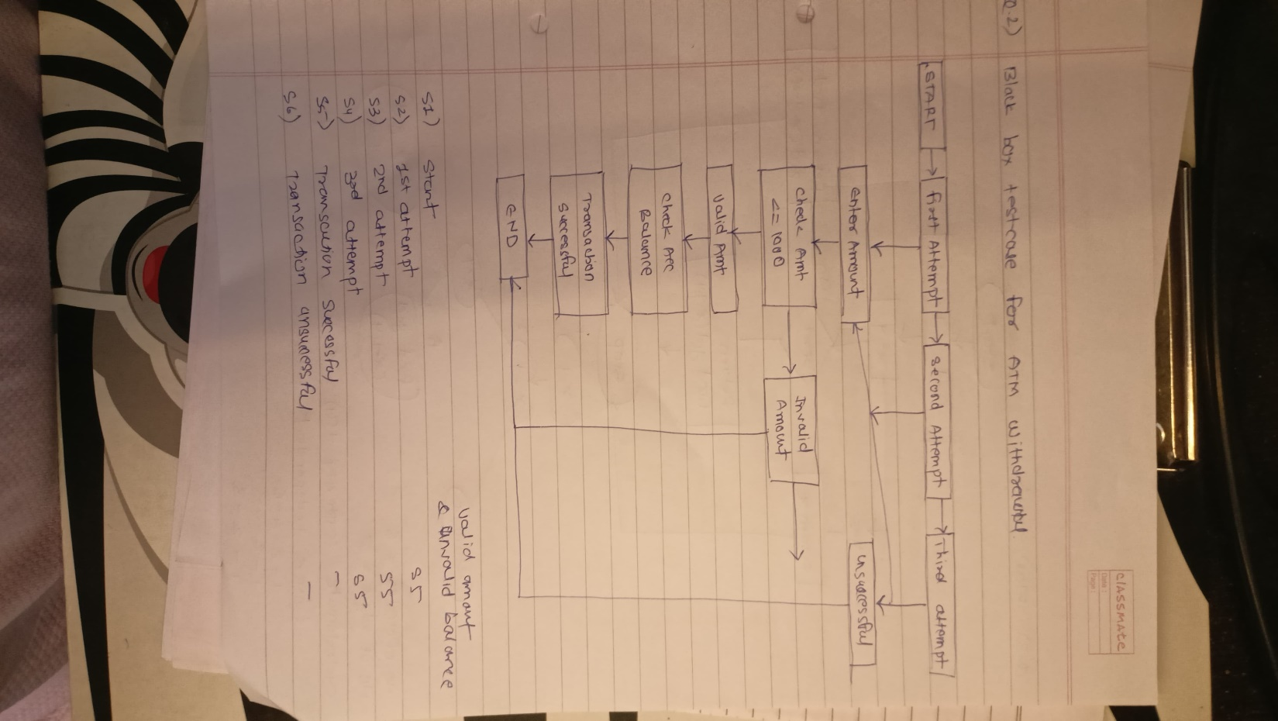

**TEST CASE:**

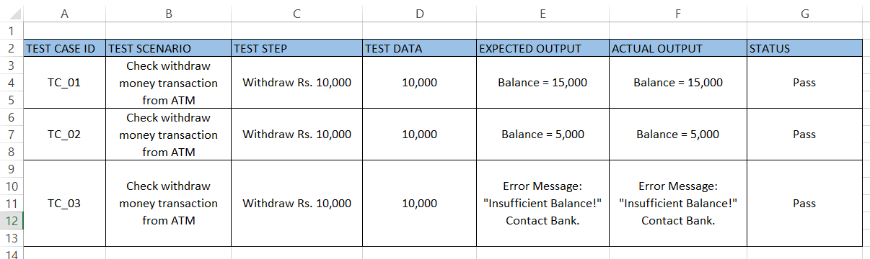

**Q3: Consider the following recursive code to find GCD of two numbers**

**findgcd (x , y)**

**{**

**if (x = y )**

**return x;**

**else if (x&gt;y)**

**return findgcd(x-y,y);**

**else**

**return findgcd(x,y-x);**

**}**

**Draw flow graph, find cyclomatic complexity and derive test cases.**

**ANSWER:**

**FLOW GRAPH**



**TEST CASE:**

