Progressive Education Society's

**Modern College of Engineering, Pune**

**MCA Department**

**A.Y.2024-25**

**(410902) Web Technologies Lab**

***************************************************************************

Class: SY-MCA Shift / Div : A Batch: S3 Roll Number : 51062

Name: Laxman Shinde Assignment No : 1 Date of Implementation : 06/08/24

***************************************************************************

**Q. 1. Create a static HTML page that displays the following output using frame:**

Code :

<!DOCTYPE html>

<html lang="en">

<head>

    <meta charset="UTF-8">

    <meta name="viewport" content="width=device-width, initial-scale=1.0">

    <title>First Assignment</title>

</head>

<body style="font-size: larger;">

    <div style="margin: 0 auto;">

        <header style="padding: 30px;">

            <h1>My Website</h1>

        </header>

        <main style="display: flex;">

            <div style="display: flex; flex-direction: column; gap: 20px; width: 40%; margin-left: 50px;">

                <a href="#" style="margin-top: 50px; font-size: 30px;"> Home</a>

                <a href="#" style="font-size: 30px;"> My Profile</a>

            </div>

            <div style="margin-top: auto;">

                <p style="font-size: 50px;">My Profile</p>

                <div style="">

                    <label for="name" style="font-size: 20px;">Name :- </label>

                    <input type="text" id="name" placeholder="Enter Name" style="padding: 15px;">

                    <br>

                    <br>

                    <label for="number" style="font-size: 20px;">Contact No :-</label>

                    <input type="number" id="number" placeholder="Enter Contact " style="padding: 15px;" >

                </div>

                <br>

                <button style="padding: 15px; font-size: 20px; border-radius: 10px;" >Button</button>

            </div>

        </main>

    </div>

</body>

</html>

Output :

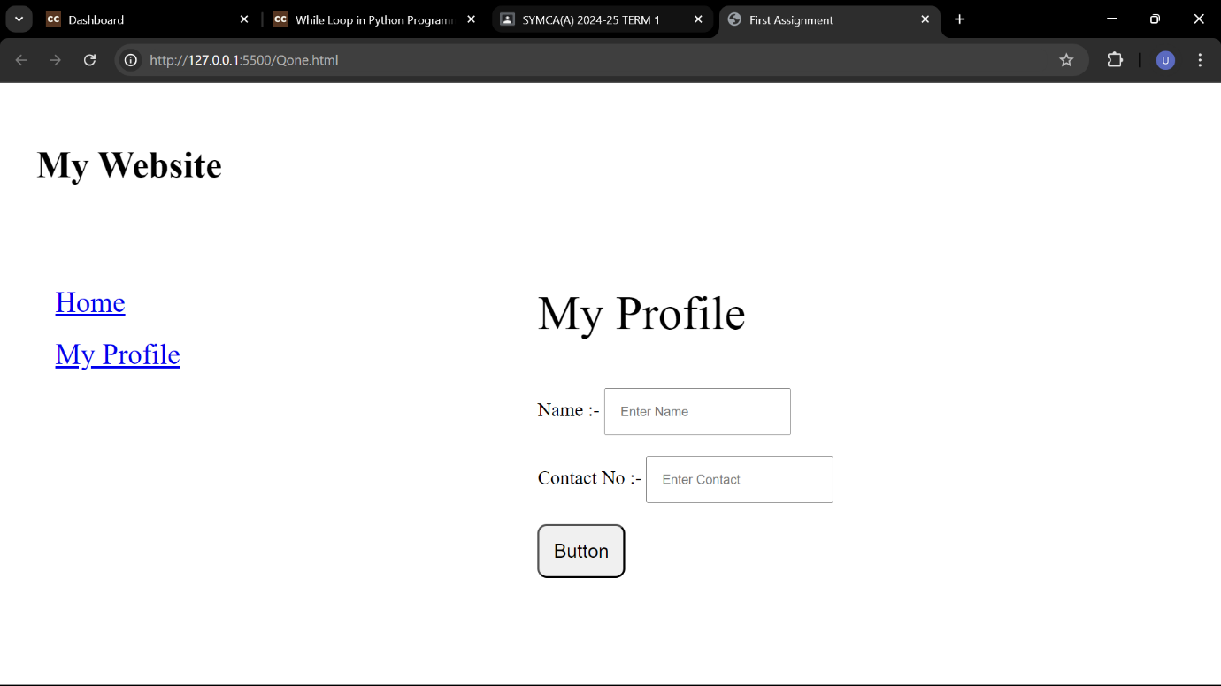

Q. 2. Create an HTML document that describes nested ordered lists of cars. The outer list must have three entries: compact, midsize and sports. Inside each of theselists there must be two sub-lists of body styles. The compact and midsize carsub-lists are two doors and four doors; the sports car sub lists are coupe andconvertible. Each body style sub-list must have at least three entries, each ofwhich is the make and model of a particular car that fits the category. The outer list must use uppercase Roman numerals, the middle lists must use uppercase letters, and the inner lists must use Arabic numerals. The background color for the compact car list must be pink; for the mid-size car list, it must be blue; for the sports car list, it must be red. All of the styles must be in a document style sheet.

Code :

**Html Code :**

<!DOCTYPE html>

<html lang="en">

<head>

    <meta charset="UTF-8">

    <meta name="viewport" content="width=device-width, initial-scale=1.0">

    <link rel="stylesheet" href="q2style.css">

    <title>Question 2</title>

</head>

<body>

    <div style="padding: 20px;">

       <b> <li class = "outer"  >Compact</li> </b>

        <ul id="compact" >

            <li class = "middle">Two Doors</li>

            <ol>

                <li>Ferrari</li>

                <li>Rolls Roys</li>

                <li>Lamborgini</li>

            </ol>

            <li class = "middle">Four Doors</li>

            <ol>

                <li>Alto</li>

                <li>Maruti 800</li>

                <li>Maruti Zen</li>

            </ol>

        </ul>

       <b> <li class = "outer">Midsize</li> </b>

        <ul id="Midsize">

            <li class = "middle">Two Doors</li>

            <ol>

                <li>Jaguar F Type</li>

                <li>Porsche 911</li>

                <li>BMW 2</li>

            </ol>

            <li class = "middle">Four Doors</li>

            <ol>

                <li>Hyubdai I20</li>

                <li>Swift Dezire</li>

                <li>Honda City</li>

            </ol>

        </ul>

        <b> <li class = "outer">Sports</li> </b>

        <ul id="Sports">

            <li class = "middle">Coupe</li>

            <ol>

                <li>Audi E-Tron</li>

                <li>Bentley Continentle</li>

                <li>Audi RS5</li>

            </ol>

            <li class = "middle">Convertible</li>

            <ol>

                <li>BMW Z4</li>

                <li>BMW 3 Series</li>

                <li>BMW M2</li>

            </ol>

        </ul>

    </ul>

    </div>

</body>

</html>

**CSS CODE :**

.outer{

    list-style: upper-roman;

}

.middle{

    list-style: upper-alpha;

}

#compact{

    background-color: pink;

    margin: 15px;

}

#Midsize{

    background-color: blue;

    margin: 15px 15px;

}

#Sports{

    background-color: red;

    margin: 15px 15px;

}

**Output :**

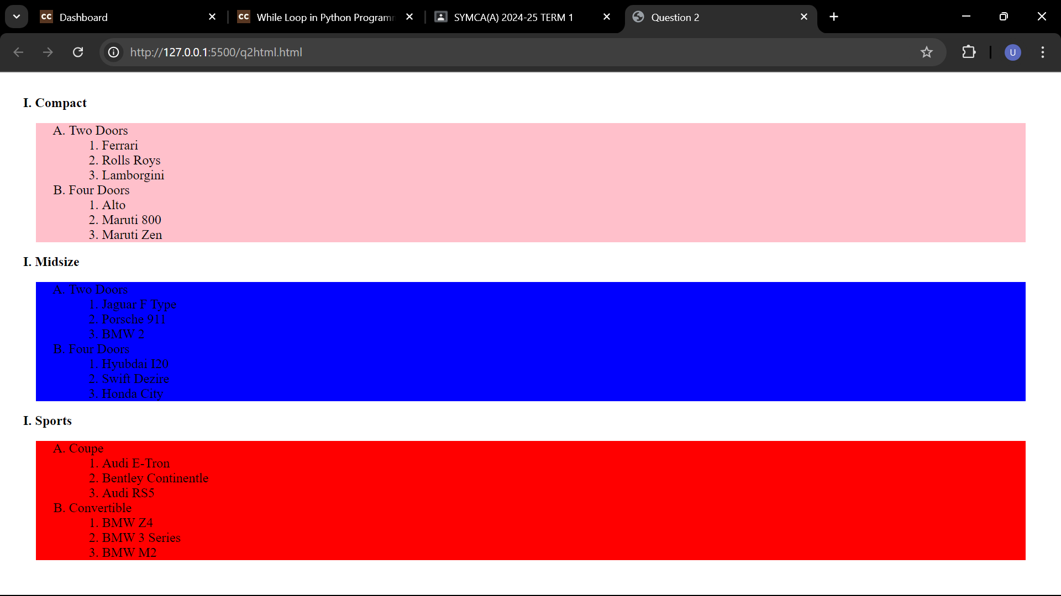

**3. Design and develop a suitable static web site for online shopping of grocery and**

**fruits using HTML and CSS.**

Code :

**Html Code :**

<!DOCTYPE html>

<html lang="en">

<head>

    <meta charset="UTF-8">

    <meta name="viewport" content="width=device-width, initial-scale=1.0">

    <title>Online Grocery and Fruits Shop</title>

    <link rel="stylesheet" href="q3style.css">

</head>

<body>

    <header>

        <div class="logo">Grocery Shop</div>

        <nav>

            <ul>

                <li><a href="#">Home</a></li>

                <li><a href="#">Shop</a></li>

                <li><a href="#">About</a></li>

                <li><a href="#">Contact</a></li>

            </ul>

        </nav>

        <div class="search-bar">

            <input type="text" placeholder="Search...">

            <button>Search</button>

        </div>

        <div class="cart-icon">🛒</div>

    </header>

    <main>

        <section style="align-items: center; justify-content: center;">

            <h1>Fresh Groceries & Fruits Delivered to Your Doorstep</h1>

            <p>Quality products at the best prices</p>

        </section>

        <section class="featured-products">

            <h2>Featured Products</h2>

            <div class="product-grid">

                <div class="product">

                    <img src="apple.jpg" alt="Apple">

                    <h3>Apple</h3>

                    <p>200 rs pr kg</p>

                    <button>Add to Cart</button>

                </div>

                <div class="product">

                    <img src="banana.jpg" alt="Banana">

                    <h3>Banana</h3>

                    <p>50 rs Dozen</p>

                    <button>Add to Cart</button>

                </div>

            </div>

        </section>

    </main>

    <footer>

        <div class="footer-content">

            <p>&copy; 2024 Grocery Shop. All rights reserved.</p>

            <ul>

                <li><a href="#">Privacy Policy</a></li>

                <li><a href="#">Terms of Service</a></li>

            </ul>

        </div>

    </footer>

</body>

</html>

**CSS Code :**

/* styles.css */

body {

    font-family: Arial, sans-serif;

    margin: 0;

    padding: 0;

    box-sizing: border-box;

}

header {

    display: flex;

    justify-content: space-between;

    align-items: center;

    background-color: #4CAF50;

    color: white;

    padding: 10px 20px;

}

.logo {

    font-size: 24px;

    font-weight: bold;

}

nav ul {

    list-style: none;

    margin: 0;

    padding: 0;

    display: flex;

}

nav ul li {

    margin: 0 10px;

}

nav ul li a {

    color: white;

    text-decoration: none;

}

.search-bar {

    display: flex;

}

.search-bar input {

    padding: 5px;

}

.search-bar button {

    padding: 5px;

    background-color: #f0f0f0;

    border: none;

    cursor: pointer;

}

.cart-icon {

    font-size: 24px;

}

.hero {

    /* background: url('hero-banner.jpg') no-repeat center center/cover; */

    color: white;

    text-align: center;

    padding: 100px 20px;

}

.featured-products {

    text-align: center;

    padding: 20px;

}

.product-grid {

    display: flex;

    justify-content: space-around;

    flex-wrap: wrap;

}

.product {

    background-color: #f0f0f0;

    padding: 20px;

    margin: 10px;

    flex: 1;

    max-width: 200px;

    text-align: center;

    border-radius: 5px;

}

.product img {

    max-width: 100%;

    height: auto;

    border-radius: 5px;

}

footer {

    background-color: #333;

    color: white;

    text-align: center;

    padding: 10px 20px;

}

footer ul {

    list-style: none;

    margin: 0;

    padding: 0;

    display: flex;

    justify-content: center;

}

footer ul li {

    margin: 0 10px;

}

footer ul li a {

    color: white;

    text-decoration: none;

}

**OUTPUT :**

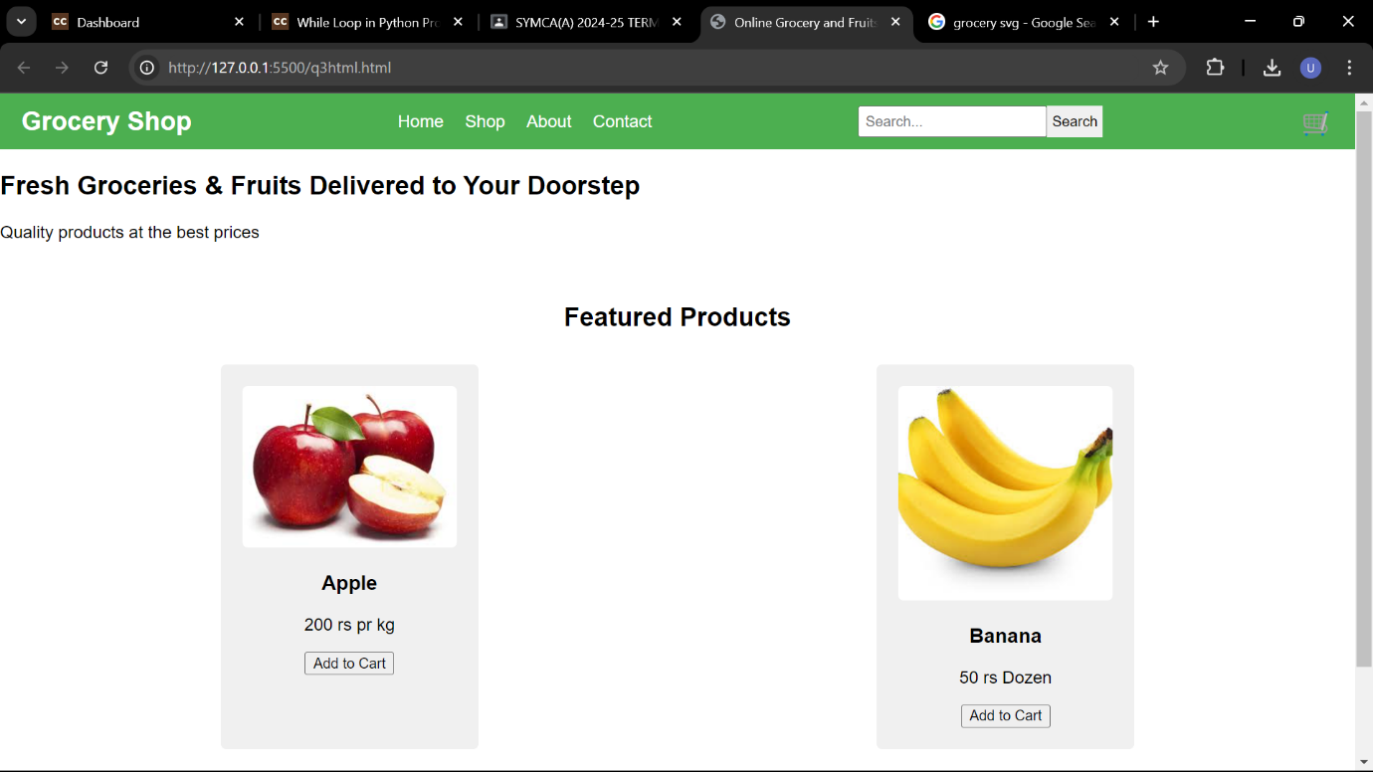

**Q4. Design external CSS to set the following rules and link in HTML file.**

**a. Give Heading**

**b. Set paragraph with font size 13,**

**c. Set text color as blue.**

**d. Set Heading text color as green.**

Code :

**Html Code :**

<!DOCTYPE html>

<html lang="en">

<head>

    <meta charset="UTF-8">

    <meta name="viewport" content="width=device-width, initial-scale=1.0">

    <title>Html Document</title>

    <link rel="stylesheet" href="q4style.css">

</head>

<body>

    <h1>This is heading</h1>

    <p>Lorem, ipsum dolor sit amet consectetur adipisicing elit. Iste, ex molestias. Similique quos nobis sapiente expedita non sint quisquam minus itaque, cumque deserunt? Quod necessitatibus officia saepe ut et doloribus molestias hic, quam dignissimos earum ratione non corporis ducimus suscipit. Lorem ipsum dolor sit amet consectetur adipisicing elit. Corporis ipsam quos impedit repudiandae temporibus? Doloribus libero, quae officiis unde itaque dignissimos accusantium non quo culpa consequatur asperiores velit beatae. Pariatur esse labore dolorum, beatae cum quo inventore id officia est ducimus commodi earum adipisci veniam aliquam distinctio quis cupiditate aut? Fugit, fuga labore quis eius fugiat corporis sunt delectus distinctio.</p>

</body>

</html>

**CSS code :**

h1{

    color: green;

}

p{

    font-size: 13pt;

    color: blue;

}

body{

    padding: 20px;

}

Output :

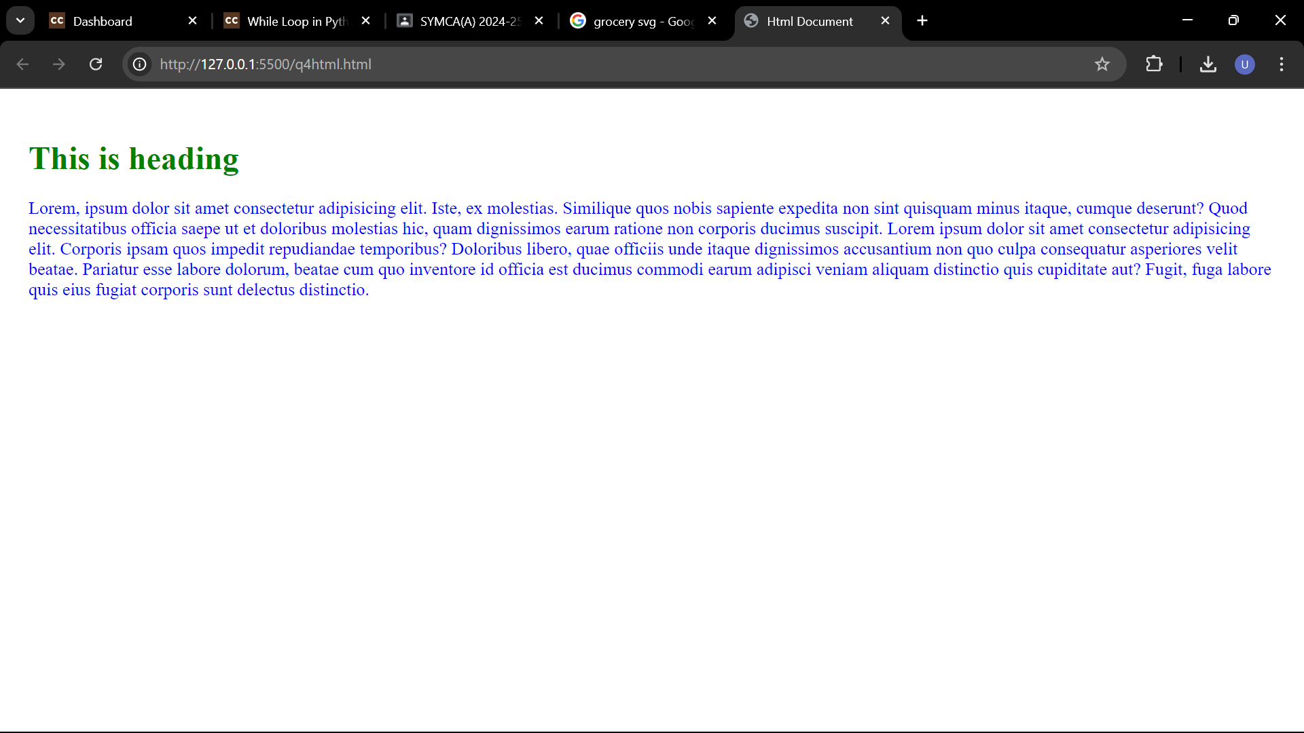

**Q. 5. Create an inline CSS that changes the font color of the h1 heading by setting the color property to blue with center aligned And internal DTD for the Library Information like Book Name, Author Name, Publication and Year of Publication.**

**a. Ensure its validity**

**b. Then try to break it**

Code :

**Html file :**

<!DOCTYPE html>

<html lang="en">

<head>

    <meta charset="UTF-8">

    <title>Library Information</title>

</head>

<body>

    <h1 style="color: blue; text-align: center;">Library Information</h1>

    <p>Book Name: The Great Gatsby</p>

    <p>Author Name: F. Scott Fitzgerald</p>

    <p>Publication: Scribner</p>

    <p>Year of Publication: 1925</p>

</body>

</html>

**Output :**

