Progressive Education Society's

**Modern College of Engineering, Pune**

**MCA Department**

**A.Y.2024-25**

**(410902) Web Technologies Lab**

*****************************************************************************************

Class: SY-MCA Shift / Div : A Batch: S3 Roll Number : 52062

Name: Laxman Shinde Assignment No : 4 Date of Implementation : 04/09/24

*****************************************************************************************

**Q1. Write a simple Angular Js program which takes Name of user as input in the textbox and say Hello to him/her.**

Code: q1.html:

<!DOCTYPE html>

<html ng-app="HelloApp">

<head>

    <title>Hello AngularJS</title>

    <script src="https://ajax.googleapis.com/ajax/libs/angularjs/1.8.2/angular.min.js"></script>

</head>

<body>

    <div ng-controller="HelloController">

        <input type="text" ng-model="userName" placeholder="Enter your name">

        <p>Hello, {{ userName }}!</p>

    </div>

    <script>

        angular.module('HelloApp', [])

            .controller('HelloController', function ($scope) {

                $scope.userName = '';

            });

    </script>

</body>

</html>

Output:

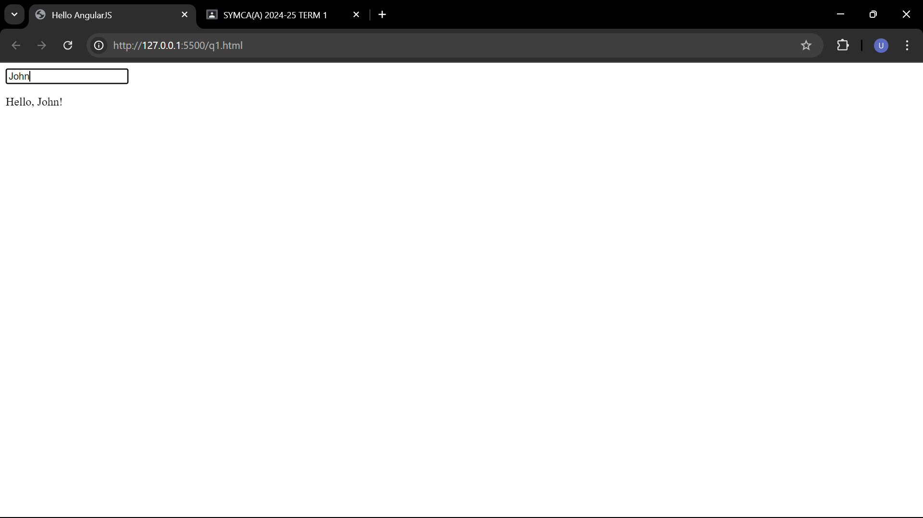

**Q2. Build a navigation menu that highlights the selected entry. Use only Angular&#39;s directives.**

**Code : q2.html**

<!DOCTYPE html>

<html ng-app="NavigationApp">

<head>

    <title>Navigation Menu</title>

    <script src="https://ajax.googleapis.com/ajax/libs/angularjs/1.8.2/angular.min.js"></script>

    <style>

        .menu-item {

            cursor: pointer;

        }

        .active {

            background-color: #337ab7;

            color: #fff;

        }

    </style>

</head>

<body>

    <div ng-controller="NavigationController">

        <ul>

            <li ng-repeat="item in menuItems" ng-click="selectItem(item)"

                ng-class="{ 'active': selectedItem === item }">

                {{ item }}

            </li>

        </ul>

        <p ng-if="selectedItem">You selected: {{ selectedItem }}</p>

    </div>

    <script>

        angular.module('NavigationApp', [])

            .controller('NavigationController', function ($scope) {

                $scope.menuItems = ['Home', 'About', 'Services', 'Contact'];

                $scope.selectedItem = '';

                $scope.selectItem = function (item) {

                    $scope.selectedItem = item;

                };

            });

    </script>

</body>

</html>

**Output:**

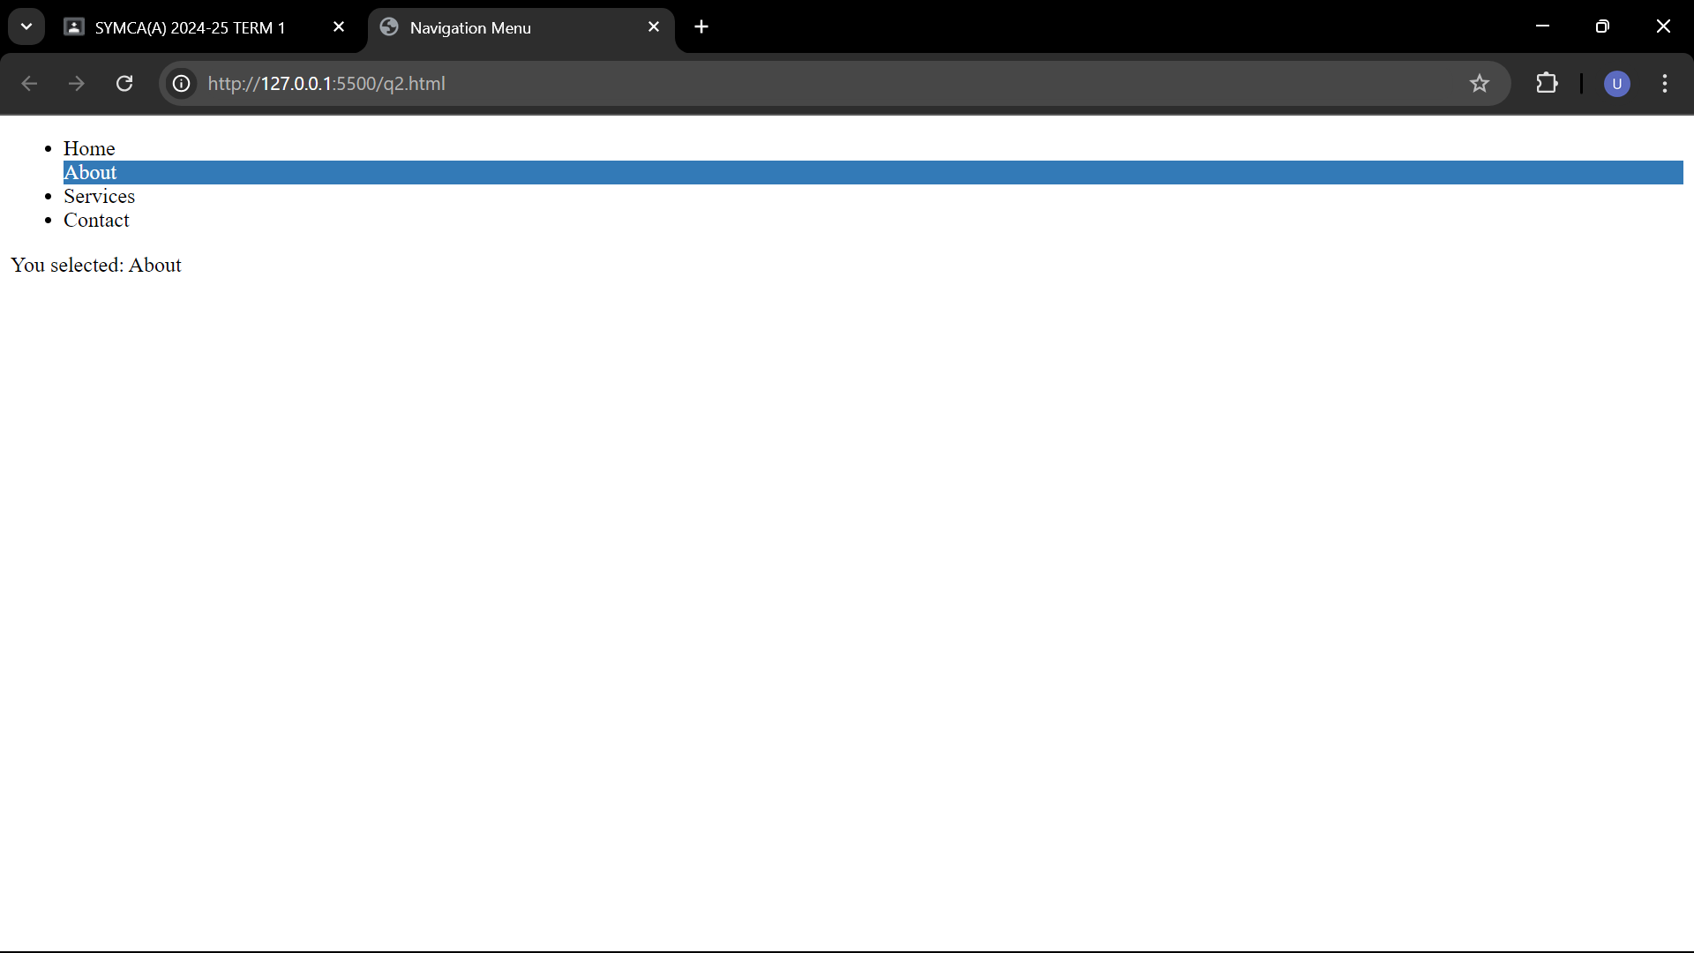

**Q.3. Create an application for Students Record using AngularJS.**

**Code:**

**Q3.html:**

<!DOCTYPE html>

<html lang="en">

<head>

<meta charset="UTF-8">

<meta name="viewport" content="width=device-width, initial-scale=1.0">

<title>Student Record Management</title>

<link rel="stylesheet" href="q3.css">

<script src="https://ajax.googleapis.com/ajax/libs/angularjs/1.8.2/angular.min.js"></script>

<script src="q3.js"></script>

</head>

<body ng-app="studentApp" ng-controller="studentController">

<h1>Student Record Management</h1>

<!-- Form to Add/Edit Students -->

<div>

<h3>{{editMode ? 'Edit' : 'Add'}} Student</h3>

<form ng-submit="addOrEditStudent()">

<label>Name:</label>

<input type="text" ng-model="student.name" required /><br />

<label>Age:</label>

<input type="number" ng-model="student.age" required /><br />

<label>Grade:</label>

<input type="text" ng-model="student.grade" required /><br />

<button type="submit">{{editMode ? 'Update' : 'Add'}} Student</button>

</form>

</div>

<h3>Student List</h3>

<table>

<thead>

<tr>

<th>Name</th>

<th>Age</th>

<th>Grade</th>

<th>Actions</th>

</tr>

</thead>

<tbody>

<tr ng-repeat="stu in students">

<td>{{stu.name}}</td>

<td>{{stu.age}}</td>

<td>{{stu.grade}}</td>

<td>

<button ng-click="editStudent($index)">Edit</button>

<button ng-click="deleteStudent($index)">Delete</button>

</td>

</tr>

</tbody>

</table>

</body>

</html>

Q3.css

body {

font-family: Arial, sans-serif;

margin: 20px;

}

form {

margin-bottom: 20px;

}

input {

margin: 5px;

padding: 8px;

}

table {

width: 100%;

border-collapse: collapse;

margin-top: 20px;

}

table, th, td {

border: 1px solid #ddd;

}

th, td {

padding: 10px;

text-align: left;

}

button {

padding: 6px 10px;

margin: 2px;

cursor: pointer;

}

button:hover {

background-color: #ddd;

}

Q3.js:

var app = angular.module('studentApp', []);

app.controller('studentController', function($scope) {

$scope.students = [];

$scope.editMode = false;

$scope.addOrEditStudent = function() {

if ($scope.editMode) {

// Update student in the list

$scope.students[$scope.editIndex] = $scope.student;

$scope.editMode = false;

} else {

// Add new student to the list

$scope.students.push($scope.student);

}

$scope.student = {};

};

$scope.editStudent = function(index) {

$scope.student = angular.copy($scope.students[index]);

$scope.editIndex = index;

$scope.editMode = true;

};

$scope.deleteStudent = function(index) {

$scope.students.splice(index, 1);

};

});

Output:

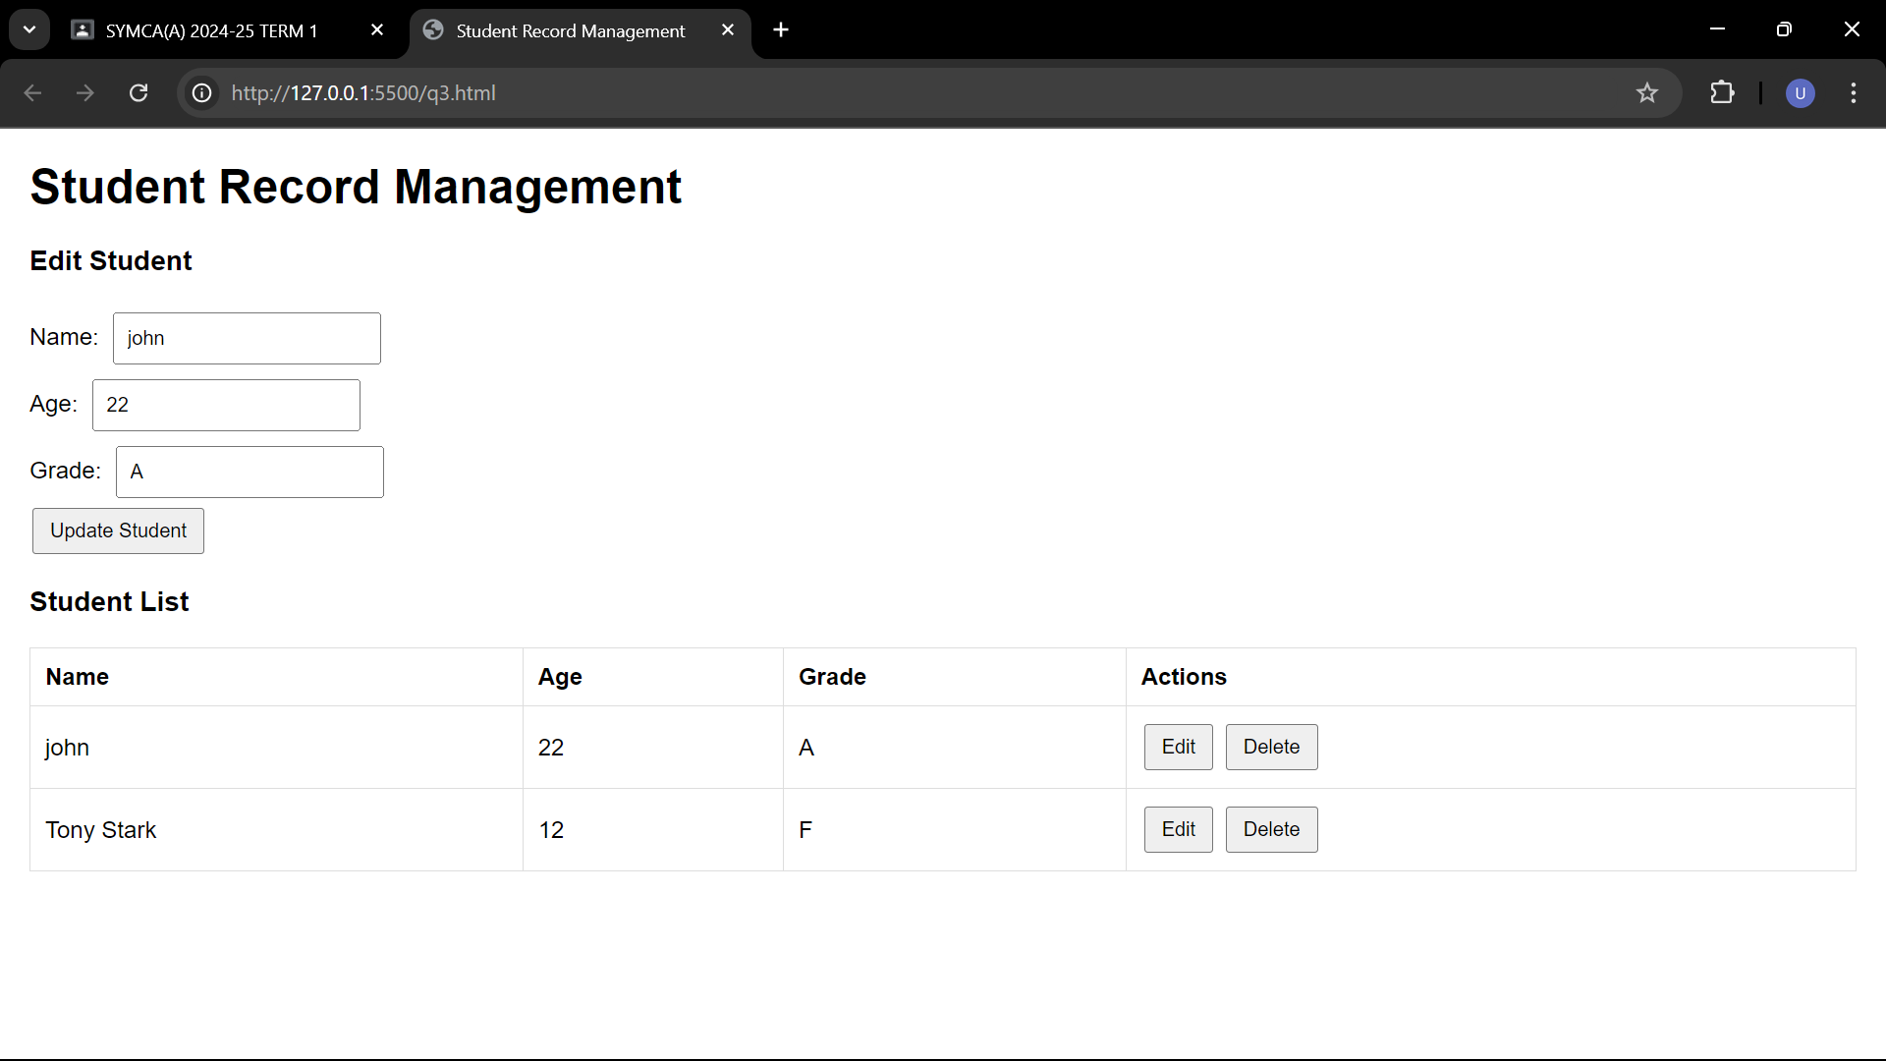

**Q4. Design simple AngularJs program which takes two numbers as input from user in two textfield and display addition of these numbers in another textfield. Use AngularJS expression for addition.**

**Code :**

**Q4.html:**

<!DOCTYPE html>

<html ng-app="AdditionApp">

<head>

    <title>Addition Program</title>

    <script src="https://ajax.googleapis.com/ajax/libs/angularjs/1.8.2/angular.min.js"></script>

</head>

<body>

    <div ng-controller="AdditionController">

        <label for="num1">Number 1:</label>

        <input type="number" id="num1" ng-model="number1"><br>

        <label for="num2">Number 2:</label>

        <input type="number" id="num2" ng-model="number2"><br>

        <label for="result">Result (Sum):</label>

        <input type="number" id="result" ng-value="number1 + number2"><br>

    </div>

    <script>

        angular.module('AdditionApp', [])

            .controller('AdditionController', function ($scope) {

                $scope.number1 = 0;

                $scope.number2 = 0;

            });

    </script>

</body>

</html>

Output:

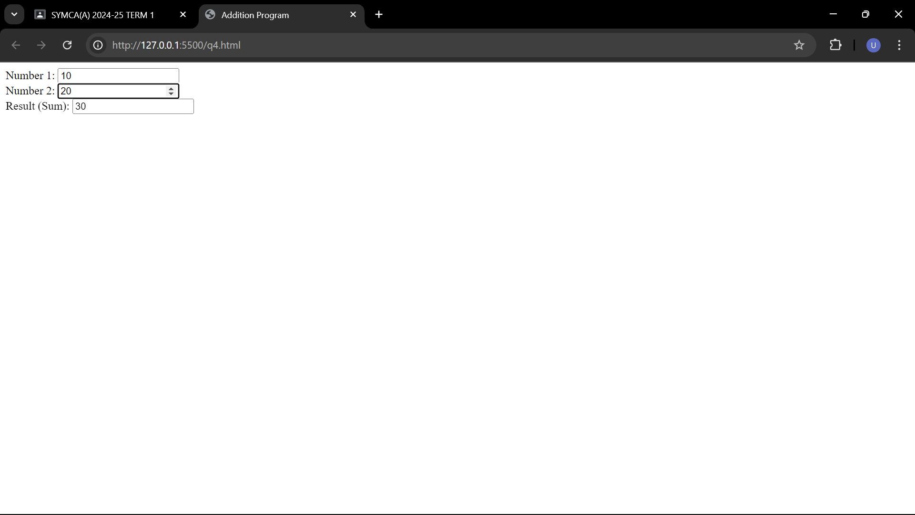

**Q5. Design and Implement Timer Application using angular JS, HTML, CSS.**

**Code:**

**Q5.html:**

<!DOCTYPE html>

<html ng-app="TimerApp">

<head>

    <title>Timer Application</title>

    <link rel="stylesheet" type="text/css" href="q5.css">

    <script src="https://ajax.googleapis.com/ajax/libs/angularjs/1.8.2/angular.min.js"></script>

</head>

<body>

    <div ng-controller="TimerController" class="timer-container">

        <h2>Timer</h2>

        <div class="timer-display">

            {{ displayTime }}

        </div>

        <div class="timer-controls">

            <button ng-click="startTimer()" ng-disabled="timerRunning">Start</button>

            <button ng-click="stopTimer()" ng-disabled="!timerRunning">Stop</button>

            <button ng-click="resetTimer()">Reset</button>

        </div>

    </div>

    <script src="q5.js"></script>

</body>

</html>

Q5.css:

body {

    display: flex;

    justify-content: center;

    align-items: center;

    height: 100vh;

    margin: 0;

}

.timer-container {

    background: #f2f2f2;

    padding: 20px;

    border-radius: 5px;

    box-shadow: 0px 0px 5px 0px #888888;

    text-align: center;

}

h2 {

    margin: 0;

}

.timer-display {

    font-size: 2em;

    margin: 10px 0;

}

.timer-controls button {

    padding: 10px 20px;

    background-color: #337ab7;

    color: #fff;

    border: none;

    border-radius: 5px;

    cursor: pointer;

    margin: 5px;

}

.timer-controls button[disabled] {

    background-color: #ccc;

    cursor: not-allowed;

}

Q5.js:

angular.module('TimerApp', [])

    .controller('TimerController', function ($scope, $interval) {

        $scope.displayTime = '00:00:00';

        $scope.timerRunning = false;

        let timer;

        function formatTime(time) {

            const hours = Math.floor(time / 3600);

            const minutes = Math.floor((time % 3600) / 60);

            const seconds = time % 60;

            return (

                (hours < 10 ? '0' : '') + hours + ':' +

                (minutes < 10 ? '0' : '') + minutes + ':' +

                (seconds < 10 ? '0' : '') + seconds

            );

        }

        $scope.startTimer = function () {

            if (!$scope.timerRunning) {

                let startTime = 0;

                timer = $interval(function () {

                    startTime++;

                    $scope.displayTime = formatTime(startTime);

                }, 1000);

                $scope.timerRunning = true;

            }

        };

        $scope.stopTimer = function () {

            if ($scope.timerRunning) {

                $interval.cancel(timer);

                $scope.timerRunning = false;

            }

        };

        $scope.resetTimer = function () {

            $scope.displayTime = '00:00:00';

            $scope.stopTimer();

        };

    });

Output:

