- Overlapping with header in Event update

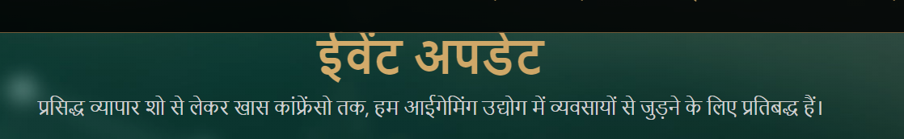

- Overlapping of Hindi characters
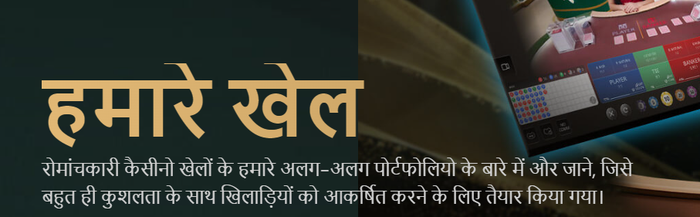

- Skype link not working in simple play.com

