Major Project Report
On

“ATM SYSTEM”

Submitted in partial fulfillment of requirements
for the award of the degree

Bachelor of Technology
In
Computer Science and Engineering

To
Punjab Technical University, Jalandhar

SUBMITTED BY:
Name: ADHIRAJ
Roll no.: 1602188
Semester: 5th
Batch: 2016-2020



DEPARTMENT OF COMPUTER SCIENCE AND ENGINEERING
Chandigarh Engineering College –Landran
Mohali, Punjab - 140307

Acknowledgement

Foremost of all, I express my sincere indebtedness to the “Almighty”, for bestowing me with all the favourable circumstances and kept me in high spirits, I am very great full to my advisor, “MR. PRADEEP KUMAR ” for his/her patience, encouragement, and many fruitful discussions from the very early stage of this project. I would like to thank , Head of Department of Computer Science and Engineering, Chandigarh Engineering College, Landran. .I wish to express my appreciation to my family for my continuous love and encouragement, for always believing in me, for never failing to provide all the support, and for coping with the pressure that naturally comes with such endeavour.

Name ADHIRAJ
B.tech (CSE)
Rollno 1602188

CERTIFICATE

Certified that Project work entitled “ATM SYSTEM” is a bonafide work carried out in the third semester by “ADHIRAJ“ roll number 1602188” in partial fulfillment for the award of Bachelor of Technology in Computer Science and Engineering at Chandigarh Engineering College Landran from Punjab Technical University, Jalandhar during the academic year BATCH(2016-2020) who carried out the project work under the guidance and no part of this work has been submitted earlier for the award of B.Tech degree .

Date: 4 july 2018 Signature of Student

This is to certify that the above statement made by the candidate is correct to best of my knowledge.

Mr. Rajeev Sharma
Assistant Professor

Prof(Dr).Amit Verma
Professor and Head

ABSTRACT

This report attempts to understand the design of an Automated Teller Machine (ATM) system, a device used by bank customers to process account transactions. Typically, a user inserts into the ATM a special plastic card that is encoded with information on a magnetic strip. The strip contains an identification code that is transmitted to the bank's central computer by modem. To prevent unauthorized transactions, a personal identification number (PIN) must also be entered by the user using a keypad. The computer then permits the ATM to complete the transaction; most machines can dispense cash, accept deposits, transfer funds, and provide information on account balances. Banks have formed cooperative, nationwide networks so that a customer of one bank can use an ATM of another for cash access. Some ATMs will also accept credit cards for cash advances. The first ATM was installed in 1969 by Chemical Bank at its branch in Rockville Centre, New York. A customer using a coded card was dispensed a package containing a set sum of money.

Project Profile

Project Title : ATM Sytem

Front End Tool : Turbo C++

Back End Tool : Turbo C++

Project Guide :Mr. Pradeep

Developed By :Adhiraj

Submitted To : Department of Computer Engineering,
Chandigarh Engineering college

1.0 Introduction

  - Project Summary

An automated teller machine (ATM) or automatic banking machine (ABM) is a computerised telecommunications device that provides the clients of a financial institution with access to financial transactions in a public space without the need for a cashier, human clerk or bank teller. On most modern ATMs, the customer is identified by inserting a plastic ATM card with a magnetic stripe or a plastic smart card with a chip, that contains a unique card number and some security information such as an expiration date or CVVC (CVV). Authentication is provided by the customer entering a personal identification number (PIN).

  - Purpose

Using an ATM, customers can access their bank accounts in order to make cash withdrawals (or credit card cash advances) and check their account balances as well as purchase cellphone prepaid credit. If the currency being withdrawn from the ATM is different from that which the bank account is denominated in (eg: Withdrawing Japanese Yen from a bank account containing US Dollars), the money will be converted at a wholesale exchange rate. Thus, ATMs often provide the best possible exchange rate for foreign travelers and are heavily used for this purpose as well.
ATMs are known by various other names including Automated Transaction Machine, automated banking machine, cashpoint (in Britain),money machine, bank machine, cash machine, hole-in-the-wall, Bancomat (in various countries in Europe and Russia), Multibanco (after a registered trade mark, in Portugal), and Any Time Money (in India)

  - Scope

The main purpose of the ATM division and information service is to provide the customers financial flexibility, worldwide acceptance and round-the clock convenience. Bank issues only VISA Credit Cards, the renowned Credit Card brand. Cardholders can purchase goods/services up to the credit limit and can reuse the credit facility upon repayment. Credit Card is a safer substitute to cash and is the major mode of payment worldwide. Standard Chartered Bank is the first to introduce the TAKA CREDIT CARD. The card is issued basically to a person’s name and the specific person can use the card in anywhere in Bangladesh. The business activity of Premier Bank Credit Card section is to keep the records of all sales and customers’ requests, the information of cardholders and reports them to necessary documents.

2.0 Project management
In this chapter we will discuss about project planning and scheduling. Our goal is to establish a pragmatic strategy for controlling, tracking, and monitoring a complex technical project.
In project management following things must be done.
- Project Planning and Scheduling
- Risk Management
- Estimation
In Project planning and scheduling, Planning of the project is done. In scheduling different task are schedule according to the deadline of the project.
2.1Project Planning and scheduling
Project planning must deals with the following things.
- Project Complexity: - Project complexity has a strong effect but is heavily influenced by past practitioner experience.
- Project Size: - As size increases the interdependency of elements also grow. Watch out for scope creep.
- The degree of structural uncertainty: - the degree to which requirements are solidified and the ease of functional decomposition.The purpose of project planning is to ensure that the end result is completed on time, within budget, and exhibits quality!.
2.1.2Project Plan
Stages of Software Lifecycle
- Software Requirement Analysis
This is the first stage of the project, which involves interaction with the customer to understand his/her needs, requirements, information, required functions, performance and interfacing in MLM software. For this purpose requirement analyst will arrange a meeting for gathering information and additional details for software development. After completing requirement gathering tasks developer team will take a look for understand how requirements can be computerized. The requirement is documented in the form of a Software Requirement Specification (SRS) which is then presented to the customer for review.
- Design
Beginning once software requirements have been analyzed and specified, software design is the first of three technical activities – design, code generation, and test – that are required to build and verify the software.
Design is multi level process which defines following details:
- Data Design
- Architecture Design
- Interface Design
- Component level Design

- Development
The design must be translated into a machine-readable form. The coding step performs this task. In this stage, the developers will actually code the programs. The specifications arrived at the design stage for each and every function will be converted to code using tools that are finalized for the implementation of the Software. At this stage the testing methodology to be adopted will be finalized. For each program test cases will be prepared and for each of these test cases, test data will also be prepared. The actual developers will do a first cur checking at this stage to see that the programs written by them are error free.
- Testing
In this stages the test group of the development team, using the cases and the test data already prepared will test the programs. Only after all the functions are tested singularly, an integrated testing will be performed to see that inter-function dependability is satisfied. Separate test cases and test data will be worked out for the integrated testing.
- Acceptance Test
This round of testing will be performed by the test group formed by the users of MLM software. This test group has to insure that the developed software is working as per their requirements. If some problems are found then it should be immediately communicated Development group so that the problem can be looked into and hence rectified.
- Data Creation
For software, data is most important part. Data is information which is handled by software. So before coding software, all master table data will have to be created.
- Implementation
Now the implementation of software is to be done by programmers. All the requirements and information gathered by the analyst is now take actual image in form of software. After making software it is uploaded in to the system so users, for whom software is developed, can use the software.
Once we examine that the project is feasible, we undertake project planning. The table below describes how we planned our project.
2.2 Risk Management
2.2.1 Risk Identification
During the project plan we have consider all the proactive which we have think we will face during the project period. Here I have listed the risks which we have considered during the project plan:
- Possibility that the components are not available during the project period.
- Possibility that products purchased was not compatible.
- Possibility that the hardware resources are not available during the project period.
- Possibility that Ethernet connection between robot controller and computer may not occur, to which we have to make the connection might not available.
- Possibility that software inter-compatibility may not be there.
2.2.2 Risk Analysis
Risk analysis is the important aspect of the project planning, whenever planning the software, programmer always has to consider the risks of the projects which he might face in the future during designing the software.
Risks are of two types
- Proactive Risk.
- Reactive Risk.
Risk Impact
Risk | Effect
Possibility of getting illness. | Serious.
Possibility of component not available. | Catastrophic
Possibility of component not effective. | Serious.
Possibilities of hardware resources are not available. | Catastrophic.
Possibility of robot controller not available. | Serious.
Possibility of communication between systems might not happen on time. | Serious
Proactive Risk Assessment Table
This are the proactive risks which we can consider during the project plan period so we can cop up with them easily and we can find the solution easily but we can find other proactive risks which we haven’t considered in the project plan:

Risk | Effect
Possibility that because of some problem we have lost the backup of some days. | Serious
Possibility that because of finance problem in the company we won’t get the full resources. | Catastrophic
Possibilities that project Manager leave the project. | Serious

Reactive Risk Assessment Table
Proactive risks are most dangerous risks which we haven’t considered during the project period and to cop up with them is not easy. These kinds of risks are risks, so programmer must have been active to cop up with them smartly.
Risk Estimation
Risk estimation attempts to rate each risk in two ways:
- The likelihood or probability that risk is real and.
- The consequences of the problems associated with the risk should it occurs.
- The project planner, along with other managers and technical staff, performs four risk projection steps:
- Establish a scale rate that reflects the perceived likelihood of a risk.
- Delineate the consequences of the risk.
- Estimate the impact of the risk on the project and the product.
- Note the overall accuracy of the risk projection so that there will be no misunderstanding.
The intent if these steps are to consider risks in a manner that leads to prioritization. No software team has the resources to address every possible risk with the same degree of rigor. By prioritizing risks, the team can allocate resources where they will have the most impact.
2.2.3 Risk Planning
After estimating all the risks and risk effects, we will look how to manage this kind of risks:
With the kind of proactive risks we will prepare the plan for how to manage these risks, we will think about their options, if their kinds of risks are facing and if they are reactive risks we have to manage them on the spot to avoid their dangerous effects:
Risk | Risk Management
Possibility of getting illness. | We will provide some more time (approx. one week) to prepare the software.
Possibilities of the components are not available. | We will check for other components, which have the same effect as those components.
Possibility of component not effective. | We will manage for the new components of that kind.
Possibilities of hardware resources are not available | We will manage for optional hardware, while starting the project.
Possibility of robot controller not available. | We try to arrange a new controller.

2.3 Estimation

2.3.1 Effort Estimation

Effort estimation methods are one of the important tools for project managers in controlling human resources of ongoing or future software projects. The estimations require historical project data including process and product metrics that characterize past projects.

Software cost and effort estimation will never be an exact science. Too many variables human, technical, environment, political can affect the ultimate cost of software and effort applied to develop it. However, software project estimation can be transformed from a black art to a series of systematic steps that provide estimate with acceptable risk. To achieve reliable cost and effort estimates, a number of options arise:

- Software Sizing

- Function point sizing
- Standard component sizing

- Problem-Based Estimation

LOC and FP data are used in two ways during software project Estimation:-

- As an estimation variable to size each element of the software and
- As baseline matrices collected from past projects and used in conjunction
with estimation variables to develop cost and effort projections.

- Schedules

Obtain an early view of staffing requirements and constraints, and demonstrate the impact of changing deadlines, understaffing, and staff loading.

- Quality

Quantify the impact on defect rates of building to deadlines or reducing staff.
- Risk

Fine tune risk levels for all the major types of risk: size, requirements, technology, maintenance, systems integration, and defects.

3.0 System Requirements Study

3.1 User Characteristics

There are 4 types of user dealing with the system.
User A? Administrator
Administrator: Admin is having all the rights on the application.
User B? Employee
Employee: Employee of the company is one of the 4 users of this project
User C? Anonymous User
Anonymous User: Anyone who visits website. And any person applying for the posted job on the website.
User D? Client
Client: This is the registered user. Who come to know about his/her project’s progress

3.2 Hardware and Software Requirement:
Hardware Specification:
Processor : Intel Dual based system
Processor Speed : 1GHz to 2 GHz
RAM : 256MB to 512 MB
Hard Disk : 4 GB to 30 GB
Keyboard : 104 keys

3.3 Constraints:

General Constraints

1) This system will not take care of any virus problem that might occur on the computer with which it is installed. Avoiding the use of pirated/illegal software and ensuring that floppies and other removable media are scanned for viruses before use could minimize the possibility of viral infection.
2) Recovery of data after a system crash will be possible only if backups are taken at regular intervals.
3) Manual interfaces cannot be fully avoided. Documented proofs like dates etc. will have to be verified by the concerned staff before entering it into the computerized system

Hardware Constraints

The performance of the system will be dependent on the machine conditions. The primary memory (RAM) and the secondary memory (Hard Disk Space) requirement of the system will be the same as that required by the normal application and the operating system. And the space required storing the data. The space required to store the data would increase as more and more records are added to the system.

Assumptions and Dependencies

a. It is assumed that the user is familiar with the basic computer fundamentals.
b. Timely backup of data should be taken to avoid data loss in case of system
crash.
c. Floppies and other removable media should be scanned for viruses before use.
d. It is assumed that the maintenance of the database will be assigned to the
authorized person only.
e. Only authorized persons will be allowed inside the system

4.0 System Analysis

4.1 Study of Current System

The OBS Administration falls short of controlling the employee’s activities in analyzing his/her strengths and weakness. The decision for appraisal of assigning next project to the employee or to train him/her to enhance the skills – where lies with proper projection. He is not provided with the detailed project information done or to be assigned based on Application / Verticals.

4.2 Problem and Weaknesses of Current System

- Need of extra manual effort.
- It used to take much time to find any employee
- Not very much accurate.
- Danger of losing the files in some cases.

4.3 Requirements of New System

Decision in assigning proper skillful hands for the project is an important issue in OBS Module. The OBS Administrator should report with the personal holding the necessary skills required for the project assignment. The decision in making analysis about the employee’s skills is a prime important before booting in. The proposed system of OBS Module is the right software to be incorporated into the Automation of OBS Software for helping the organization needs with respect to skilful Human Resource.
The proposed system provides detail general information about the employee along with Educational, Certification, Skill and Project details. It enhances the OBS Management in adding, viewing and updating employees’ details and generates various reports regarding employee’s skill and experience. Suggestions and Grievances posted by the employees are upheld for taking care of the necessary steps in forwarding company’s obligation.
.
ADVANTAGES OF PROPOSED SYSTEM:

- Very fast and accurate.
- No need of any extra manual effort.
- No fever of data loss.
- Just need a little knowledge to operate the system.
- Doesn’t require any extra hardware device.
- At last very easy to find the employees.

4.4 FEASIBILITY STUDY:

Once the problem is clearly understood, the next step is to conduct feasibility study, which is high-level capsule version of the entered systems and design process. The objective is to determine whether or not the proposed system is feasible. The tOBSee tests of feasibility have been carried out.

- Technical Feasibility
- Economical Feasibility
- Operational Feasibility

- TECHNICAL FEASIBILITY

In Technical Feasibility study, one has to test whether the proposed system can be developed using existing technology or not. It is planned to implement the proposed system using java technology. It is evident that the necessary hardware and software are available for development and implementation of the proposed system. Hence, the solution is technically feasible.

- ECONOMICAL FEASIBILITY

As part of this, the costs and benefits associated with the proposed system compared and the project is economically feasible only if tangible or intangible benefits outweigh costs. The system development costs will be significant. So the proposed system is economically feasible.

- OPERATIONAL FEASIBILITY

It is a standard that ensures interoperability without stifling competition and innovation among users, to the benefit of the public both in terms of cost and service quality. The proposed system is acceptable to users. So the proposed system is operationally feasible.

4.5 Requirements Validation:

Requirement Validation examines the specification to ensure that all system requirements have been stated unambiguously; those inconsistencies, errors have been detected and corrected and the work products conform to the standard.

There are many requirements from user perspective and taken care while designing a system, are as follows:

- Dynamic nature of system. i.e. System change its working depending on situation.
- Component based definition of system. i.e. System is divided into smaller components which will work independently also there combined affort is result into output of system.
- Flexibility of system. i.e. System should work with great ease with different types of documents.
- Flexible Database design should be done to accommodate information about new input.
- Flexible front-end design so that it can support functionality of all types of input.
- Back-end should not affect front-end or vice versa.
- All Database changes should be done by front-end only.
- Simplicity should be there in system design.
- User friendliness should be achieved.
- System should be easily Maintainable and Adaptive.
- Design for such system is created in such a way that related information is kept in same tables.
- Different information related to different component is stored in different tables.
- To make the task of data entry easy various combo boxes and list The Database design should support the accommodation of new component information in a way, such that it should allow to continue the existing relationship with the other components and other parts of system. boxes are designed so that user can have to just select the values from the given options.

4.6 Functions of System:

Use Case:

Use case is a description of a set of sequence of actions that a system performs that yields an observable result of value to a particular thing in a model. Graphically, Use Case is rendered as an ellipse with dashed lines, usually including only its name as shown below.

USE CASE DIAGRAM

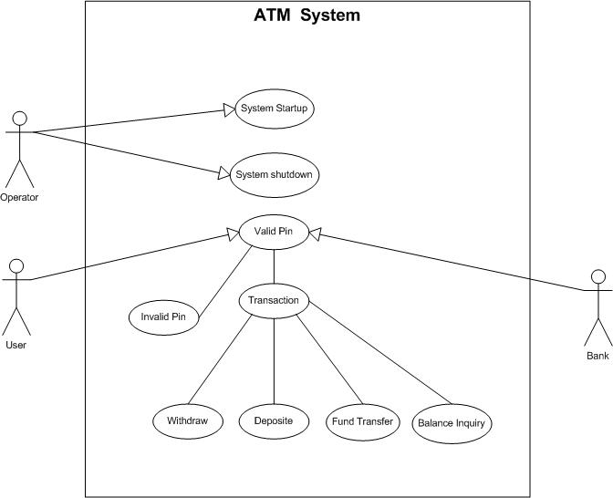

ACTIVITY DIAGRAM

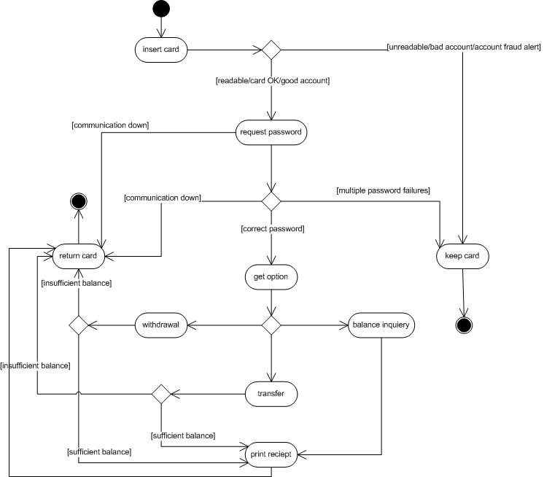

- Here ATM works as main class. All other classes are related with this class. ATM does following operations:
- Verify_pin()
- Check_balance()
- Cash_withdrawal()
- Ministatement()
- Print_receipt()
- Another_transaction()

- ATM card related with ATM through many to many relationship.
It does following operations:
- Insert_card_into_ATM()
- Insert_Pin_code()
- Remove_card_after_transaction()

- Account holder related with ATM through many to many relationship.
It performs following operations:
- Withdrawal()
- Transfer()
- Balance_inquiry()

- ATM server related with ATM by one or many to one or many relationship. It also performs some task shown as below:
- Updating_after_each_transaction()
- Changing_the_pin_code()
- Showing_exact_balance_after_each_transaction()

- Bank Manager associated with ATM through one or many to one relationship. ATM is not related with this class, but dependent on this class. So there is a dependent relationship assigned to them. Bank Manager does following tasks:
- Managing_different_accounts()
- Maintaining_sufficient_balance_in_ATM()
- Access_to_the_ATM_server()

- Here, a class Bank not related to any of the class, but some classes are dependent on these classes which are shown as dependent relationship with it. Normally this class performs following operations:
- Create_Account()
- Accessing_Account()
- Providing_ATM_card()

4.7.3 System Activity or Object interaction Diagram:

An Interaction diagram shows an interaction, consisting of a set of objects and their relationships, including the messages that may be dispatched among them. Interaction diagrams are used for modeling the dynamic aspects of the system.

.

INTERACTION DIAGRAM:-

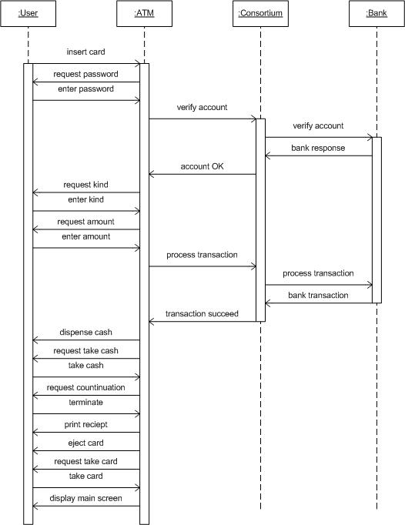

4.7.4 Data Dictionary:

A Data Dictionary is a Catalogue – a repository of element in a system. As the name suggest, these elements center around data and the way these are structured to meet the user requirement and system needs. In Data Dictionary we find list of all the elements are data flows, data stores, and process. The Data Dictionary stores details and description of these elements.
If anybody wants to know how many characters are in a data item, by what other names it is referenced in the system, or where it is used in the system, they should be able to find the answer in a property developed data dictionary.
The Data Dictionary is developed during data flow analysis and assists the system development in determining the user requirement.

- Importance of Data Dictionary:-

Analysis use data dictionary for five important reasons:
1. To manage the detail in large system.
2. To communicate a common meaning for all system elements.
3. To Document the feature of the system.
4. To Facilitates analysis of the details in order to evaluate characteristics and determine where system changes should be made.
5. To Locate error and omissions in the system.

The Following Tables are used within the system:
- ATM ::
It provides information about ATM’s Bank, Branch and Company.
 | ATM
Branch_Code | Integer | Code of particular Branch
ATM_Code | Integer | Code of particular ATM
Company | String | Name of Manufacturer of ATM

- ATM_Card ::
It provides information about ATM card, its holder and Bank.
 | ATM_Card
Card_No | Integer | No. of particular Card
PIN_Code | Integer | Secrete code of card
Customer_Name | String | Name of Card Holder
Bank_Name | String | Name of Bank

- Account_holder ::
It has all the details about ATM Card holder.
 | Account_holder
Name | String | Name of Account owner
Address | String | Address of Account owner
Account_No | Integer | Account no. of card holder
Phone_No | Integer | Phone no. of Account owner

- ATM_server ::
It has detail of ATM. As well as it provides interface between Bank and Account holder
- Bank ::
It provides detail of Bank to get information about Account of a user.

 | Bank
Bank_Name | String | Name of Bank
Location | String | Location of Bank
Bank_Code | Integer | Code of Bank to identify it

4.8.1 Context Diagram

The top-level diagram is often called a “context diagram”. It contains a single process, but it plays a very important role in studying the current system. The context diagram defines the system that will be studied in the sense that it determines the boundaries. Anything that is not inside the process identified in the context diagram will not be part of the system study.

4.8.2 Data Flow Diagram (0 and 1 level)

A graphical tool used to describe and analyze the moment of data tOBSough a system manual or automated including the process, stores of data, and delays in the system. Data Flow Diagrams are the central tool and the basis from which other components are developed. The transformation of data from input to output, tOBSough processes, may be described logically and independently of the physical components associated with the system. The DFD is also known as a data flow graph or a bubble chart.
A graphical tool used to describe and analyze the moment of data through a system manual or automated including the process, stores of data, and delays in the system. Data Flow Diagrams are the central tool and the basis from which other components are developed. The transformation of data from input to output, through processes, may be described logically and independently of the physical components associated with the system. The DFD is also known as a data flow graph or a bubble chart.

Data Flow Diagram(Level-0):-
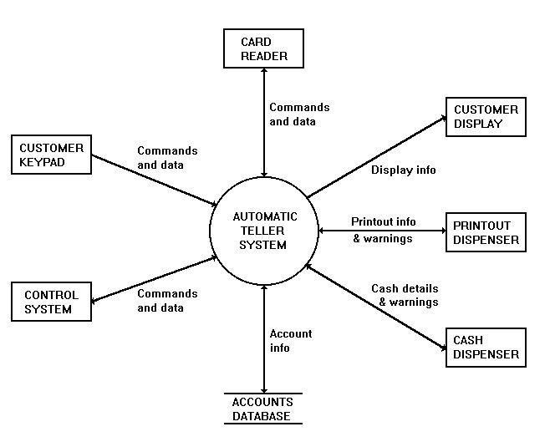

This diagram shows the Automatic Teller System Software and the hardware that it interacts with. The arrows show the direction and type of data flowing between the software and each hardware element.

External Entities:-
CONTROL SYSTEM
This system enables and disables the customer interface and receives customer requests and system reports. A suitable Control System would be a personal computer linked to a central computer system with access to the Accounts Database. The customer interface (keypad, display, etc) is controlled by enabling and disabling the Card Reader, which is the customer's entry-point to the system. Requests for statements and chequebooks are posted to the Control System. It also receives status reports for low printer-paper and cash levels.

ACCOUNTS DATABASE
This is a database containing account numbers, balances and other account information. Data is retrieved from the database when a customer requests a balance report or a cash withdrawal. The database is updated after a withdrawal.

CARD READER
The Card Reader receives the customer's card and retrieves the PIN and account number stored on it. This information is transmitted to the software system which enables the Customer Keypad and initiates the PIN verification procedure. When business is completed the Card Reader is instructed to return the card. If the customer enters an incorrect PIN, a fixed number of retries is permitted, after which the Card Reader is instructed to confiscate the card.

CUSTOMER KEYPAD
The Customer Keypad allows a customer to enter a PIN number, select options and enter cash values. The keypad is only enabled when a card is detected in the Card Reader.

CUSTOMER DISPLAY
The Customer Display presents messages, options and reports to the customer. The display is active at all times.

PRINTOUT DISPENSER
This provides the customer with a printed balance or receipt. The Printout Dispenser reports to the system if the paper level is low.

CASH DISPENSER
This assembles and delivers cash to the customer. The dispenser receives information about the values and quantities of notes to dispense (1 x $20, 2 x $5, etc). The Cash Dispenser reports to the system if the cash levels are low.

6.0 Limitation and Future Enhancement

Limitation:
- Although I have tried to add all the related features to this online Bus Reservation System but there are also some limitation.
- This system is stand alone system so data saved during different processes are stored in the machine in which that process was executed.
- So there is the problem of distributed database.

Future Enhancement:
- As discussed the limitation of this system, we can implement this as client/server system. So all the data will be stored in the single machine, and for any purpose all the data will be retrieved from this central database.

- So there will be no human work require for the employee. There will be only one person required who will maintain this central database.

Conclusion

Back in 1969, Chemical Bank announced that a new form of banking was being launched. With that, customers were provided with plastic cards designed with a magnetic strip that could be used with a machine built into a wall. Gone were the days of having to stand in line for a teller or not having money on hand after normal banking hours. Almost everyone has heard of and used an ATM machine. Interestingly, some of people feel that ATM machines are the best thing to happen in the banking world while other people consider them a curse. The main complaint heard about ATM machines is that while they are convenient, they are expensive to
use. However, if we look at it from a banking perspective, business is business. Regardless of what we think of ATM machines, there is no doubt that they have changed the world and the way in which we do things. For example, think how many times we have been out somewhere only to discover we have no cash and we are out of checks, ah, but in the corner, there is an ATM machine. In the blink of an eye, we swipe the card and now have cash on hand. In addition to pulling money out, the ATM machine also makes it convenient to deposit money, transfer money, and check balances. Best of all, to use an ATM machine, we do not have to go to the bank. We will find ATM machines at other banks, grocery stores, shopping malls, along the
roadside, Buckingham Palace, airports, in casinos, and even on the South Rim of the Grand Canyon. For this reason, ATM machines are extremely helpful!

Bibliography

Book Reference

➔ Fundamentals of Software Engineering
By Rajib Mall
➔Software Engineering
By Ian Somerville
➔ Analysis and Design of Information Systems
By James Senn

Website Reference

- www.google.com
- www.microsoft.com

