Accesco Replenishment: Phase 1 Schema Design
This document details the operational database schema (Azure PostgreSQL) required to execute Phase 1 of the Hybrid Replenishment Architecture. This schema bridges Argha's Day-1 mathematical formulas (Pull Theory & HCE) and prepares the data collection pipelines for Month-2 Machine Learning (Databricks).

1. Schema Entity-Relationship Diagram (ERD)
The following diagram maps how the Warehouse Management System (WMS), Order Management System (OMS), and CDAO configuration tables relate to one another to power the calculations.
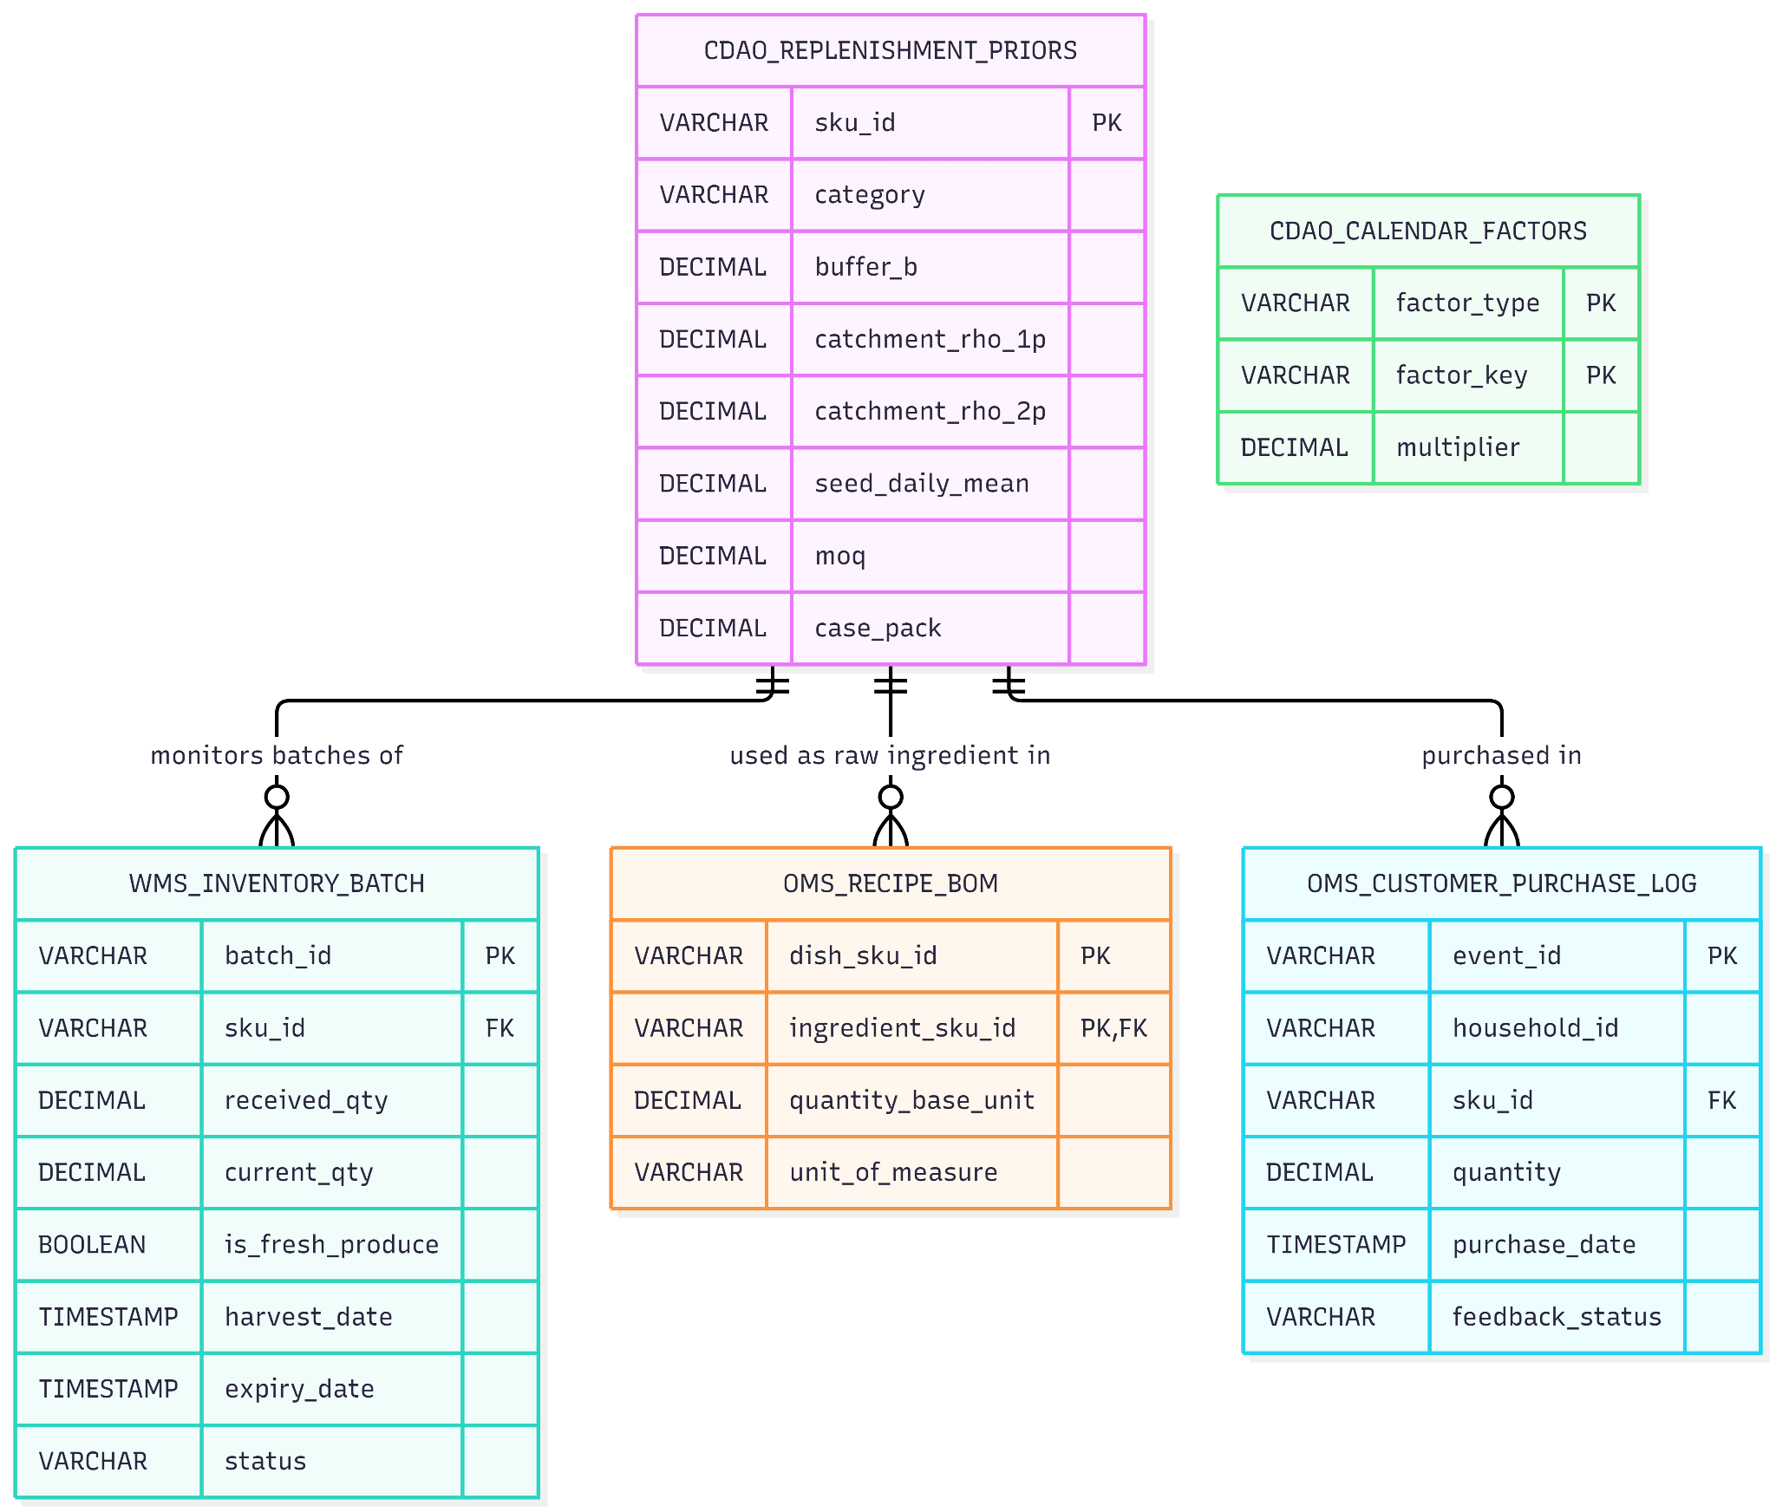

2. Table Definitions & Data Types
Note: DECIMAL(10,3) is used for all quantities to ensure precision up to grams/milliliters and avoid floating-point math errors inherent to standard FLOAT types.

Table A: wms_inventory_batch
Owner: WMS (Warehouse Management System)
Purpose: Powers the No-Expiry Engine and Fresh Routing. Tracks exactly how old a batch is so it can be routed to the Swadishtt kitchen before it rots.
Column Name | Data Type | Constraints | Description | Example
batch_id | VARCHAR(50) | PRIMARY KEY | Unique barcode/batch identifier. | B-TOM-10492
sku_id | VARCHAR(50) | FOREIGN KEY | Links to the master product catalogue. | SKU-TOMATO-HYBRID
received_qty | DECIMAL(10,3) | NOT NULL | Total volume received originally. | 50.000
current_qty | DECIMAL(10,3) | NOT NULL | Current sound volume on the shelf. | 20.000
is_fresh_produce | BOOLEAN | NOT NULL | Flags if item uses harvest hours vs mfg days. | TRUE
manufacture_date | TIMESTAMP | NULL | When packaged goods were made. | NULL
harvest_date | TIMESTAMP | NULL | When fresh produce was picked. | 2026-11-06T06:00:00Z
expiry_date | TIMESTAMP | NOT NULL | Hard expiry / use-by date. | 2026-11-09T23:59:59Z
status | VARCHAR(20) | DEFAULT 'SELLABLE' | SELLABLE, KITCHEN_ROUTED, COMPOST | SELLABLE

Table B: oms_recipe_bom (Bill of Materials)
Owner: OMS (Order Management System)
Purpose: Explodes cooked meal orders (e.g., Palak Paneer) into raw ingredient consumption (Spinach, Paneer) so the Pull Theory engine orders enough raw stock to cover the kitchen.
Column Name | Data Type | Constraints | Description | Example
dish_sku_id | VARCHAR(50) | PK, FK | The cooked meal sold to the customer. | MEAL-PALAK-PANEER-1
ingredient_sku_id | VARCHAR(50) | PK, FK | The raw ingredient required. | SKU-SPINACH-BUNCH
quantity_base_unit | DECIMAL(10,3) | NOT NULL | Amount of ingredient required per dish. | 0.150
unit_of_measure | VARCHAR(10) | NOT NULL | Base metric unit. | kg

Table C: cdao_replenishment_priors
Owner: CDAO (Chief Data & Analytics Office)
Purpose: Houses Argha's Day-1 parameters. Bypasses the ML cold-start problem by providing explicit neighborhood averages and buffer margins.
Column Name | Data Type | Constraints | Description | Example
sku_id | VARCHAR(50) | PRIMARY KEY | The product identifier. | SKU-ATTA-5KG
category | VARCHAR(50) | NOT NULL | Groups by perishability (e.g., leafy_greens). | fmcg
buffer_b | DECIMAL(4,3) | NOT NULL | Overstock buffer (e.g., 0.15 for 15%). | 0.250
catchment_rho_1p | DECIMAL(10,3) | NOT NULL | Daily consumption rate for 1-person home. | 0.250
catchment_rho_2p | DECIMAL(10,3) | NOT NULL | Daily consumption rate for 2+ person home. | 0.450
seed_daily_mean | DECIMAL(10,3) | NOT NULL | Expected daily baseline sales for Week 1-3. | 45.000
moq | DECIMAL(10,3) | DEFAULT 1.0 | Minimum Order Quantity from supplier. | 10.000
case_pack | DECIMAL(10,3) | DEFAULT 1.0 | Must be ordered in multiples of this unit. | 5.000

Table D: oms_customer_purchase_log
Owner: OMS / CDAO
Purpose: The lifeblood of the Household Consumption Engine (HCE) and the future Databricks ML models. Records when a household acquires a product and tracks feedback (from the Nudge Matrix).
Column Name | Data Type | Constraints | Description | Example
event_id | VARCHAR(50) | PRIMARY KEY | Unique log ID. | EVT-9928103
household_id | VARCHAR(50) | NOT NULL | Linked household ID for the customer. | HH-RAJ-001
sku_id | VARCHAR(50) | FOREIGN KEY | Product purchased or recorded. | SKU-ATTA-5KG
quantity | DECIMAL(10,3) | NOT NULL | Quantity in base units. | 5.000
purchase_date | TIMESTAMP | NOT NULL | Exact time of acquisition/delivery. | 2026-11-01T14:30:00Z
feedback_status | VARCHAR(30) | DEFAULT 'NORMAL' | Adjusts HCE decay (e.g. BOUGHT_ELSEWHERE). | NORMAL

Table E: cdao_calendar_factors
Owner: CDAO
Purpose: Stores multipliers for Day-of-Week $c(w)$ and Month-Cycle/Payday $M(t)$ effects.
Column Name | Data Type | Constraints | Description | Example
factor_type | VARCHAR(20) | PK | WEEKDAY or MONTH_CYCLE or FESTIVAL. | WEEKDAY
factor_key | VARCHAR(20) | PK | The specific day (e.g., Sat, Days_1_7). | Sat
multiplier | DECIMAL(4,3) | NOT NULL | Scalar to apply against baseline demand. | 1.100

3. Usage Notes for the Engineering Team
- Timezones: All TIMESTAMP values should be stored in UTC (TIMESTAMP WITH TIME ZONE) to prevent discrepancies between the server and the physical dark store in Karnataka.
- Database Engine: These tables are designed for the Azure Database for PostgreSQL Flexible Server.
- Integration: In Phase 2, the Python/FastAPI service will query these tables using an ORM (like SQLAlchemy or SQLModel) to execute the nightly 9:30 PM Pull Replenishment and HCE calculations.

