SOCIAL MEDIA SIMULATION

REGIONAL LEVEL
SCIENCE EXHIBITION
2023-24

K.V.S. PATNA REGION

CONTENTS

- Introduction
- Model
- Recommendation Algorithm
- Social Influence Functions
- Interest Function
- Usage
- Conclusions
- Acknowledgements

INTRODUCTION
This project is about developing a framework for social simulation in the online space, like social media apps. It aims to provide a framework for simulation which can be used for further investigation of various hypotheses and try to model the dynamics that may take place in a real scenario as best as possible.
We achieve this using an agent based approach, various models of social influence and different recommendation algorithms.
The model uses what’s called an agent based model in which multiple virtual agents which are programmed to mimic human behaviour. These agents interact with each other and advance the state of the simulation.
In this particular model the agents are programmed to randomly create a post and update their opinion values based on the posts they are recommended by the recommendation system.

MODEL
First the model is initialized with some initial parameters. These are:
- Number of agents -
The number of agents the model starts with. The number does not change with time.
- Influence factor -
How much the agents are influenced by posts. Lower values mean low influence and higher values mean high influence. It is used in the social influence functions implemented like bounded confidence or relative agreement.
- Posting probability -
How often an agent create a post. Max is 1 which means a new post will be created by the agent every step.
- Network graph -
A graph of the social network. In terms of social media this essentially means who is following who. It can be custom or a random one is generated.
- Recommendation algorithm -
The algorithm used to recommend posts. Currently only heuristic based algorithms are implemented which include a proximity based, popularity based, similarity based or a hybrid algorithm.

Each agent is initialized with the following parameters:
- Opinion -
This is a continous one dimensional opinion value between \-1 and 1. It is kept deliberately simple to make the analysis easier but can be easily extended to multi\-dimensional opinion.
- Confidence bound -
It is a parameter used in the social influence functions and represents either a limit on the similarity between persons for influence to take place or a measure of how much a person’s opinion will change by influence of others.

The model runs in discrete time steps. In each time step the following actions happen:
- Every agent is stepped in a random order.
- Each agent is recommended a number of posts using the recommendation algorithm.
- The agent selects a random post to interact with.
- It updates it’s opinion and confidence based on the post and influence function.
- It creates a post of similar opinion to itself based on the posting probability.
RECOMMENDATION ALGORITHMS
There are many heuristic based reommendatio algorithms provided in the model:
- Similarity -
This algorithm recommends posts based on how similar the opinion of the person and the post are.
- Random -
This algorithm recommends random posts.
- Proximity -
It recommends posts based on how close on the network two people are.
- Popularity -
It recommends posts based on how many followers the creator of the post has.
- Hybrid -
This algorithm combines all the previous heuristics and recommends posts based on a weighted sum of the heuristics.

SOCIAL INFLUENCE FUNCTIONS
Social influence functions are the backbone of the simulation. They define how agents change thier opinion in response to a post. Two main influence functions are used in the simulation:
- Bounded confidence -
This was first introduced by ... It is the default function used in the model. It says that a person shows assimilation behaviour until the difference in opinion is greater than a maximum value which is the confidence bound. A modification of this model called the gaussian bounded confidence is also provied but the behaviour is almost identical.
- Relative agreement -
This model is more complex and was first introduced by... It is quite a bit more complicated than the bounded confidence model and so it is only used sparingly for some demostrations.

INTEREST FUNCTION

This is a function which determines how interested a person is in a post. It is the least theoretically sound part of the model. This was based purely off of instinct as I could not find any research about modelling the interest function. This could be because the goal of most recommendation algorithms is to approximate the interest function which means this is the unknown in most cases. Also because interest of a human is a highly non-linear and stochastic function. So modelling it as a function of opinion difference is probably not very accurate.
These are the points it tries to account for in the interest calculation:
- Posts close to agent’s opinion are more interesting.
- Posts which are very far from agent’s opinion are also interesting.
- The interest falls if same posts are recommended multiple times in a row.
As you can see these are based on rules of thumb. No testing has been done to ensure that these heuristics are accurate due to lack of time and resources.

INTERFACE
The model has a graphical interface which can be used to control many initial parameters and run the model. The interface also provides charts of various model stastistics like average opinion of the agents and the opinion distribution at the current step.
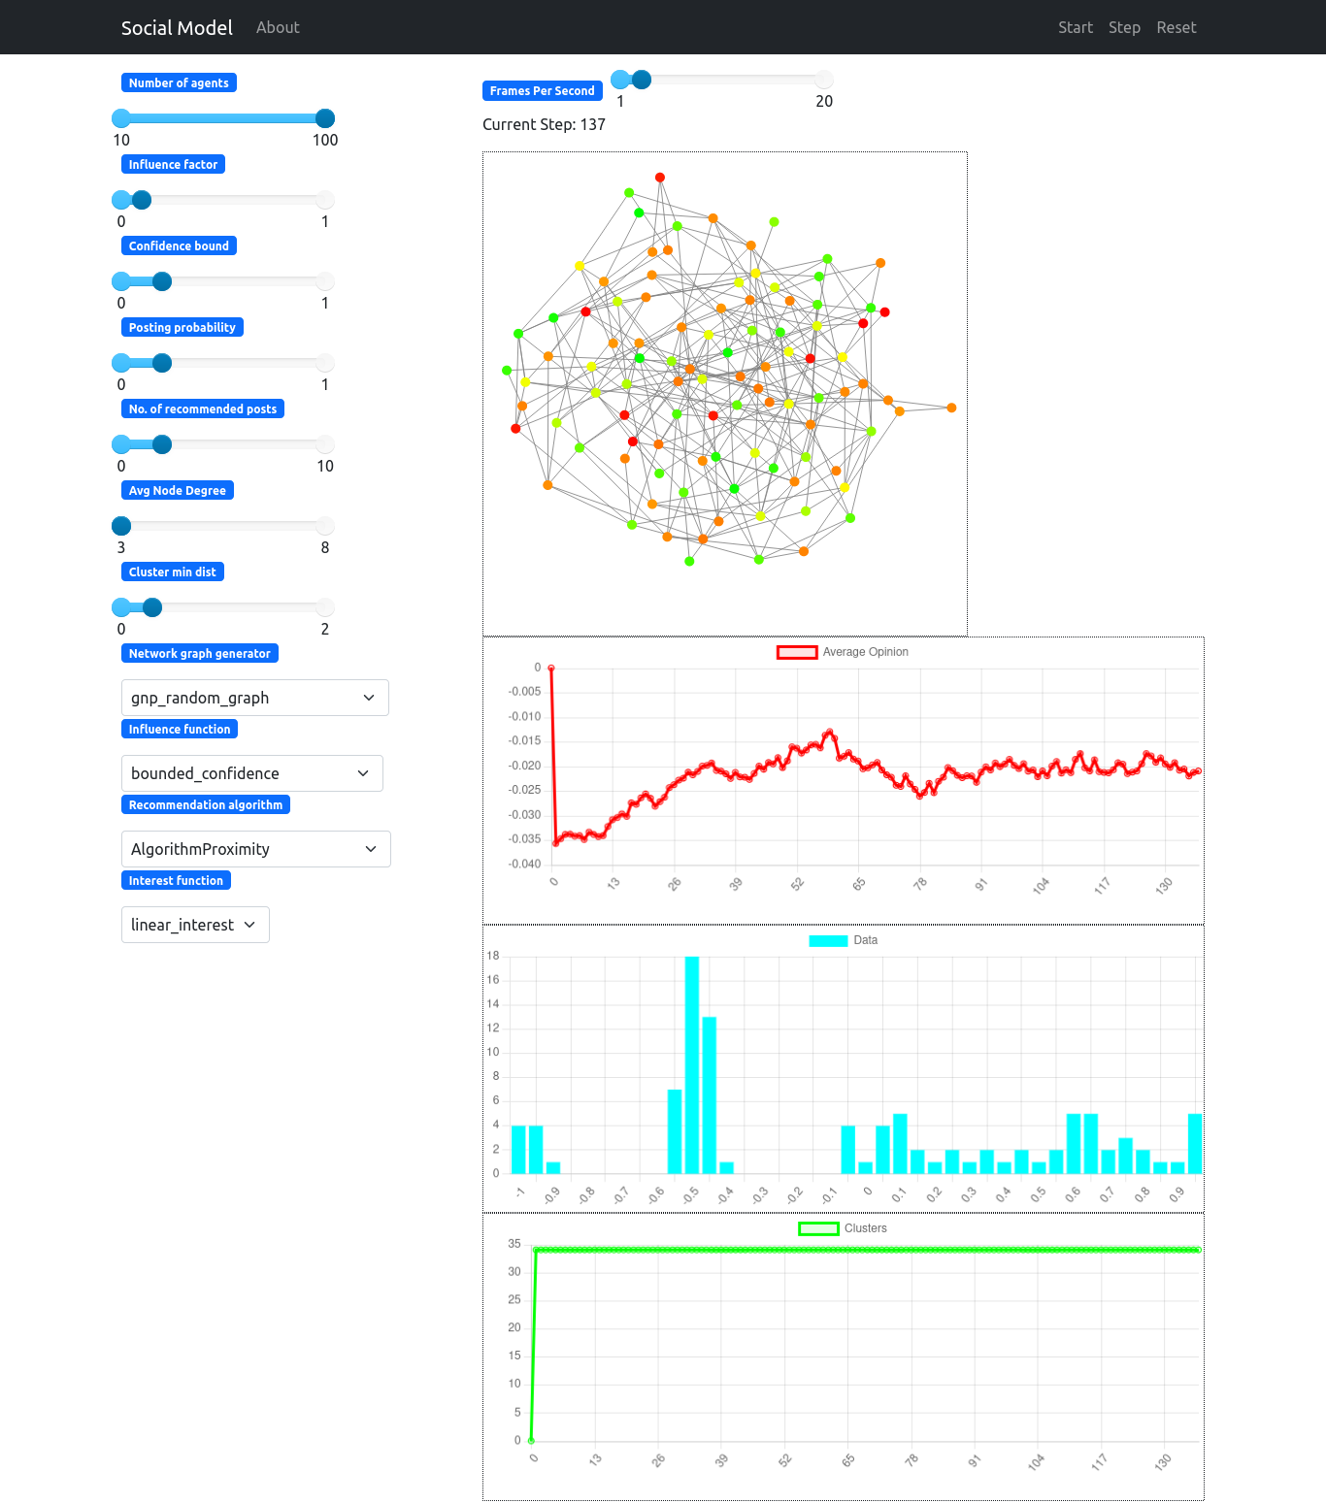
USAGE

The model can be used to study the effects of different parameters in a simulated environment as testing in a live environment is generally not feasible. As an example of such use of the model I have provided two case studies of different hypotheses which were tested on the model.
Some of the ways in which the simulation framework can be used are described below:
- By social scientists -
This program can be used by social scientists to study the effects of various changes to the opinions of people in social media platforms. It is a virtual environment which provides the essential features of a real social media environment. For example if a scoial scientist wants to study the effect that a celebrity’s post may have on opinion about a topic then that situation can be simulated.
- By market analysts -
Market analysts can use the simulation to design effective product campaigns without actually having to test the programs in a real environment. This will help them test our more ideas in a short amount of time.
- By recommendation algorithm developers -
If a developer for a social media platform has developed a new recommendation algorithm and wants to test the performance in a dynamic environment then this simulation also allows rapid prototyping and testing.

SHORTCOMINGS

There are obviously disadvantages of such a simulation for understanding complex social systems. The main disadvantages of the approach are as follows:
- Simplistic view -
The model can never capture all the complexities of human interactions. It has to make reasonable assumptions to simplify the model for making it practical for computation. This means that if an assumption turns out to be too simplistic then the results of our model will not be applicable to the real world. An example of this is the opinion system. It is currently a one-dimensional value which is not realistic as people have opinions on a variety of topics.
- Interpretation of results -
The results of the model can be interpreted differently depending on what the incentive of the researcher is. For example if a researcher wants to portray a negative image of recommendation algorithms then the parameters can be tuned to show that the presence of recommnedation algorithms leads to opinion polarisation when in reality it only happens for some initial parameters.

There are some other problems which are not inherently problems of the agent based approach but rather are shortcomings of this particular model:
- Validation -
The model has not been validated on real world data and that is one of the most prominent fallacies of it. A result cannot be considered correct until there is real world data to support it.
- Performance -
The model does not perform well for over 100 agents which can be a hurdle to simulating scenarios which require the interactions of thousands of agents.

WHAT’S NEXT

Future plans for this project, in no particular order, include:
- Add a machine learning based recommendation algorithm.
- Add a collaborative filtering based recommendation algorithm.
- Make the network dynamic (agents can follow and unfollow each other).
- Validate the model.
- Increase performance.
- Do more case studies.
- Add multi-dimensional opinion.
- Add better visualization.
- Add more customizability.

ACKNOWLEDEGMENTS

