##### INFORMATICS & COMPUTATIONAL SCIENCES PROGRAMME UNIVERSITY COLLEGE OF SCIENCE

**MOHANLAL SUKHADIA UNIVERSITY**

##### (NAAC Accredited 'A' Grade University)

**Masters in Computer Application (A Choice Based Credit System)**

##### VI SEMESTER

**(Batch 2021)**



##### A Project Report on

**Meditation**

Submitted to: Submitted by:

**Prof. M.K Jain** Namrata Karda

Priyanka Madhwani

##### CERTIFICATE

This is to certify that **Namrata Karda and Priyanka Madhwani***.*has successfully Completed the project titled “**Meditation**” as a partial fulfilment for the award of the degree in **Masters of Computer Applications, Mohanlal Sukhadia University (Rajasthan)**

##### DECLARATION

I hereby declare that the work, which is being presented in this project entitled “**Meditation** ” in partial fulfilment of the requirement for the award of the degree Master of Computer application, MLSU is an authentic and original record of my own work carried out by me for a period of MCA VI Semester (2021) .

Also this project has not formed the basis for the award of any other degree, associate ship, fellowship or any other similar titles.

Place: **Udaipur Namrata Karda.**

Date: **24th October 2020 Priyanka Madhwani**

## ACKNOWLEDGEMENT

The satisfaction that accompanies the successful completion of any task would be incomplete without the mention of people whose ceaseless cooperation made it possible, whose constant guidance and encouragement crown all efforts with success.

I would like to express my sincere thanks to Prof. M.K Jain and Mrs. Deepti Shrimali , MLSU for giving me this opportunity to undertake this project.

I am grateful to my project guide Prof. M.K Jain for the guidance, inspiration and constructive suggestions that help me in the preparation of this project.

I also thank my Parents and guardians who have cooperates me for successful completion of the project.

I also thank my colleagues who have helped in successful completion of the project.

Sincerely, Namrata Karda.

Priyanka Madhwani

**PREFACE**

The well planned, properly executed and evaluated Project helps a lot in inoculating good work culture. It provides linkage between the student and the Programming in order to develop the awareness and knowledge of Language to problem solving.

Project Entitled “Meditation” Meditation is an area which allows a person to talk to the conscience, where freedom is considered to be a state of mind.

This project has been developed using Visual Studio 2010, Notepad at of

UNIVERSITY COLLEGE OF SCIENCE MOHANLAL SUKHADIA UNIVERSITY, Udaipur.

This is user friendly, easy to use, understandable and satisfies all requirements.

The introduction is followed by a detailed description of the project and covers various aspects of the project such as system analysis, system design and system implementation. This project report has been designed in accordance with the various stages in software development life cycle and in precisely the same order.

I hope that readers will enjoy reading this report.

## TABLEOF CONTENTS

1. Synopsis 1
   1. Project Title 2
   2. Project Duration 2
   3. Project Team 2
   4. Project Identification 2
   5. Aim of Project 2
   6. Technical Specification 3
   7. Project Features 3
   8. Module Introduction 3
   9. Expected Result 3
   10. Future Scope 3
   11. Users of System 4
2. SoftwareRequirementSpecification 5
   1. Introduction 6
      1. Purpose 6
      2. Scope 6
      3. Definitions, Acronyms and Abbreviations 6
      4. References 6
      5. Overview 6
   2. General Description 7
      1. Product Perspective 7
      2. Product Functions 7
      3. User Characteristics 7
      4. General Constraints 7
      5. Assumptions and Dependencies 8
   3. Specific Requirements 8
      1. External Interface Requirements 8
         1. User Interfaces 8
         2. Hardware Interfaces 8
         3. Software Interfaces 8
         4. Communications Interfaces 9
      2. Functional Requirements 9
         1. Introduction 9
         2. Inputs 9
         3. Processing 9
         4. Outputs 9
         5. Error Handling 9
      3. Use Case 10
         1. Actors 11
         2. Use Cases 11
      4. Activity Diagram 11
         1. Login Activity Diagram 12
         2. Administrator Activity Diagram 13
         3. Faculty Activity Diagram 14
         4. Student Activity Diagram 14
         5. Anonymous User Activity Diagram 15
      5. Sequence Diagrams 15
         1. Login Sequence Diagram 16
         2. Administrator Sequence Diagram 16
         3. Faculty Sequence Diagram 17
         4. Student Sequence Diagram 17
         5. Anonymous User Sequence Diagram 18
      6. Non-Functional Requirements 18
         1. Performance 18
         2. Reliability 18
         3. Availability 19
         4. Security 19
         5. Maintainability 19
         6. Platform Independent 19
      7. Design Constraints 19
      8. Logical Database Requirements 19
3. Database Diagram 20
4. Class Diagram 22
5. Snapshots with Coding 24

Conclusion and Recommendations 32

References 33

### Project Title

**Meditation**

# 1

## Synopsis

### Project Duration

6 Months

* 1. **Project Team** Namrata Karda.

Priyanka Madhwani

### Project Identification

The user will register and log in and We welcome you to our Mindful guide to meditation, which includes a variety of styles of meditation, information about the benefits of each practice, and free guided audio practices that help you learn how to meditate and incorporate meditation into your daily life. Keep reading to learn more about the basics of this transformative practice that enables us to find more joy in daily living.

**Drawbacks of Existing System**

* + 1. Internet connection needed.
    2. User must have the knowledge to operate the computer.
    3. Possible.

### Aim of Project

#### User

1. **Admin**

**User:-** The user will register and log in and We welcome you to our Mindful guide to meditation, which includes a variety of styles of meditation, information about the benefits of each practice, and free guided audio practices that help you learn how to meditate and incorporate meditation into your daily life. Keep reading to learn more about the basics of this transformative practice that enables us to find more joy in daily living.

**Admin:-** This module provides administrator related functionality like from this module use can add guide to meditation information, Trainer information, Event information, Online and Offline Event information etc. From this module Admin can view daily, weekly and monthly report. This module is develop for admin of the website and admin can add, delete, edit and view the data related to places, travels, routes, bookings from this module.

.

### Technical Specification

* + 1. Designing Language: HTML, CSS and JavaScript.
    2. Designing Framework: .NET(Visual Studio).
    3. Database Language: My Access.
    4. Developing Language: ASP.NET.
    5. Developing Tool: Visual Studio IDE.
    6. Local Web Server: PWS (Personal Web Server).

### Project Features

The proposed system is used increase access to high-quality education for everyone, everywhere. This ensures the following features:

* + 1. Web Based Application.
    2. User friendly UI.
    3. No need to pay for notes.
    4. Less time consumption. **1.8 Module Introduction** There are two modules in project:

1. Admin Module.
2. User Module.

### Expected Result

1. First Step is a project that mainly manages Online Meditation System. The concept of this project is to make it easy to get information about families who are in need. It would provide a link to the nearest family based on the criteria the user chooses. The idea is to either enter data about a family or to get information. The application will be a mobile application due to the current atmosphere where it is common to use specified apps for most activities.

### Users of System

There are two types of users

* + 1. Users who want to provide information about families

1. They will be able to create a profile with the necessary Information (contact, location, etc.)
2. Add/check reviews
   * 1. Users who want to donate
3. They will be able to access profiles based on the criteria they Specify
4. Add/check reviews

**Client Analysis**:

Usually people Mediation they actually know that they are in need or go directly to an association. we’re learning how to pay attention to the breath as it goes in and out, and notice when the mind wanders from this task.

# 2

## Software Requirement Specification

### Introduction

The Meditation is a web based application. The main purpose of “Meditation ” of this website is to make it the best possible resource to help you achieve Greatness!  The other way I often put it, is that it’s purpose is to help you live your life at your Highest Potential.  Over the past two and half years, free techniques, tips, classes and articles have been added to the blog and I have tried hard to organize the website so you can easily navigate all this content and find that which you need most to help you be your best.

### Purpose

The Main objective of this project is to make  I can confidently say that this blog is now fast becoming one of the largest and most visited meditation and yoga website on the internet.  This would only be possible if it was providing you with great value and service, so I am happy you are all enjoying and benefiting from the website.

### Scope

Doing my research, I could not find a similar application already existing. The applications that

My application focuses mainly on helping citizens accessing information and also identifying.

### Definitions, Acronyms and Abbreviations

|  |  |
| --- | --- |
| Users | He/she  will register and log in and the find the specific yoga and meditation techniques. |
| Anonymous User | They will be able to access profiles based on the criteria they Specify  Book/check Meditation Events. |
| Administrator | He/she can add, delete, edit and view the data related to Meditation, Event, Trainer from this module. |

* + 1. **Market Analysis:**

Doing my research, I could not find a similar application already existing. The applications that are available belong to certain organizations and their goal is to Online Meditation.

My application focuses mainly on helping citizens accessing information and also identifying cases that need help through profiles and reviews.

### Economic feasibility:

This first part of the project does not generate any financial costs because the tools that will be used to develop this application are all open-source tools. The only cost will be time and human efforts. However, the second part requires many costs. For submitting the app to a certain app store, the submission fees is required. Also, maintenance of the app, managing the raising amount of users and storing data will generate costs.

### Technical feasibility:

This project is feasible in the technical sense. All tools necessary are available and only requires a fair amount of time to acquire a good knowledge about how to use them.

### Conclusion:

Conclusion Mindfulness meditation is a significant practice that can provide natural remedies to a variety of issues related to human health as a cognitive strategy that helps in recognition of feelings and thoughts as passive events created in a human mind it cultivates consistent present moment awareness that is not reactive, allowing for a more powerful and useful utilisation of brain activity.

### Assumptions and Dependencies

It is to be assumed that all clients are internet user and have enough computer skills. At the provider side, it is assumed that the system will be running on a properly working web server and database system with an Internet connection that allows this system to perform all communications with clients.

### Specific Requirements

Specific Requirements for this Application are as follows:

### External Interface Requirements

External Interface Requirements for this Application are as follows:

### User Interfaces

The application is the user interface, where multiple users can view Meditation project.

### Hardware Interfaces

Hardware requirements for Insurance on internet will be same for both the parties which are follows:

Processor: - Pentium I or above. RAM: - 128 MB or above.

HD: - 20 GB or above.

NIC: - For both users and admin.

Since the application must run over the internet, all the hardware shall require to connect internet will be hardware interface for the system. As for e.g. Modem, WAN

– LAN, Ethernet Cross-Cable.

### Software Interfaces

**Server Side:** An IIS server will accept all requests from the client and forward it accordingly. A database will be hosted centrally using MS-SQL.

**Client Side:** An Operating System which is capable of running a modern web browser which supports JavaScript and HTML 5.

### 2.3.1.4 Communications Interfaces

The HTTP and HTTPS protocol(s) will be used to facilitate communication between the client and server.

### Functional Requirements

Functional requirement of the application are:

### Introduction

User has to open web browser and put the web address to view Handy notes.

### Inputs

First Step is a project that mainly manages Yoga and Meditation Events. The concept of this project is to make it easy to get information about families who are in need. It would provide a link to the nearest family based on the criteria the user chooses.

### Processing

The idea is to either enter data about a family or to get information. The application will be a mobile application due to the current atmosphere where it is common to use specified apps for most activities

### Outputs

Meditation aids productivity because it promotes qualities that help you be more productive. These qualities include sustained attention and emotional agility. Mindfulness meditation is like going to the gym to build your focus muscle, while visualization and other types of guided meditations found.

## User & System Requirements:

### Functional Requirements: User account management:

1. User registration:

The application shall allow users to register and create a profile

1. User authentication

When registering, the application shall allow users to authenticate using their user name and password.

1. User Log in

Users shall be able deactivate their account Users shall be able log out

## Profile Management:

The profiles of users shall contain the following:

* First name
* Last name
* Phone number
* Location
* Whether they are a User or an LUP

2. User profile modification:

* Users shall be able to edit/delete data on their profiles.

## Event Management:

LUP profile creation:

* The application shall enable users registered under a LUP profile to add the following information about themselves or about the ones concerned:
* The state of the family.
* General information about the help needed.
* Location.

10

* Phone number.
* The system shall enable donators to evaluate the profiles using reviews and comments

LUP profiles modification:

* Users under this category shall be able to change information about their profiles. LUP profiles deletion:
* LUP profiles’ owners shall be able to deactivate their accounts. LUP profiles display:
* Users of the application shall be able to search LUP profiles based on their category and sub-category and it will be sorted based on their location.

## Booking Management:

Booking request creation:

* Users shall be able to browse LUP profiles using:
* Meditation category
* Location.
* Notifications shall be sent to appropriate LUP users when there is a possible donor
* Notifications shall be sent to LUP chosen by the users.
* Search results for LUP shall enable location filters and reviews/comments filters.

## Use Case Diagram

Admin

User

### Actors

* + - * 1. Administrator
        2. User

### Use Cases

#### User registration:

I) The application shall allow users to register and create a profile

#### User authentication

I) When registering, the application shall allow users to authenticate using their user name and password.

#### User Log in

1. Users shall be able deactivate their account
2. Users shall be able log out

.

### Activity Diagram

Activity diagrams are graphical representations of workflows of stepwise activities and actions with support for choice, iteration and concurrency. In the Unified Modelling Language, activity diagrams are intended to model both computational and organizational processes. Activity diagrams show the overall flow of control of this application.

### Login Activity Diagram

Get

login detail

Invalid

Login

**False**

Check username

password

**True**

Successfully

logged in

A

**1) Admin Login Activity Diagram**

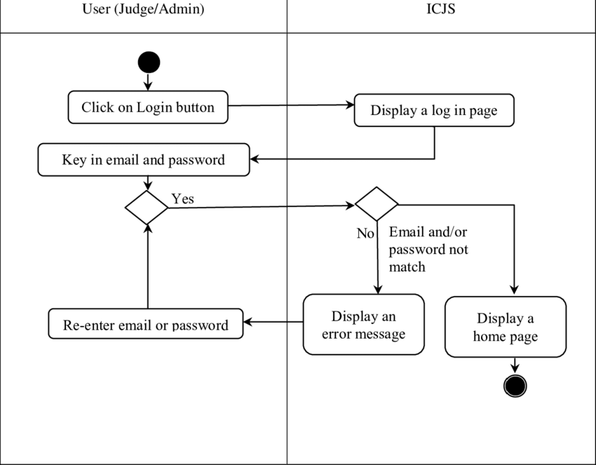

## Sequence Diagrams

A sequence diagram in Unified Modelling Language (UML) is a kind of interaction diagram that shows how processes operate with one another and in what order. It is a construct of a Message Sequence Chart. Sequence diagrams are sometimes called event diagrams, event scenarios and timing diagrams.

### Login Sequence Diagram



1: Enter Login and

Password

1.1: Validate Login

Information

2: Redirect to

Homepage

1.2: Invalid

Information

3: User logout

**Logout**

**Homepage**

**Login validator**

**Login**

**User**

Figure 2.3.5.1: Login Sequence Diagram

## Non-Functional Requirements

Non-Functional Requirements of this application are as follows:

### Performance

The system can handle high number of users without any fault.

### Reliability

The reliability of the overall program depends on the reliability of the separate components.

### Availability

The system should be available at all times, meaning the User can access it any time anywhere on web.

### Security

The system should be highly secure since only authenticated users can have access to the server. It should respect the 3 aspects:

Confidentiality:

The user shall ensure who gets to see their information Integrity:

Editing data shall be authorized only to owners of the accounts Availability:

The application shall be available at all times.

### Maintainability

The system should be easily maintainable to allow for additional upgrades that can be implemented in the future.

### Platform

Development language is ASP.NET (Web Application). This application is accessed by the browser of any platform.

### Design Constraints

The web application has the following design constraints:

* Able to support almost all operating system with internet configured.
* The communication between the application and the database will be in Access.
* The product will be written in ASP.NET using C#.

# 3

## SNAPSHOT

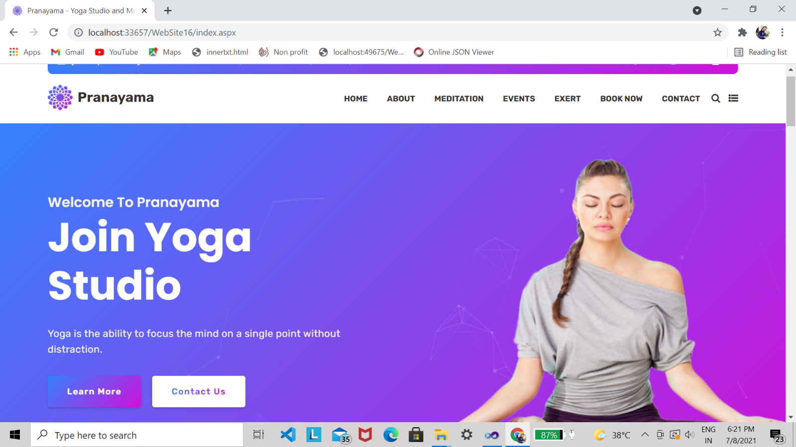

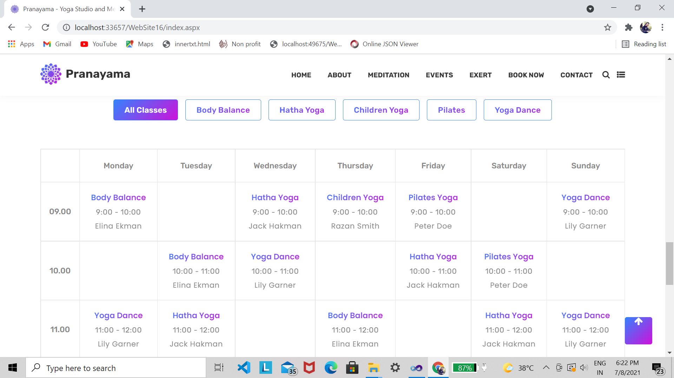

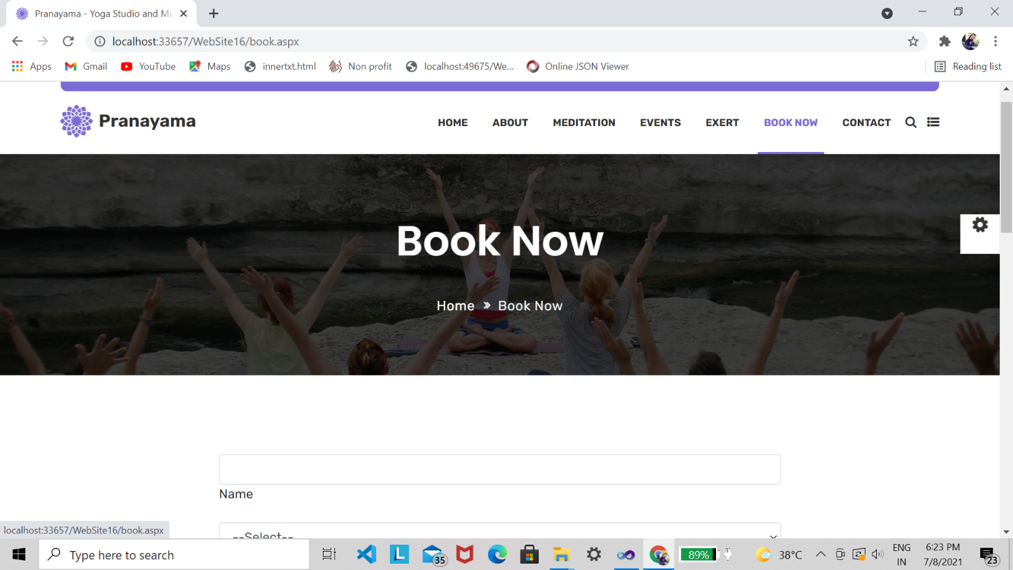

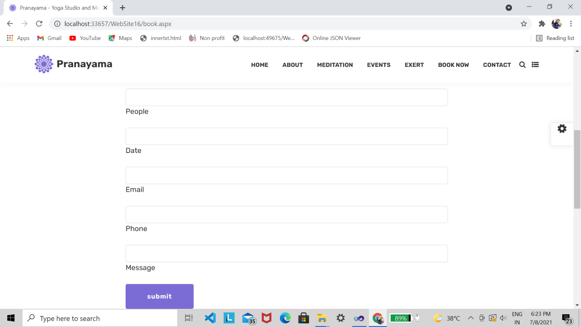

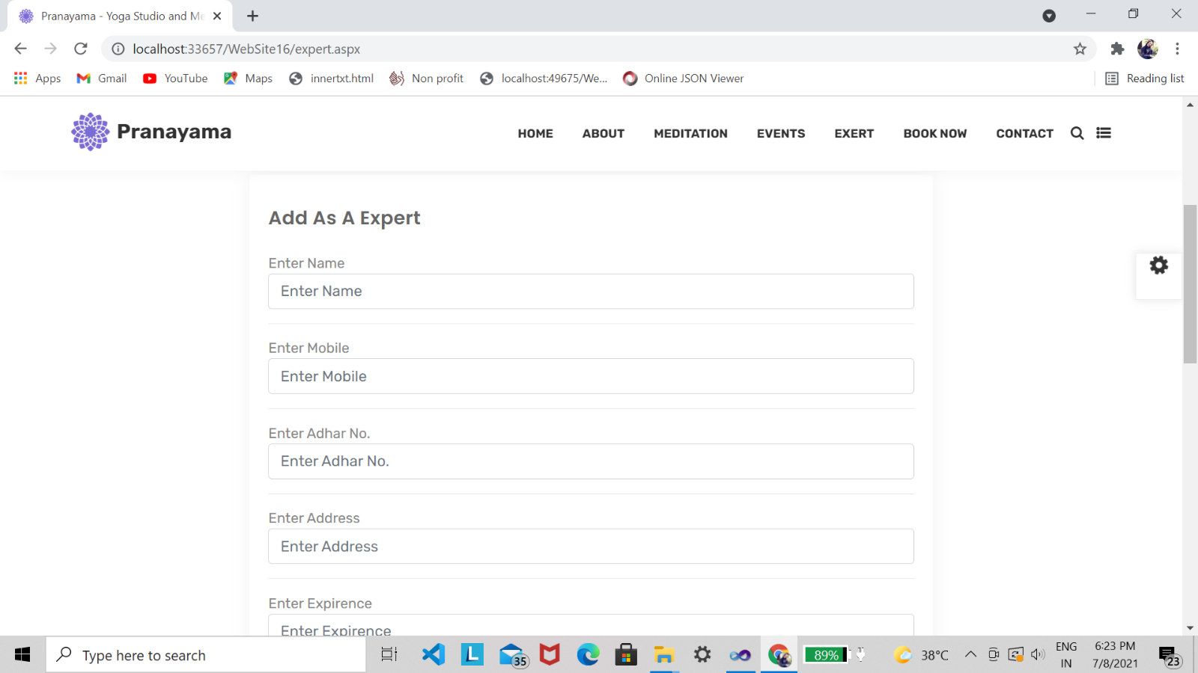

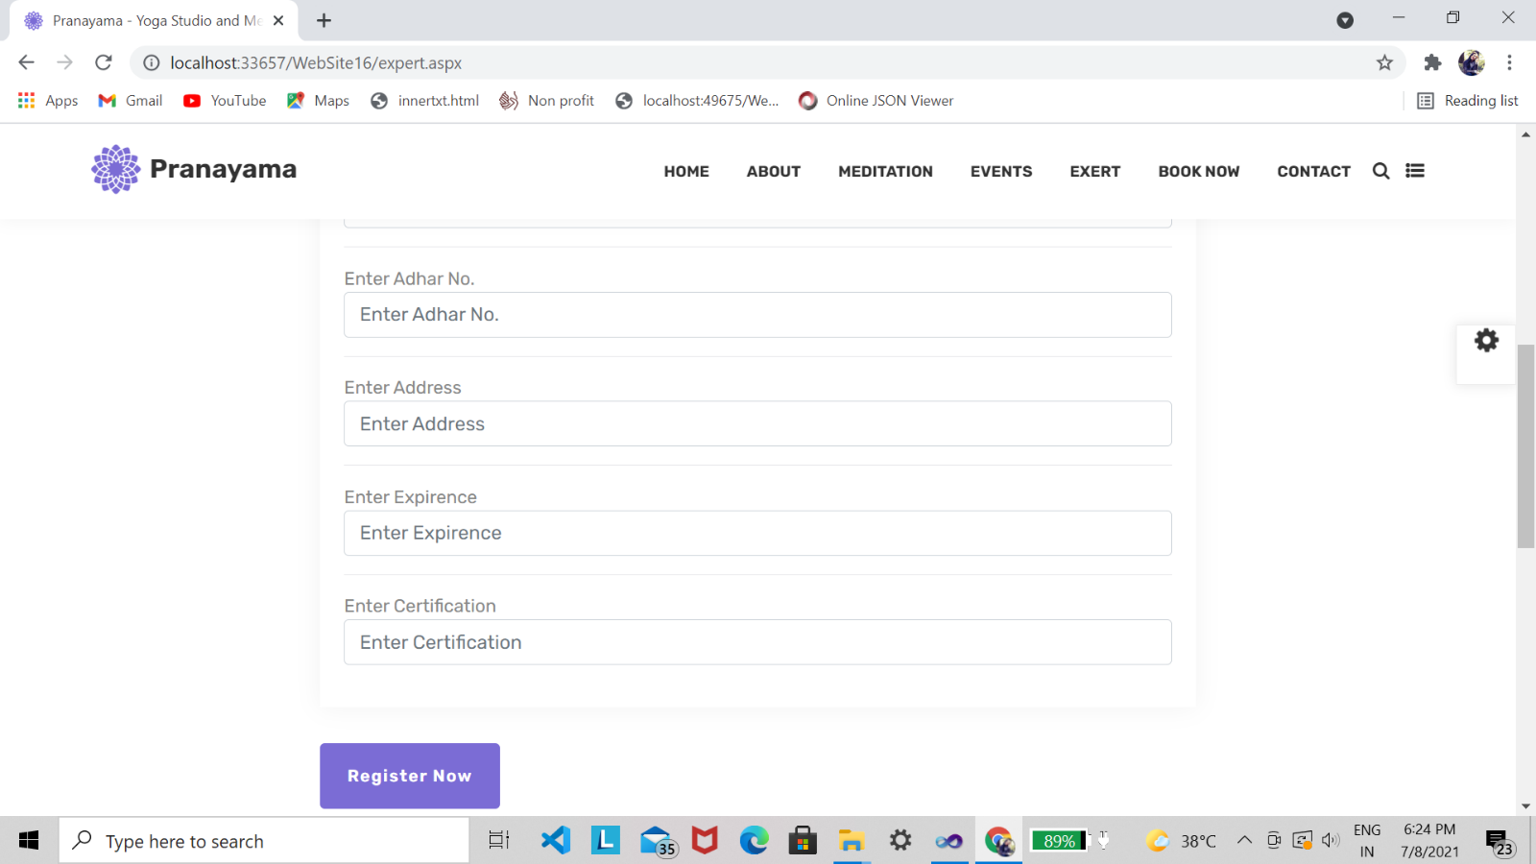

**Admin Pane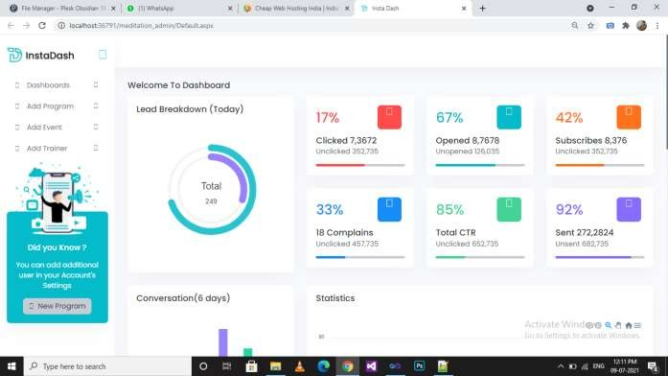l**

