PES University – Dept. of CSE
Lab 1: Requirements Engineering & UML Use-Case Modelling
Problem Statement #11 – Healthcare & Telemedicine
Title: Telemedicine Slot Booking & Prescription Portal
Name: LAKSHYA BUDHAULIYA SRN: PES1UG24AM147
Section: C Date: 31 August 2026

1. Problem Context & Overview
The Telemedicine Slot Booking & Prescription Portal is a secure healthcare consultation platform that allows remote patients to view doctor specialties, book video consultation slots, receive encrypted tele-consultation room links, and download digitally signed prescriptions. The system involves two primary stakeholders: the Patient, who books consultations and retrieves prescriptions, and the Attending Physician, who manages availability, conducts consultations, and authors signed prescriptions.

2. Functional Requirements
ID | Description | Priority | Acceptance Criteria | Rationale
FR-001 | The system shall enable physicians to author and digitally sign structured prescriptions that are automatically compiled into downloadable PDF records. | High | Pass: Valid cryptographic signature attached to prescription PDF.  Fail: Prescription generated without doctor license validation. | Ensures prescriptions are legally valid, tamper-evident, and traceable to a verified physician.
FR-002 | The system shall allow patients to search and filter doctors by specialty, language, and available time slots. | High | Pass: Search returns only doctors matching the selected specialty and showing real-time availability.  Fail: Results include doctors with no published availability or wrong specialty. | Patients need an efficient way to locate a suitable doctor before they can book a consultation.
FR-003 | The system shall allow a patient to book an available video consultation slot with a chosen physician, preventing double-booking of the same slot. | High | Pass: Slot is locked and confirmed only if it was still free at the time of booking; a confirmation is generated.  Fail: Two patients are able to book the same slot simultaneously. | Slot integrity is core to the scheduling function; conflicts directly harm patient trust and physician scheduling.
FR-004 | The system shall generate a unique, encrypted, time-bound video consultation room link and deliver it to both the patient and the physician upon booking confirmation. | High | Pass: Link is valid only within the scheduled window and cannot be accessed by unauthorized users.  Fail: Link remains active outside the consultation window or is guessable/reusable. | Protects patient privacy and consultation confidentiality as mandated by healthcare data-protection norms.
FR-005 | The system shall allow patients to view and download their digitally signed prescription as a PDF from their account after the consultation. | Medium | Pass: Downloaded PDF matches the signed prescription record and displays the verified signature.  Fail: PDF is downloadable before physician signing is complete. | Gives patients self-service access to their medical records for pharmacy use and personal reference.

3. Non-Functional Requirements
ID | Type | Description | Priority | Acceptance Criteria | Rationale
NFR-001 | Performance & Security | All video session metadata and patient clinical notes must be encrypted in transit using TLS 1.3 and at rest with AES-256. | High | Pass: Benchmarking tests confirm target latency and security standards under simulated peak load.  Fail: Any data found unencrypted in transit or at rest. | Healthcare data is highly sensitive; encryption is required for regulatory compliance (e.g., HIPAA-equivalent norms) and patient trust.
NFR-002 | Availability & Reliability | The slot booking and video consultation subsystems shall maintain 99.9% uptime, measured monthly, with automatic failover for the video signaling service. | High | Pass: Uptime monitoring logs show ≤ ~43 minutes of downtime per month and failover completes within 30 seconds.  Fail: Unplanned downtime exceeds the monthly budget or failover does not trigger automatically. | Missed or dropped consultations due to downtime can directly delay patient care, so high availability is critical for a healthcare service.

4. List of Use Cases
The table below lists every use case shown in the UML diagram on the following page, along with its primary actor(s) and a brief description of its purpose.
Use Case | Primary Actor(s) | Brief Description
Login / Authenticate | Patient, Attending Physician | Verifies user credentials and grants role-based access to the portal.
View Doctor Specialties | Patient | Allows the patient to browse and filter physicians by specialty and availability.
Book Consultation Slot | Patient | Lets the patient reserve an available video consultation slot with a chosen physician.
Send Booking Notification | Patient, Attending Physician | Delivers the booking confirmation and encrypted video room link to both parties. Always triggered by Book Consultation Slot («include»).
Reschedule / Cancel Booking | Patient | Allows the patient to change or cancel an existing booking. Optionally extends Book Consultation Slot («extend»).
Join Video Consultation | Patient, Attending Physician | Connects both participants to the encrypted video session at the scheduled time.
Request Technical Support | Attending Physician | Provides in-session help if connectivity issues occur. Optionally extends Join Video Consultation («extend»).
Author & Sign Prescription | Attending Physician | Lets the physician create a structured prescription and apply a digital signature to it.
Validate Doctor License | Attending Physician | Confirms the physician's medical license and signature certificate are current. Always triggered by Author & Sign Prescription («include»).
Download Prescription PDF | Patient | Allows the patient to retrieve the signed prescription as a downloadable PDF.

5. UML Use-Case Diagram
The diagram below models the two primary actors (Patient, Attending Physician) and an external actor (Payment Gateway) against the system's use cases. It includes one <<include>> relationship (Book Consultation Slot always includes Send Booking Notification; Author & Sign Prescription always includes Validate Doctor License) and two <<extend>> relationships (Reschedule/Cancel Booking optionally extends Book Consultation Slot; Request Technical Support optionally extends Join Video Consultation).
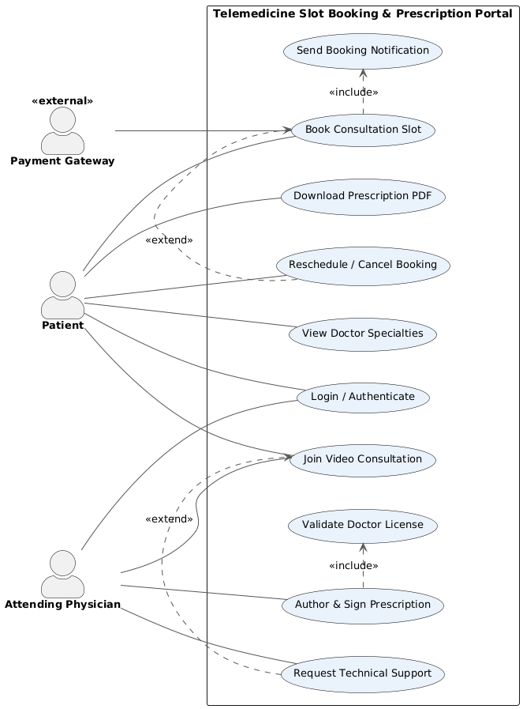

6. Use-Case Flow Specification: Book Consultation Slot
Use Case Name | Book Consultation Slot
Actors | Patient (primary), Attending Physician (secondary), Payment Gateway (external)
Preconditions | 1. The patient is registered and logged into the portal.  2. At least one physician has published available time slots.
Postconditions | 1. The selected slot is reserved exclusively for the patient.  2. A booking confirmation and encrypted video room link are generated and sent to both patient and physician (via the included Send Booking Notification use case).
Main Success Scenario | 1. Patient selects “Book Consultation” and chooses a physician from the specialty listing.  2. System displays the physician’s available time slots for the next 14 days.  3. Patient selects a slot and confirms intent to book.  4. System checks real-time availability of the slot and temporarily locks it.  5. Patient completes payment via the Payment Gateway.  6. System confirms the booking, permanently reserves the slot, and includes the Send Booking Notification use case to email/SMS both parties with an encrypted video room link.  7. System displays a booking confirmation screen to the patient with date, time, and physician details.
Alternate Flow | A1: Slot Becomes Unavailable Mid-Booking  3a. After the patient selects a slot but before payment is completed, another patient books the same slot first.  3a1. System detects the conflict during the availability re-check in step 4.  3a2. System notifies the patient that the slot is no longer available and displays the next closest available slots for the same physician.  3a3. Patient selects an alternate slot and the flow resumes at step 3 of the main scenario.

