PES University – Dept. of CSE
Lab 1: Requirements Engineering & UML Use-Case Modelling
Problem Statement #11 – Healthcare & Telemedicine
Title: Telemedicine Slot Booking & Prescription Portal
Name: Deepesh M SRN: PES1UG24AM150
Section: C Date: 31 August 2026

1. Problem Context & Overview
The Telemedicine Slot Booking & Prescription Portal is a secure healthcare consultation platform that allows remote patients to view doctor specialties, book video consultation slots, receive encrypted tele-consultation room links, and download digitally signed prescriptions. The system involves two primary stakeholders: the Patient, who books consultations and retrieves prescriptions, and the Attending Physician, who manages availability, conducts consultations, and authors signed prescriptions.

2. Functional Requirements
ID | Description | Priority | Acceptance Criteria | Rationale
FR-001 | The system shall enable physicians to author and digitally sign structured prescriptions that are automatically compiled into downloadable PDF records. | High | Pass: Valid cryptographic signature attached to prescription PDF.  Fail: Prescription generated without doctor license validation. | Ensures prescriptions are legally valid, tamper-evident, and traceable to a verified physician.
FR-002 | The system shall allow patients to search and filter doctors by specialty, language, and available time slots. | High | Pass: Search returns only doctors matching the selected specialty and showing real-time availability.  Fail: Results include doctors with no published availability or wrong specialty. | Patients need an efficient way to locate a suitable doctor before they can book a consultation.
FR-003 | The system shall allow a patient to book an available video consultation slot with a chosen physician, preventing double-booking of the same slot. | High | Pass: Slot is locked and confirmed only if it was still free at the time of booking; a confirmation is generated.  Fail: Two patients are able to book the same slot simultaneously. | Slot integrity is core to the scheduling function; conflicts directly harm patient trust and physician scheduling.
FR-004 | The system shall generate a unique, encrypted, time-bound video consultation room link and deliver it to both the patient and the physician upon booking confirmation. | High | Pass: Link is valid only within the scheduled window and cannot be accessed by unauthorized users.  Fail: Link remains active outside the consultation window or is guessable/reusable. | Protects patient privacy and consultation confidentiality as mandated by healthcare data-protection norms.
FR-005 | The system shall allow patients to view and download their digitally signed prescription as a PDF from their account after the consultation. | Medium | Pass: Downloaded PDF matches the signed prescription record and displays the verified signature.  Fail: PDF is downloadable before physician signing is complete. | Gives patients self-service access to their medical records for pharmacy use and personal reference.

3. Non-Functional Requirements
ID | Type | Description | Priority | Acceptance Criteria | Rationale
NFR-001 | Performance & Security | All video session metadata and patient clinical notes must be encrypted in transit using TLS 1.3 and at rest with AES-256. | High | Pass: Benchmarking tests confirm target latency and security standards under simulated peak load.  Fail: Any data found unencrypted in transit or at rest. | Healthcare data is highly sensitive; encryption is required for regulatory compliance (e.g., HIPAA-equivalent norms) and patient trust.
NFR-002 | Availability & Reliability | The slot booking and video consultation subsystems shall maintain 99.9% uptime, measured monthly, with automatic failover for the video signaling service. | High | Pass: Uptime monitoring logs show ≤ ~43 minutes of downtime per month and failover completes within 30 seconds.  Fail: Unplanned downtime exceeds the monthly budget or failover does not trigger automatically. | Missed or dropped consultations due to downtime can directly delay patient care, so high availability is critical for a healthcare service.

4. List of Use Cases
The table below lists every use case shown in the UML diagram on the following page, along with its primary actor(s) and a brief description of its purpose.
Use Case | Primary Actor(s) | Brief Description
Login / Authenticate | Patient, Attending Physician | Verifies user credentials and grants role-based access to the portal.
View Doctor Specialties | Patient | Allows the patient to browse and filter physicians by specialty and availability.
Book Consultation Slot | Patient | Lets the patient reserve an available video consultation slot with a chosen physician.
Send Booking Notification | Patient, Attending Physician | Delivers the booking confirmation and encrypted video room link to both parties. Always triggered by Book Consultation Slot («include»).
Reschedule / Cancel Booking | Patient | Allows the patient to change or cancel an existing booking. Optionally extends Book Consultation Slot («extend»).
Join Video Consultation | Patient, Attending Physician | Connects both participants to the encrypted video session at the scheduled time.
Request Technical Support | Attending Physician | Provides in-session help if connectivity issues occur. Optionally extends Join Video Consultation («extend»).
Author & Sign Prescription | Attending Physician | Lets the physician create a structured prescription and apply a digital signature to it.
Validate Doctor License | Attending Physician | Confirms the physician's medical license and signature certificate are current. Always triggered by Author & Sign Prescription («include»).
Download Prescription PDF | Patient | Allows the patient to retrieve the signed prescription as a downloadable PDF.

5. UML Use-Case Diagram
The diagram below models the two primary actors (Patient, Attending Physician) and an external actor (Payment Gateway) against the system's use cases. It includes one <<include>> relationship (Book Consultation Slot always includes Send Booking Notification; Author & Sign Prescription always includes Validate Doctor License) and two <<extend>> relationships (Reschedule/Cancel Booking optionally extends Book Consultation Slot; Request Technical Support optionally extends Join Video Consultation).
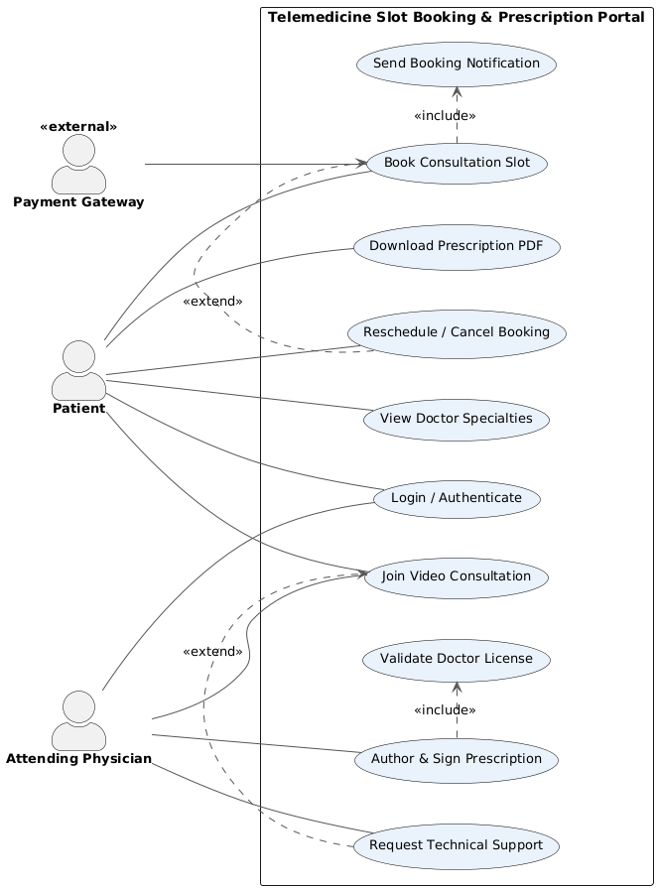

6. Use-Case Flow Specification: Download Prescription PDF
Use Case Name | Download Prescription PDF
Actors | Patient (primary)
Preconditions | 1. The patient is logged into the portal.  2. The physician has completed and digitally signed at least one prescription for the patient.
Postconditions | 1. The patient has a local copy of the signed prescription PDF.  2. The system logs the download event for audit and compliance tracking.
Main Success Scenario | 1. Patient navigates to “My Prescriptions” in their account dashboard.  2. System displays a list of all signed prescriptions linked to the patient, sorted by consultation date.  3. Patient selects a prescription record and clicks “Download PDF.”  4. System verifies the patient's identity and confirms the prescription's digital signature is intact and unaltered.  5. System generates a secure, time-limited download link and streams the PDF to the patient's device.  6. System logs the download timestamp against the prescription record.
Alternate Flow | A1: Signature Verification Fails  4a. During signature verification, the system detects that the prescription record appears altered or the certificate chain is invalid.  4a1. System blocks the download and displays a warning that the document integrity could not be verified.  4a2. System flags the record for administrator review and notifies the attending physician.  4a3. Patient is advised to contact support; download remains blocked until the record is re-verified or re-issued.

