



CONTACT BOOK APPLICATION

A Major Project Report Submitted In partial fulfillment For the award of the Degree of BACHELOR OF TECHNOLOGY In the Department of Computer Science and Engineering
Submitted by:
Lakshyaraj Purbia
Ashwinraj Singh Chouhan
Divyansh Bolia
Achal Jain
Department of Computer Science and Engineering
TECHNO INDIA NJR INSTITUTE OF TECHNOLOGY
RAJASTHAN TECHNICAL UNIVERSITY



CERTIFICATE

This is to certify that the project report titled “Contact Book Application” is the bonafide work carried out by the student under my supervision. This project is approved for submission for the award of the degree of Bachelor of Technology in the Department of Computer Science and Engineering, Techno India NJR Institute of Technology, affiliated to Rajasthan Technical University.

Mr. Vijay Soni
Project In-charge
Department of Computer Science

ABSTRACT

1. Introduction
The Contact Book Application is a web-based system developed using Python Flask and SQLite. The application helps users manage their contacts digitally instead of maintaining them manually.

1.2 Scope
The system allows users to:
- Add new contacts
- View all contacts
- Update contact details
- Delete contacts
- Search contacts

1.3 Document Overview
This document contains introduction, system requirements, design, database structure, screenshots, testing, conclusion, and future enhancements.

ACKNOWLEDGEMENT

I express my sincere gratitude to my project guide and faculty members for their support and guidance throughout the project. I also thank my friends and family for their encouragement.
Lakshyaraj Purbia
Ashwinraj Singh Chauhan
Divyansh Bolia
Achal Jain

Place - Udaipur
Date - 09/02/2026

TABLE OF CONTENTS
Table of Contents
Abstract....................................................................................................................................... 3
Acknowledgement ...................................................................................................................... 5
Table of Contents .................................................................................................................... 6-7
List of Figures.............................................................................................................................. 8
CHAPTER – 1 Introduction....................................................................................................9-10
Introduction ................................................................................................................................. 9
1.1.Purpose................................................................................................................................ 10
CHAPTER – 2 Software Requirement Specification ....................................................... 11-18
2.1. Purpose.......................................................................................................................... 11-13
2.2. Overall Description......................................................................................................... 14-15
2.3. Functional Requirements............................................................................................... 15-16
2.4. Use Cases.......................................................................................................................... 17
2.5. Non functional requirements……………………………………………………………………...17
2.6. Hardware and Software Requirements ............................................................................. 18
CHAPTER – 3 System Analysis and Design .................................................................... 19-27
3.1. Analysis of current system ............................................................................. 20
3.2.Benefits of using this over current system ..................................................................... 21-22
3.3. Limitations of this system ................................................................................................... 23
3.4. Data flow diagram …..................................................................................................... 23-26
3.5 Class Diagram ….............................................................................................................. 27
3.6 Context Diagram .............................................................................................................. 27
3.7. Sequence Diagram .......................................................................................................... 27
CHAPTER – 4 Data Dictionary ........................................................................................ 28-38
4.1. Table Details ................................................................................................................28-38
4.2. E-R Diagram ................................................................................................................... 38
CHAPTER - 5 Screenshots ................................................................................................ 39-46
CHAPTER – 6 Testing ...................................................................................................... 47-52
CHAPTER – 7 Conclusion and Future Enhancements ................................................... 53-54
7.1. Limitations ......................................................................................................................... 53
7.2. Future Enhancements ....................................................................................................... 53
7.3. Conclusion ..........................................................................................................................54
CHAPTER – 8 Project Timeline……………………………...................................................... 55
CHAPTER – 9 Bibliography and Dependencies .................................................................. 56

TABLE OF CONTENTS
Chapter 1 – Introduction
Chapter 2 – Software Requirement Specification
Chapter 3 – System Analysis and Design
Chapter 4 – Data Dictionary
Chapter 5 – Screenshots
Chapter 6 – Testing
Chapter 7 – Conclusion and Future Enhancements
Chapter 8 – Bibliography

CHAPTER – I

INTRODUCTION

Purpose
The purpose of the Contact Book Application is to provide a simple and efficient way to store and manage contact information digitally.

Scope

The system allows users to:

Add new contacts

View stored contacts

Update contact details

Delete contacts

Search contacts instantly

Import and export contact data using CSV files

Toggle between Light and Dark themes

References
IEEE Software Engineering Standards
Python & Flask Documentation

CHAPTER – II

SOFTWARE REQUIREMENT SPECIFICATION

2.1 Overall Description
The Software Requirement Specification defines the complete functionality of the system. It acts as a blueprint for both development and testing phases. The application is designed to be lightweight and easy to deploy on local machines, while SQLite provides a reliable local database solution. The system is developed keeping usability and performance in mind.

2.2 User Characteristics
- Basic computer literacy
- Single-user system
- No technical expertise required

2.3 Functional Requirements
- Add contact information
- Edit existing contacts
- Delete contacts
- Search contacts by name or phone number
- Import contacts from CSV
- Export contacts to CSV
- Right-click context menu for quick actions

2.4 Non-Functional Requirements
- Fast response time
- Easy-to-use graphical interface
- Reliable local data storage
- Theme consistency across UI

2.5 Hardware & Software Requirements
Hardware:
- 4GB RAM minimum
- Any modern processor
Software:
- Python 3.x
- SQLite

CHAPTER – III

SYSTEM ANALYSIS AND DESIGN

Existing System
Manual contact storage using notebooks or mobile phone contacts which is difficult to manage and backup.
System analysis helps in understanding the existing problems and identifying suitable solutions. The proposed system overcomes the drawbacks of manual contact management. The design follows a modular approach, making the system easy to maintain and extend. Data flow and system interactions are kept simple for better performance. The architecture ensures smooth communication between frontend, backend, and database.

Proposed System

The proposed system is a desktop-based Contact Management System that provides efficient contact handling with a modern GUI, database integration, and advanced usability features.

Benefits
- Quick search
- Easy modification
- Data security
- Reduced paperwork

Limitations
- No multi-user support
- No cloud backup

CHAPTER – IV

DATA DICTIONARY
The data dictionary provides a clear description of database structure and attributes. It helps developers understand how data is stored and accessed within the system. Each field is carefully defined to avoid redundancy and inconsistency. Proper data types ensure efficient storage and retrieval. The database structure supports easy future enhancements

Table: contacts
Field Name | Data Type | Description
Mem_id | Integer | Primary Key
Firstname | Text | Firstname
Lastname | Text | Lastname
Gender | Text | Gender
Age | Text | Age
Address | Text | Address
contact | Text | contact

CHAPTER – V

SCREENSHOTS

DashBoard

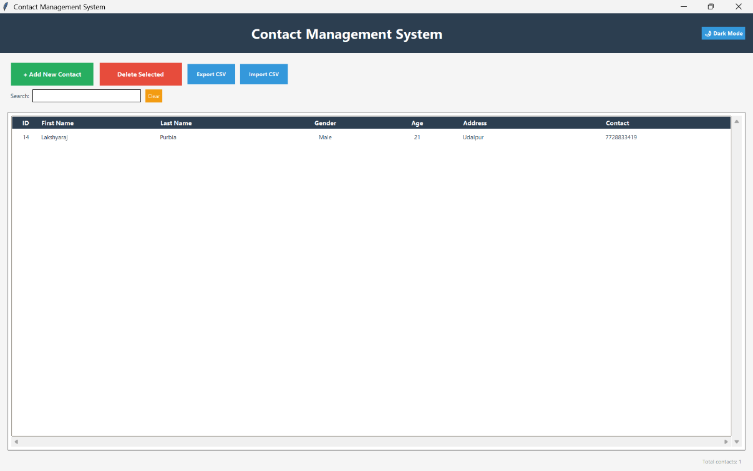
- Add Contact
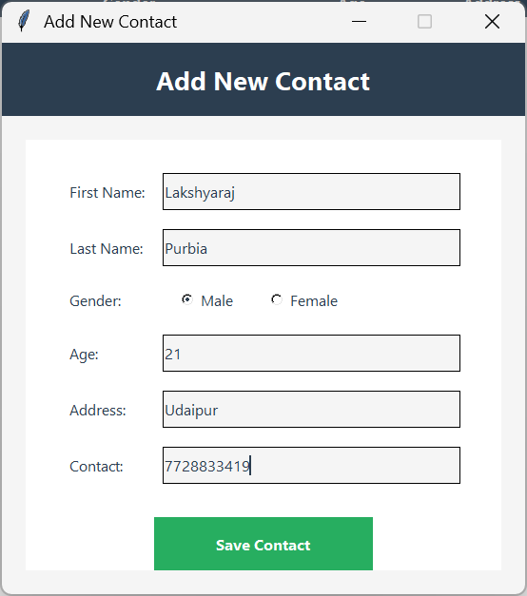

CHAPTER – VI

TESTING
Testing ensures that the application works as expected under different conditions. Both functional and system testing were performed to validate the system. Errors were identified and corrected during testing phases. The application was tested with multiple input values to ensure reliability. Successful testing confirms system stability and correctness.

Unit Testing

Each functional module such as Add, Update, Delete, Search, Import, and Export was tested individually.

System Testing
The system was tested for:
- Data insertion
- Data modification
- Data deletion
- Search accuracy
- CSV import/export

All test cases were executed successfully without errors.

CHAPTER – VII

CONCLUSION AND FUTURE ENHANCEMENTS

Conclusion
The Contact Book Application successfully digitizes contact management and provides a simple and efficient solution. The project fulfills all the defined objectives successfully. It provides an efficient and user-friendly solution for contact management. The system reduces manual effort and improves data organization. Future enhancements can further increase usability and scalability. The project also helped in understanding real-world web application development.

Future Enhancements
- User authentication
- Cloud database integration
- Mobile responsive design
- Import/Export contacts

CHAPTER – VIII

BIBLIOGRAPHY
The references used in this project helped in understanding technical concepts clearly. Official documentation ensured correct implementation of features. Online resources provided solutions to practical problems. These references played an important role in successful project completion.
- Python Official Documentation
- SQLite Documentation
- Stack Overflow

