**WRITE-UP FOR QUESTION-1**

We made three threads using pthread_create and set their priority using sched_param. We used clock_gettime to get the time and made six histograms using Gnuplot where SCHED_OTHER takes maximum time, SCHED_FIFO takes minimum time, and SCHED_RR in between them.

We also made three functions countA, countB, and countC to get their time.

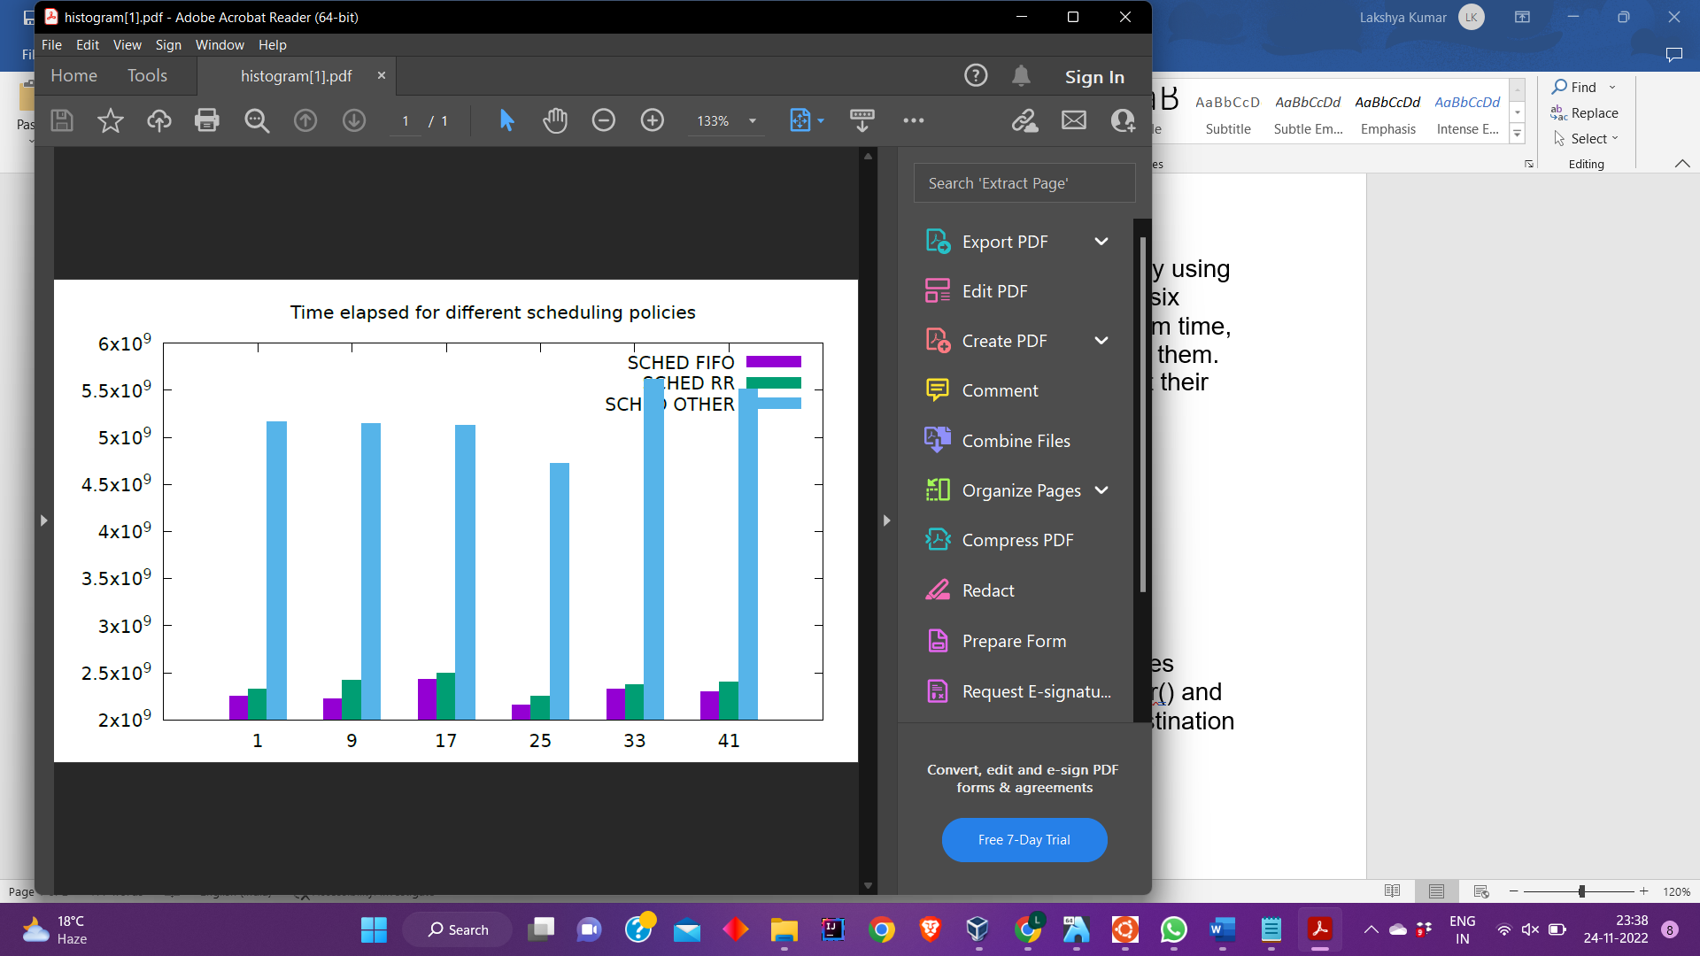

**WRITE-UP FOR QUESTION-2**

Steps followed for compiling and adding the system call :-

1. Create a custom SYSCALL which takes in input two matrices (source and destination matrix) and uses__copy_from_user() and __copy_from_user() to copy data from source matrix to destination matrix.

1. Copy of Linux kernel before adding syscall.

1. Add the system call in sys.c file.

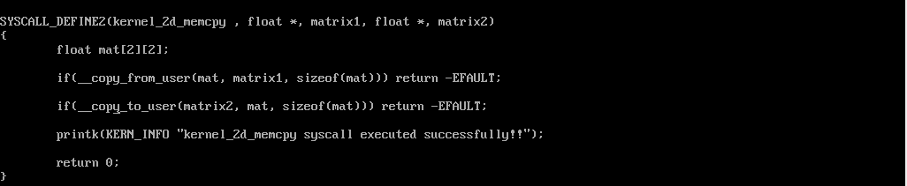

1. Now add the custom SYSCALL in the table syscall_64.tbl.

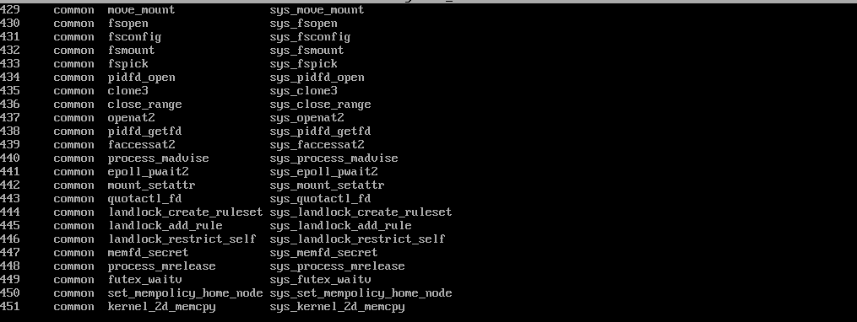

1. Compile the kernel
2. Now reboot the system

1. Create a driver code to call our custom syscall with source matrix which is the matrix to be copied and destination matrix which is matrix where data has to be copied.

1. Now compile and run the driver code to test the working of SYSCALL

