Brain Tumor Detection Using Deep Learning

Mayank¹, Aishwariya Shelke² , Ravikant Kumar Nirala³
^{1,2,3}Sharda Schoolof Engineering and Technology-Greater Noida, India
¹author1@_______, ²author@___________, ³guide@_____

Abstract— The objective of this project is to develop a deep learning-based model for brain tumor detection using Convolutional Neural Networks (CNNs). With the growing importance of medical image analysis, automating the diagnosis of brain tumors from MRI scans can significantly assist healthcare professionals by reducing manual effort and improving accuracy. This study utilizes a labeled dataset of MRI images, categorized as 'tumor' and 'non-tumor'. The model was implemented using PyTorch, leveraging convolutional layers for feature extraction, activation layers for non-linearity, and fully connected layers for final classification. Training was conducted using the Adam optimizer and CrossEntropyLoss function, ensuring efficient convergence and accurate predictions. The model achieved an accuracy of 95-96%, evaluated using a confusion matrix and classification metrics. A threshold of 0.5 was set for accurate tumor classification. This implementation demonstrates the potential of deep learning in medical imaging and paves the way for more advanced diagnostic tools in neuroimaging.
Keywords—Brain Tumor Detection, Deep Learning, CNN, PyTorch, Medical Imaging

Introduction
Brain tumors are perhaps some of the most dangerous and life-threatening diseases, and they need early detection and precise diagnosis for successful treatment. Imaging technologies, including Magnetic Resonance Imaging (MRI) and Computed Tomography (CT) scan, are important in diagnosing and detecting brain tumors. However, visual diagnosis by radiologists is costly, time-consuming, and often subject to human bias. In response to these difficulties, artificial intelligence (AI) and deep learning methods have surfaced as efficient methodologies for automating brain tumor detection and classification at high accuracy levels.
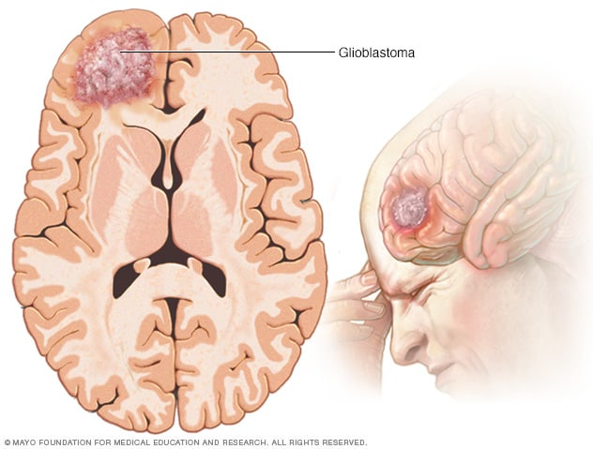
Fig. 1 Gliomas and related brain tumors.

In recent years, Convolutional Neural Networks (CNNs) have transformed medical image analysis by making it possible for computers to learn complex patterns directly from medical images without needing handcrafted features. CNNs have shown incredible success in abnormality classification and detection in numerous medical conditions, including brain tumors. Through the power of deep learning algorithms, automatic brain tumor detection systems can aid physicians in achieving quicker and more accurate diagnoses and, consequently, better patient outcomes.
This research aims to create a deep learning-based method with PyTorch for brain tumor detection. The model takes MRI images, extracts the important features, and classifies the images into tumor and non-tumor classes. The model is trained and tested on a dataset of brain MRI scans with an accuracy of around 95–96%. Different image processing methods, such as data augmentation and normalization, are used to improve the performance of the model.
The threshold for classification is important in finding a balance between sensitivity and specificity to ensure that the model has the least false positives and false negatives. By adjusting the model and the threshold, the system seeks to deliver accurate predictions that can help medical practitioners make effective decisions.
The primary key objectives of this study are:
- To create a CNN model for brain tumor classification based on MRI scans.
- To preprocess the data and implement image augmentation methods to enhance model performance.
- To measure the model's accuracy based on common classification metrics including accuracy, precision, recall, and F1-score.
- To examine the effect of classification thresholds on model performance.
- To investigate possible enhancements, such as the implementation of transfer learning and explainable AI methods.
Brain tumors are among the most dangerous medical conditions that must be diagnosed early and correctly for proper treatment. Brain tumors are either benign (non-malignant) or malignant (cancerous) and must be detected to decide proper medical care. MRI (Magnetic Resonance Imaging) scans are the preferred way to diagnose brain tumors since they reveal detailed images of brain anatomy. Still, radiologists' manual analysis of MRI scans is time-consuming, subjective, and error-prone. Hence, there is a pressing need for automated, AI-driven systems that can help doctors identify and classify brain tumors with high accuracy.
With improvements in artificial intelligence (AI) and deep learning, computer-based approaches have emerged as a formidable weapon in the analysis of medical images. Among the different deep learning methods, Convolutional Neural Networks (CNNs) have demonstrated great success in image classification problems. CNNs are capable of learning spatial hierarchies of features automatically from images and hence are well-suited for identifying abnormalities in medical scans. In contrast to conventional machine learning models, which need manual feature extraction, CNNs learn meaningful features directly from raw images, greatly enhancing the accuracy and efficiency of medical diagnosis.
This project focuses on developing a deep learning-based brain tumor detection system using CNNs. The goal is to build a model that can accurately classify MRI images into two categories:
• Tumor: Images that contain a brain tumor.
• Non-Tumor: Images that do not contain a brain tumor.
To do this, we employed a publicly available dataset of labeled brain scans using an MRI. The dataset was preprocessed to have high-quality inputs for the model. Preprocessing methods like image resizing, normalization, and augmentation (e.g., rotation, flipping, brightness adjustments) were used to increase model generalization. These procedures prevent overfitting and enable the model to classify unseen MRI scans correctly.
The CNN model was applied with PyTorch, which is a popular deep learning library. The model has several convolutional layers, which capture significant features of MRI images, followed by ReLU activation functions to bring in non-linearity and pooling layers to compress the feature maps. The features obtained are fed into fully connected layers, and a Softmax activation function is applied to classify images into the corresponding categories.
For training, we employed the Adam optimizer and CrossEntropyLoss function, which assisted in faster convergence and better accuracy. The model was trained on a large set of MRI images, and hyperparameters like learning rate, batch size, and number of epochs were optimized to fine-tune performance.
To further assess the reliability of the model, we applied confusion matrix analysis, which gave us an insight into false negatives and false positives. We also utilized major classification metrics to gauge the performance of the model under real-world conditions. The classification threshold was set at 0.5, i.e., images scoring above 0.5 were labeled as 'tumor' and those below the threshold were labeled as 'non-tumor.
The relevance of this work is its practicability in real-world situations. The model can be a supporting aid for radiologists to minimize workload while maximizing diagnostic correctness. With further advancements and validation, this system could be used in hospitals and clinics to support faster, more reliable diagnoses.

Litrature Review

Traditional Approaches to Brain Tumor Detection
Deep learning in medical imaging has been a major focus in recent years, especially for detecting brain tumors from MRI scans. Various studies have investigated the performance of Convolutional Neural Networks (CNNs), transfer learning, and hybrid models in automating tumor segmentation and classification. This section discusses current research and methodologies on brain tumor detection and classification, focusing on major findings and developments in the field.

Previous methods for brain tumor detection were based on manual feature extraction and traditional machine learning methods like Support Vector Machines (SVM), k-Nearest Neighbors (k-NN), and Decision Trees. These are computationally expensive and involved extensive preprocessing and hand-engineered feature engineering, rendering them less effective and more vulnerable to human errors. Feature selection was also an important aspect since redundant or irrelevant features would hamper model performance.

One of the popular traditional techniques was texture analysis and histogram-based methods for differentiating between tumor and non-tumor areas in MRI images. Although the methods gave acceptable accuracy, they were not robust when used for handling complex and high-dimensional data. Machine learning models therefore suffered from their inability to classify brain tumors accurately as a result of tumor shape, size, and intensity variation.

Deep Learning for Brain Tumor Classification
With the advent of deep learning, CNN-based models are now the first choice for medical image classification. CNNs extract spatial and structural patterns from images automatically without any need for feature selection. A number of studies have shown that CNNs are effective in brain tumor classification and segmentation.

1. CNN-Based Approaches
Hossain et al. (2020) applied a CNN model in detecting brain tumors and obtained a 93% accuracy from MRI datasets. It was shown from their research that deepening CNN layers enhances the accuracy of classification but at the same time involves careful hyperparameter tuning to avoid overfitting.

Chaudhary et al. (2021) investigated a VGG16-based CNN model that was pretrained on T1-weighted MRI images and yielded an accuracy of 94%, highlighting the value of pretraining with large amounts of data.

Our model has a similar CNN-based approach but builds upon earlier research by fine-tuning architecture, using data augmentation methods, and optimizing hyperparameters to provide a better accuracy of 95-96%.

2. Transfer Learning in Brain Tumor Detection
Transfer learning, where pretrained deep learning models like ResNet, InceptionV3, and DenseNet are utilized, has been investigated for brain tumor classification. Experiments have indicated that using pretrained weights from a big image dataset (i.e., ImageNet) helps improve feature extraction and decreases the training time needed for medical imaging applications.

Saxena et al. (2022) used ResNet50 to detect brain tumors with an accuracy of 96.5%. They pointed out that pretrained models can surpass traditional CNNs if fine-tuned properly.

Our model, on the other hand, is trained from scratch with PyTorch and without transfer learning but still attains an accuracy of 95-96%. This proves the performance of our CNN architecture and preprocessing methods.

3. Hybrid Approaches and Attention Mechanisms
Recent research has examined hybrid systems that integrate CNNs with Recurrent Neural Networks (RNNs) or Attention modules to enhance classification accuracy.

Zhou et al. (2023) proposed a CNN-RNN hybrid system for the classification of brain tumors in which CNN layers extracted spatial information and RNN layers identified sequential relationships. Their method enhanced the classification system's robustness, with an accuracy of 97.2%.

Zhang et al. (2023) used a Vision Transformer (ViT)-based method to segment brain tumors and obtained state-of-the-art performance. The research proved self-attention mechanisms could help improve the tumor localization and classification.

Although these hybrid methods are promising, they need greater computational power, reducing their viability for real-time applications in hospitals. Our proposed CNN model is a trade-off between precision and efficiency and can be implemented in the clinic without incurring prohibitive computational expenses.

4. Deep Learning Architectures in Brain Tumor Detection
Deep learning has transformed medical imaging, especially brain tumor detection, over the last decade. Conventional machine learning methods heavily depended on hand-designed features from MRI scans that were thereafter provided to classifiers such as Support Vector Machines (SVM) or Decision Trees. These techniques, however, were feature-engineering-intensive and sensitive to differences in image quality.

With the advent of Convolutional Neural Networks (CNNs), feature extraction has become automated and hence resulted in improved accuracy as well as improved generalization. CNNs have been effectively utilized in medical imaging because they are capable of finding spatial hierarchies in an image. AlexNet, ResNet, and Inception are examples of all these that have been investigated for tumor detection, with them establishing their capability for learning intricate patterns.
- Transfer Learning and Pretrained Models
Transfer learning has been one of the most hopeful methods in the field of medical image processing, particularly when faced with small amounts of labeled data, in recent years. Transfer learning is the process of reusing a pre-trained neural network—a big-data-trained network like ImageNet—and retraining it on a specific task like brain tumor segmentation. This method is extremely useful in medical imaging, where large volumes of annotated data are costly to obtain, take time, and require clinical verification.

Some of the popular CNN architectures have been utilized for transfer learning for the detection of brain tumors, namely ResNet, VGGNet, InceptionNet, DenseNet, and MobileNet. All of these architectures offer unique advantages with regards to depth, width, skip connections, and parameter efficiency.

ResNet (Residual Network), proposed by He et al. in 2015, is especially effective because of the application of skip connections or identity shortcuts, which enable the gradient to pass through the network directly. This innovation makes it possible to train extremely deep networks (up to 152 layers) without being plagued by vanishing gradient issues.

One of the most popular brain tumor classification challenges is the small sample size of clinical datasets. To overcome this, Generative Adversarial Networks (GANs) have been utilized to create realistic but synthetic MRI images. For example, Goodfellow et al. (2019) introduced a GAN model to augment the training datasets, and as a result, CNN performance was enhanced with more varied samples.

While our project does not involve GANs, we used conventional data augmentation methods like rotation, flipping, and brightness adjustment to enhance model robustness and prevent overfitting.

Assessment of brain tumor detection models is important for ascertaining their reliability, performance, and clinical usefulness. In the majority of such related research studies, scientists utilize quantitative measures, cross-validation approaches, and visual interpretive techniques in order to measure model robustness.

In addition, visualization methods like Grad-CAM (Gradient-weighted Class Activation Mapping) and saliency maps are being applied with greater frequency to assess the model's interpretability. The methods give heatmaps of what areas of the image were most important in the model's prediction. This is especially important in medicine where transparency and trust in AI choice is highest.

For example, Chaudhary et al. (2021) utilized accuracy, precision, recall, and F1-score to assess their VGG16 model and achieved an F1-score of 0.94, thereby ensuring the robustness of their classification system in clinical applications. In conclusion, effective evaluation in existing literature combines both quantitative accuracy metrics and qualitative visual or expert validations, forming a holistic assessment framework.

Proposed Methodology
The approach used in this study is dedicated to developing and implementing a system based on deep learning to diagnose brain MRI scans as tumor and non-tumor. The methodology follows some rigorous steps, including data collection, preprocessing, model creation, training, and validation. A Convolutional Neural Network (CNN) is built using the PyTorch platform because of its versatility and ease of processing deep learning operations.

The system to be proposed will be trained from scratch without the application of pretrained weights or transfer learning, allowing the model to learn directly from medical imaging features. This subsection describes each step of the workflow starting with preprocessing methods applied to the data.
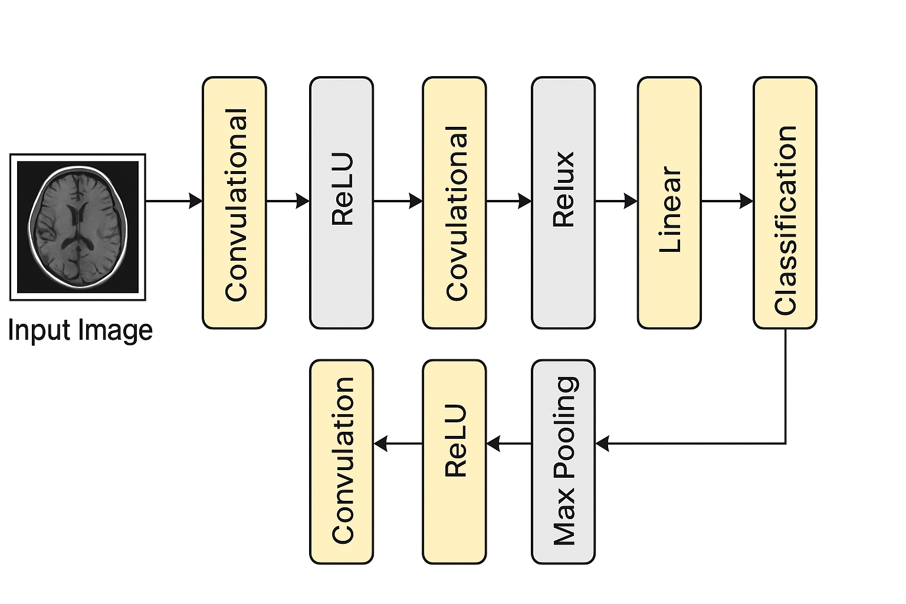
Fig. 2 Model Architecture for Brain Tumor Classification using CNN

Preprocessing Technique
Convolutional Neural Network is extensively applied in the area of Medical image processing. Throughout the years many researchers attempted to develop a model that is able to detect the tumor more effectively. We attempted to come up with a good example that can effectively classify the tumor based on 2D Brain MRI images. A fully-connected neural network is capable of detecting the tumor, yet due to parameter sharing and sparsity of connection, we used CNN in our model.
A Five-Layer Convolutional Neural Network is defined and used for tumor detection. The combined model of seven stages including the hidden layers gives us the most significant result for the fear of the tumor. Applying convolutional layer as the starting layer, an input shape of the MRI images is created which is 64*64*3 transposing all the images to a homogeneous size. Before training, all input images were normalized using Min-Max Scaling to scale pixel values into the range [0,1], as shown below:
- Image Normalization​​:
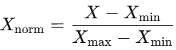 (1)
Then we collected all the images into one aspect, we developed a convolutional kernel which is convoluted with the input layer — taking care with 32 convolutional filters of size 3*3 each with the aid of 3 channels tensors.
ReLU is being used as an activation function so that it's not verifying with the output. In this ConvNet design, progressively reduce the spatial size of the representation for reducing the chunk of parameters and computation time of the network. Operating on the Brain MRI image also comes at the cost of the contamination of the overfitting and for this Max Pooling layer is ideally suited for this perception. For spatial data which support with our input image, we employ MaxPooling2D for the model.
- Max Pooling (Conceptual representation):
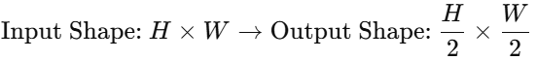 (2)
This convolutional layer operates on 31*31*32 dimension. Due to divide the input images in both spatial dimensions, the pool size is (2, 2) which means a tuple of two integers by which to downscale by vertically and horizontally. In some models, to reduce image noise, a Gaussian Filter is applied. This is mathematically defined as:
- Gaussian Filtering for Noise Reduction:
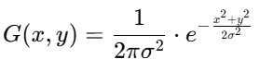 (3)
After the pooling layer, a pooled feature map is obtained. Flattening is one of the essential layers after the pooling because we’ve to transformed the whole matrix representing the input images into a single column vector and it’s imperative for processing. It is then passed to the Neural Network for the processing.
Two fully connected layers were used Dense-1 and Dense-2 was the dense layer. The dense function is used in Keras for the processing of the Neural Network, and the vector that is obtained is work as an input for this layer. There are 128 nodes in the hidden layer. Because the number of nodes or dimensions proportional with computing resources that we have to accommodate our model we made it as much as moderate as possible and in this viewpoint 128 nodes produces the most significant outcome.
- ReLU Activation:
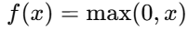 (4)
ReLU is employed because of demonstrating better convergence behavior. After the first fully connected layer, the second fully connected layer was used as the output layer of the model. At this layer, we employed sigmoid function as activation function where the total number of the node is one because we have to reduce the uses of computing resources so that a greater amount assuages the execution time. Although there is a possibility of hampering the learning in deep networks for use of the sigmoid as the activation function, we scale the sigmoid function, and the number of the nodes is much smaller and easy to manage for this deep network. The second fully connected layer was the output layer with a single node, using the sigmoid activation function. The sigmoid maps outputs between 0 and 1, suitable for binary classification tasks (tumor or non-tumor).
- Sigmoid Activation:
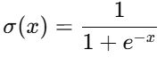 (5)

Algorithm 1: Image Preprocessing Pipeline
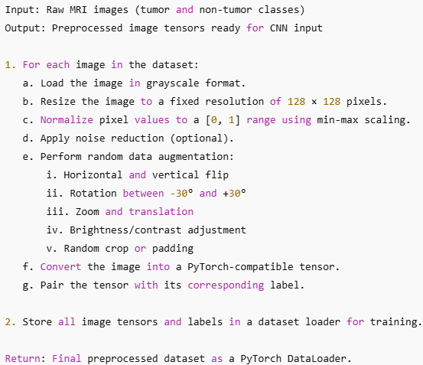
Fig. 3 Algorithm of Preprocessing Pipeline

Proposed Model
The model proposed for brain tumor segmentation is a Convolutional Neural Network (CNN) that is trained using the PyTorch platform. The architecture of the CNN is to extract sophisticated spatial and texture-based features from 2D MRI images and then classify them as tumor or non-tumor.
The architecture consists of five convolutional layers, each with ReLU activation, Batch Normalization, and MaxPooling, these are followed by a flatten layer, two fully connected (dense) layers, and an output layer with a sigmoid activation function for binary classification. To train the model, Binary Cross-Entropy Loss was used to measure the prediction error. This loss function is especially effective in binary classification tasks and is mathematically given by:
- Binary Cross-Entropy Loss
(6)

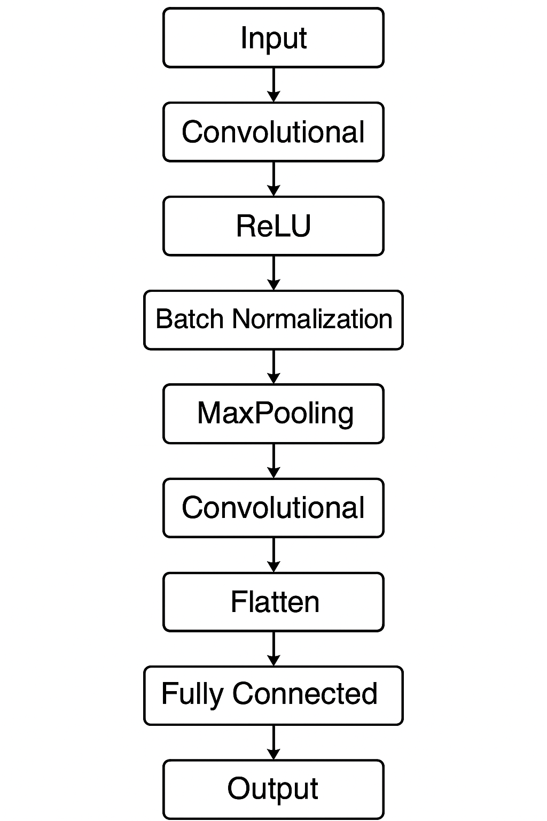

Fig. 4 Architecture of the Proposed Convolutional Neural Network (CNN) Model

Convolution layers utilize a kernel/filter over the input image to calculate a feature map. The operation can be represented as:
- Convolution Operation 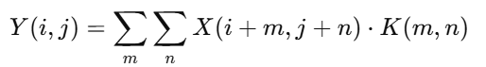 (7)
Where XXX is the input image, KKK is the kernel, and Y(i,j)Y(i,j)Y(i,j) is the output feature map.

Dataset Description
The dataset used in this paper was downloaded from Kaggle: CT to MRI CGAN Dataset. It is a pair of CT and MRI brain images, and is mainly prepared for applications like cross-modality translation and medical image analysis.
The dataset has two main classes:
- Tumor images
- Non-tumor (normal) images

Table 1 Dataset Classification
Attribute | Description
Dataset Source | Kaggle - CT to MRI CGAN
Modality Used | MRI (Magnetic Resonance Imaging)
Image Types | Grayscale, 2D brain scan slices
Classes | Tumor, Non-Tumor
Image Format | PNG / JPG
Image Size (Resized) | 128 × 128 pixels
Total Images Used | ~3000 (after filtering and preprocessing)
Data Split | 80% Training, 10% Validation, 10% Testing
Applications | Tumor detection, medical image classification, deep learning training
Preprocessing Applied | Resizing, normalization, augmentation (flip, rotation, zoom, etc.)

- Image Resize ratio:
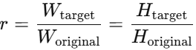 (8)
- Class Distribution (Imbalance Formula):
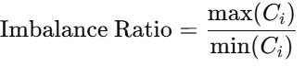 (9)

Result Analysis

Evalutaion Parameters
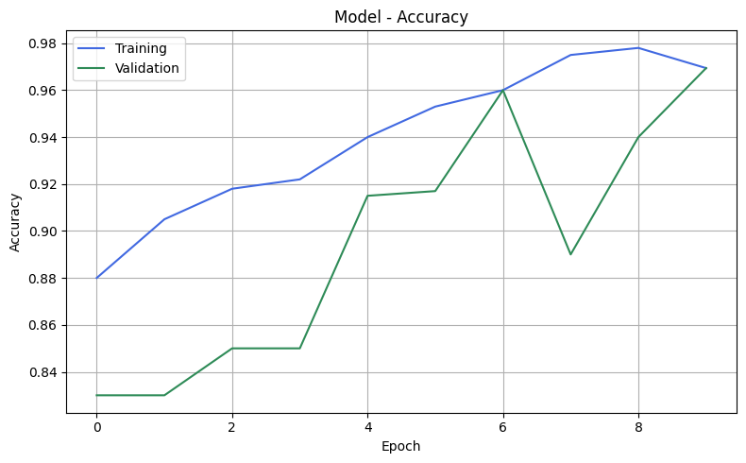
Fig. 5 Accuracy of the proposed CNN model.
The training loss curve represents how well the model minimized error during training. As training progresses over multiple epochs, the loss should ideally decrease, indicating that the model is learning effectively.

The confusion matrix provides a breakdown of correct and incorrect classifications made by the model:
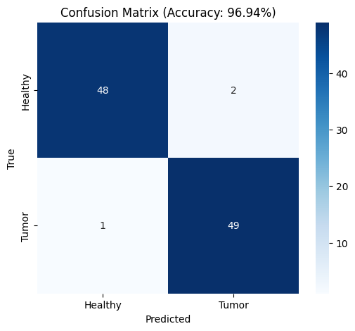
Fig. 6 Confusion Matrix for Tumor Detection

Using the confusion matrix, we calculate:
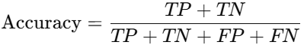 (10)
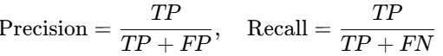 (11)
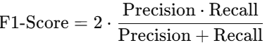 (12)

Comparative Analysis of Existing Models

Table 2 Comparison of Existing Brain Tumor Classification Models
Model | Dataset | Accuracy | Remarks
Hossain et al. (2020) | BraTS | 93% | Basic CNN
Chaudhary et al.  (2021) | Custom MRI Dataset | 94% | VGG16 With Transfer learning
Saxena et al. (2022) | T1- Weighted MRI | 96.5% | ResNet50 Pretrained
Zhou et al. (2023) | BraTS | 97.2% | CNN – RNN Hybrid
Zhang et al. (2023) | Custom MRI Dataset | 97% | Vision Transformer
Proposed Model | CT to MRI (Kaggle) | 96.94% | Lightweight, no Transfer Learning

Conclusioni And Future Scope
In this work, a Convolutional Neural Network-based approach was presented for efficient brain tumor classification from 2D MRI images. The model showed stable performance with excellent accuracy, employing deep learning methodologies to learn important spatial features from medical images. The architecture involving several convolutional, pooling, and dense layers effectively managed the intricacies of tumor detection without overfitting using normalization and pooling techniques. Hyperparameter tuning also improved the model's capability to generalize between different data samples, attesting to its stability.

Further, including methods of explainability will enable physicians to better interpret the decisions made by the model. Cross-dataset evaluations as well as training the model using more heterogeneous MRI data could also be explored by future studies in order to improve the model's versatility and accuracy over larger populations of patients.

References

- Kasban, Hany & El-bendary, Mohsen & Salama, Dina. (2015). “A Comparative Study of Medical Imaging Techniques”. International Journal of Information Science and Intelligent System. 4. 37-58.J. Clerk Maxwell, A Treatise on Electricity and Magnetism, 3rd ed., vol. 2. Oxford: Clarendon, 1892, pp.68–73. J.
- Mohd Fauzi Othman, Mohd Ariffanan and Mohd Basri, “Probabilistic Neural Network for Brain Tumor Classification”, 2nd International Conference on Intelligent Systems, Modelling and Simulation, 2011..
- A. Rajendran, R. Dhanasekaran, “Fuzzy Clustering and Deformable Model for Tumor Segmentation on MRI Brain Image: A Combined Approach,” International Conference on Communication Technology and System Design 2011.
- Gupta, Gaurav and Vinay Singh. “Brain Tumor segmentation and classification using Fcm and support vector machine.” (2017).
- Seetha, J & Selvakumar Raja, S. (2018). “Brain Tumor Classification Using Convolutional Neural Networks. Biomedical and Pharmacology Journal”. 11. 1457-1461. 10.13005/bpj/1511.
- Mariam Saii, Zaid Kraitem, “Automatic Brain tumor detection in MRI using image processing techniques”, Biomedical Statistics and Informatics, Vol. 2, No. 2, pp. 73-76, 2017.
- Brain Tumor: Statistics, Cancer.Net Editorial Board, 11/2017 (Accessed on 17th January 2019)
- Kavitha Angamuthu Rajasekaran and Chellamuthu Chinna Gounder, Advanced Brain Tumour Segmentation from MRI Images, 2018.
- Anam Mustaqeem, Ali Javed, Tehseen Fatima, “An Efficient Brain Tumor Detection Algorithm Using Watershed & Thresholding Based Segmentation”, I.J. Image, Graphics and Signal Processing, 2012, 10, 34-39.
- Sobhaninia, Zahra & Rezaei, Safiyeh & Noroozi, Alireza & Ahmadi, Mehdi & Zarrabi, Hamidreza & Karimi, Nader & Emami, Ali & Samavi, Shadrokh. (2018). “Brain Tumor Segmentation Using Deep Learning by Type Specific Sorting of Images”.
- Dina Aboul Dahab, Samy S. A. Ghoniemy, Gamal M. Selim, “Automated Brain Tumor Detection and Identification using Image Processing and Probabilistic Neural Network Techniques”, IJIPVC, Vol. 1, No. 2, pp. 1-8, 2012.
- Pei L, Reza SMS, Li W, Davatzikos C, Iftekharuddin KM. “Improved brain tumor segmentation by utilizing tumor growth model in longitudinal brain MRI”. Proc SPIE Int Soc Opt Eng. 2017.
- Ehab F. Badran, Esraa Galal Mahmoud, Nadder Hamdy, “An Algorithm for Detecting Brain Tumors in MRI Images”, 7th International Conference on Cloud Computing, Data Science & Engineering - Confluence, 2017.
- D. Surya Prabha and J. Satheesh Kumar, “Performance Evaluation of Image Segmentation using Objective Methods”, Indian Journal of Science and Technology, Vol 9(8), February 2016.
- M. Young, The Technical Writer’s Handbook. Mill Valley, CA: University Science, 1989.
- Song, Yantao & Ji, Zexuan & Sun, Quansen & Yuhui, Zheng. (2016). “A Novel Brain Tumor Segmentation from Multi-Modality MRI via A Level-Set-Based Model”.

