Assignment-1
1.)calculator
import java.util.Scanner;

public class Calculator {
int ch, num1, num2;

public int addNums(int n1, int n2) {
return n1 + n2;
}

public int subNums(int n1, int n2) {
return n1 - n2;
}

public long mulNums(int n1, int n2) {
return (long) n1 * n2;
}

public float divNums(int n1, int n2) {
return (float) n1 / n2;
}

public int calcMod(int n1, int n2) {
return n1 % n2;
}

public static void main(String args[]) {
Calculator calc = new Calculator();
Scanner sc = new Scanner(System.in);

do {
System.out.println("\nEnter first number:");
calc.num1 = sc.nextInt();

System.out.println("Enter second number:");
calc.num2 = sc.nextInt();

System.out.println(
"Select operation:\n" +
"1. Add\n" +
"2. Subtract\n" +
"3. Multiply\n" +
"4. Divide\n" +
"5. Modulus\n" +
"0. Exit"
);

calc.ch = sc.nextInt();

switch (calc.ch) {
case 1:
System.out.println("Addition: " +
calc.addNums(calc.num1, calc.num2));
break;

case 2:
System.out.println("Subtraction: " +
calc.subNums(calc.num1, calc.num2));
break;

case 3:
System.out.println("Multiplication: " +
calc.mulNums(calc.num1, calc.num2));
break;

case 4:
if (calc.num2 != 0)
System.out.println("Division: " +
calc.divNums(calc.num1, calc.num2));
else
System.out.println("Cannot divide by zero");
break;

case 5:
System.out.println("Modulus: " +
calc.calcMod(calc.num1, calc.num2));
break;

case 0:
System.out.println("Exiting Calculator...");
break;

default:
System.out.println("Invalid choice");
}

} while (calc.ch != 0);

sc.close();
}
}

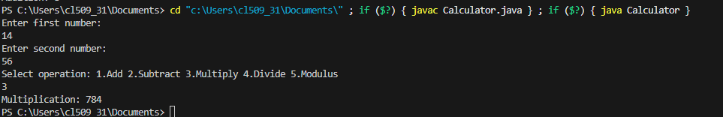
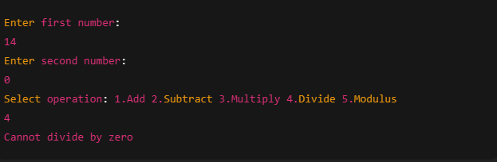
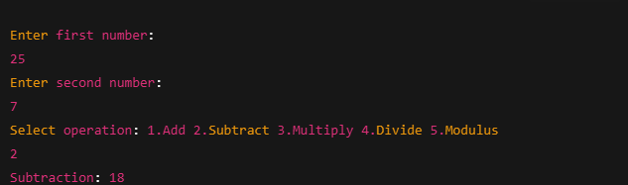
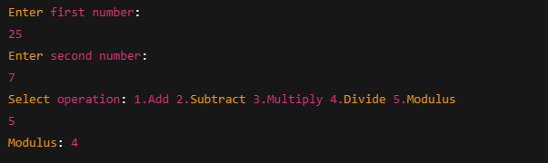

2.)simple arthimetic operation
import java.util.Scanner;

public class ArithmeticOperations {

public int num1, num2;

public int addNums(int n1, int n2) {
return n1 + n2;
}

public int subNums(int n1, int n2) {
return n1 - n2;
}

public int mulNums(int n1, int n2) {
return n1 * n2;
}

public float divNums(int n1, int n2) {
return (float) n1 / n2;
}

public int calcMod(int n1, int n2) {
return n1 % n2;
}

public static void main(String args[]) {

ArithmeticOperations obj = new ArithmeticOperations();
Scanner sc = new Scanner(System.in);

System.out.println("Enter first number:");
obj.num1 = sc.nextInt();

System.out.println("Enter second number:");
obj.num2 = sc.nextInt();

System.out.println("Addition: " + obj.addNums(obj.num1, obj.num2));
System.out.println("Subtraction: " + obj.subNums(obj.num1, obj.num2));
System.out.println("Multiplication: " + obj.mulNums(obj.num1, obj.num2));
System.out.println("Division: " + obj.divNums(obj.num1, obj.num2));
System.out.println("Modulus: " + obj.calcMod(obj.num1, obj.num2));

// Additional calculations
int sum = obj.addNums(5, 10);
int difference = obj.subNums(10, 5);
int product = obj.mulNums(5, 10);
float div = obj.divNums(10, 5);
int remainder = obj.calcMod(10, 3);

System.out.println("Sum: " + sum);
System.out.println("Difference: " + difference);
System.out.println("Product: " + product);
System.out.println("Division: " + div);
System.out.println("Remainder: " + remainder);

sc.close();
}
}

