**INDIAN INSTIT UTE OF REMOTE SENSING**

**Indian Sp ace Research Organization**

**Departmen t of space, Government of India**



**DOCUMENTATION**

**“Implementation of RNN and Image-Classification in Remote Sensing”**

**June-July, 2018**

**Under the guidance of**

**Dr. Anil Kumar**

**Head PRSD, Scientist/Engineer ‘SG’**

**PRSD/IIRS/ISRO**

**Submitted By:**

**Lakshya Dhingra**

**Pawandeep Singh**

**Pratyush Jha**

**Pranav Negi**

**Gurdeep Singh**

**Vinay Sahanan**

**INTRODUCTION:**

**The image classification is done on the given BIL-image dataset “apex12bands” of 8 bands, 12 bands and 17 bands using the concepts of RNN and deep learning. The implementation is done on the Python 3 using the editor Anaconda. The image is classified into 7 clusters namely grasslands, building1, building2, bright forest, dull forest, river and road. Encouraging results of 94.21% accuracy is achieved as a result of fuzzy classification.**

**REQUIREMENTS: Knowledge of ANN/RNN, Basics of Deep leaning, python 3**

**MODULES: TensorFlow, Keras, GDAL, numpy, learning, matplotlib**

**SOFTWARE USED: Anaconda, Jupyter notebook.**

**EXPLANATION:**

**The image classification is done on the dataset provided and has been tested against different bands i.e. 8, 12 and 17 bands.**

**The dataset was imaged in the vicinity of Baden, Switzerland on a clear day, with the sensor mounted on a Dornier DO-228 aircraft.**

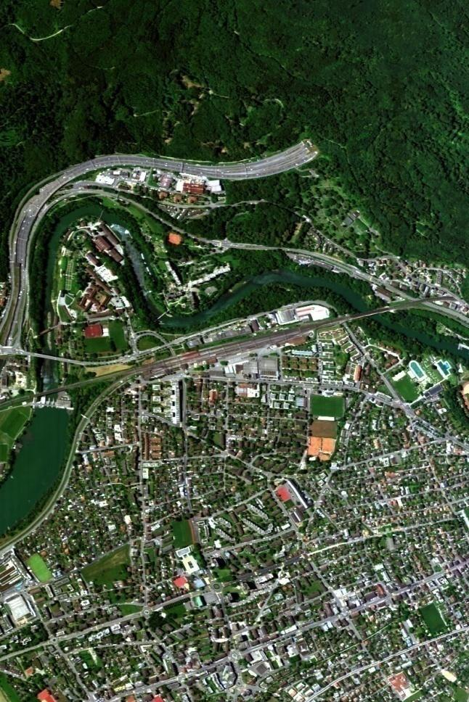

**Image Interpretation includes:**

1. **Training the classifiers**
2. **Testing the dataset**

**The classes were identified from the interpretation from the image provided. Regions of Interest were collected, verified with the data providers and used for classification and accuracy analysis.**

**Given below are the Identified Classes from the input given using soft classification methods stored in the array named path**

**path = ["grass_17", "build1_17", "build2_17", "Bright17", "Dull17", "river_17", "road_17"]**

**Sequence of Implementation**

**Import the libraries and their modules: numpy, matplotlib, gdal, keras Read the BIL file for input**

**Define the training data and read the data from BIL file**

**Define xtest,ytest,path and initial values for all the classes to be classified on the basis of model being run.**

**Calculate all the clicks and store in clicks{ } array. Swap little-endian and Big-Endian.**

**Calculate the length of all values Define the training data**

**Print xtest, xtrain, ytest, ytrain**

**Define the model: model = Sequential()**

**Add the LSTM, MaxPooling and dense (fully-connected) layers**

**model.add(LSTM(2 ** 7,2, return_sequences="True", input_shape=[12, 1]))**

**model.add(MaxPooling1D(2))**

**model.add(LSTM(2**7,return_sequences=”True”)**

**model.add(MaxPooling1D(2))**

**model.add(LSTM(2**7))**

**model.add(Dense(n_classes,activation=’sigmoid’))**

**model.compile(loss=’catergorical_crossentropy’,optimizer=’adam’,metrics=[‘accuracy’]**

**model.summary()**

**model.fit(X,y_train,batch_size=10,epochs=1500)**

**y_test_new=model.predict(x_test,batch_size=50)**

**Run the model as many times as epochs is defined in batch size. Predict the model**

**Save images in specified folders : images are saved in .tiff format**

**OUTPUT:**

**For Soft Classification:**

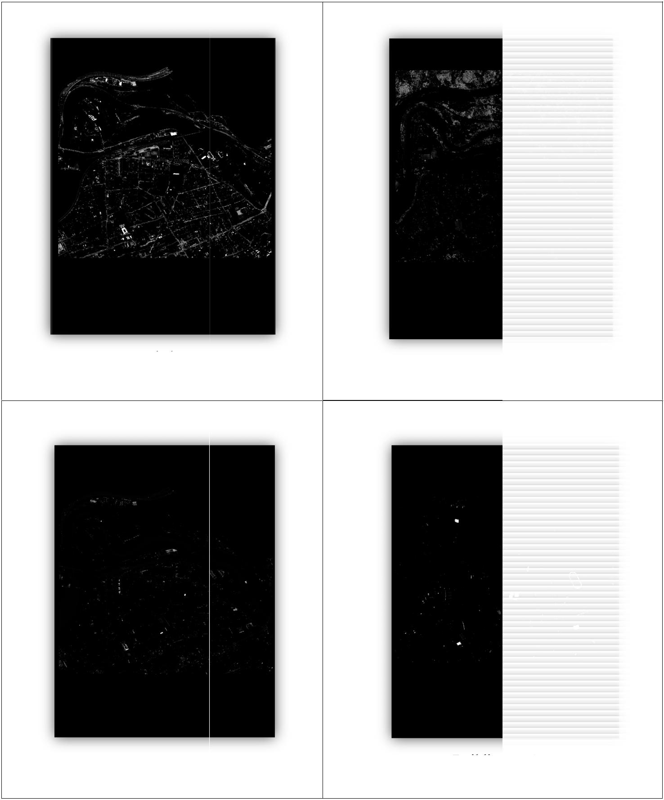

**Road class** **Dull-For est class**

**Building_1 class** **Building _2 class**

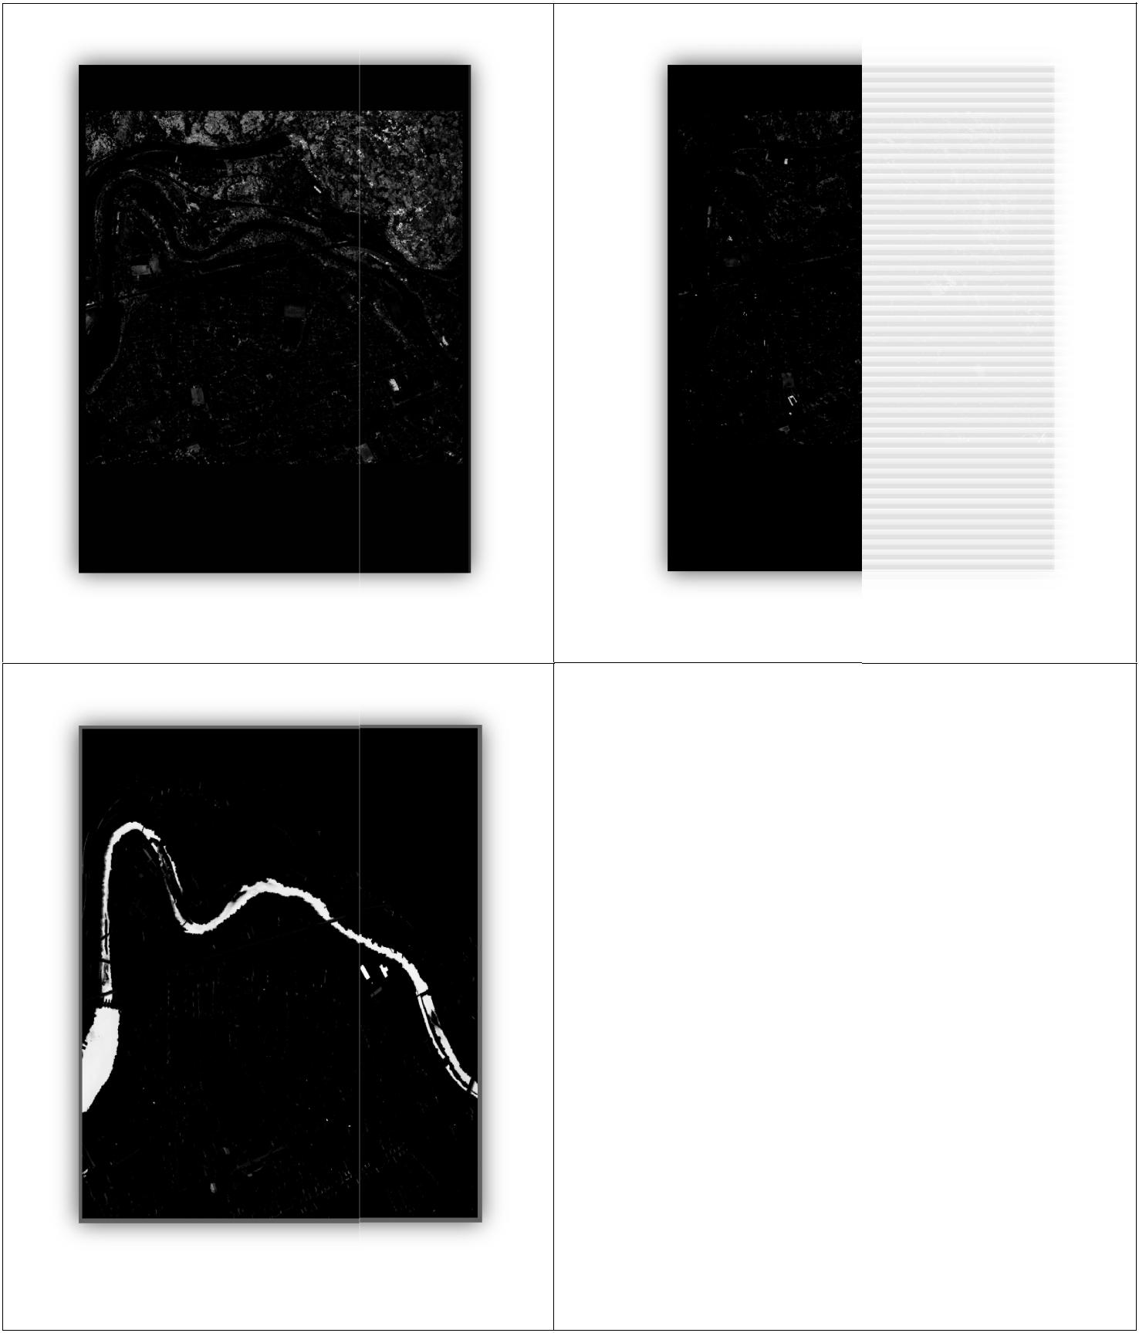

**Bright forest class** **Grassland class**

**River class**

**For Hard Classification:**

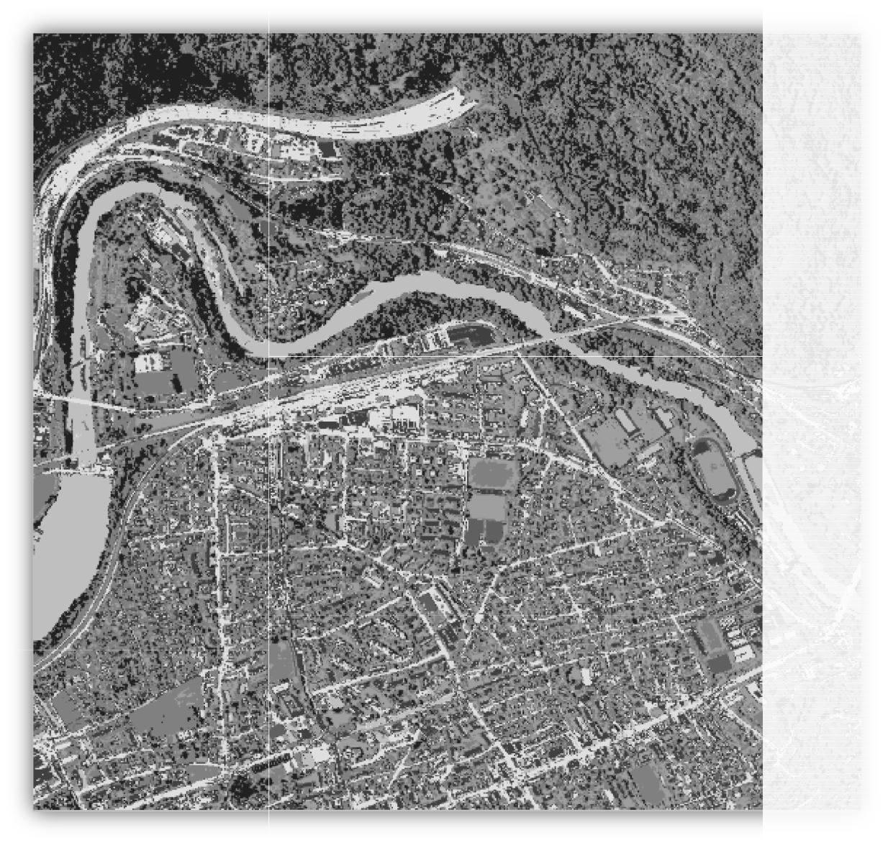

**Hard classification of the image**

**CONCLUSION:**

**On running this project the given i mage dataset “apex12 bands” of 8 bands,12 bands and 17 bands is classified based on the files defined in the path array i.e. Roads, dull forest, building_1, building_2, bright forest, grassland s and river.**

**The classification is done on the basis of soft and hard classification and resulting images are saved in the defined folders in .tiff format.**