BACSE301-Exploratory Data Analysis
Experiment 1
25BAI0193
Lakshya Chandralal
Date: 07.07.2026
1. To Check if a number is an armstrong number
def armstrong(a):
temp=a
digits=len(str(a))
sum=0
while temp>0:
d=temp%10
sum+=d**digits
temp//=10
return sum==a
a=int(input("enter number: "))
if armstrong(a):
print(a,"is an Armstrong number")
else:
print(a,"is not an Armstrong number")
OUTPUT
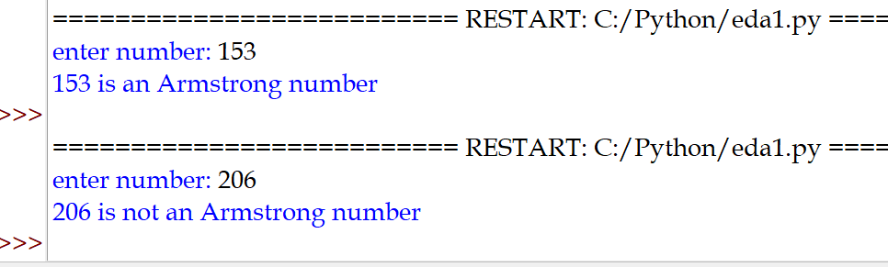
2. Python function to generate 100 distinct random numbers between 100 and 1000 and displays count of even and odd numbers
import random
def randfun():
val=[]
while len(val)<100:
p=random.randrange(100,1000)
if p not in val:
val.append(p)
e,o=0,0
for i in val:
if i%2==0:
e+=1
else:
o+=1
return e,o,val
e,o,val=randfun()
print("list: ",val)
print("number of even numbers: ",e)
print("number of odd numbers: ",o)
OUTPUT
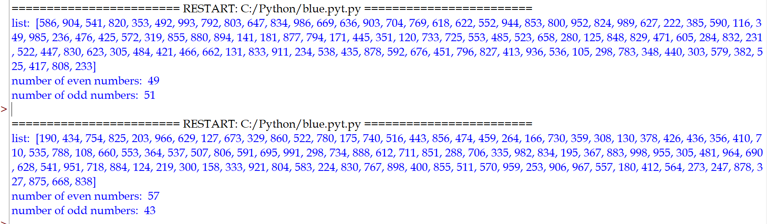

3. Pyramid Generator
def pyramid(n):
for i in range(1,n+1):
num=1
print(' '*(n-i),end='')
for j in range(1,i+1):
print(num,end='')
num+=1
num-=1
for k in range(num-1,0,-1):
print(k,end='')
print()
n=int(input("Enter n: "))
pyramid(n)
OUTPUT
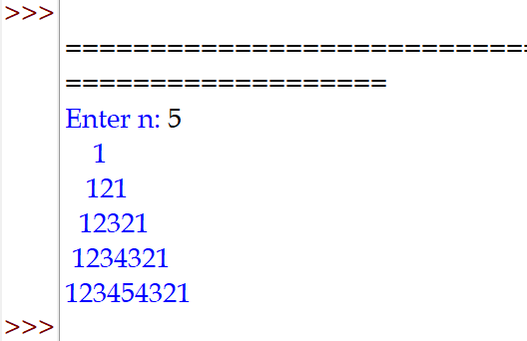

4. Program to find tuples which have all elements divisible by K from a list of tuples
def counter(l,k):
for i in l:
for j in i:
if j%k!=0:
break
else:
print(i)
l=[]
n=int(input("Enter number of tuples: "))
for i in range (n):
l.append(eval(input("Enter tuple: ")))
k=int(input("Enter k: "))
counter(l,k)
OUTPUT
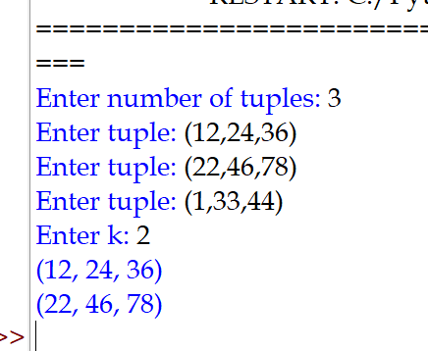

5. A function to create a dictionary with the roll number, name and marks of n students in a class and display the names of students scoring above 75.
def result(n):
d={}
for i in range(n):
r=int(input("enter roll no: "))
nam=input("enter name: ")
m=eval(input("enter mark: "))
d[r]={'name': nam,'marks' : m}
print("students who scored above 75: ")
for i in d:
D=d[i]
z=D['marks']
if str(z)>'75':
print(D['name'])
n=int(input("enter number of students: "))
result(n)
OUTPUT
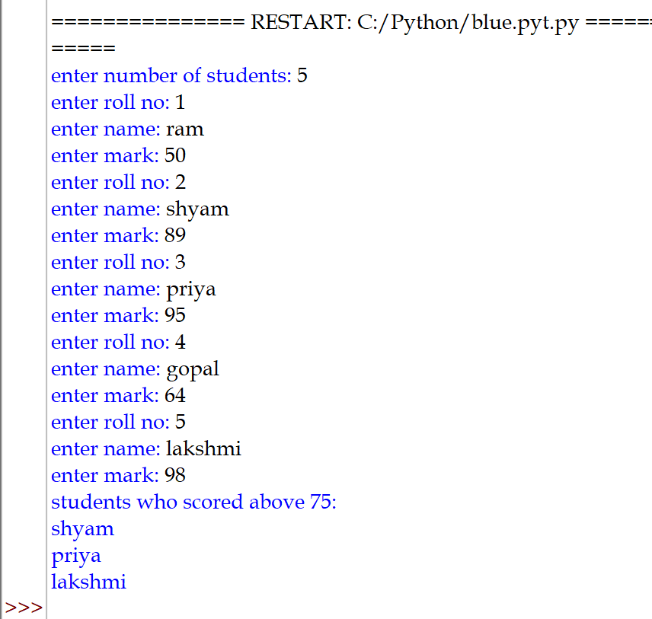

6. A function that takes a list as an argument, generates a unique list from it, and then calculates the difference between the sums of elements in the original and unique lists.

def unique(L1):
L2=[]
for i in L1:
if L1.count(i)==1:
L2.append(i)
print ("New List is",L2)
print("Difference is",(sum(L1))-(sum(L2)))
L1=eval(input("Enter List: "))
unique(L1)
OUTPUT
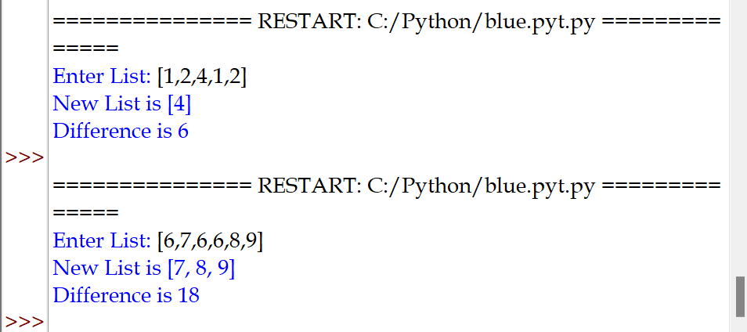

7. A function to pass a tuple of integer elements and an element to be searched as arguments and then search for a given element in the tuple and if found print its position otherwise display appropriate message.

def searchapp(t,e):
for i in range(len(t)):
if t[i]==e:
print("element found at positon: ",i)
break
else:
print("element not found")
t=eval(input("enter tuple: "))
e=eval(input("enter element to be searched: "))
searchapp(t,e)
OUTPUT
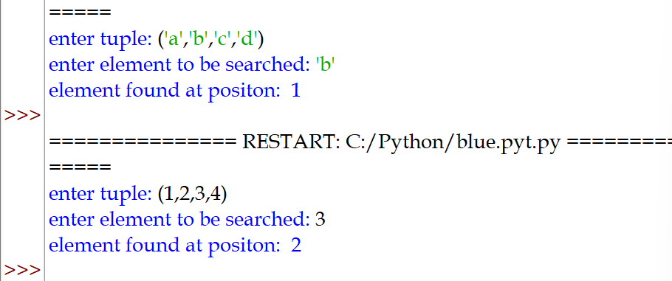

8. Grade and Grade Point Calculator
def report_card():
global d
for i in d:
if d[i][0]>=91 and d[i][0]<=100:
d[i]=d[i]+["A1",10.0]
elif d[i][0]>=81 and d[i][0]<=90:
d[i]=d[i]+["A2",9.0]
elif d[i][0]>=71 and d[i][0]<=80:
d[i]=d[i]+["B1",8.0]
elif d[i][0]>=61 and d[i][0]<=70:
d[i]=d[i]+["B2",7.0]
elif d[i][0]>=51 and d[i][0]<=60:
d[i]=d[i]+["C1",6.0]
elif d[i][0]>=41 and d[i][0]<=50:
d[i]=d[i]+["C2",5.0]
elif d[i][0]>=33 and d[i][0]<=40:
d[i]=d[i]+["D",4.0]
elif d[i][0]>=21 and d[i][0]<=320:
d[i]=d[i]+["E1",0.0]
else:
d[i]=d[i]+["E2",0.0]
print("ENTER DETAILS BELOW")
print()
n=input("Enter name: ")
print()
print("Enter subject and marks one by one")
d={}
for i in range (5):
s=input("Enter subject: ")
m=int(input("Enter marks: "))
L=[m]
d[s]=L
report_card()
print()
print("\tREPORT CARD")
print("Name of Student: ",n)
print("Subject\tMarks\tGrade\tGrade Point")
for i in d:
print(i,"\t",d[i][0],"\t",d[i][1],"\t",d[i][2])
OUTPUT
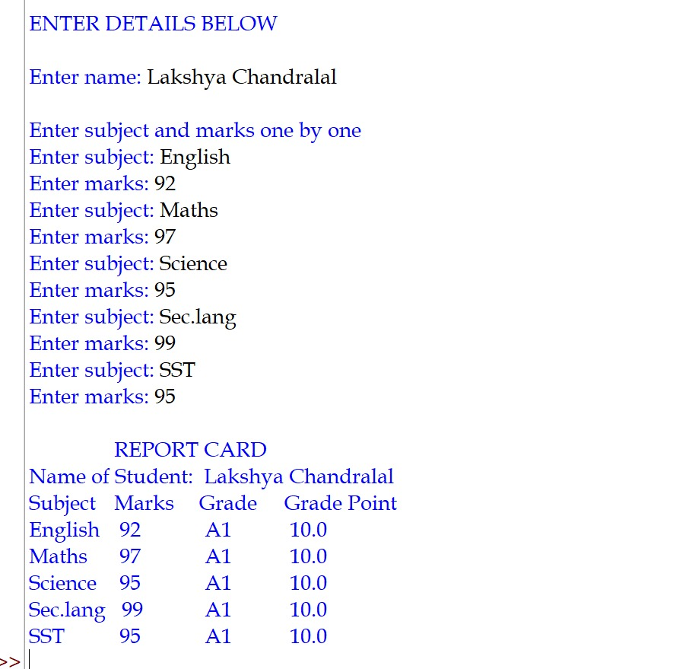

9. Rotate a list by K positions.
def rotate_list(l,k,dirn):
n=len(l)
k=k%n
if dirn.lower()=="left":
return l[k:]+l[:k]
elif dirn.lower()=="right":
return l[-k:]+l[:-k]
else:
return "invalid direction"
l=list(map(int,input("enter list elements: ").split()))
k=int(input("enter k: "))
dirn=input("enter direction (left/right): ")
result=rotate_list(l,k,dirn)
print("rotated list: ",result)
OUTPUT
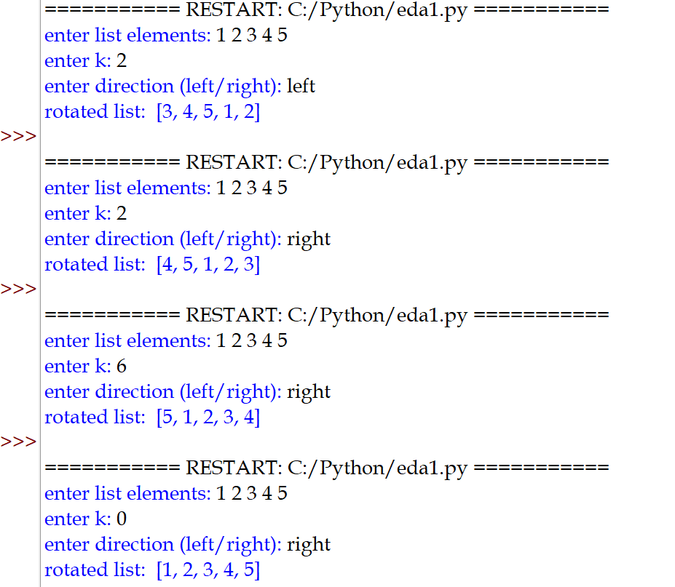
10. A menu driven program to input a string and invoke following functions based upon user’s choice.
- palindrome (s) – to check whether passed string is palindrome. It returns True, if it is a palindrome otherwise False.
- is_anagram(s1, s2) – to check whether the number of occurrences of each letter remain the same, but their positions different.
- is_evenstring(s) – to check whether passed string is even length string.
- is_Substring_exists(s,sub) – to checks whether substring sub exists in s.
def palindrome(s):
if s[::-1]==s:
return("true")
else:
return("false")
def is_evenstring(s):
if len(s)%2==0:
print("string is of even length")
else:
print("string is not of even length")
def is_anagram(s1, s2):
s1=s1.replace(" ", "")
s2 = s2.replace(" ", "")
s1.lower()
s2.lower()
if len(s1)==len(s2):
c1={}
c2={}
for i in s1:
if i in c1:
c1[i]+= 1
else:
c1[i] = 1
for j in s2:
if j in c2:
c2[j] += 1
else:
c2[j]= 1
return c1==c2
def is_Substring_exists(s,sub):
if sub in s:
print("substring present in the string")
else:
print("substring not present in the string")
print("starting menu driven program")
print("choose the following options:")
ch=0
while ch<6:
print("choice menu: ")
print("1.to check palindrome")
print("2.to check anagram")
print("3.to check even string")
print("4.to check if substring present in given string")
print("5.Exit")
ch=int(input("enter choice number: "))
if ch==1:
s=input("enter string: ")
print(palindrome(s))
elif ch==2:
s1=input("enter string 1: ")
s2=input("enter string 2: ")
print(is_anagram(s1, s2))
elif ch==3:
s=input("enter string: ")
is_evenstring(s)
elif ch==4:
s=input("enter string: ")
sub=input("enter string: ")
is_Substring_exists(s,sub)
elif ch==5:
print("exiting menu driven program")
break
else:
print("invalid choice")

OUTPUT
