End-to-End Machine Learning System for Diabetes
Risk Prediction

Project Id: AIML- 14

Name : UDDHAV BHARGAVA
Class Roll Number: 75
University Roll Number : 2028889
Section and Group: Q & G2

Name : LAKSHYA GUSAIN
Class Roll Number: 52
University Roll Number : 2028753
Section and Group: Q & G2

Student Name – JASMEET SINGH
University Roll number – 2028732
Section – Q & G3

- Problem Description 3
- Architecture 4
- Models model 5
- Evaluation metrics used 6
- Preliminary Results and Visualizations 7
- References 8

- Problem Description

Diabetes is a chronic medical condition that affects millions of people globally and can lead to severe complications like heart disease, kidney failure, and nerve damage if not managed early. In real life, early detection is often difficult because symptoms can be subtle. This project aims to bridge that gap by using Machine Learning to analyze clinical data—such as blood pressure, glucose levels, and BMI—to predict a patient's risk of being diabetic. By automating this screening process, healthcare providers can prioritize high-risk patients for further testing, leading to faster intervention, reduced healthcare costs, and significantly better long-term health outcomes for patients.

- Architecture

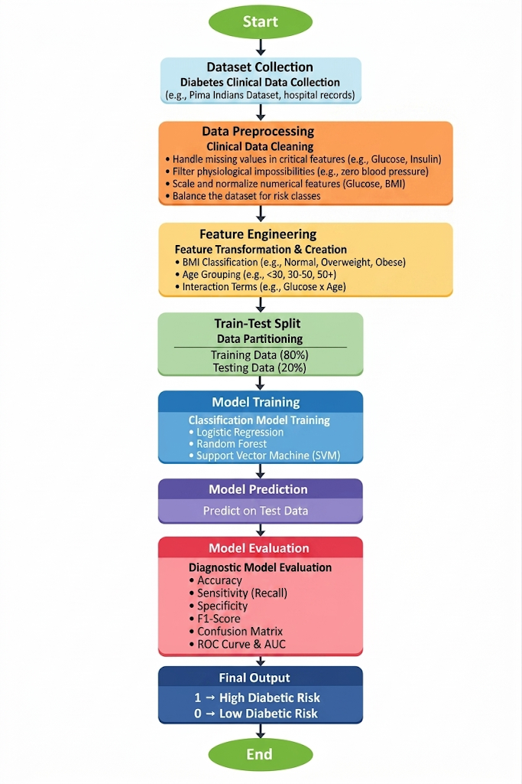

- Models Used(Applied/ Planned) Give a brief introduction of the models used

1. Logistic Regression
Despite its name, Logistic Regression is a fundamental linear model used for binary classification.
- How it works: It uses the Logistic Function (Sigmoid) to map any real-valued number into a probability between 0 and 1. If the probability is above 0.5, the patient is classified as Diabetic (1); otherwise, they are Non-Diabetic (0).

- Role in Project: It serves as a strong baseline model. It is highly explainable, allowing healthcare providers to see how much a single unit increase in glucose increases the mathematical odds of having diabetes.

2. K-Nearest Neighbors (KNN)
KNN is a non-parametric, instance-based learning algorithm.
- How it works: It operates on the principle of similarity. To predict a new patient's status, the model looks at the "$k$" most similar patients in the clinical dataset (based on features like BMI and Age). The final prediction is determined by a majority vote of those neighbors.
- Role in Project: KNN is effective at capturing local patterns and non-linear relationships in medical data that a simple linear model might miss. It requires careful normalization/standardization since it relies on calculating distances between data points.

3. Support Vector Machine (SVM)
SVM is a powerful supervised learning model used for both linear and non-linear classification.
- How it works: SVM seeks to find the optimal hyperplane (a decision boundary) that maximizes the margin between the two classes (Diabetic vs. Non-Diabetic). In cases where the data isn't linearly separable, it uses a "kernel trick" to project the data into a higher-dimensional space where a boundary can be drawn.
- Role in Project: SVM is known for its high accuracy in high-dimensional spaces. It is particularly robust against overfitting, making it a reliable choice for clinical settings where precision and generalization to new patients are critical.

- Evaluation metrics used

The following metrics are used to evaluate model performance:
1. Accuracy
- Definition: The proportion of correct predictions (both diabetic and non-diabetic) out of the total number of cases.
- Clinical Context: While a fundamental metric, accuracy alone can be misleading if the dataset is imbalanced (e.g., far more non-diabetic than diabetic records).
2. Precision
- Definition: The ratio of true positive (correctly predicted diabetic) cases to all cases predicted as positive by the model.
- Clinical Context: Higher precision reduces "false alarms,"
ensuring that patients identified as "High Risk" are highly likely to actually have the condition.
3. Recall (Sensitivity)
- Definition: The proportion of actual diabetic cases that were correctly identified by the model.
- Clinical Context: This is the most critical metric in medical screening. High recall minimizes False Negatives, ensuring that diabetic patients are not incorrectly cleared as healthy.

4. F1-Score
- Definition: The harmonic mean of precision and recall, providing a single score that balances both.
- Clinical Context: It is particularly useful for assessing models on imbalanced medical datasets where a balance between capturing all cases (Recall) and maintaining accuracy (Precision) is required.
- Confusion Matrix

- Definition: A $2 \times 2$ table showing the counts of True Positives (TP), True Negatives (TN), False Positives (FP), and False Negatives (FN).
- Clinical Context: It provides a clear visualization of where the model "gets confused"—specifically, whether it is more prone to over-diagnosing or under-diagnosing diabetes.
6. ROC Curve and AUC
- ROC Curve: A graphical plot that illustrates the diagnostic ability of a classifier by comparing the True Positive Rate vs. the False Positive Rate at various thresholds.
- AUC (Area Under the Curve): A single value summarizing the ROC curve. An AUC of 1.0 represents perfect discrimination, while values above 0.80 are generally considered clinically useful for medical diagnostic tests.
5. Preliminary Results and Visualizations
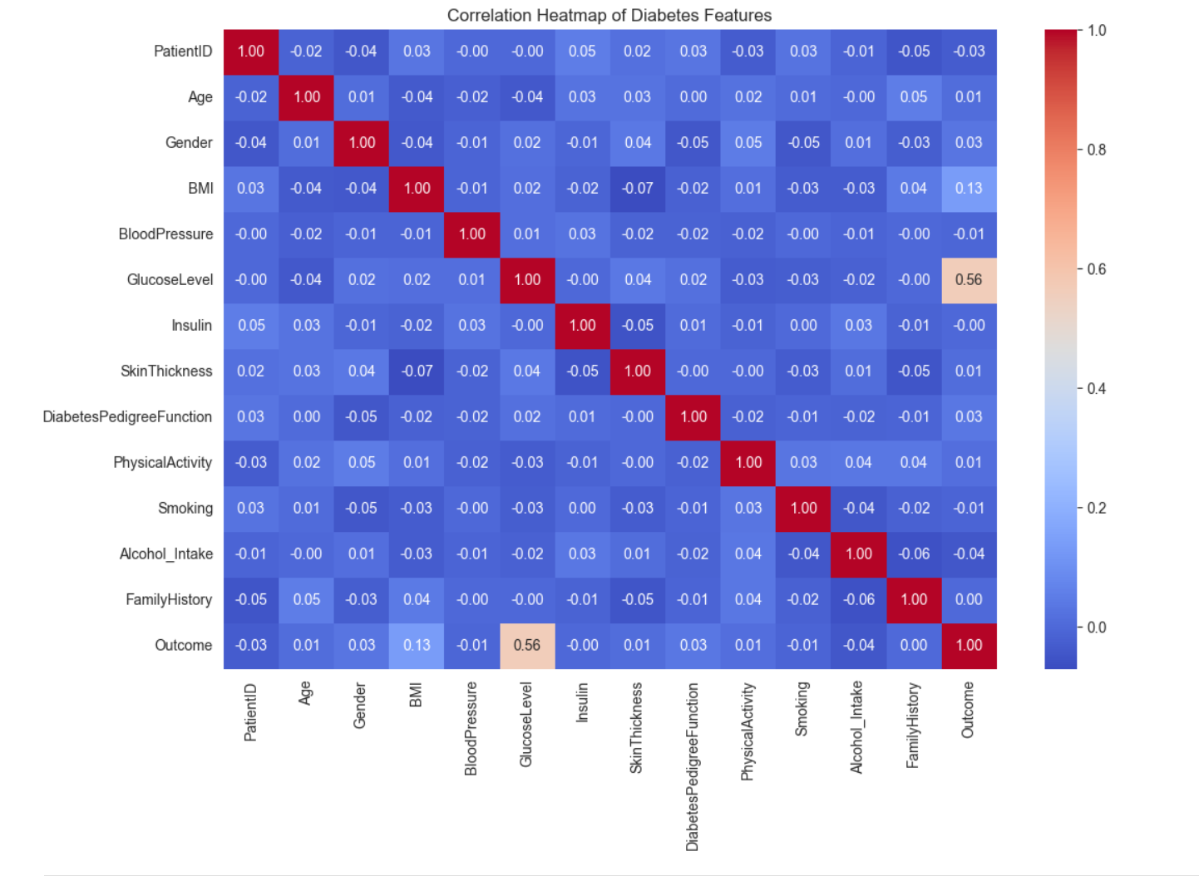

6. References:
Books:
- Let Us Python – Yashavant Kanetkar

Online Resources:
• Harris, C. R., et al. (2020). Array programming with NumPy. Nature, 585(7825), 357–362.
• Hunter, J. D. (2007). Matplotlib: A 2D graphics environment. Computing in Science & Engineering, 9(3), 90–95.
• Pedregosa, F., et al. (2011). Scikit-learn: Machine Learning in Python. Journal of Machine Learning Research, 12, 2825–2830.

