Data Visualization and Reporting for Business Insights
How Python charts turn raw numbers into decisions
Prepared by Lucky | ML Internship, 3Skill | Week 3

1. Overview
A table with 100,000 rows doesn't tell anyone anything. A single well-chosen chart of the same data can tell a manager, in about five seconds, that sales spike every November, that one region is falling behind, or that late deliveries are dragging reviews down. That jump from numbers to understanding is the whole point of visual analytics, and it's why visualisation sits at the centre of business intelligence.
People are good at spotting shapes, gaps and changes, and not so good at scanning columns of digits. A chart takes advantage of that. It helps a team see a trend before it becomes a problem, compare options at a glance, and agree on what the data is actually saying. It also makes insights easy to share. A decision-maker who has never opened a notebook can still read a clear chart.

Why Python for visualisation
- One environment from start to finish. The same notebook that cleans and analyses the data can draw the charts, so there's no copy-pasting between tools and fewer chances for numbers to get out of sync.
- Reproducible. A chart made with code can be regenerated in seconds when the data updates, and anyone can check exactly how it was built.
- Flexible. From a quick histogram to a polished interactive dashboard, there's a library for each level of effort.
- Free and well supported. Matplotlib, Seaborn and Plotly are open source with large communities and plenty of documentation.
- Plays well with the rest of the stack. Pandas, NumPy and Scikit-learn outputs plug straight into plotting functions.
This document explains how I plan to use visualisation in the e-commerce analytics project from Weeks 1 and 2. It covers which charts to use and when, which Python tools suit which job, how to read charts correctly, and how to wrap a chart in a short narrative that a business reader can act on.

2. Visualisation Techniques
The right chart depends on the question being asked. I start from the question and then pick the form, not the other way round. The table below sums up the main types and how I'd use each one in this project.
Chart type | Best for | Example in this project | Watch out for
Bar chart | Comparing amounts across categories | Revenue by product category | Start the axis at zero; sort bars so the ranking is obvious
Horizontal bar | Comparing many categories with long names | Top 15 product categories by orders | Too many bars gets cluttered; show a top N
Line chart | Change over time | Monthly sales across the year | Don't use for unordered categories; avoid too many lines
Scatter plot | Relationship between two numbers | Delivery delay against review score | Overplotting on large data; use transparency or hexbin
Histogram | Shape of one numeric variable | Distribution of order values | Bin width changes the story; try a few
Box plot | Spread, median and outliers across groups | Delivery time by region | Hides the shape of the data; pair with a histogram if needed
Heatmap | Patterns across two dimensions | Orders by weekday and hour; correlation matrix | Needs a sensible one-hue colour scale and clear labels
Stacked bar | Parts of a total across a few groups | Revenue split by payment type per quarter | Only the bottom segment is easy to compare; keep segments few
Pie / donut | Share of a whole, only with 2 to 4 slices | Share of new vs returning customers | Hard to compare similar slices; a bar is usually clearer
Cohort heatmap | Retention over time by sign-up group | Share of customers returning month by month | Make sure cohort sizes are shown, as small cohorts are noisy
Map | Geographic differences | Order volume by state | Big areas draw the eye even if they have few customers
Single number (KPI tile) | One headline figure | Total revenue, repeat-purchase rate | Always show a comparison such as last period, or the number means little

Matching chart to business question
- "How much?" or "Which is biggest?" Bar charts.
- "How is it changing?" Line charts, with a clear time axis.
- "Are these two things related?" Scatter plots, with a trend line if it helps.
- "What does typical look like, and how spread out is it?" Histograms and box plots.
- "When or where is it busiest?" Heatmaps and maps.
- "Are customers sticking around?" Cohort retention heatmaps and line charts.

Design principles I'll follow
- One message per chart. The title should say what the reader should take away, not just name the variables.
- Use colour with purpose. Pick one colour for one series, and use a second colour only to highlight something that matters. Avoid rainbow palettes.
- Keep the axes honest: bars start at zero, and I avoid dual-axis charts, because two scales on one chart make it easy to imply a link that isn't there.
- Label directly where possible, so the reader doesn't have to hunt through a legend.
- Cut the clutter: light gridlines, no 3D effects, no unnecessary borders or decoration.
- Think about accessibility. Don't rely on colour alone to tell series apart, and check that text is readable.
- Always state units, time period and data source.

3. Tool Descriptions
Library | Strengths | Best use case | Limitations
Matplotlib | The foundation of Python plotting. Total control over every element; produces publication-quality static images. | Custom, polished charts for reports and documents | More code for good-looking results; defaults need styling
Seaborn | Built on Matplotlib. Attractive defaults and statistical charts (distributions, box plots, heatmaps, regression plots) in a line or two, works directly with Pandas. | Fast exploratory analysis and statistical visuals | Less control over fine details; still static
Plotly | Interactive charts with hover, zoom and filtering, plus maps and animations. Exports to HTML. | Interactive exploration and shareable dashboards | Larger files; styling takes a bit of learning
Pandas plotting | df.plot() gives a quick chart straight from a DataFrame. | Very quick first looks during cleaning | Basic styling only
Dash or Streamlit (optional) | Turn Plotly charts into a small web dashboard with filters. | A simple dashboard for stakeholders | Needs extra setup; outside the core scope of this project

My plan is to use each tool for what it's best at. Pandas plotting and Seaborn for fast exploration, Matplotlib for the final polished charts that go into the report, and Plotly where interactivity helps a reader explore, such as hovering over regions on a map.
Sample code: a clean line chart in Matplotlib
import matplotlib.pyplot as plt

monthly = orders.groupby("order_month")["revenue"].sum()

fig, ax = plt.subplots(figsize=(8, 4))
ax.plot(monthly.index, monthly.values, linewidth=2, marker="o")
ax.set_title("Revenue peaks in November")
ax.set_ylabel("Revenue")
ax.grid(axis="y", alpha=0.3)
for side in ["top", "right"]:
ax.spines[side].set_visible(False)
fig.savefig("revenue_trend.png", dpi=200, bbox_inches="tight")

Sample code: a statistical view in Seaborn
import seaborn as sns

sns.boxplot(data=orders, x="delivery_bucket", y="review_score")
sns.heatmap(df[numeric_cols].corr(), annot=True, cmap="Blues")

Sample code: an interactive chart in Plotly
import plotly.express as px

fig = px.bar(category_sales, x="category", y="revenue",
title="Revenue by product category")
fig.update_layout(template="simple_white")
fig.write_html("category_revenue.html")

4. Interpretation Guidelines
Making a chart is only half the job. Reading it properly, and helping others read it, is the other half. These are the questions I'll ask of each chart type.
Chart | What to look for | Common traps
Bar chart | Which categories are largest and smallest, how big the gaps are, and whether the ranking matches what the business expects. | A truncated axis exaggerates differences. Large totals may hide poor profitability.
Line chart | The overall direction, repeating seasonal patterns, sudden jumps or drops, and whether a change is lasting or a one-off. | Reading too much into a single point; comparing years with different lengths; ignoring promotions or holidays that explain a spike.
Scatter plot | Direction and strength of the relationship, clusters, and points that sit far from the rest. | Correlation is not causation. A hidden third factor may drive both variables.
Histogram | Where most values sit, how spread out they are, whether the shape is skewed, and whether there are several peaks. | A skewed shape means the average can be misleading; the median may describe the typical case better.
Box plot | The median line, the box (middle half of the data), and the dots beyond the whiskers, which are potential outliers. | Outlier dots are worth investigating, not automatically errors.
Heatmap | Dark or bright zones that mark hot spots, such as busiest days and hours, or strongly correlated variables. | Colour scale choice changes the impression. Check the legend first.
Cohort heatmap | How quickly each group drops off, and whether newer groups retain better than older ones. | Recent cohorts have less history, so don't compare them to older cohorts at the same calendar date.
Pie chart | Whether one slice clearly dominates. | Similar slices can't be ranked by eye. Switch to a bar.

A general reading routine
- Read the title, axes and units first. Many misreadings come from skipping this.
- Find the main pattern. What's the single biggest thing the chart is saying?
- Look for exceptions. Spikes, dips, outliers and gaps are often where the insight is.
- Ask "compared with what?" A number is only meaningful against last period, a target or another group.
- Ask "so what?" Turn the pattern into a business action or a follow-up question.
- Check the context. Sample size, time period, missing data and known events (festivals, sales, outages) can all change the meaning.

5. Reporting Workflow
Charts are most useful when they're part of a clear report. This is the workflow I plan to follow for the final project report.
- Start with the audience and the decision. A marketing manager and an operations manager need different views of the same data.
- Lead with the answer. Put the key finding and recommendation first, then the supporting charts.
- One chart, one idea. If a chart needs a long explanation, it's probably trying to do too much.
- Pair every chart with a short caption or narrative. What it shows, why it matters, what to do about it.
- Keep a KPI summary at the top. Total revenue, repeat-purchase rate, average delivery delay and average review score, each shown against a comparison.
- Be honest about limits. Mention data gaps, assumptions and anything the charts can't prove.
- Make it reproducible. Keep the plotting code in the notebook so charts can be refreshed when new data arrives.

6. Sample Narrative for a Business Scenario
Below is an example of how I'd present two charts to a business reader. The numbers here are made up to show the style of narrative; the real project will use the actual dataset.
Scenario: The operations and marketing heads of an online retailer want to know when to prepare for peak demand, and whether delivery problems are hurting customer satisfaction.

Example 1: Revenue over the year
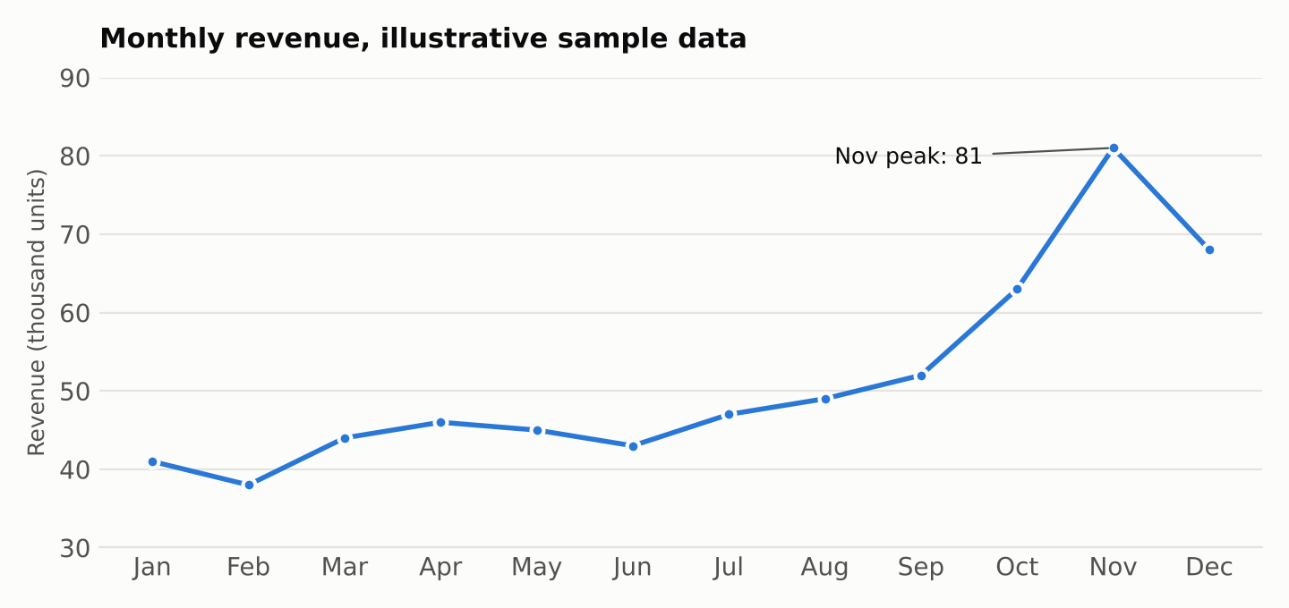
Figure 1. Monthly revenue (illustrative sample data)
Narrative: Revenue stays fairly steady at around 40 to 50 thousand units a month from January to August, then starts to climb in September. It jumps to 63 in October and peaks at 81 in November, nearly double the spring average, before falling back to 68 in December. This pattern points to a strong festive-season effect, with demand building weeks before the peak and staying elevated into December.
Why it matters: The warehouse and delivery partners have to be ready by early October, not in November when orders are already arriving. Marketing spend is likely to work hardest in the build-up, so campaigns should start in September. And because the quiet months look stable, they're the right time for planned maintenance or system changes.
Caution: This is one year of data. Before locking in a plan, I'd check whether the same pattern shows up in other years and whether a one-off promotion helped cause the peak.

Example 2: Delivery timing and customer reviews
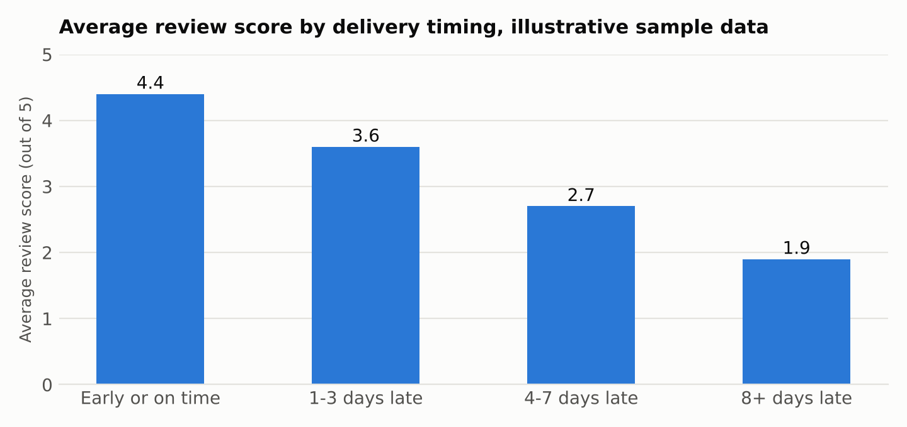
Figure 2. Average review score by delivery timing (illustrative sample data)
Narrative: Orders delivered early or on time earn an average review of 4.4 out of 5. Each step of lateness brings a clear drop: 3.6 for orders a few days late, 2.7 for four to seven days late, and just 1.9 when delivery is more than a week late. The decline is steady, and the worst group scores less than half as well as the best.
Why it matters: If late delivery is really driving the poor reviews, then improving logistics could lift satisfaction more than any new marketing campaign. The first target should be the longest delays, since those orders are the most damaging. Reviews are public, so fixing this also protects future sales.
Caution: The chart shows an association and not proof of cause. Late orders may also involve other problems, such as damaged items or stock-outs. I'd follow up by splitting the results by product category and region, and by reading a sample of the written complaints.

Recommended actions from the two charts
- Agree peak-season staffing and stock plans with operations by the end of September.
- Start festive marketing earlier, to catch the October build-up.
- Set a target to cut deliveries more than a week late, and track the share of such orders as a monthly KPI.
- Review the slowest regions and carriers first.

7. Common Pitfalls and How to Avoid Them
Pitfall | How to avoid it
Choosing a chart because it looks impressive | Start from the question. If a simple bar answers it, use the bar.
Misleading axes | Start bars at zero, keep scales consistent, and avoid dual axes.
Too many colours or categories | Limit to a handful, group the rest as "Other", and use colour to highlight, not decorate.
Unlabelled or vague charts | Give every chart a clear title, units, period and source.
Showing everything | Pick the few charts that support the decision. Move the rest to an appendix.
Claiming cause from correlation | Use careful words such as "is associated with" and suggest a follow-up test.
Ignoring the audience | Match the level of detail and jargon to the reader.
Hard-to-update charts | Generate charts from code so they refresh when the data does.

8. Conclusion
Good visualisation isn't about making data look pretty. It's about making it understood. By choosing the chart that fits each business question, using Python tools for the jobs they do best, reading charts carefully, and wrapping each one in a short narrative with a clear recommendation, I can turn the analysis in this project into something a business reader can actually use.
In the coming weeks I'll apply this approach to the cleaned retail data, building the charts for customer segments, sales trends, product performance and delivery impact, and pulling them into a final report that supports real decisions.

