Advanced Analytics and Time-Series Analysis
Finding trends, seasonality and surprises in business data with Python
Prepared by Lucky | ML Internship, 3Skill | Week 5

1. Introduction
Raw data on its own doesn't help anyone make a decision. It has to be turned into something that answers a question: what happened, why it happened, what is likely to happen next, and what the business should do about it. Those four questions map neatly onto the four levels of analytics that most organisations climb through.
Level | Question it answers | Example in this project
Descriptive | What happened? | Monthly revenue and order counts over the last four years
Diagnostic | Why did it happen? | Why revenue dropped in one month; which region or category drove it
Predictive | What is likely to happen? | Forecasting the next six months of revenue and demand
Prescriptive | What should we do? | How much stock to order and when to start festive campaigns

The earlier weeks of this project covered the descriptive and diagnostic side (cleaning, exploring and visualising the data) and the predictive side through regression. This week goes a step further into advanced analytics, with a focus on time-series analysis. Time is the dimension on which almost every business runs: sales by month, orders by hour, stock by week, customers by sign-up date. Techniques that respect the order of time can pull out insights that ordinary methods miss, and they're the foundation of forecasting.
Advanced analytics adds value because it moves a business from reacting to anticipating. A team that sees a seasonal peak coming can prepare for it. A team that gets an alert about an unusual drop in orders can look into it the same day, not at the end of the quarter. This document explains how I plan to detect trends, seasonal patterns and anomalies in the retail data using Python, how to build and check forecasts, and how to translate the results into business action.

2. Time-Series Analysis

2.1 What a time series is
A time series is a set of observations recorded in time order, usually at regular intervals, such as daily orders, weekly revenue or monthly average delivery time. What makes it different from ordinary tabular data is that the order matters. Today's value is usually related to yesterday's, so the rows can't be shuffled or treated as independent, and many standard techniques (including random train/test splits) need adjusting.

2.2 The components of a time series
Component | What it means | Retail example
Trend | The long-run direction: upward, downward or flat | Revenue slowly growing as the customer base expands
Seasonality | Patterns that repeat at a fixed period, such as weekly, monthly or yearly | A festive-season spike every October to December; busier weekends
Cycles | Longer, irregular swings without a fixed period, often linked to the economy | Spending slowing during an economic downturn
Irregular (noise) | Random variation that can't be explained by the other components | Day-to-day fluctuation in orders
Events and anomalies | One-off shocks and unusual points | A site outage, a viral product, a supply problem

Components can combine in two ways. In an additive series the seasonal swing stays about the same size however high the trend goes (value = trend + seasonal + noise). In a multiplicative series the swing grows along with the trend (value = trend x seasonal x noise). Retail revenue is often multiplicative, since a 20 percent festive boost is a bigger absolute number when the business is larger. Plotting the series makes the choice clear: if the seasonal peaks get taller as the trend rises, use multiplicative, or take logs and use additive.

2.3 Challenges of time-series data
- Dependence over time. Observations aren't independent, so random shuffling and ordinary cross-validation give falsely optimistic results. Splits must respect time.
- Non-stationarity. Many models assume the statistical properties of the series (average, spread, autocorrelation) stay stable. Series with a trend or seasonality usually don't, so they need to be transformed, for example by differencing.
- Gaps and irregular timestamps. Missing days, duplicated timestamps and mixed time zones are common in real order data and can quietly distort results.
- Short history. Estimating yearly seasonality needs at least two or three full years. With less, the model can't separate a seasonal pattern from a one-off.
- Structural breaks. A new warehouse, a price change or a pandemic can change the series permanently. Models trained on the old regime can fail afterwards.
- Moving events. Festivals and sales that fall on different dates each year don't fit a simple calendar-based seasonal pattern and need to be modelled as events.
- Granularity. Daily data is noisy; monthly data is smooth but short. The level of aggregation should match the decision being made.
- Uncertainty grows with the horizon. Forecasting next week is much easier than forecasting next year, so every forecast should come with a range.

2.4 Trend analysis techniques
- Moving averages and rolling means: smooth out the noise so the direction is visible. A 12-month average also removes yearly seasonality.
- Year-over-year and month-over-month growth: simple percentage changes that compare like with like and cancel out seasonality.
- Linear or polynomial trend fitting: regress the value on time to measure the average rate of change.
- Decomposition (classical or STL): separates the series into trend, seasonal and residual parts, so the trend can be read cleanly.
- Differencing: subtracting the previous value turns a trending series into changes, which is a standard way to remove trend before modelling.

2.5 Seasonality detection techniques
- Seasonal plots and calendar profiles: plot each year on the same axes, or average by month, weekday or hour, and the repeating shape stands out.
- Decomposition: the seasonal component shows how large the pattern is in real units.
- Autocorrelation (ACF) plots: a strong spike at lag 12 in monthly data, or lag 7 in daily data, is the signature of seasonality.
- Periodograms or Fourier analysis: find the dominant cycle lengths when the period isn't obvious in advance.
- Model components: Prophet and similar models report the yearly and weekly effects they have learned, which can be inspected directly.

2.6 Anomaly detection techniques
An anomaly in a time series is a point that doesn't fit the expected pattern. The key is to compare each value against what was expected given the trend and seasonality, not against a single overall average, because a December peak would otherwise look "unusual" every year.
- Residual-based: decompose the series, then flag points where the residual is far from normal, for example more than 3 standard deviations, or outside the IQR fences.
- Forecast-interval-based: flag actual values that fall outside the prediction interval of a model trained on earlier data.
- Rolling statistics: compare each point with a rolling mean and standard deviation over recent weeks.
- Machine learning methods (optional): Isolation Forest or similar models on features such as lags and rolling statistics, for many series at once.
A flag is a prompt to investigate, not a verdict. Each one might be a data error (a missing feed or duplicated load), a real one-off event (an outage or a viral product), or the early sign of a lasting change. The right response is different in each case, so the context has to be checked before anything is removed or acted on.

3. Python Tools
Library | What it offers | Typical use in this project
Pandas | Datetime parsing, DatetimeIndex, resample(), asfreq(), rolling(), shift(), diff(), date-part features | Turning raw orders into clean daily, weekly or monthly series; rolling averages; lag features
NumPy | Fast numerical operations, log transforms, array maths | Transforms and error calculations
statsmodels | seasonal_decompose, STL, adfuller (stationarity test), ACF/PACF, ExponentialSmoothing (Holt-Winters), ARIMA and SARIMAX, prediction intervals | Decomposition, stationarity checks and classical forecasting models
Prophet | Additive model with trend, yearly/weekly seasonality, holidays and changepoints. Handles gaps and outliers well and needs little tuning; gives uncertainty intervals | Quick, robust forecasts with holiday effects such as festive sales
scikit-learn | Metrics, TimeSeriesSplit, regression and tree models on lag features | Evaluation and machine-learning forecasts built from engineered features
Matplotlib, Seaborn, Plotly | Static and interactive charts | Trend lines, seasonal plots, decomposition and forecast charts
pmdarima, sktime, darts (optional) | Automatic ARIMA selection and wider forecasting toolkits | Extra options if the core tools fall short

3.1 How statsmodels is used
statsmodels is the workhorse for classical analysis. seasonal_decompose and STL split a series into trend, seasonal and residual parts. STL is more flexible and handles outliers better when robust=True. The adfuller function runs the Augmented Dickey-Fuller test, where a small p-value (commonly under 0.05) suggests the series is stationary. ExponentialSmoothing implements Holt-Winters, which models level, trend and seasonality directly and is surprisingly hard to beat on regular business data. SARIMAX adds the full ARIMA family with seasonal terms and returns confidence intervals through get_forecast().

3.2 How Prophet is used
Prophet expects a DataFrame with two columns named ds (the date) and y (the value). It fits a piecewise trend with automatic changepoints plus seasonal terms, and lets you add a table of holidays or special events with a window around each date. After fitting, make_future_dataframe() creates the dates to forecast (use freq="MS" for monthly data) and predict() returns yhat with yhat_lower and yhat_upper as the uncertainty range. Its built-in cross_validation() and performance_metrics() functions provide rolling-origin evaluation. Prophet works best with a few years of data that has strong seasonality. With short or very regular series, simpler models like Holt-Winters can do just as well, so both should be tried.

4. Step-by-Step Analysis Process
The workflow below is what I plan to follow for each series in the project. The code was tested on a synthetic monthly revenue series, and in the real project the column names will match the actual order data.

Step 1: Define the question, the horizon and the granularity
Decide what will be forecast or monitored, how far ahead, and at what level. For example: "Forecast total monthly revenue for the next six months so operations can plan stock and staffing." This choice sets how the data is aggregated and what counts as an accurate-enough forecast.

Step 2: Wrangle the data
import numpy as np, pandas as pd

orders["order_date"] = pd.to_datetime(orders["order_date"],
errors="coerce")
orders = orders.dropna(subset=["order_date"])

# Aggregate to one value per month and make gaps visible
monthly = (orders.set_index("order_date")["revenue"]
.resample("MS").sum() # month-start frequency
.asfreq("MS"))

print(monthly.isna().sum()) # any missing months?
monthly = monthly.interpolate(limit=2) # fill only short gaps

Other wrangling points: convert everything to a single time zone, remove duplicated timestamps, decide whether zero means "no sales" or "no data", and keep a note of any months known to be affected by outages or unusual events.

Step 3: Explore visually
import matplotlib.pyplot as plt

monthly.plot(figsize=(8, 3), title="Monthly revenue")
monthly.rolling(12).mean().plot() # 12-month rolling mean

# Seasonal view: one line per year over the same 12 months
tmp = monthly.to_frame("rev")
tmp["year"], tmp["month"] = tmp.index.year, tmp.index.month
tmp.pivot(index="month", columns="year", values="rev").plot()

Step 4: Decompose the series
from statsmodels.tsa.seasonal import STL

stl = STL(monthly, period=12, robust=True).fit()
stl.plot() # observed, trend, seasonal, residual

trend, seasonal, resid = stl.trend, stl.seasonal, stl.resid
strength = max(0, 1 - resid.var() / (seasonal + resid).var())
print("Seasonal strength:", round(strength, 2)) # closer to 1 = stronger

Step 5: Check stationarity and autocorrelation
from statsmodels.tsa.stattools import adfuller
from statsmodels.graphics.tsaplots import plot_acf, plot_pacf

p_level = adfuller(monthly.dropna())[1]
p_diff = adfuller(monthly.diff().dropna())[1]
print("ADF p-value, original:", round(p_level, 3))
print("ADF p-value, differenced:", round(p_diff, 3))

plot_acf(monthly.diff().dropna(), lags=24) # spike at lag 12 = yearly
plot_pacf(monthly.diff().dropna(), lags=24)

Step 6: Split by time and set a baseline
H = 6 # forecast horizon in months
train, test = monthly[:-H], monthly[-H:] # test = most recent months

# Seasonal naive baseline: repeat the same months from last year
naive = pd.Series(train.iloc[-12:-12 + H].values, index=test.index)

Step 7: Fit the models
from statsmodels.tsa.holtwinters import ExponentialSmoothing
from statsmodels.tsa.statespace.sarimax import SARIMAX
from prophet import Prophet

# Holt-Winters (level + trend + seasonality)
hw = ExponentialSmoothing(train, trend="add", seasonal="add",
seasonal_periods=12).fit()
hw_fc = hw.forecast(H)

# SARIMAX with one difference and a seasonal difference
sar = SARIMAX(train, order=(1, 1, 1),
seasonal_order=(1, 1, 0, 12)).fit(disp=False)
f = sar.get_forecast(H)
sar_fc, sar_ci = f.predicted_mean, f.conf_int()

# Prophet (needs columns named ds and y)
df = train.reset_index(); df.columns = ["ds", "y"]
m = Prophet(weekly_seasonality=False, daily_seasonality=False)
m.fit(df)
future = m.make_future_dataframe(periods=H, freq="MS")
fc = m.predict(future) # yhat, yhat_lower, yhat_upper
prophet_fc = fc["yhat"].tail(H).values

For Prophet, special events can be added through the holidays argument, a DataFrame with the columns holiday, ds, lower_window and upper_window, so that a festive sale gets its own effect instead of being absorbed into the trend. The changepoint_prior_scale setting controls how flexible the trend is.

Step 8: Evaluate accuracy
from sklearn.metrics import mean_absolute_error, mean_squared_error

def report(name, actual, forecast):
mae = mean_absolute_error(actual, forecast)
rmse = np.sqrt(mean_squared_error(actual, forecast))
mape = np.mean(np.abs((actual - forecast) / actual)) * 100
print(f"{name}: MAE {mae:.2f} RMSE {rmse:.2f} MAPE {mape:.1f}%")

report("Seasonal naive", test, naive)
report("Holt-Winters", test, hw_fc)
report("SARIMAX", test, sar_fc)
report("Prophet", test.values, prophet_fc)

A single six-month test window is a small sample, so I also use rolling-origin evaluation: train on the first part, forecast the next few months, move the cut-off forward, and repeat, then average the errors. This is the time-series version of cross-validation.
def rolling_origin(series, first_train=30, h=3, step=3):
errors = []
for end in range(first_train, len(series) - h + 1, step):
tr, te = series.iloc[:end], series.iloc[end:end + h]
f = ExponentialSmoothing(tr, trend="add", seasonal="add",
seasonal_periods=12).fit().forecast(h)
errors.append(np.mean(np.abs(te.values - f.values)))
return np.mean(errors)

# Prophet has this built in:
# from prophet.diagnostics import cross_validation, performance_metrics
# cv = cross_validation(m, initial="1095 days", period="90 days",
# horizon="90 days")
# performance_metrics(cv)

Step 9: Detect anomalies
resid = STL(monthly, period=12, robust=True).fit().resid
z = (resid - resid.mean()) / resid.std()
anomalies = monthly[np.abs(z) > 3]
print(anomalies) # investigate each one before acting on it

Step 10: Forecast forward and communicate
Once the best model is chosen, retrain it on all available data and forecast the future horizon. Always show the prediction interval next to the central forecast, label what was assumed (for example, no major price change), and set a date to re-check the forecast against what actually happened.
final = ExponentialSmoothing(monthly, trend="add", seasonal="add",
seasonal_periods=12).fit()
next_6 = final.forecast(6)

# For an interval, SARIMAX or Prophet give one directly:
# SARIMAX: get_forecast(6).conf_int() Prophet: yhat_lower / yhat_upper

Choosing an accuracy measure
Measure | Meaning | Comment
MAE | Average absolute error, in the units of the series | Easy to explain and not dominated by single large misses
RMSE | Square root of the average squared error | Penalises big misses more; useful when large errors are especially costly
MAPE | Average percentage error | Good for communication, but unreliable when values are near zero
Compared with baseline | How much better than the seasonal naive forecast | The most honest check. If a model can't beat "same as last year", it adds no value

5. Worked Example on Sample Data
To check that the process works end to end, I ran it on a synthetic monthly revenue series covering four years. The series was built with a gentle upward trend, a strong November peak, random noise and one deliberate outage month in July 2024. Everything in this section comes from that made-up data. It's here only to show how to read the outputs, and these aren't findings about any real business.

5.1 Decomposition and anomalies
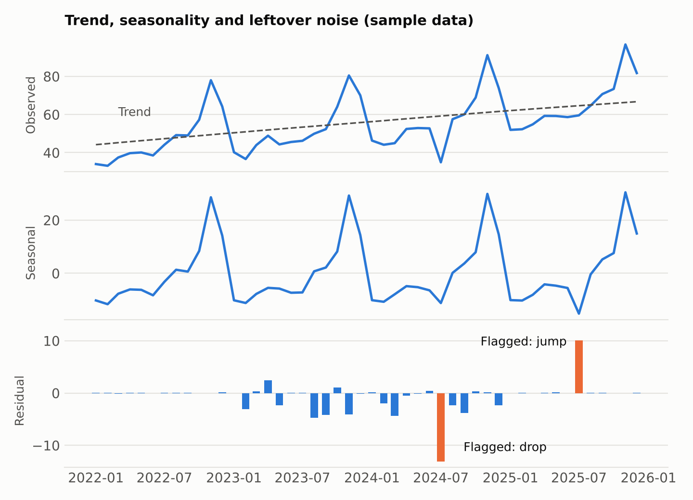
Figure 1. Decomposition of the synthetic series (sample data)
The decomposition separates a steady upward trend from a very regular yearly pattern, with a sharp peak every November and a lull in the first half of the year. The ADF test gave a p-value of about 0.96 on the original series, so it is not stationary, and about 0.00 after taking first differences, which tells me one difference is enough. The residual panel is where anomalies show up. Using robust STL and a threshold of 3 standard deviations, two months were flagged. The large drop in July 2024 matches the outage I built in. The second, a smaller jump in July 2025, wasn't planted at all and is ordinary noise that happened to cross the line. That's a useful reminder that a flag is where an investigation starts, and each one needs checking against what really happened.

5.2 Forecast accuracy
Model | MAE | RMSE | MAPE | Comment
Seasonal naive (baseline) | 10.06 | 12.14 | 14.8% | The bar to beat
Holt-Winters | 3.16 | 3.91 | 4.6% | Large gain over baseline
SARIMAX (1,1,1)(1,1,0,12) | 5.09 | 8.52 | 8.0% | Better than baseline, worse than simpler models
Prophet | 2.88 | 3.99 | 4.4% | Similar to Holt-Winters

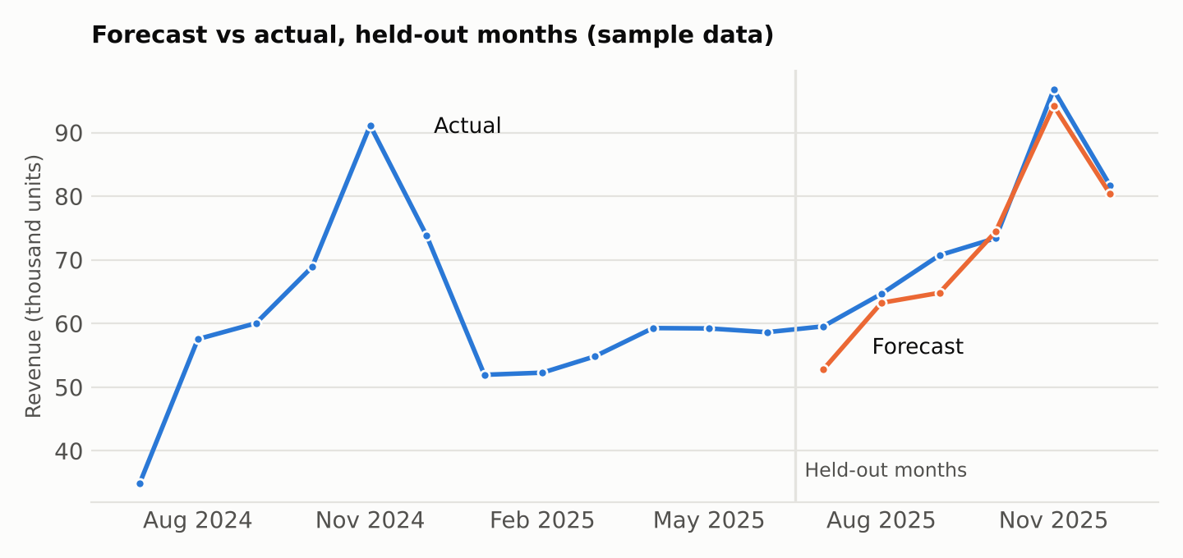
Figure 2. Holt-Winters forecast against the six held-out months (sample data)
Both Holt-Winters and Prophet cut the error by roughly two thirds compared with the seasonal naive baseline and caught the size and timing of the November peak. The more complex SARIMAX model did worse than the simpler ones on this series, which is a good example of why complexity needs to be earned. The six-month window is small, so I also ran a rolling-origin check on Holt-Winters, which gave an average error of about 3.4 on three-month forecasts, consistent with the single-window result. In a real project I'd compare models on the rolling result, not on one window.

6. Business Implications
Each technique earns its place only if it changes a decision. The table below links what the analysis produces to the actions it could support in an online retail business.
Finding | What it means | Possible business action
Strong yearly peak (for example in November) | Demand is concentrated in a few predictable weeks | Build stock, hire seasonal staff and book delivery capacity weeks ahead; start campaigns during the build-up
Steady upward trend underneath the seasonality | The business is growing apart from the festive effect | Set realistic growth targets and plan capacity for next year, not this year's level
Weak or negative trend in a category | A product line is slowly declining | Review pricing, range or marketing for that category before it becomes a loss
Quiet periods with stable demand | Low-risk windows | Schedule system upgrades, warehouse maintenance and staff leave
Forecast with an interval | A realistic range for upcoming demand, not a single number | Order to the middle of the range, keep a buffer to the upper end for items that are costly to run out of
Anomaly alert (unusual drop in orders) | Something broke or changed | Investigate the same day: website outage, payment failure, delivery partner problem or competitor promotion
Anomaly alert (unusual spike) | A product or promotion took off | Check stock levels and delivery capacity quickly, and learn from what worked
Forecast error that keeps growing | The pattern has changed | Retrain the model, add event variables, or investigate a structural change

How I'll present the results
- Lead with the decision: "Plan for 20 to 25 percent more orders in November", not "the model has a MAPE of 4.4 percent".
- Show the forecast with its range and state the main assumptions.
- Explain trend and seasonality in plain words with one clear chart each.
- Give a short list of anomalies, with the likely cause where known and a recommended follow-up.
- Agree a review date to compare the forecast with reality and refresh the model.

Limits to be honest about
- Forecasts assume the future resembles the past. New competitors, price changes or shocks can break that.
- Time-series models find patterns but don't explain causes. A promotion that coincided with a peak can look like seasonality.
- With only a few years of history, yearly seasonality estimates are uncertain.
- Accuracy falls as the horizon grows, so long-range forecasts should be treated as scenarios, not promises.

7. Common Pitfalls and How to Avoid Them
Pitfall | How to avoid it
Random train/test splits | Always split by time, and use rolling-origin or TimeSeriesSplit for validation.
Using future information (leakage) | Build lag and rolling features using past values only, and fit any scalers on training data.
Ignoring seasonality or events | Decompose first; add holidays and one-off events to the model.
Skipping the baseline | Always compare with a seasonal naive forecast.
Trusting one test window | Evaluate over several forecast origins before choosing a model.
Deleting anomalies automatically | Investigate each one; they may be the most important insight.
Over-complex models on short data | Try simple models first and keep complexity only if it clearly pays off.
Forecast without uncertainty | Show prediction intervals and say what was assumed.
Never updating the model | Track forecast error over time and retrain on a schedule.

8. Conclusion
Time-series analysis turns a history of numbers into a view of the future. By separating trend from seasonality, flagging the points that don't fit, and testing forecasts honestly against a baseline and against held-out data, it's possible to give a business forecasts it can trust and a clear sense of how much to trust them. Pandas and statsmodels cover the groundwork and classical models, Prophet adds a robust option with event handling, and scikit-learn supports evaluation and feature-based approaches.
In the next stage of the project I'll apply this workflow to the real retail data. The aim is to quantify the seasonal peaks and the underlying growth, set up simple anomaly alerts on orders and delivery performance, and produce a forecast with ranges that the operations and marketing teams can use for planning.

