 | Nitte Meenakshi Institute of Technology  (AN AUTONOMOUS INSTITUTION AFFILIATED TO VISVESVARAYA TECHNOLOGICAL UNIVERSITY, BELGAUM)  PB No. 6429, Yelahanka, Bangalore 560-064, Karnataka  Telephone: 080- 22167800, 22167860  Fax: 080 - 22167805 | 
Department of Information Science and Engineering
SMID-SEM EXAMINATION-III
Semester/ Section:“3”sem A,B,C SEC Date: 03/03/2022
Subject and Code: Digital Design (18IS32) Duration: 1.0 Hr
Faculty Name: Dr. Swarnalatha K.S, Mr. Rohith H.P, Mr.Pramod Jain S.A, Max Marks: 30

Answer any two full questions
Q. No |  |  | Questions |  | Marks | CO | Blooms level
1 | a) | Distinguish between Synchronous and asynchronous counters with suitable examples. |  | 5 |  | 5 |  | 2
1 | b) | Design a synchronous counter to sequence 0->3->1->4->7->0 using positive edge triggered JK flip flop |  | 5 |  | 4 |  | 3
1 | c) | Differentiate between VHDL and Verilog |  | 5 |  | 6 |  | 2
2 | a) | Design a 3-bit Asynchronous down counter with waveform. |  | 5 |  | 4 |  | 3
2 | b) | Write the VHDL code for full adder Circuit |  | 5 |  | 6 |  | 3
2 | c) | Explain the working of R-2R ladder digital to analog converter for the binary value 1011 with necessary circuits. |  | 5 |  | 5 |  | 2
3 | a) | Write a Verilog code for the below given combinational circuit  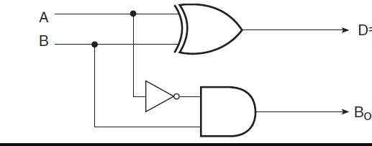 |  | 5 |  | 6 |  | 3
3 | b) | With a neat diagram explain the working of a Counter type analog to digital converters. |  | 5 |  | 5 |  | 2
3 | c) | With a neat diagram explain the working of Binary weighted resistor digital to analog converter (assume the binary value: 111), also give the generalized expression for the same. |  | 5 |  | 6 |  | 2

************************************GOOD LUCK*****************************

