The topic chosen is "**Hospital Management System**".

It demonstrates the general basic working of the hospital and the entities used are Employees , Doctors who are also employees(inheritence), Helping_staff who are also employees(inheritence), Patients and Rooms.

---ER DIAGRAM---

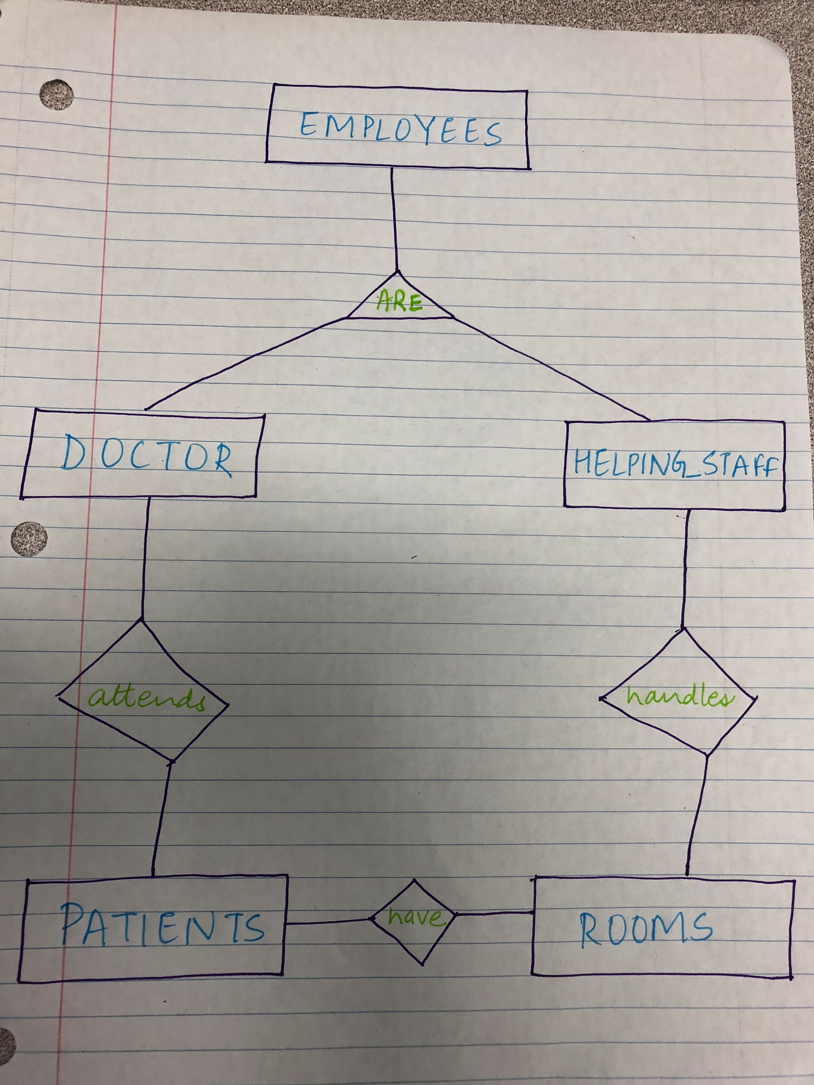

--- ATTRIBUTES ---

Employees-> e_id(primary key),e_name, address, email, age and contact.

Doctor-> e_id(primary key), specializes_in.

Helping_staff-> e_id(primary key).

Patients-> p_id(primary key), p_name, referring_doctor, age.

Rooms-> r_no(primary key), floor, e_id

--- FORIEGN KEYS ---

e_id in Rooms is a foriegn key to helping_staff.

referring_doctor in patients is a foreign key to Doctor.

---FUNCTIONING---

The program is made to the following things:

Once logged in the user could enter the following options: a,b,c,d,q or A,B,C,D,Q. The program is designed to be case insensitive.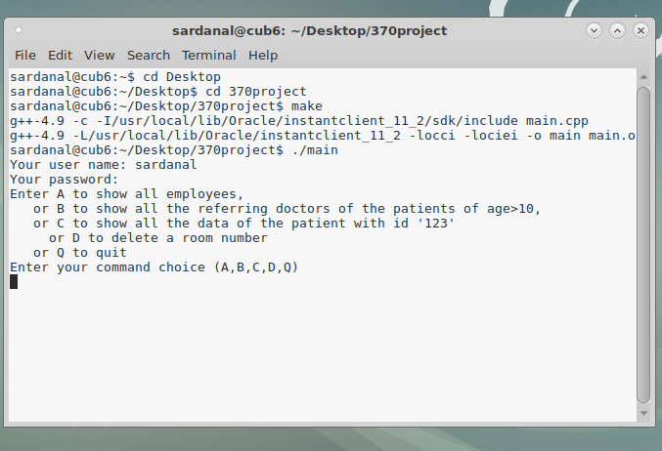

If the user presses “a” or “A” then it would display all the employees and all of their related information.

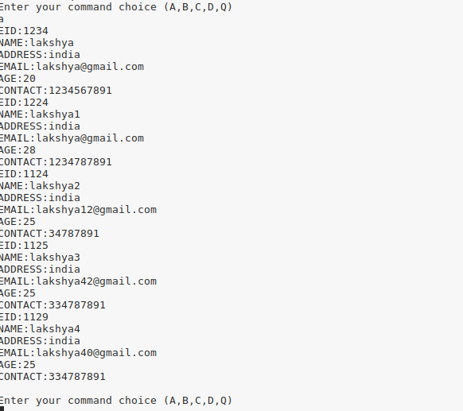

If the user enters “b” or “B” then it would show the referring doctor of the patient whose age>10.

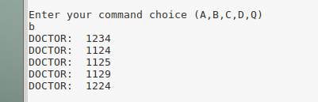

If the user enters “c” or “C” then it would display all the data of the patient with pid= ‘123’.

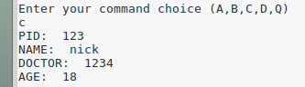

If the user enters “D” or “d” then the user could delete a room number

Confirmation of delete:

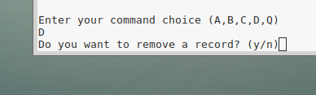

If user confirms delete, then it prompts the number of the room to be deleted:

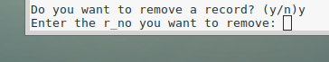

User enters the room number and presses enter:

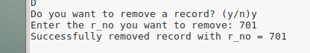

If the user enters the incorrect room number:

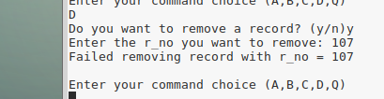

Then it shows failed to delete and comes out of the loop and asks for the command again.

If user selects “n”, means user does not want to delete the room and then also user is directed back to the commnads:

