Volume 4 — The Frontend
Five files, no framework, no build step
Describes commit eca7dee on branch main · written 1 September 2026, revised 5 September 2026 · Volume 4 of 5
Scope of this volume. public/app.js is a single 235 KB classic script — 5,611 lines and about 124 top-level functions. Cataloguing all 124 would be unreadable and would go stale with the next commit.
So this volume documents it by functional area, following the file's own // --- section banners, naming the important functions in each. Then it covers the two things that will actually break if you get them wrong: the CSS class contracts and the showView() rule.
Volume 4 — The Frontend 1
1. The shape of it 1
The nine screens 2
2. Routing 3
Two guards live in the router, not on individual links 5
The showView() rule 5
3. How the browser talks to the server 5
4. Watching a run 6
5. The functional areas of app.js 7
The gate area, in brief 8
The step editor, in brief 8
6. CSS class names are a contract 9
7. Two functions duplicated on purpose 9
8. The only automated checks on this code 10
9. Working on the frontend 10
The preview harness 11
A checklist before you commit a frontend change 11

1. The shape of it
File | Size | What it is
index.html | 17.8 KB  348 lines | The static shell. Nine view sections, the modals, the sidebar, the top bar.
app.js | 235 KB  5,611 lines | The entire application. Session, routing, rendering, the gate, the step editor.
style.css | 80 KB | The visual system. A single light theme.
icons.js | 4.8 KB | Inline SVG icons on a 24×24 stroke grid, drawn with currentColor.
preview.js | 9.4 KB | A development-only fixture harness. Inert unless the page is loaded with ?preview=states.
No bundler, no modules, no build step. index.html loads three classic scripts in order and Express serves them raw. That single fact explains several things that otherwise look like bad decisions — most importantly why two functions are duplicated between the server and the browser (§7). A classic script cannot import anything.

The nine screens
Every screen is a <section class="view" data-view="…">. Exactly one carries .view-active at any moment.
data-view | Markup | What it is
login | static | Sign-in form.
signup | static | Registration form.
home | static | The composer: prompt, URL, template chips. The Minimal/Standard/Full coverage control was removed; coverage is pinned to "standard" in app.js and still sent in the POST body, so the route's request shape is unchanged.
run | static | The live run screen. By far the densest region of the HTML.
suite | JS-rendered | A saved suite of cases.
case | JS-rendered | Case detail and the step editor. The largest region of app.js.
compare | JS-rendered | Diff two versions of a case.
history | JS-rendered | Past runs.
team | JS-rendered | Members and roles.
Correction to PROJECT_OVERVIEW.md. That document says there are six views and that suite, case and compare are "reachable stubs with no content… deliberate, not an oversight."
That is out of date on both counts. There are nine views, and all three of those named stubs are fully built: the suite view is about 220 lines, the case view about 630 lines including the whole step editor, and compare has a working diff.
It also put app.js at "~4400 lines" (it is 5,611) and said the UI uses Server-Sent Events (it does not — see §4). Those errors have since been corrected in PROJECT_OVERVIEW.md itself, on 5 September 2026; this note is kept because the same claims may still be repeated from memory.

2. Routing
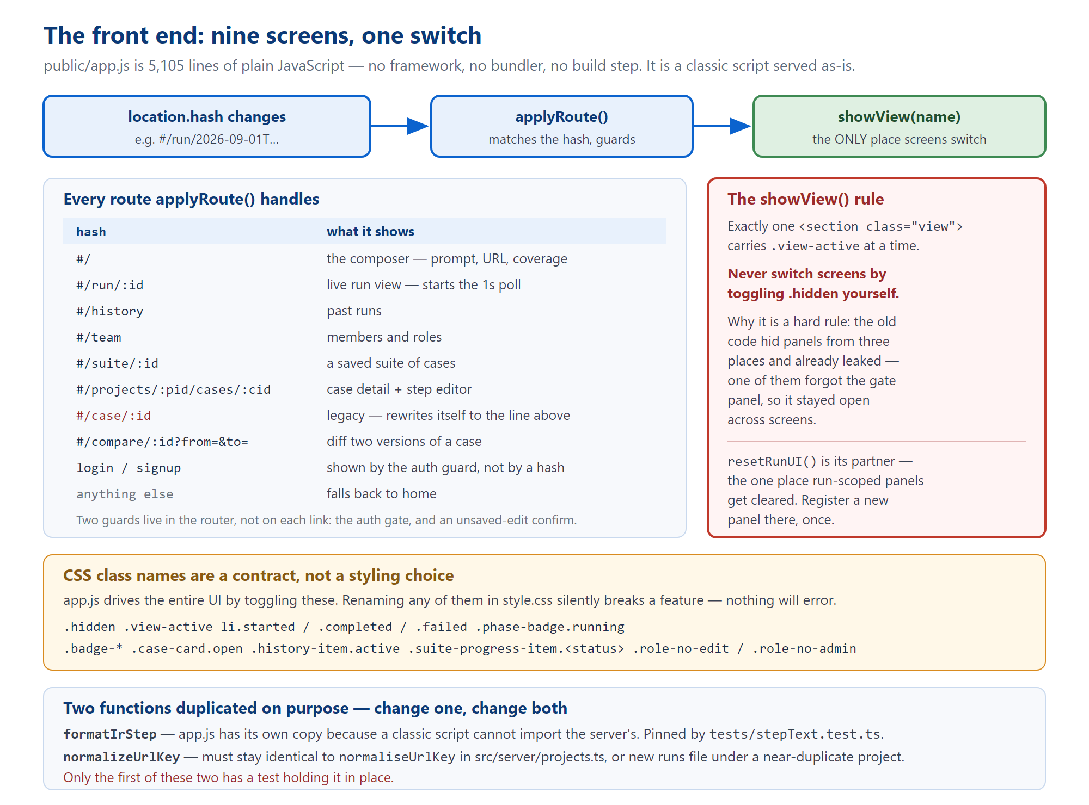
Figure 1 — hash routing, the single switching function, and the contracts that hold it together.
Routing is location.hash. No server routes are involved — everything is one page.
Hash | Action
#/ | Home. Also the fallback for anything unrecognised.
#/run/:id | Run view, and starts the poll loop if the ID changed.
#/history | Run history.
#/team | Team management.
#/suite/:id | A suite and its cases.
#/projects/:projectId/cases/:caseId | The canonical case route.
#/case/:id | Legacy. Looks up the case's project, then rewrites the URL in place so old bookmarks keep working.
#/compare/:id?from=&to= | Version diff.

Two guards live in the router, not on individual links
- The auth gate. If authentication is required and there is no token, the router sends you to login — and it does so through showView(), never by toggling classes directly.
- The unsaved-edit confirm. If the case editor is dirty, navigation prompts. A restoringHash flag makes a declined navigation restore the previous hash without poisoning the next one. A separate beforeunload handler covers reload and tab-close, which the in-app guard cannot see.

The showView() rule
This is a hard rule in the project, and the comment in the source is the authority. Paraphrasing it:
showView() is the only thing that switches screens. Never toggle .hidden yourself to change views.
The reason is recorded history, not taste: the pre-router code hid panels from three separate places and had already leaked because of it — one of those places forgot to hide the case-selection gate panel, so switching scenes left it open on top of an unrelated screen. With nine screens that failure mode multiplies.
Its partner is resetRunUI() — the one and only place run-scoped panels are cleared. Registering a new panel is therefore a one-line change in one function, rather than three that drift apart.
Note the nuance: .hidden is still the correct mechanism for things that are not views — the scrim, the toast, the screenshot grid, the credential modal. The rule is about switching screens.

3. How the browser talks to the server
There is no api() wrapper around everything. The real mechanism is a window.fetch monkey-patch installed at start-up:
const rawFetch = window.fetch.bind(window);
window.fetch = function (input, init) { /* inject Authorization on same-origin requests */ };
One wrapper instead of about twenty call sites. Two details matter:
- The token is attached only to same-origin URLs. Relative paths are same-origin by definition; absolute ones are checked against location.origin, so a token can never leak to a third-party host.
- A session cookie is also written, because <img src> and <video src> on the artifact route cannot carry a header. (Volume 3, §3 covers the server half of this.)
On top of that sits api(path, init) — a thin helper that turns 204 into null, parses JSON, and throws the server's error message on failure. The newer library and team screens use it; the older run and gate code calls fetch directly.
Role restrictions are expressed as negative classes — role-no-edit and role-no-admin on <body>. So the default state (no class) is exactly the pre-authentication behaviour, which means no flicker on load while identity is still being fetched.

4. Watching a run
connectToRun(runId) is the function that drives the live run screen.
let pollGeneration = 0;
async function connectToRun(runId) {
const generation = ++pollGeneration;
while (generation === pollGeneration) {
const res = await fetch(`/api/runs/${runId}/state`);
// … slice off events already seen, feed each to applyEvent() …
if (done) return;
await new Promise((r) => setTimeout(r, 1000));
}
}
This is a plain poll loop. It is not Server-Sent Events.
The string EventSource appears nowhere in public/ as code — the only occurrence is a comment explaining why the opposite pattern was chosen. An SSE route exists on the server and no browser code has ever called it.
The reason is recorded in that comment: a Cloudflare Quick Tunnel buffers text/event-stream responses and only flushes them when the connection closes, which a live stream never does. Behind a tunnel, SSE simply appears to hang.
Two design details in that loop:
- Cancellation is by generation counter. Incrementing pollGeneration orphans the old loop, so an abandoned run can never write to the DOM of the run you are now looking at.
- Five consecutive failures paint a reconnecting banner rather than dying silently.
There is a second, independent poller — pollCaseJob — for re-ground jobs, for the same tunnel reason.
The single reducer is applyEvent(event, runId): it takes one orchestrator event and updates the DOM, returning true when the run is terminal.

5. The functional areas of app.js
In file order, following the script's own section banners.
Area | Lines | Key functions
Constants | 1–61 | PHASES (four cards: understand, analyze, build&run, results), STAGE_TO_PHASE, TEMPLATES, STATUS_LABEL
Session & auth | 62–375 | writeSessionCookie, setSession, applyRoleRestrictions, refreshIdentity, signOut, initAuth, roleAtLeast, and the fetch patch
Phase cards | 467–636 | renderPhases, computePhaseStatus, applyPhaseUI, setPhaseFromStage
Suite progress | 637–700 | renderSuiteProgress, renderSuiteSummaryHeader, renderScreenshotGrid
Case cards | 701–1008 | renderCaseCard, toggleCaseCard, loadCaseDetails, renderSuiteResults, openSaveCasePanel
Verdict & diagnosis | 1009–1210 | verdictFor, paintVerdict, formatIrStep, buildStepNarrative, renderCaseDiagnosisBlock
Screenshot modal | 1211–1253 | openScreenshotModal, closeScreenshotModal
History sidebar | 1382–1495 | renderHistory, loadHistory, canManageProjects
Credential prompt | 1500–1565 | showCredentialPrompt, submitCredentials
The gate | 1566–2341 | ~25 functions — the largest single area. Drafts in localStorage, the case list, page elements, HTML builders, submit
Events & polling | 2342–2563 | applyEvent, connectToRun
Shell & routing | 2638–2707  4109–4269 | showView, resetRunUI, applyRoute, navigate, setCrumbs, toast
Library screens | 2708–4120 | renderSuiteView, renderCaseView, renderCompareView, diffSteps
Step editor | 3002–4031 | ~17 functions. caseEditorDirty, scheduleCaseEstimate, saveCaseSteps, pollCaseJob, cancelCaseJob, doTranslateSteps
Projects tree | 4348–4748 | loadProjects, groupRunsByUrl, renderProjectsTree, normalizeUrlKey
History & team | 4749–5105 | renderHistoryView, renderTeamView, teamCall

The gate area, in brief
Drafts are held in localStorage under testbench.gate.<runId>.<attempt>, so a refresh mid-review does not lose your edits. Everything else is list state, HTML builders, and one submit function that posts the decision.

The step editor, in brief
The shape of the interaction is worth understanding because it maps directly onto the cost model from Volume 2:
- You edit steps as plain-English lines.
- A debounced live estimate tells you what re-grounding will cost — this is free, no browser, no model.
- You save. If nothing needs re-grounding, it saves instantly.
- Otherwise a background job starts, which you follow with a progress banner and can cancel.
doTranslateSteps is the "Write it for me" feature behind NL_STEPS_ENABLED. It proposes parser-legal sentences; it never writes an IR.

6. CSS class names are a contract
style.css declares this in its own header, and it is worth quoting because it is easy to dismiss:
"The controller in app.js drives state through class names, so every one of these is a contract, not a styling choice. Renaming any of them silently breaks a feature."
The protected set:
.hidden .view-active
li.started / .completed / .failed
.phase-badge.running .badge-*
.case-card.open .history-item.active
.suite-progress-item.<status>
.tree-* .role-no-edit / .role-no-admin
Nothing will throw if you rename one. A feature will simply stop working, in a way that looks like a logic bug in JavaScript that has not changed.
The practical rule: reuse an existing class rather than minting a new one.
One note on the visual system: style.css is a single light theme (a blue, white and black palette, with every other surface being that blue or black at low opacity). A previous dark/light token pair and its toggle were deliberately removed rather than half-maintained.

7. Two functions duplicated on purpose
Both exist because app.js is a classic script and physically cannot import from src/.
Function | Also lives in | Held equal by
formatIrStep | src/stages/stepText.ts | tests/stepText.test.ts — it reads app.js as text, extracts this function, evaluates it, and asserts identical output.
normalizeUrlKey | src/server/projects.ts (as normaliseUrlKey) | Nothing. Convention only.
The second one is the risk. If the two URL-key implementations drift, new runs get filed under a near-duplicate project and the sidebar quietly grows two entries for the same site. There is no test to catch it. If you touch either, touch both.

8. The only automated checks on this code
tsconfig.json has include: ["src"]. So npm run typecheck covers neither tests/ nor public/. The entire front end has exactly two automated checks, both of which read it as text from Node:

tests/appJsDefined.test.ts — "app.js must not call a function it does not have"
This test exists because of a real shipped bug, and the story is instructive.
Adding the gate's case editor replaced a ~200-line region wholesale and silently dropped postCaseSelectionDecision — the only function through which a gate decision leaves the browser — while both call sites survived, pointing at nothing.
The symptom looked like "test cases aren't generating". In fact the gate simply waited out its full ten-minute timeout and then ran nothing.
Nothing caught it: node --check validates syntax, not references; tsc never looks at app.js; and the unit suite does not execute click handlers.
The test reads app.js as text and matches every await someFunction( against the set of declared names. It also asserts that all 23 gate-panel helpers still exist by name.

tests/stepText.test.ts — no drift with the server
Reads app.js, extracts its private copy of formatIrStep, evaluates it, and asserts it renders identically to the server's. This is the only thing standing between the two copies.

9. Working on the frontend
Hard-reload after every change to public/. Changing the URL hash is a same-document navigation and keeps the old JavaScript alive. This has cost two documented false negatives, where a fix looked missing because the browser was still running the previous app.js.
If a plain reload is not enough, run await fetch('/app.js', {cache:'reload'}) in the console first, then reload.

The preview harness
Load the page with ?preview=states and preview.js wakes up. It feeds applyEvent() a fixture sequence copied from a real events.ndjson, so you can eyeball every UI state — including blocked, unconfirmed, and the "lost contact with the server" banner — without spending a single model call or launching a browser.
This is the fastest way to work on run-screen rendering, and it is underused.

A checklist before you commit a frontend change
- Did you switch views through showView()?
- Did you reuse an existing class rather than minting one?
- If you added a panel, did you register it in resetRunUI()?
- If you touched formatIrStep or normalizeUrlKey, did you change both copies?
- Did you run node --check public/app.js and npx vitest run?
- Did you hard-reload before deciding it did not work?

