Observations

Testbench:

- Sign in with correct credentials: - able to sign in
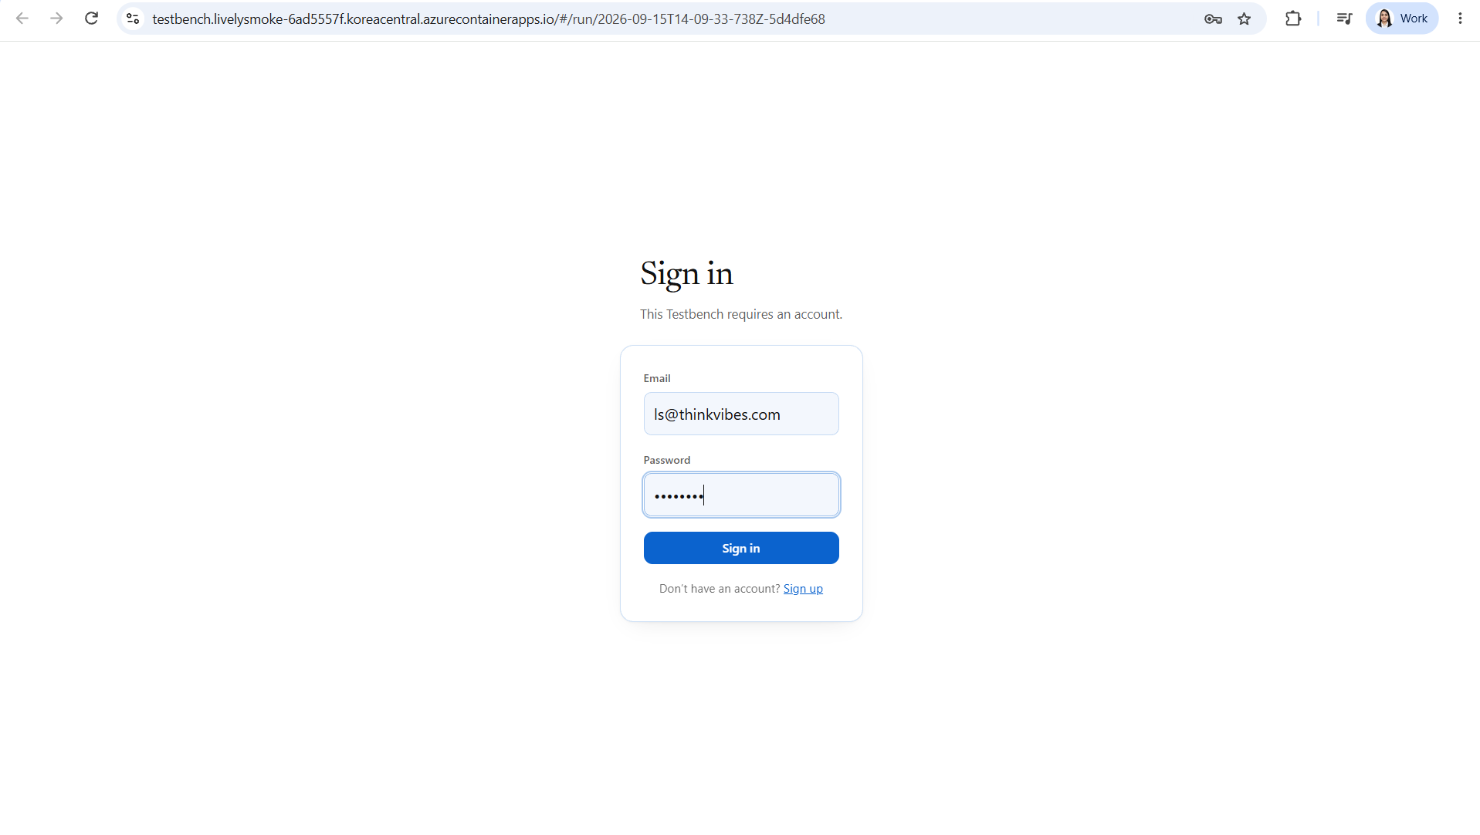

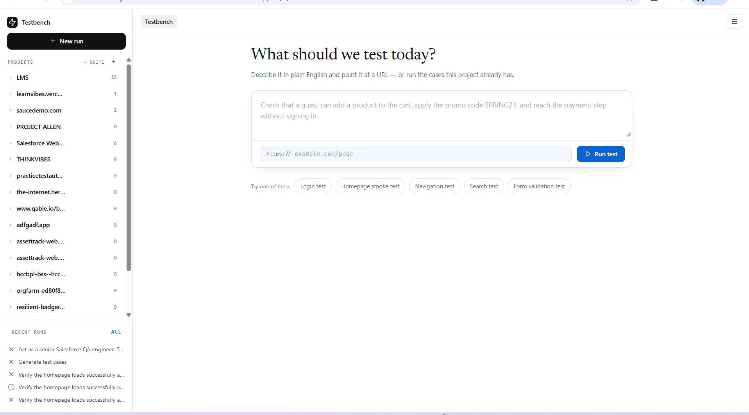

- Sign in with incorrect credentials: - working as expected
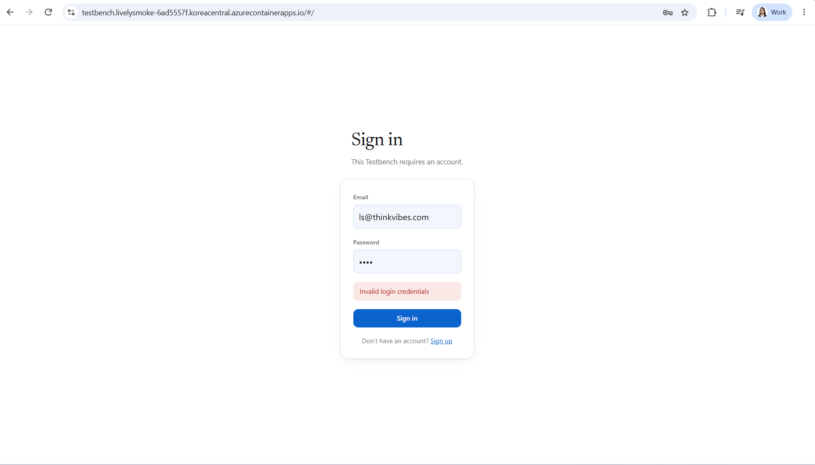

- After clicking on sign out button. It should ask “Do you really want to sign out”. Instead it signed me out directly.
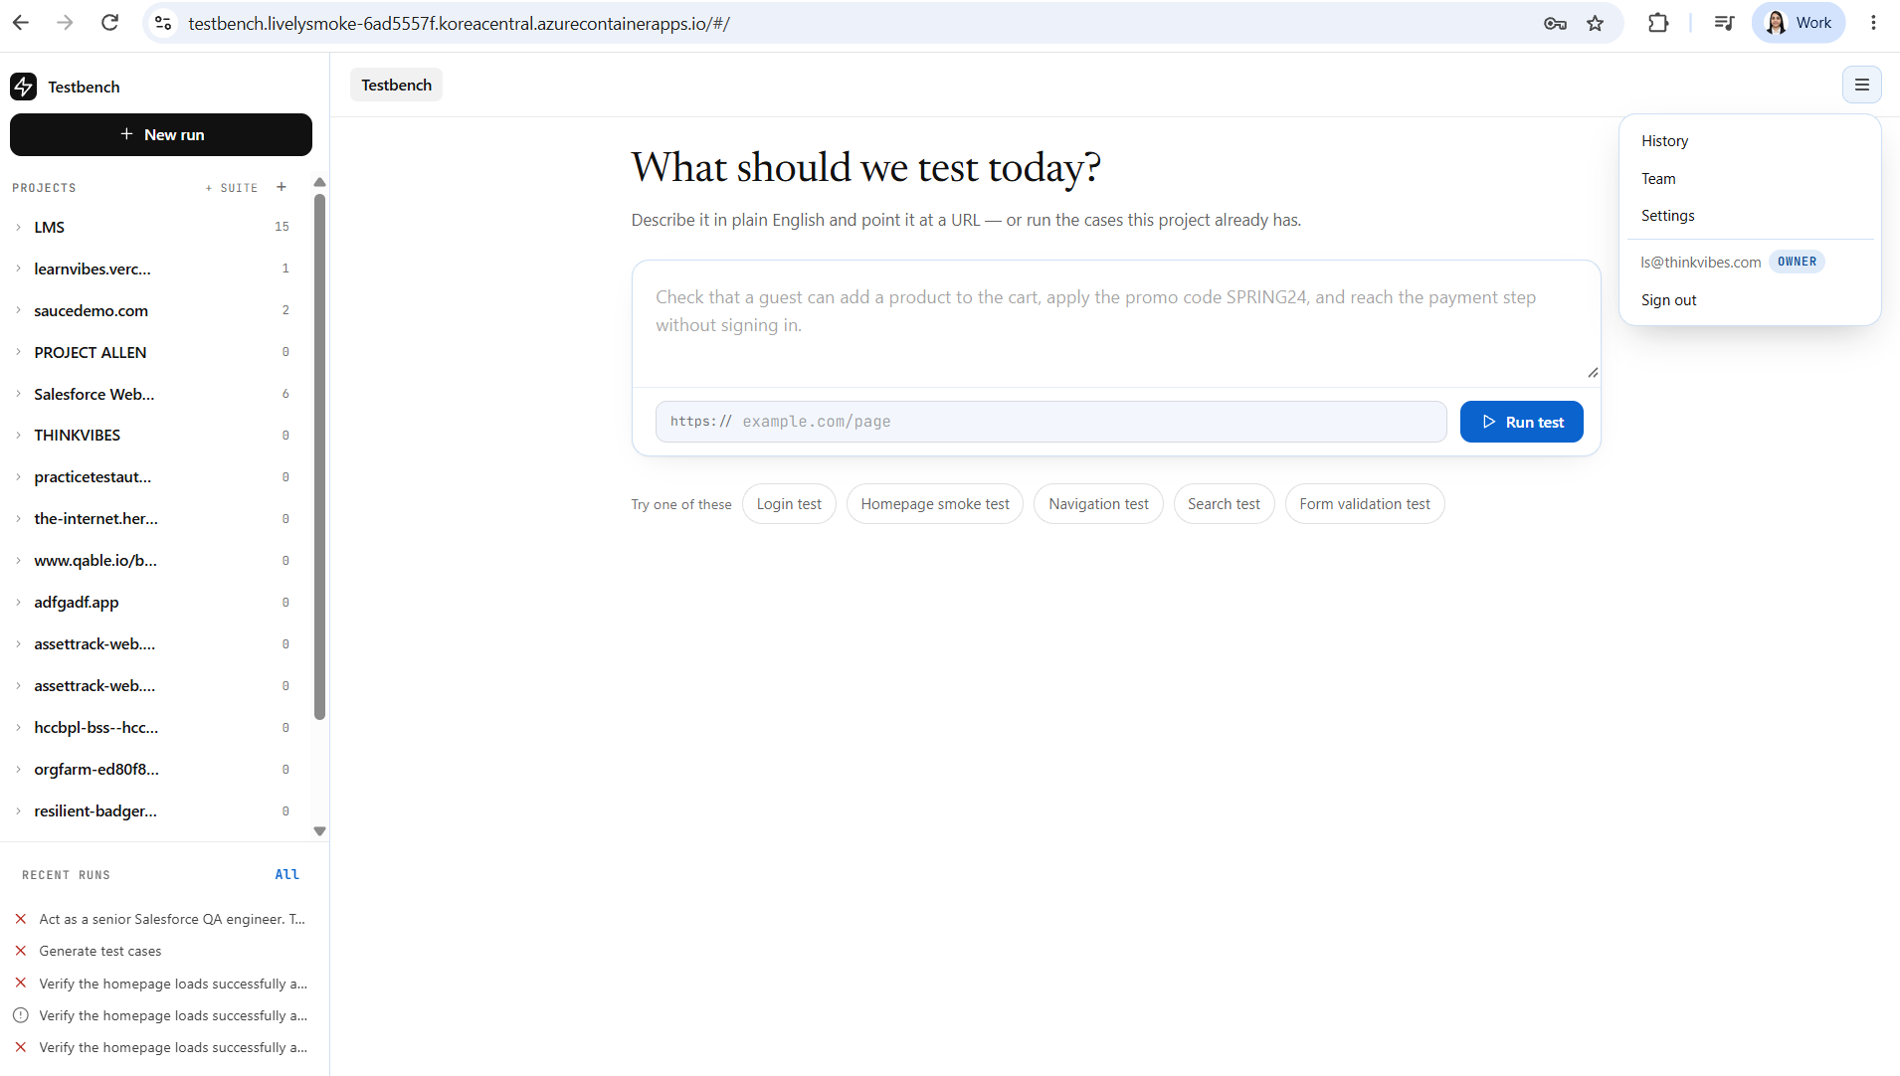

- Creating an account: - able to successfully create the account.
Password – it should check for :
At least 1 uppercase letter (A-Z)
At least 1 lowercase letter (a-z)
At least 1 number (0-9)
At least 1 special character (!@#$%^&* etc.)

After account creation I was directly logged in to the portal generally we get redirected to sign in page.

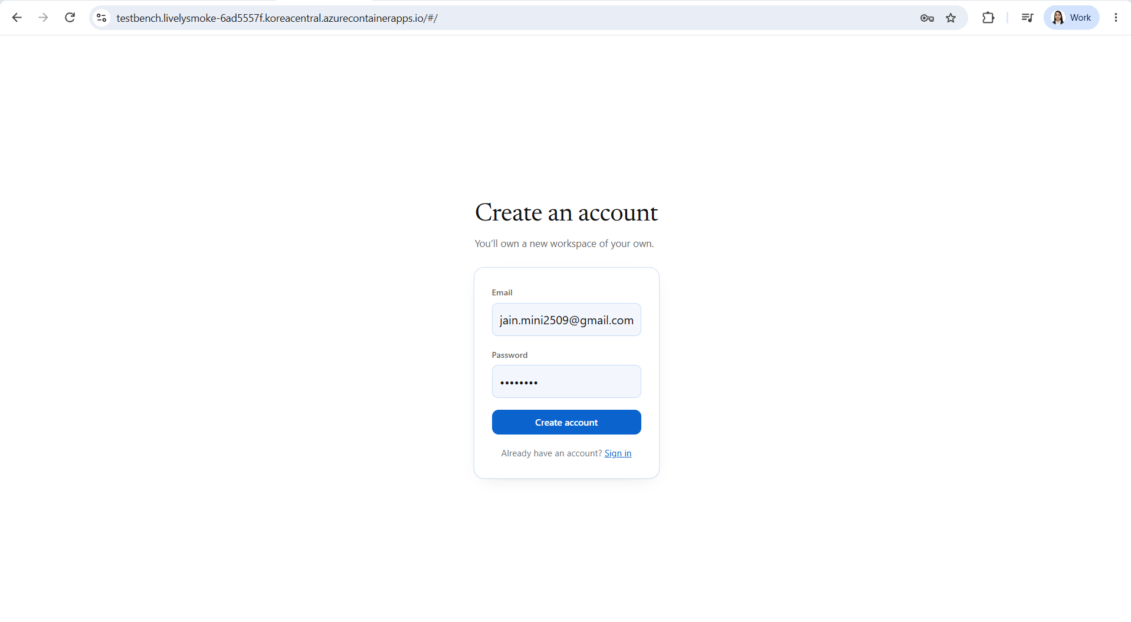

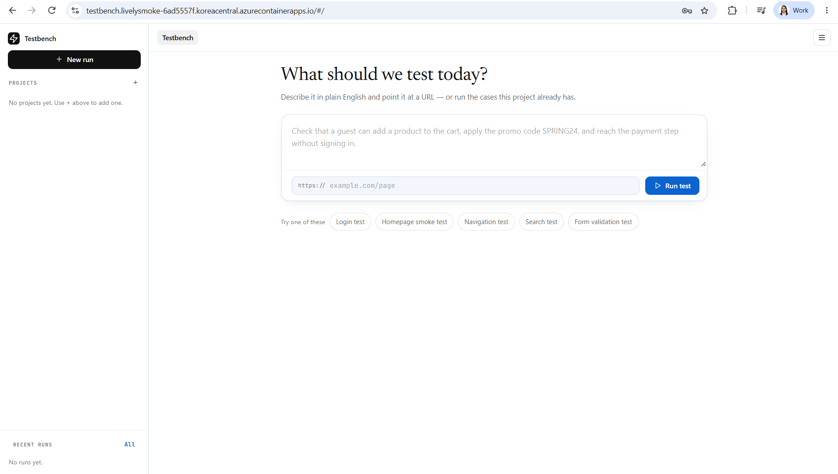
- Tried to re-run test case from history -> it ran (worked as expected)
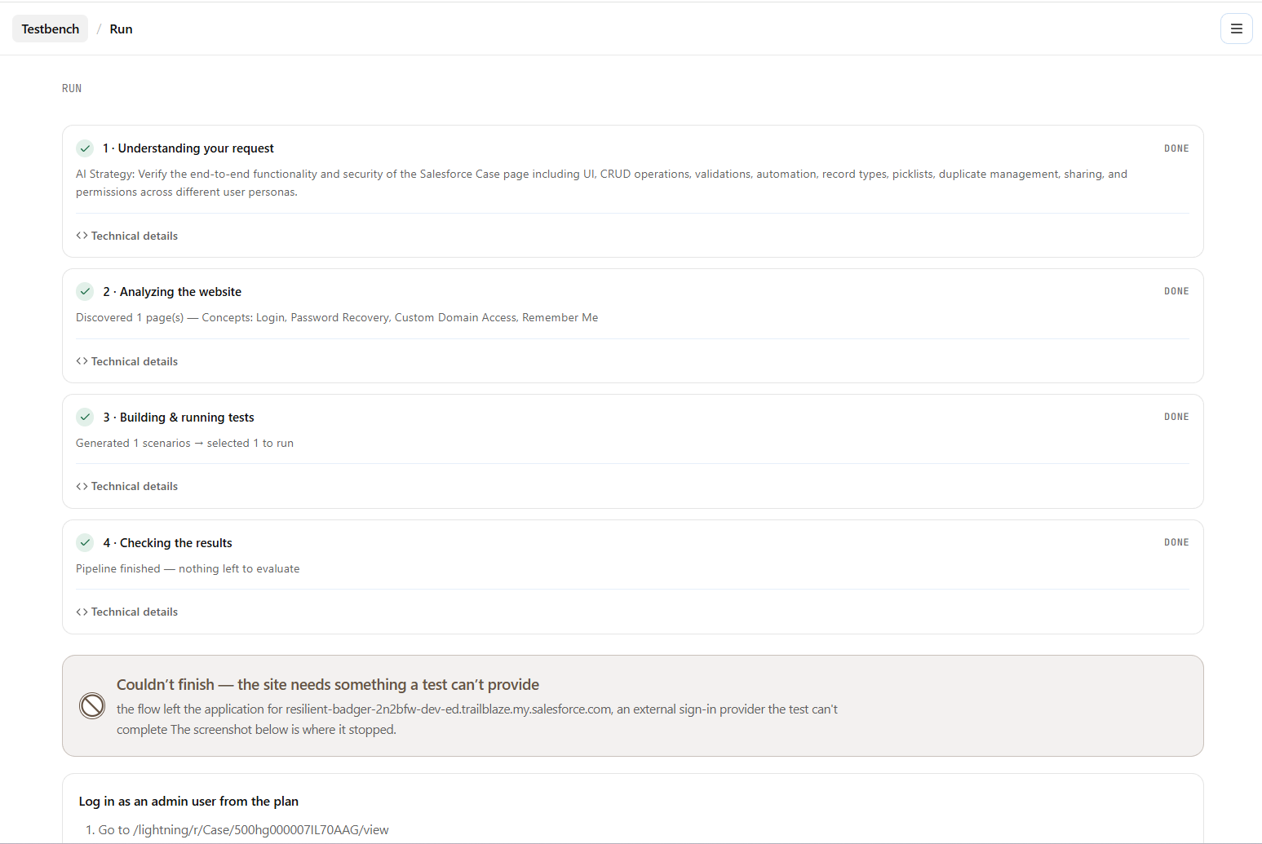

- Able to download the test script
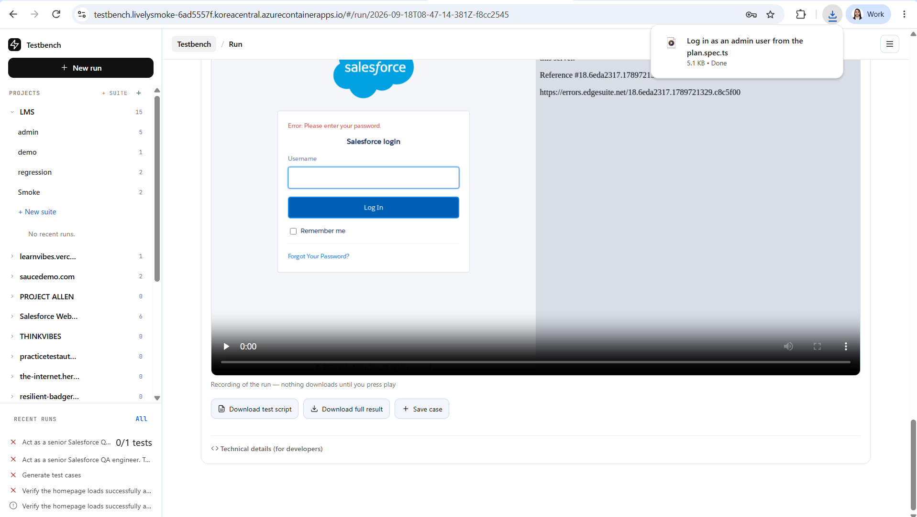

- Able to download and open the full result - to open the full result the user must have vs code or other IDE installed in the system should be mentioned as pre-requisites.
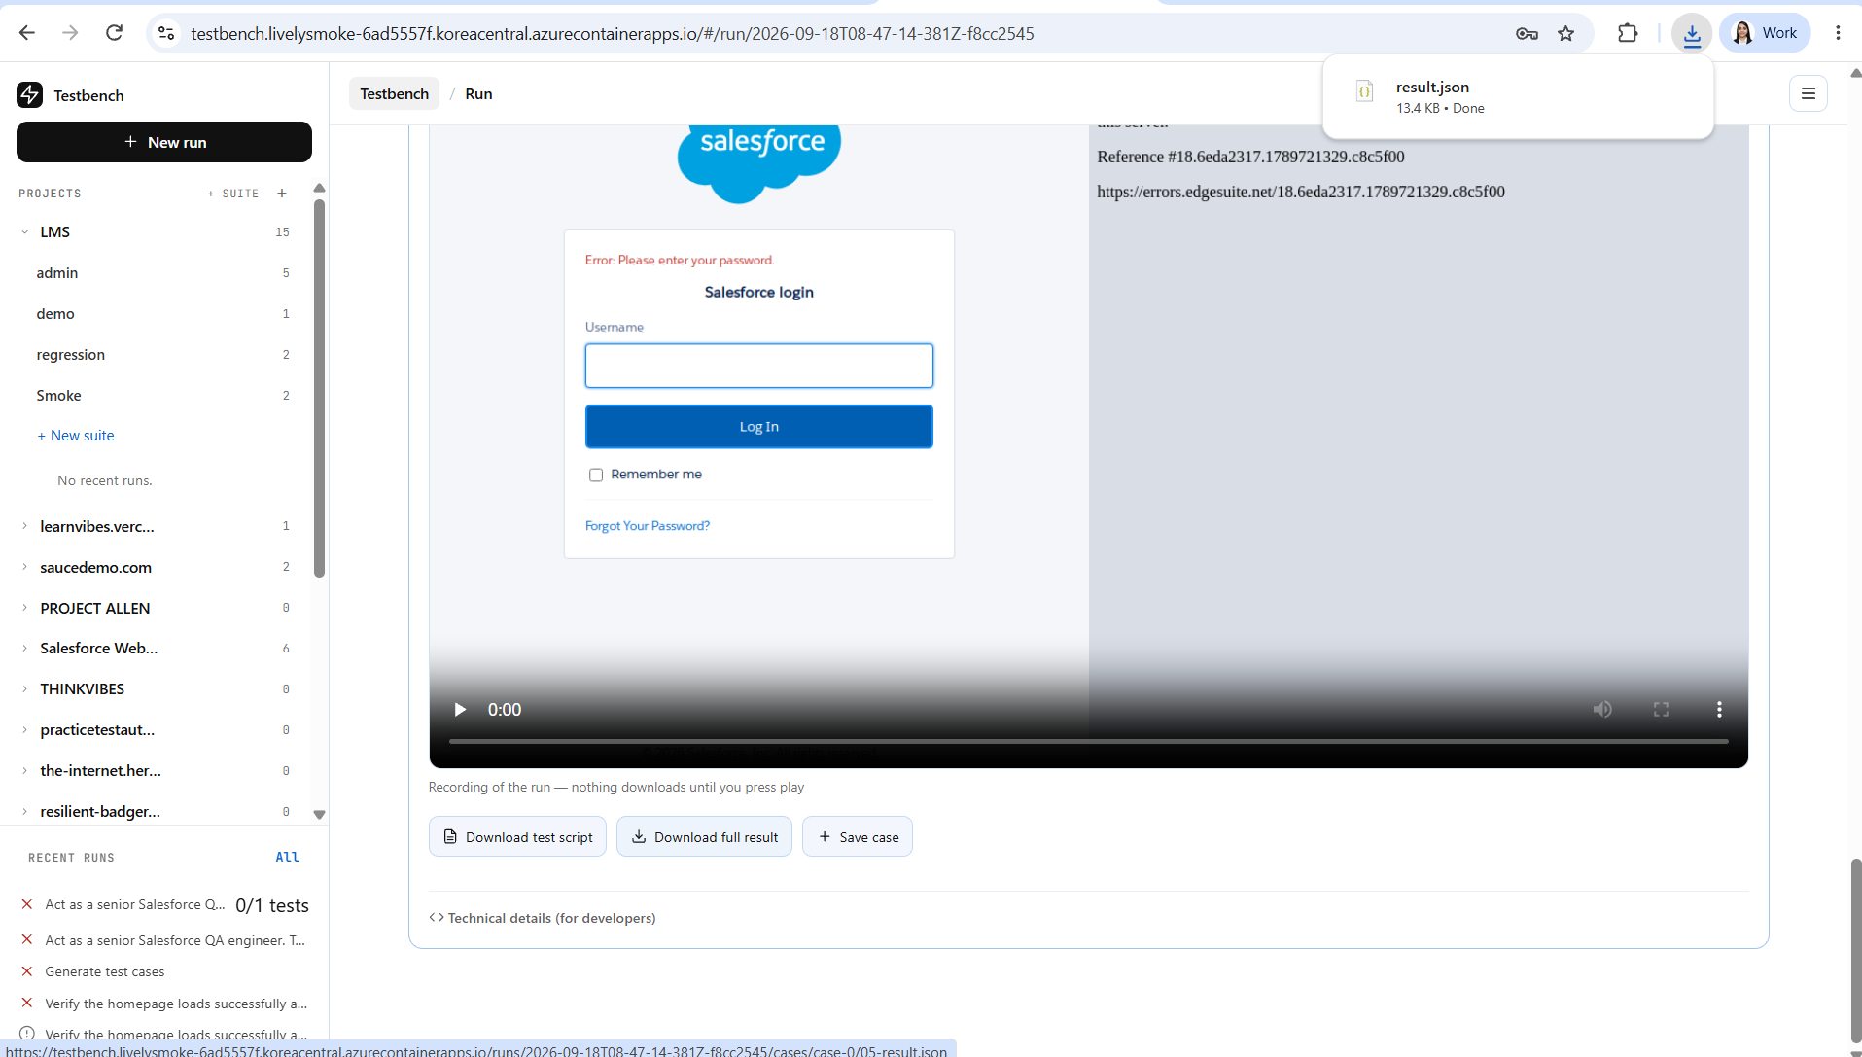

- Test case is not getting saved to the particular project structure. In below screenshot highlighted it. Post that I am not even getting the option to save it again.
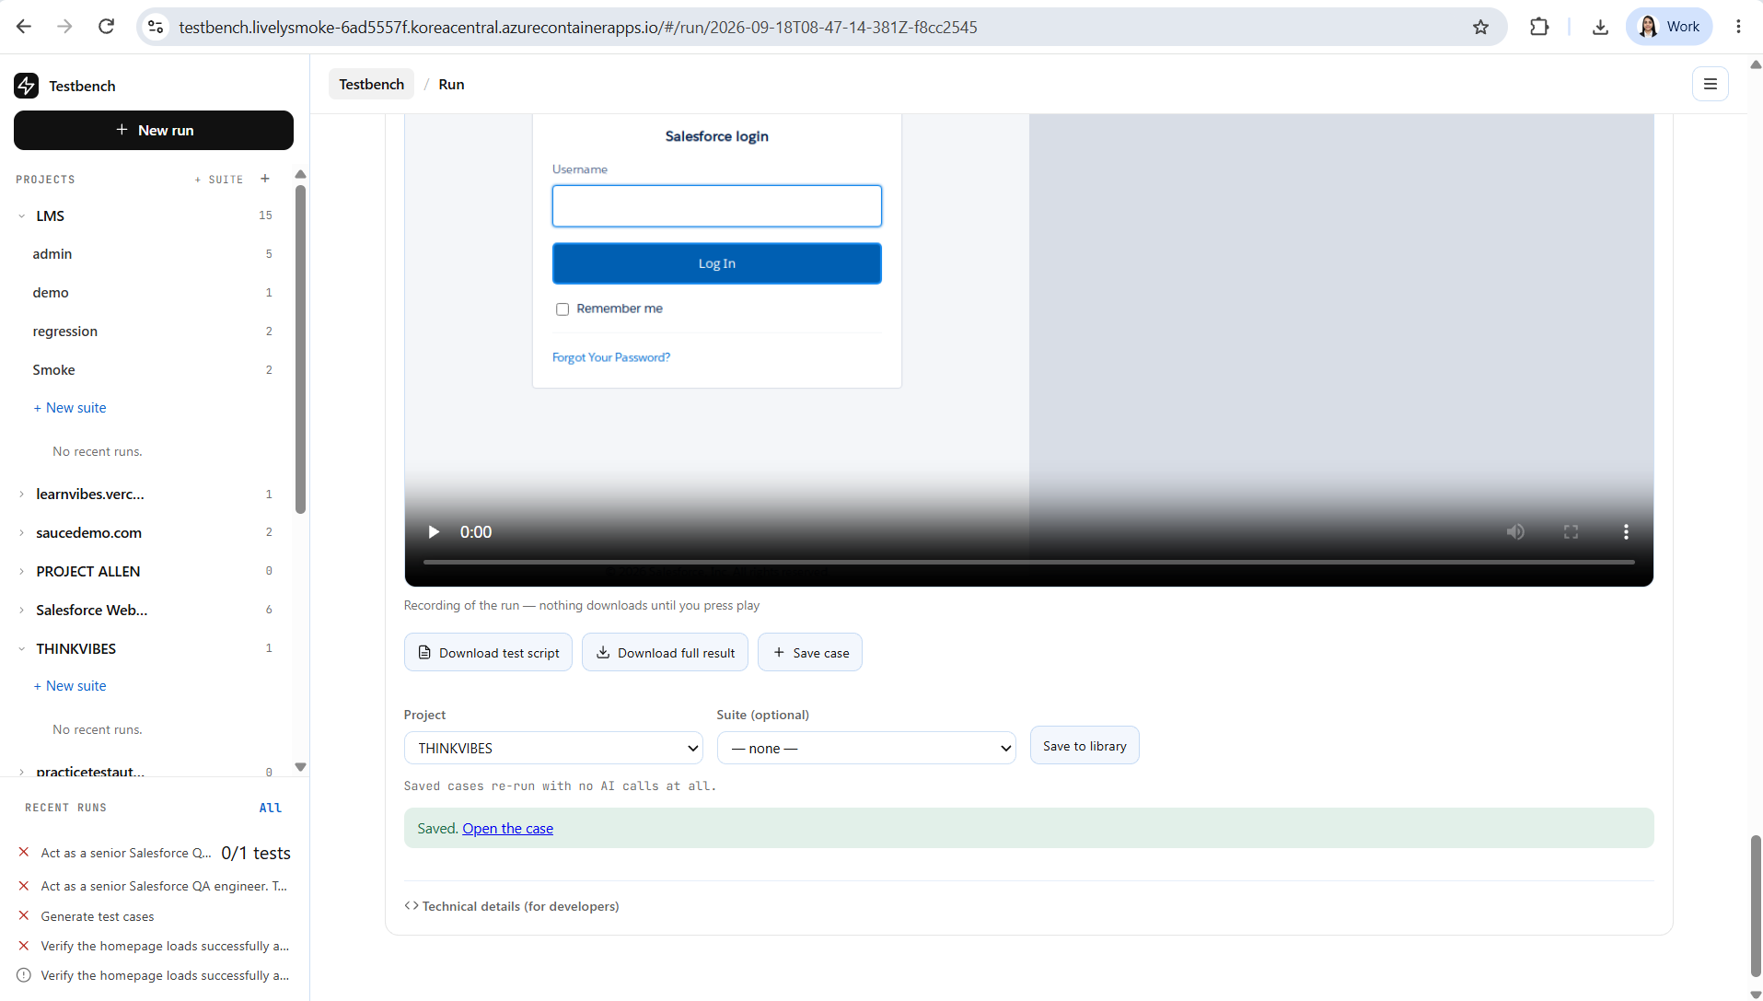
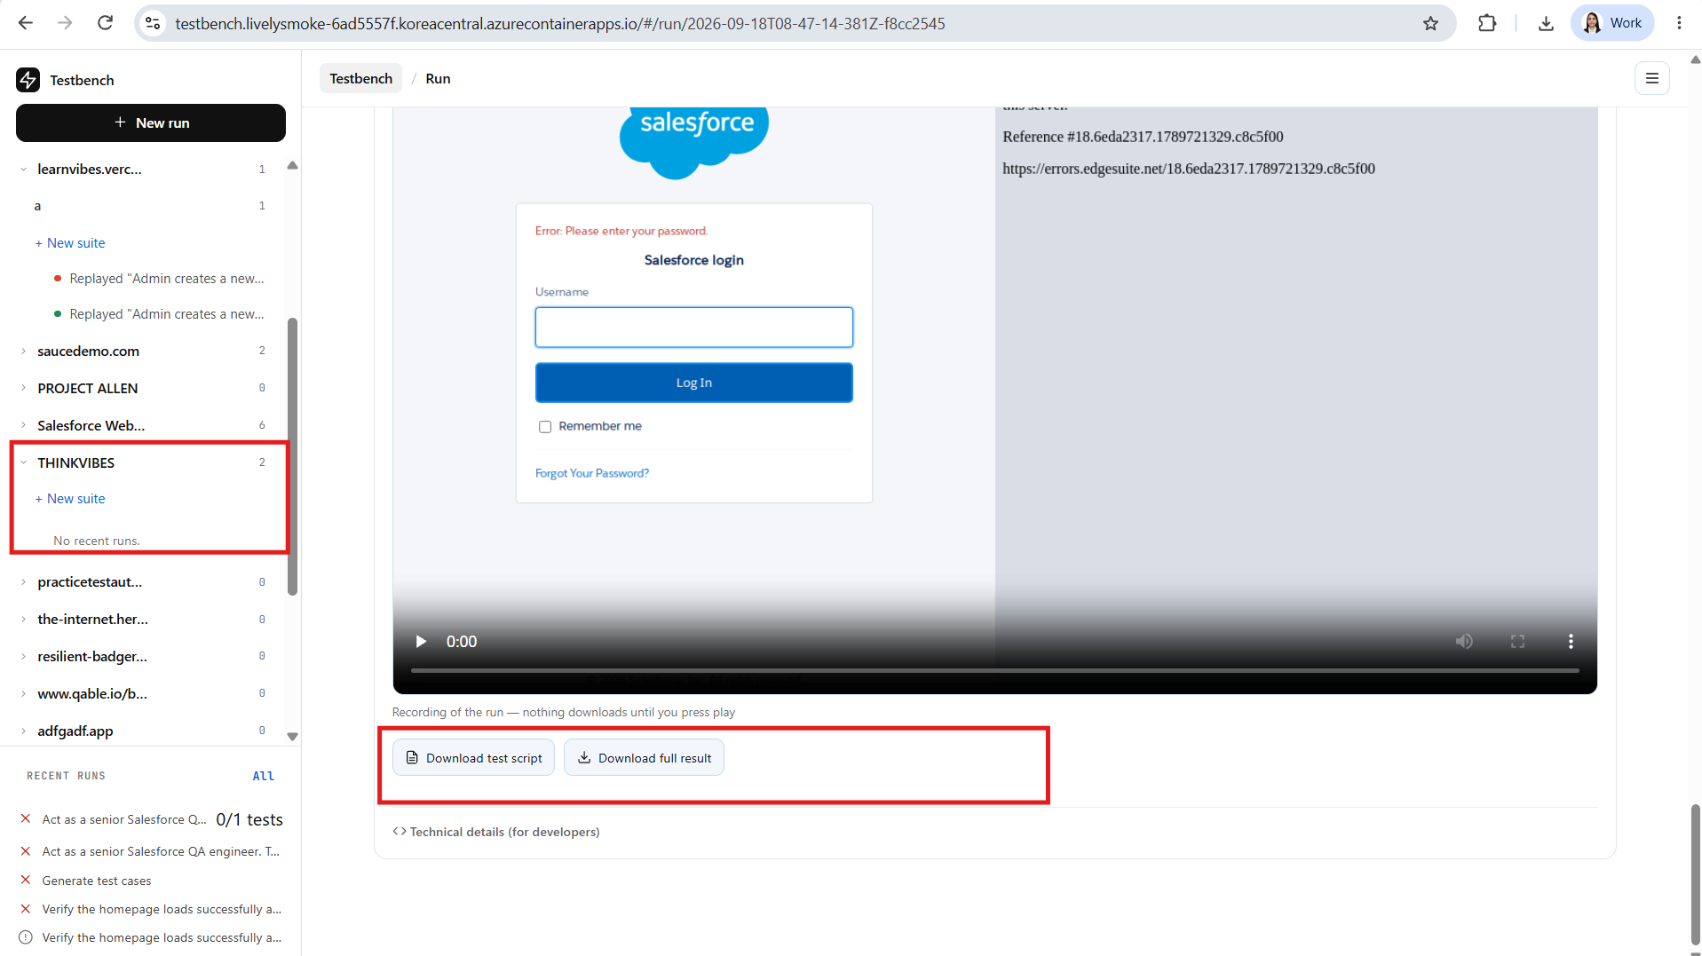

- Tried to add non existing email to the team– (working as expected)
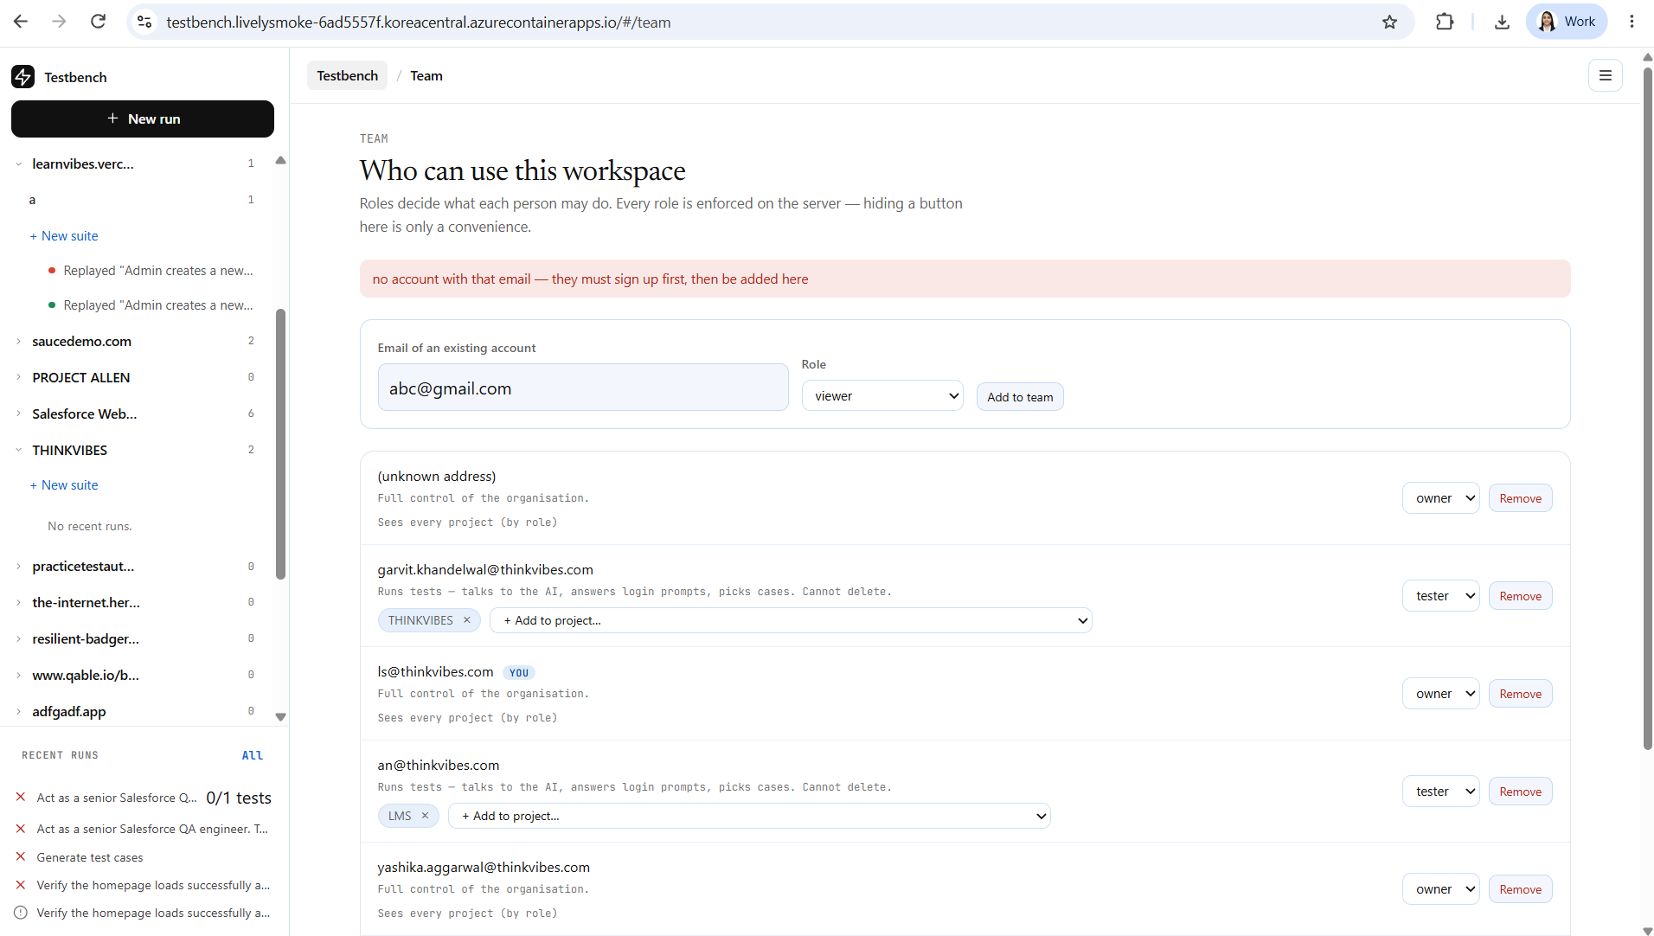

- Tried to add new suite – after entering there should be some option to “save” or “add” the suite should be there
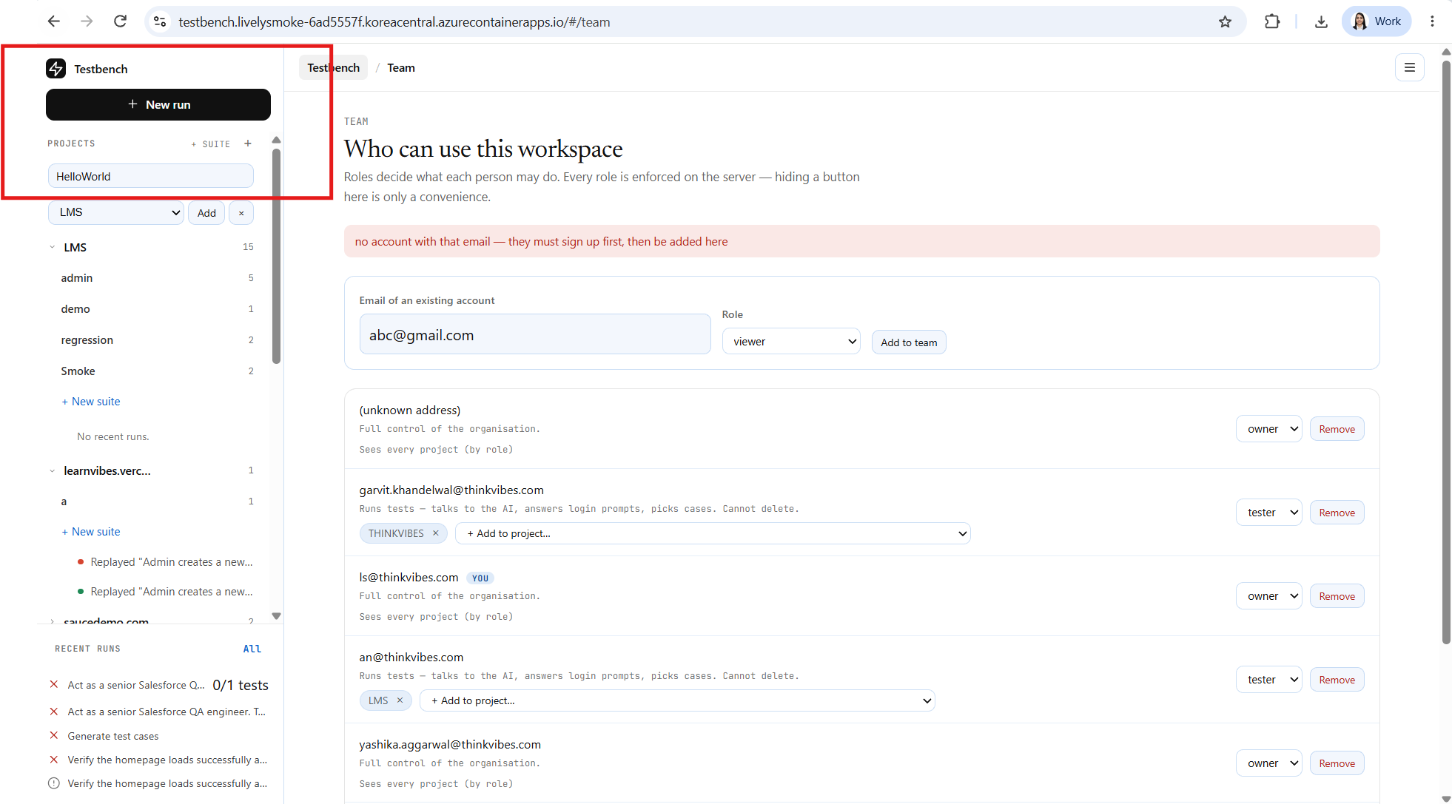

- After pressing enter it is taking time to reflect on the left window pane and on the right side. Due to which sometimes it gives a impression it is not working.
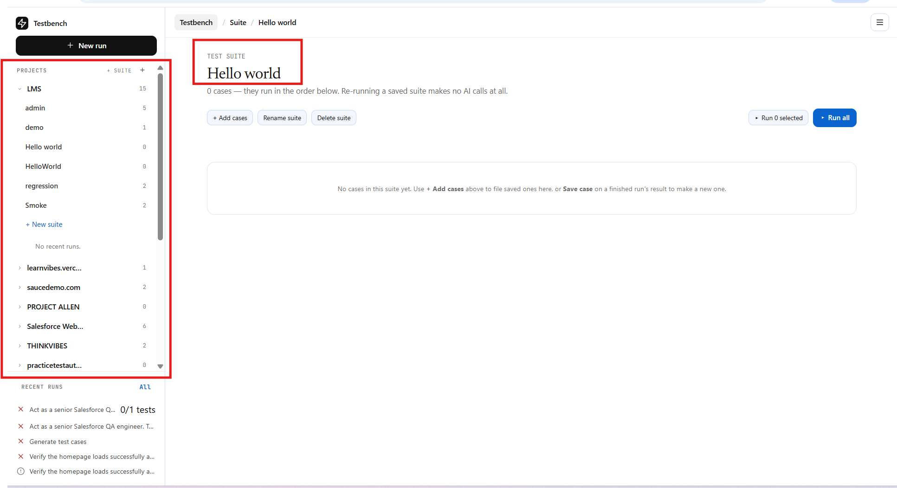

- As there are no cases in the suite “Run All” button should be disabled.
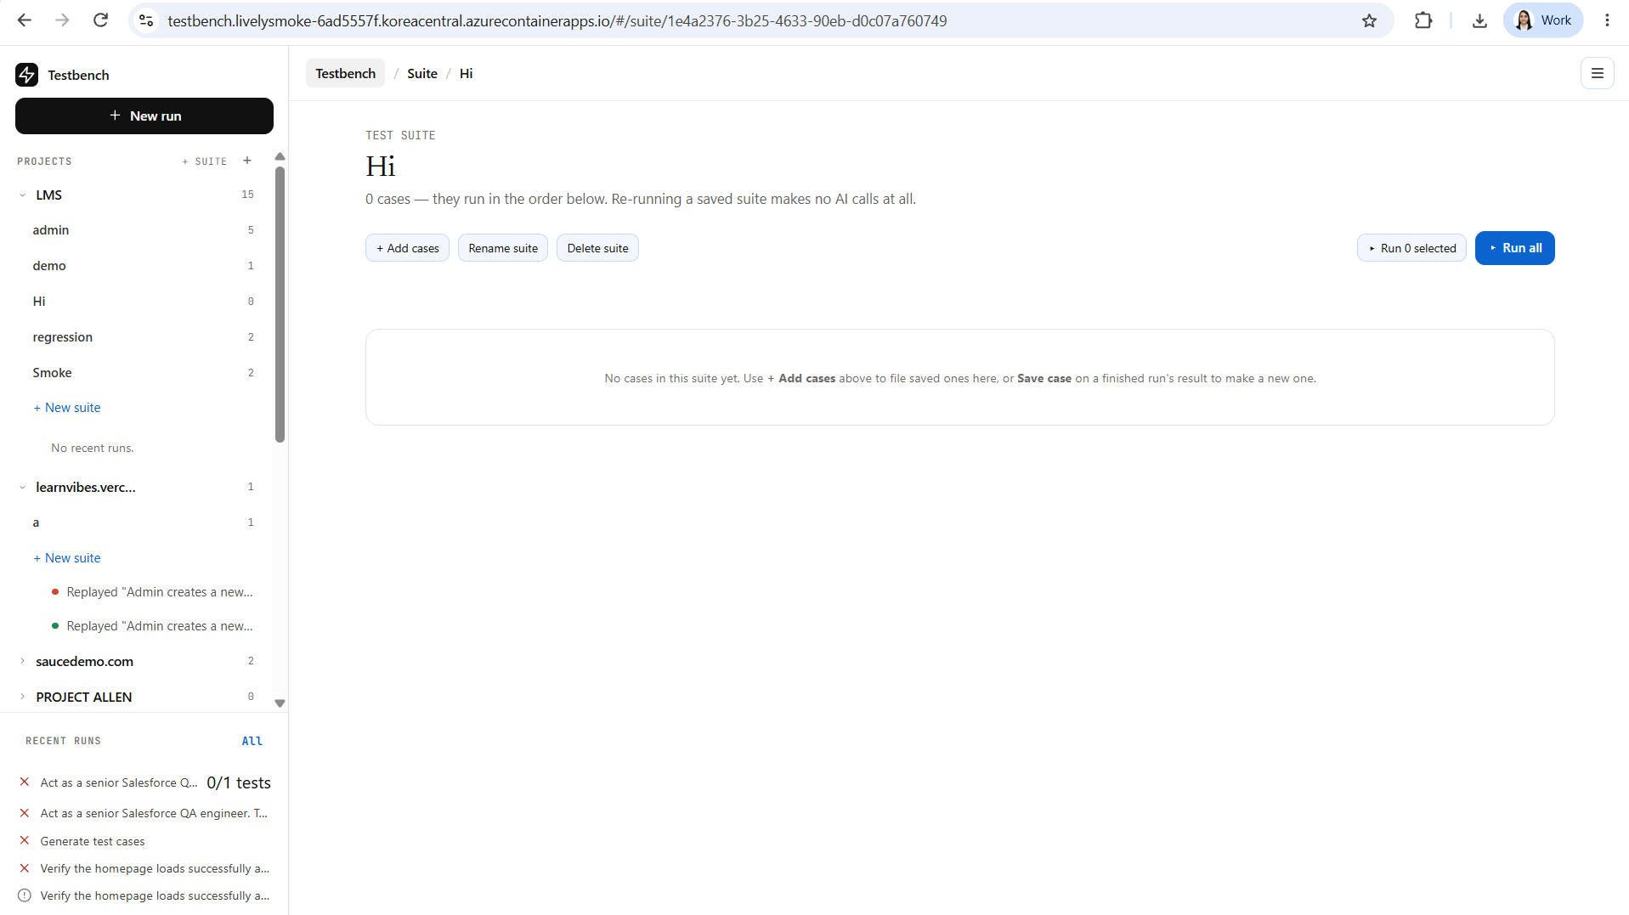

- After clicking on “Add cases” I am getting option to add from existing test cases and no option to add new cases. Not sure if this is the expected functionality or if the user should have the option to add new cases as well.
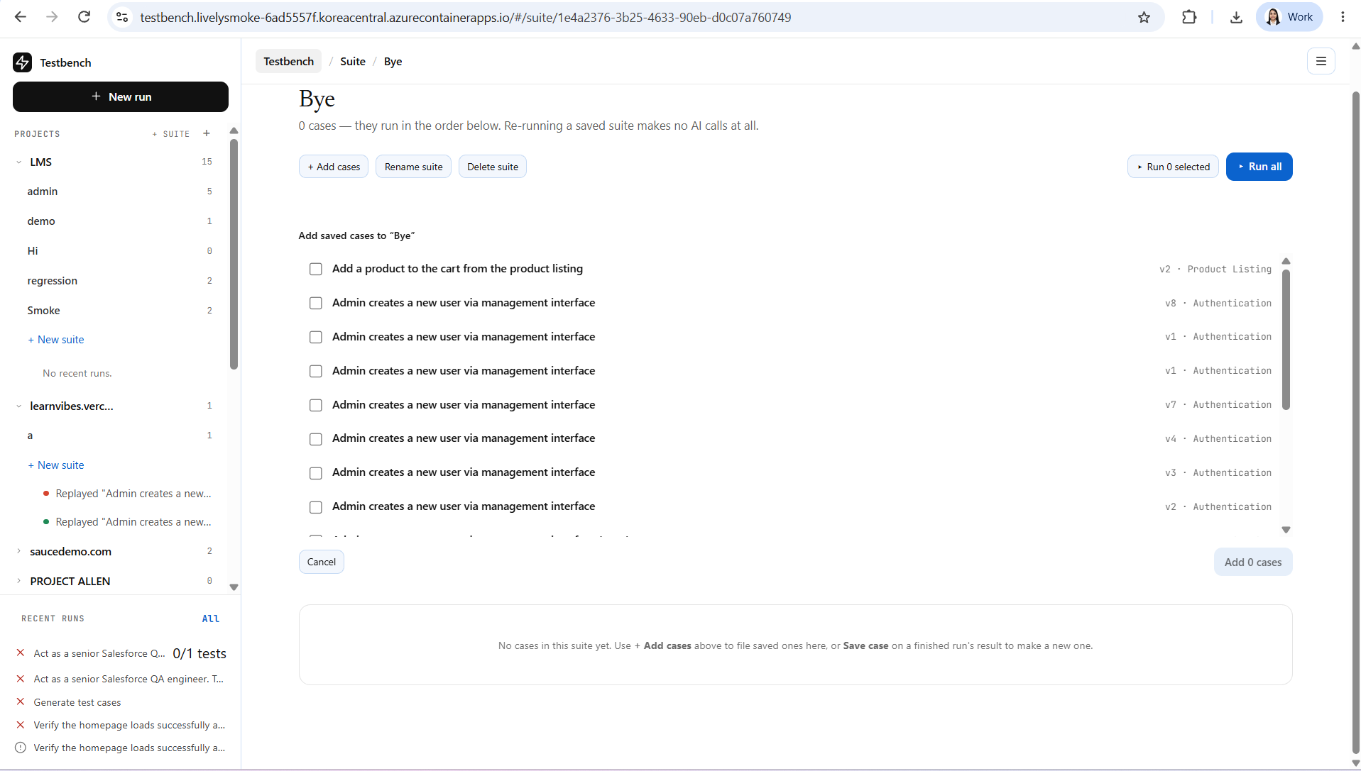

- Not able to add the cases
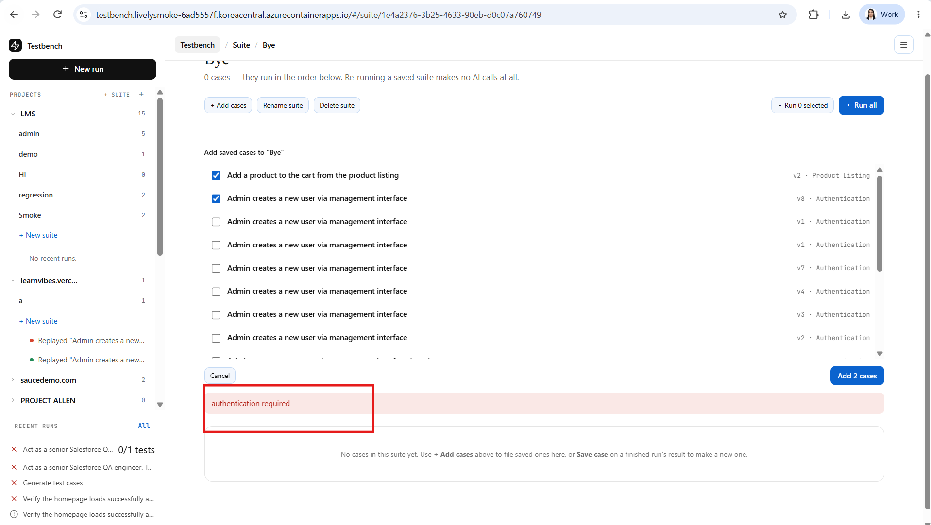

- Rename functionality is working as expected.
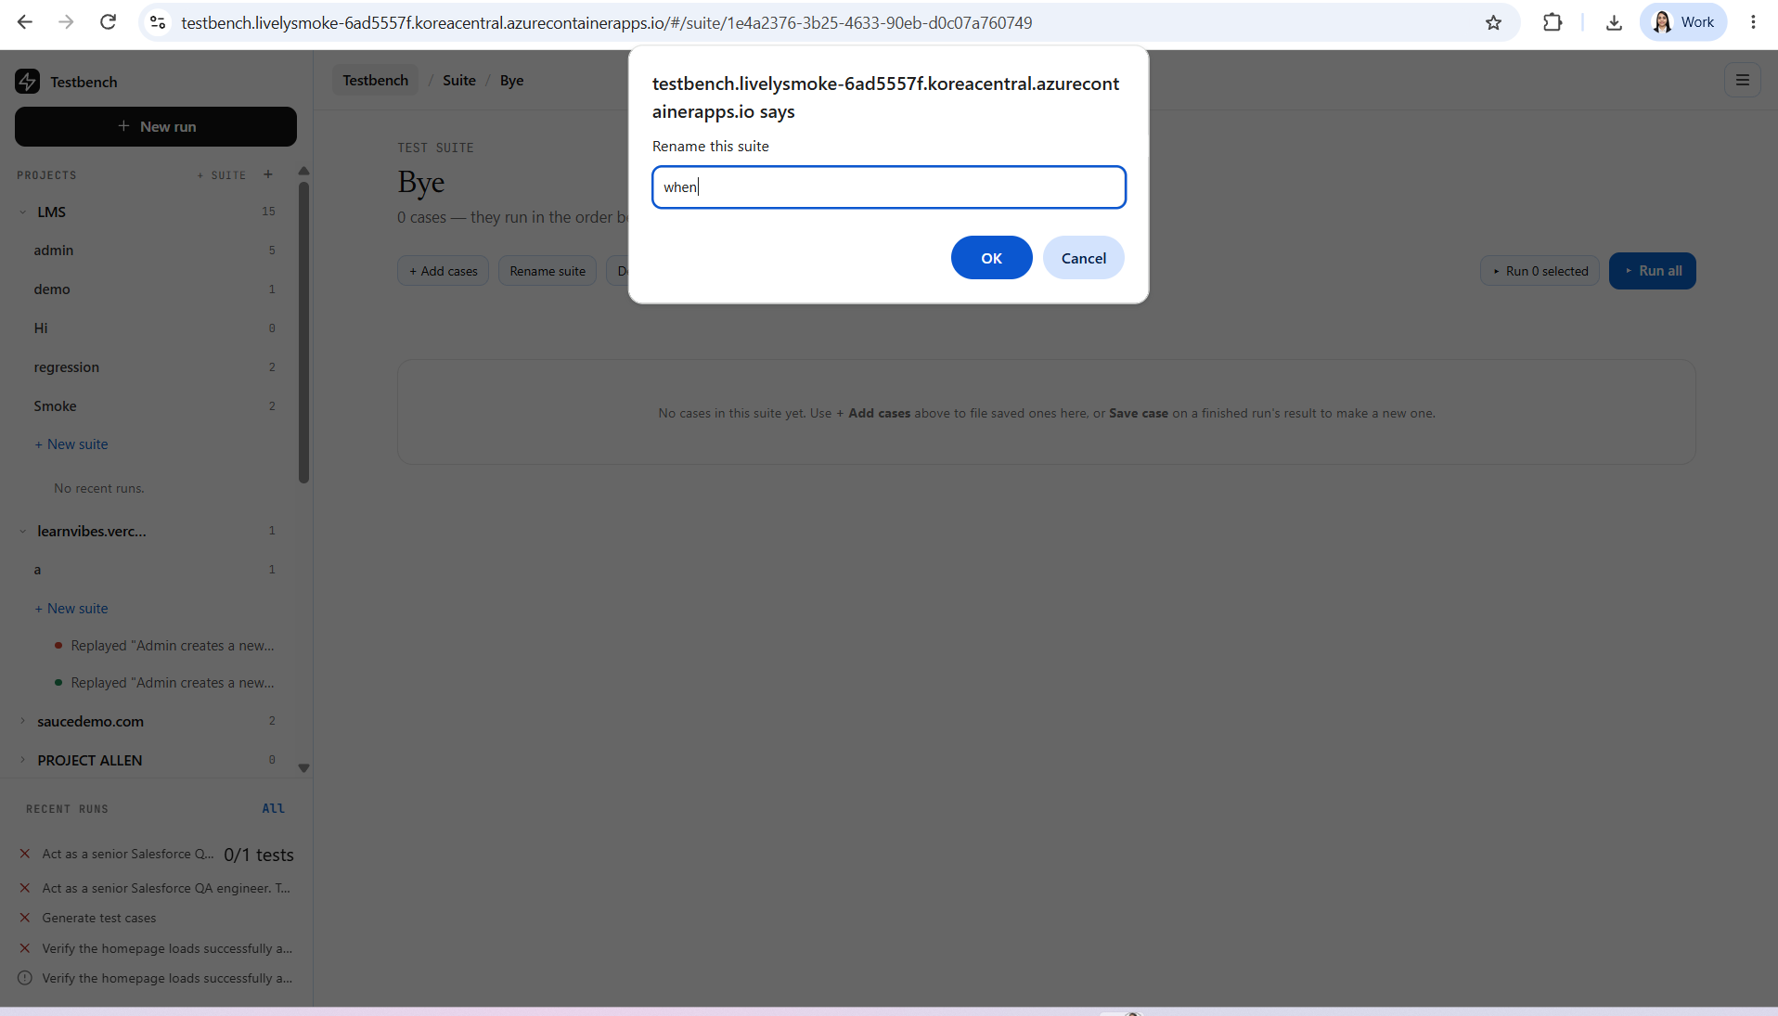

- While testing observed the server connection issue
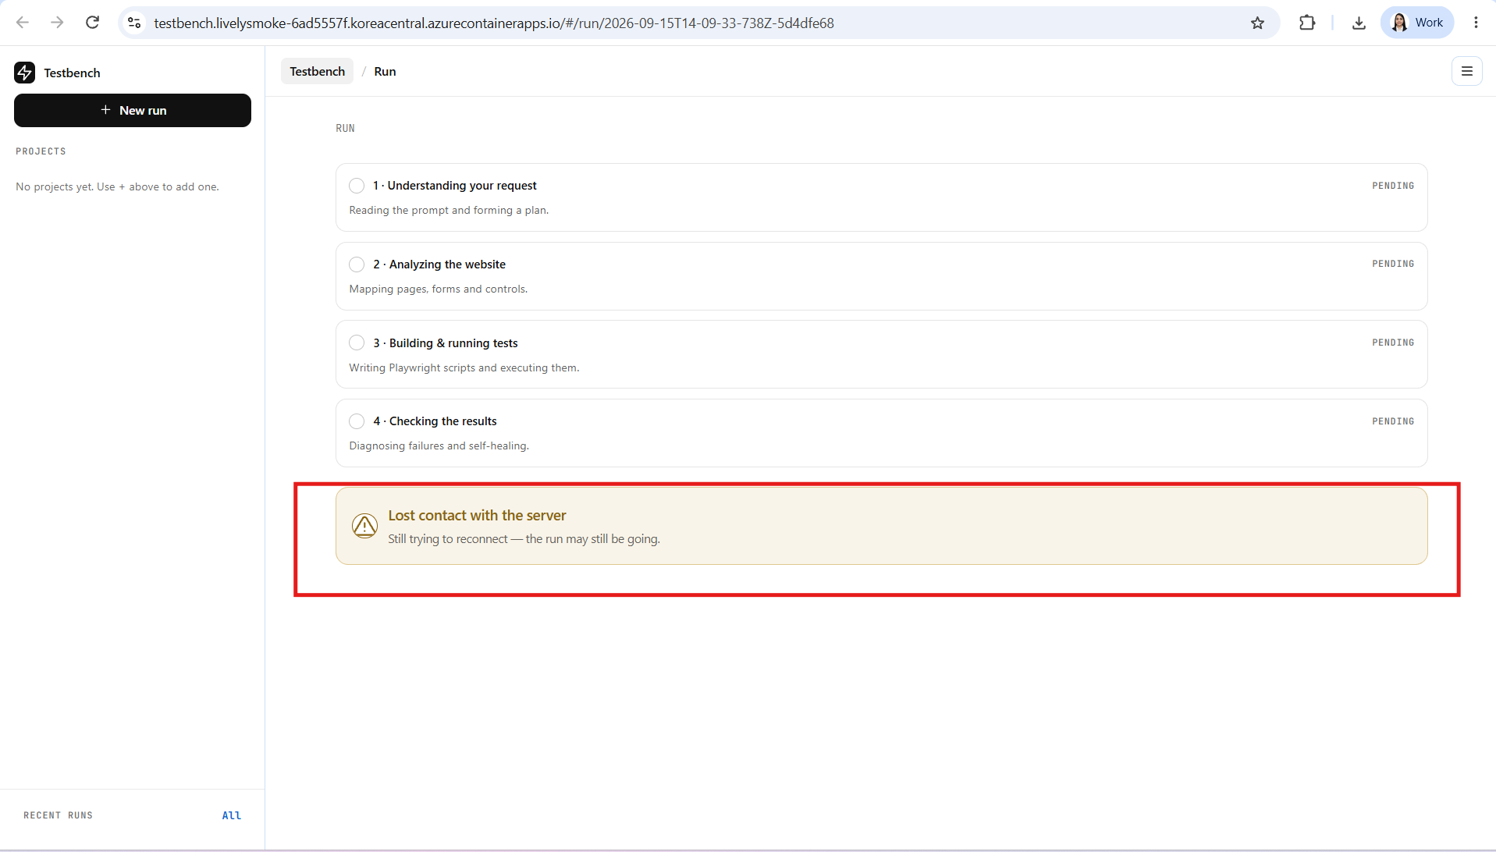

- Tested with google site verifying page load and all components are getting loaded.

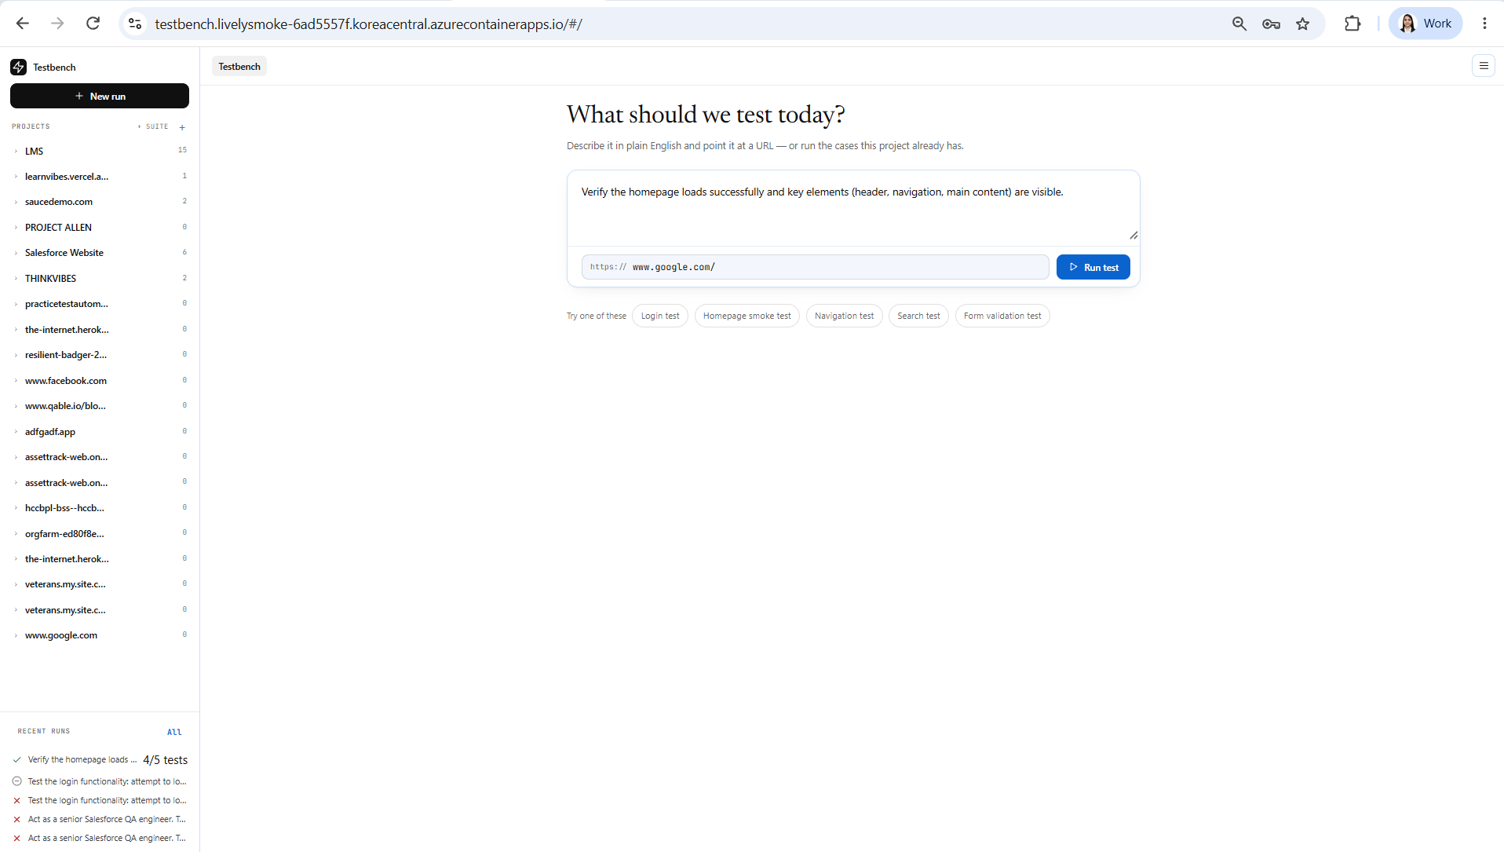

The highlighted test cases it generated are not understandable.
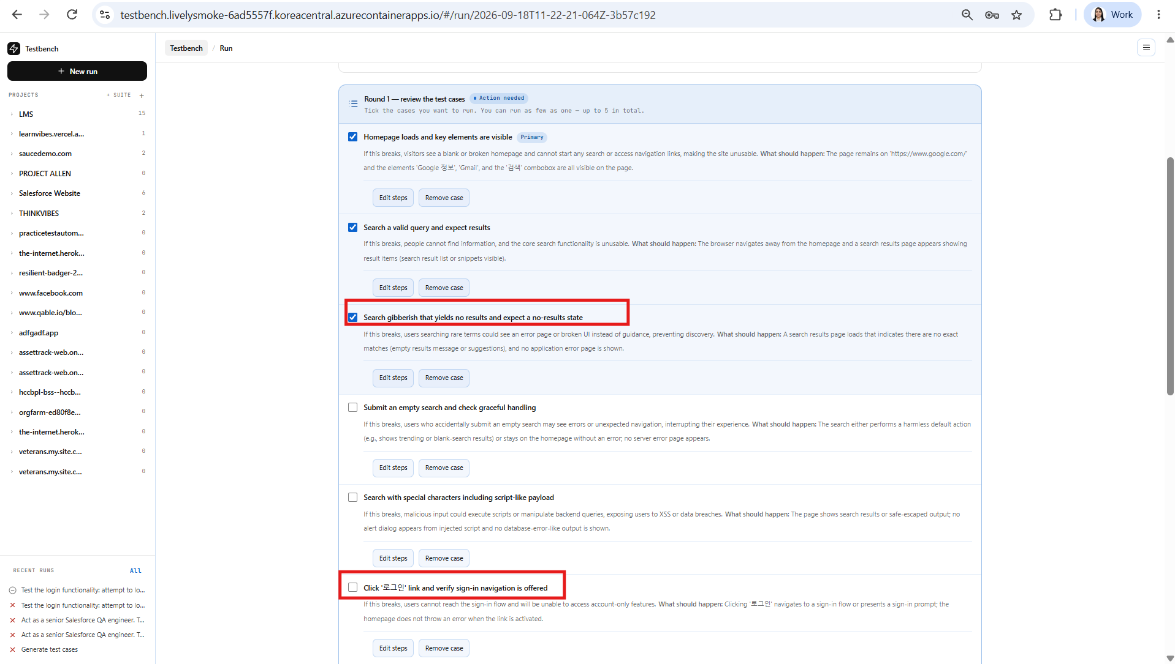

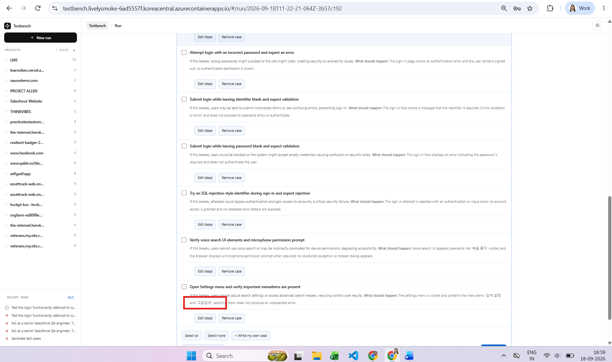

Test run:
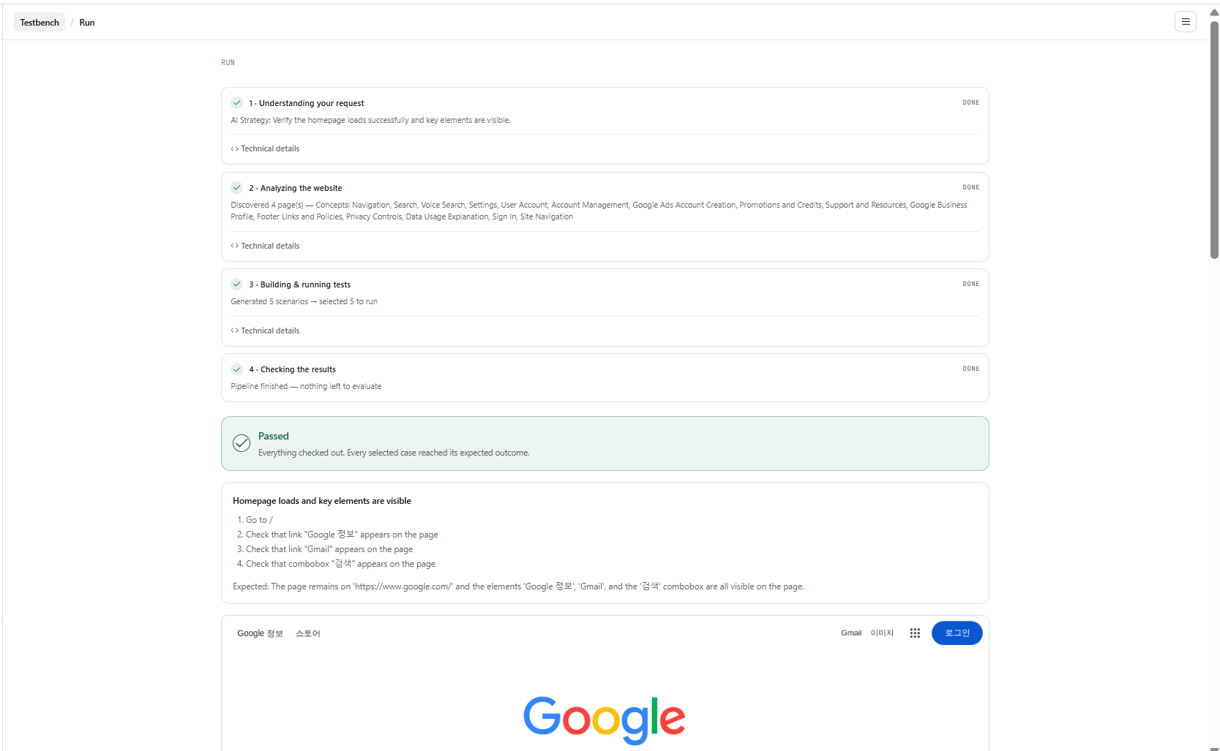

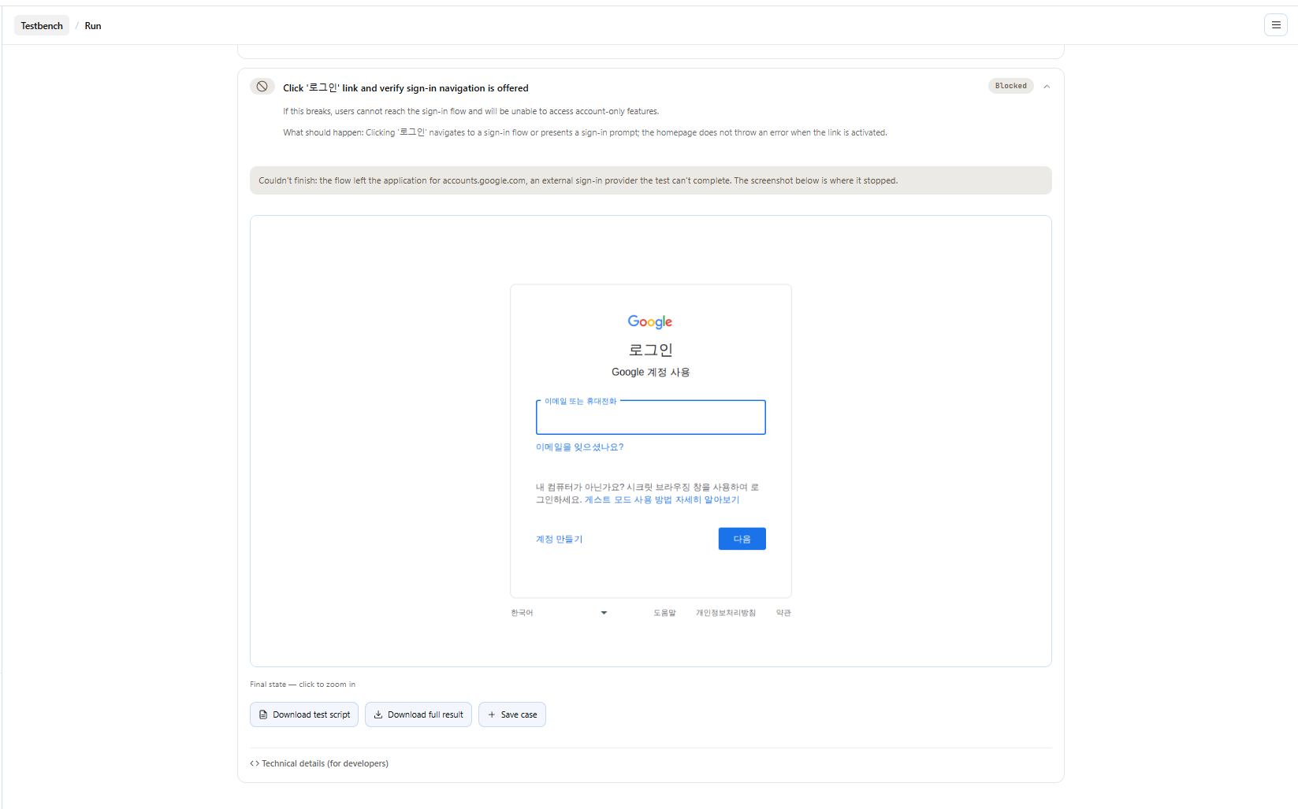

- For Demo QA site:
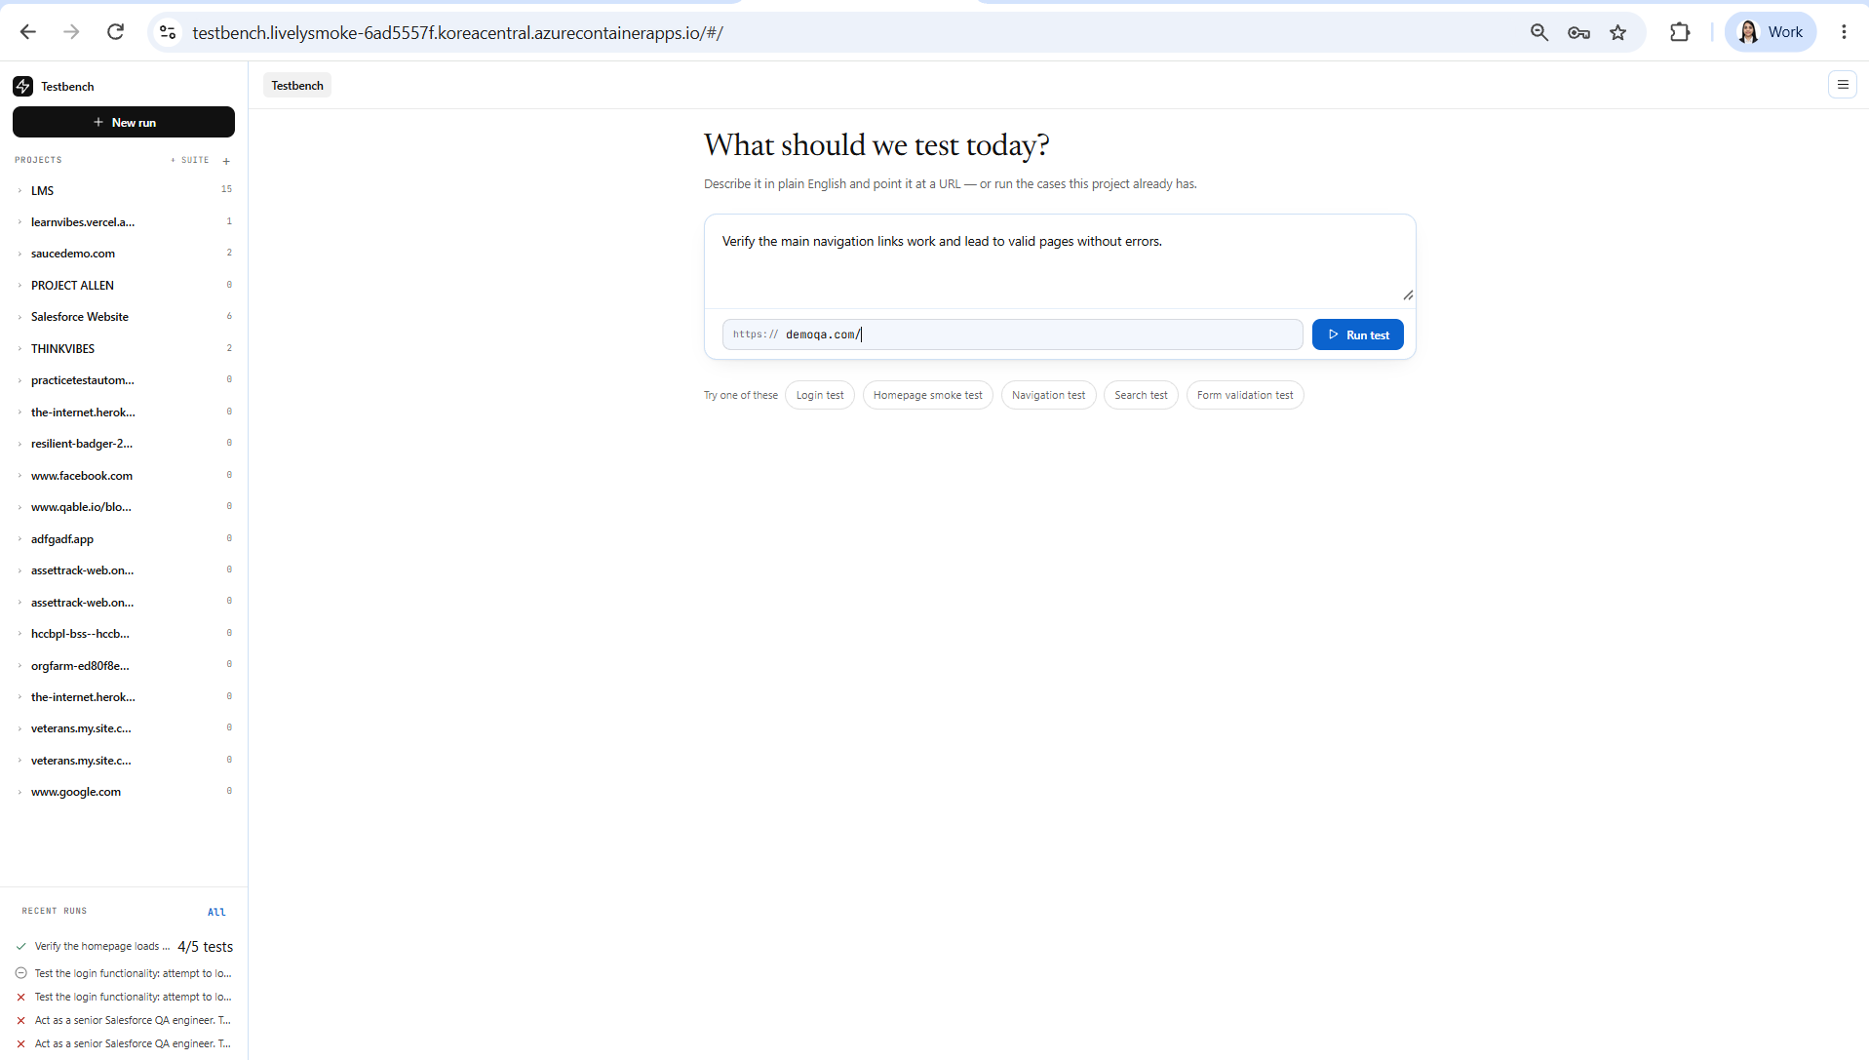

Generated below test cases:
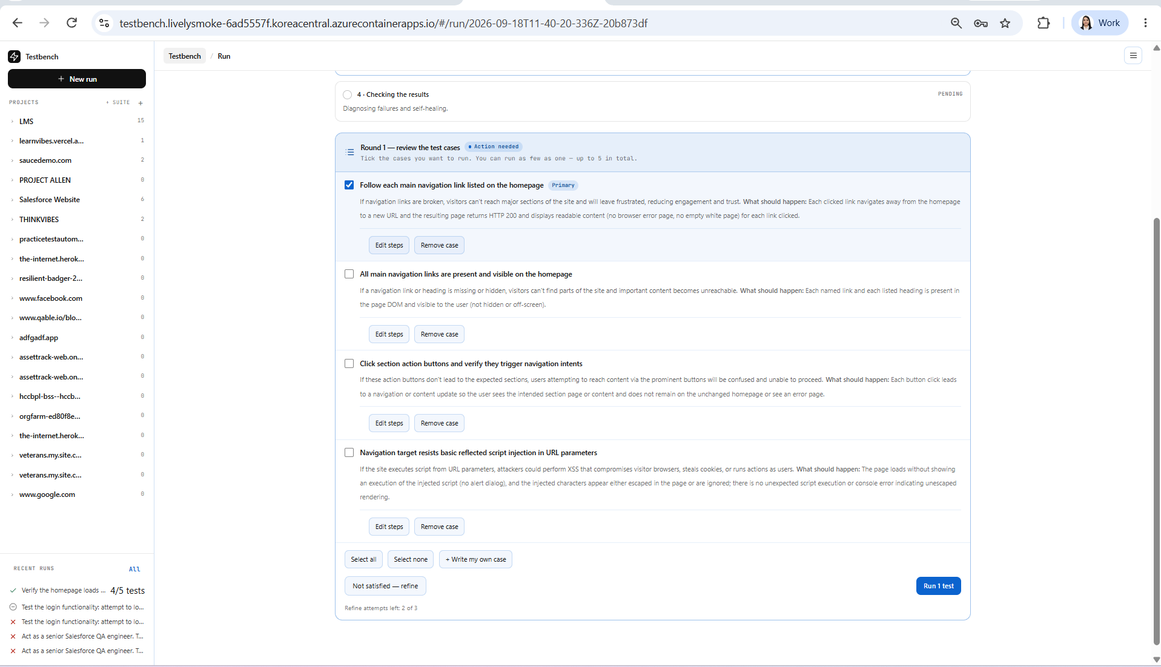

Test results: - 3 failed and 1 passed

