Volume 5 — Operations & Debugging
How to work out what went wrong, yourself
Describes commit 57e6261 on branch main · written 1 September 2026 · Volume 5 of 5
This volume exists so that when something breaks, the team can read the error and reason about it — rather than pasting it into a chatbot and hoping.
Nearly every failure in this system has already written its own explanation to disk. The skill is knowing which file to open.
Volume 5 — Operations & Debugging 1
1. The decision tree 1
The four-command triage 2
2. Is it even a failure? 3
Passed, but verified nothing 3
Blocked, not failed 3
It never ran at all 3
You are testing a stale server 3
3. A worked example 4
4. Common errors and what they mean 5
5. Configuration 6
Models and keys 6
Cost and reliability ceilings 6
Feature flags 7
Context caps 8
6. The test suite 8
What is covered 9
Before calling anything done 10
7. Known-broken things 10
8. Where the documentation lives 11
9. A checklist for a genuinely stuck run 12

1. The decision tree
Start here. Work top to bottom. Most failures are identified within two steps and without reading any source code.
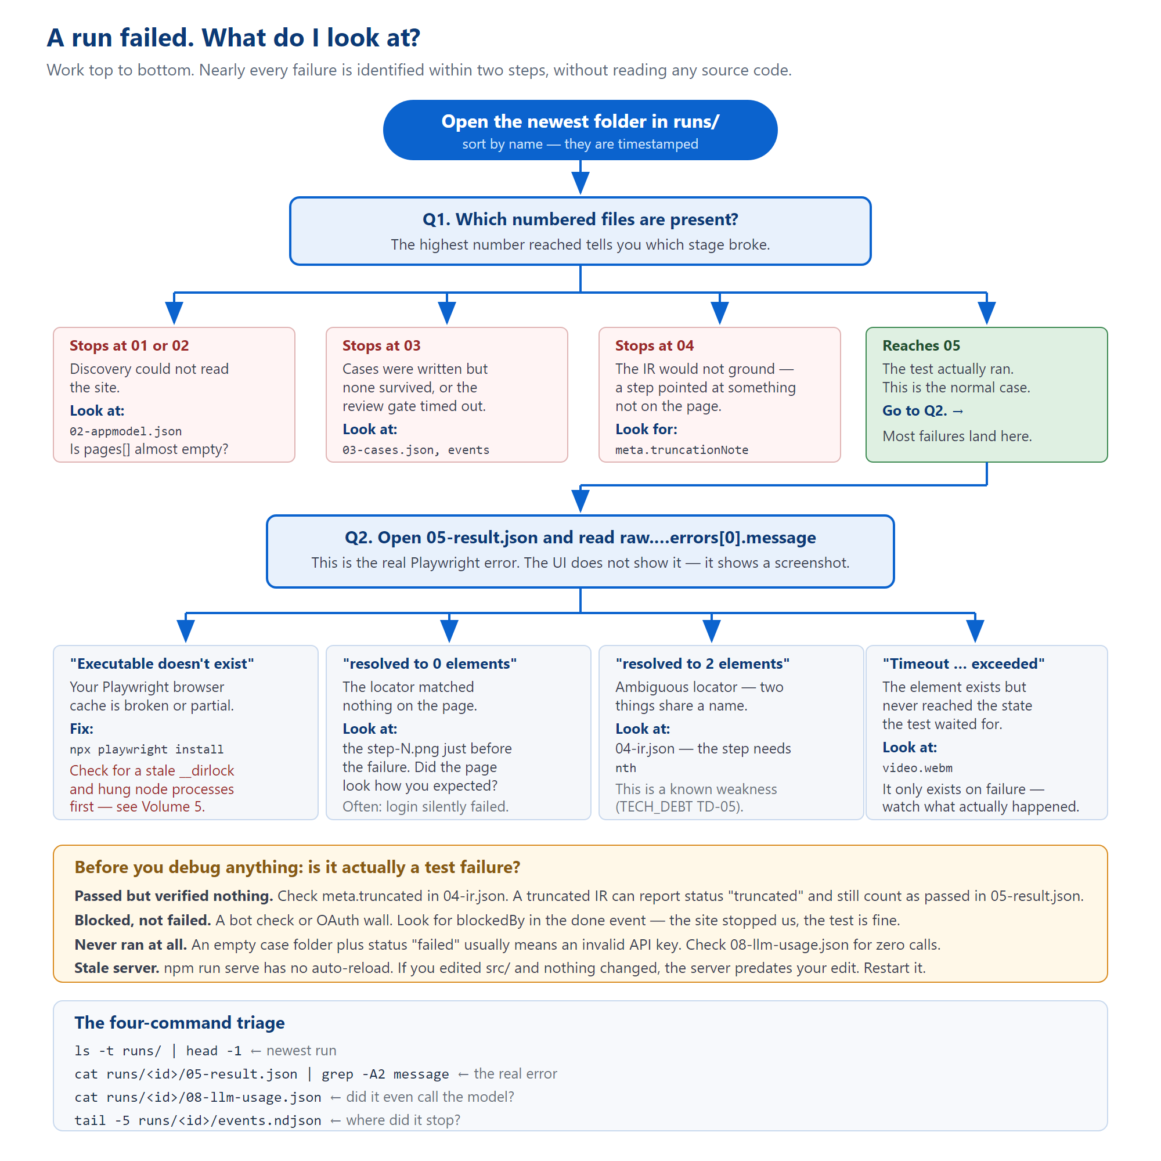
Figure 1 — from "a run failed" to a cause, using only the files on disk.

The four-command triage
ls -t runs/ | head -1 # newest run
cat runs/<id>/05-result.json | grep -A2 message # the REAL error
cat runs/<id>/08-llm-usage.json # did it even call the model?
tail -5 runs/<id>/events.ndjson # where exactly did it stop?
The single most important habit in this document.
The user interface does not show you the error. It shows a screenshot and a plain-English diagnosis. The actual Playwright error — the one with the locator, the timeout and the stack — lives in:
runs/<id>/05-result.json
→ raw.suites[0].specs[0].tests[0].results[0].errors[0].message
People routinely debug from a picture when the exact error was sitting in a file the whole time.

2. Is it even a failure?
Four situations look like test failures and are not. Check these before investigating anything.

Passed, but verified nothing
Check meta.truncated in 04-ir.json. If the compiler could only ground the first two steps, the test runs two steps and reports success. Worse: 05-result.json records passed: status === "passed" || status === "truncated" — so a truncated case counts as passed in that field. The honest status is in 07-suite-summary.json.
meta.truncationNote tells you where it gave up and why.

Blocked, not failed
A bot check, a CAPTCHA, or an OAuth wall. Look for blockedBy in the done event. The site stopped us; the test is fine. Note that blocked overrides passed in the event but does not rewrite 05-result.json — so the file and the UI can legitimately disagree.

It never ran at all
An empty case directory alongside a failed status usually means the run never reached the browser. Check 08-llm-usage.json: zero calls with a failed status normally means an invalid or exhausted API key.
This class of failure is recorded in problems.md in blunt terms: "You were told your website has failing tests when the truth was that your API key was invalid." Always confirm the run actually executed before you go looking at the site under test.

You are testing a stale server
npm run serve runs tsx once and has no watch or reload. A running server keeps executing whatever code was in memory when it started. Editing src/ changes nothing until you restart it.
There is a documented incident where a fix was verified offline, and a live run afterwards still showed the exact pre-fix behaviour — because the server process was over an hour older than the edit. Before judging any source change against a live run, check that the server started after your edit.

3. A worked example
This is a real diagnosis from 1 September 2026. It is included because the shape of it is typical: the visible symptom was three layers away from the cause, and every clue needed was already on disk.

The symptom
Every test run produced a completely white screenshot. Every run, every case. The same repository worked on a colleague's laptop.

Layer 1 — what the artifacts said
05-result.json held the real error:
Error: browserContext.newPage: Executable doesn't exist at
…\ms-playwright\ffmpeg-1010\ffmpeg-win64.exe
The chain: playwright.config.ts sets video: "retain-on-failure", so Playwright spawns ffmpeg the moment a page is created. Missing ffmpeg means newPage() throws in under a second — before any navigation. But screenshot: "on" still fires and photographs a page that was never navigated: a blank 1280×720 PNG, exactly 4,331 bytes, every time.
The UI served that PNG with a valid HTTP 200, so its onerror guard never fired and nothing hid it.

Layer 2 — why the obvious fix did not work
npx playwright install refused to start: a lockfile was held by two Node processes from the previous evening, still alive sixteen hours later having used two seconds of CPU between them. They were hung on a stalled download that never timed out. That is why every reinstall attempt for days had silently accomplished nothing.

Layer 3 — the actual defect
After clearing the lock, the error changed to spawn EFTYPE. The binary was present, had a valid executable header, and matched the machine's architecture. It was simply 31,190 bytes short — a truncated download from the same stalled installer. Valid header, missing tail; Windows refuses to load it.
Fetching the file directly from the CDN took 1.8 seconds, which also proved the network had never been the problem.

What to take from this
- The real error was in 05-result.json from the first run. The white screenshot was a symptom of a symptom.
- The platform's own failure classifier had already written the correct diagnosis into 06-diagnosis.json, days earlier.
- "It works on my machine" pointed at the environment, not the code — the Playwright version is pinned exactly, so drift was impossible; only the browser binary cache could differ.
- A file existing is not the same as a file being usable.

4. Common errors and what they mean
Error text | What it means | What to do
Executable doesn't exist at … | Playwright's browser cache is missing or partial. | npx playwright install. If it hangs, check for a stale __dirlock and hung oopDownloadBrowserMain processes first.
spawn EFTYPE / "not a valid application" | A binary is present but truncated or corrupt. | Compare its byte size against a fresh CDN download.
resolved to 0 elements | The locator matched nothing. | Open the step-N.png just before the failure. Very often the login silently failed and you are looking at a login page.
resolved to 2 elements | Two things share a name — a strict-mode violation. | The step needs an nth. This is a known weakness (TD-05).
Timeout … exceeded | The element exists but never reached the expected state. | Watch video.webm. It only exists on failure, which is exactly when you want it.
ReferenceError: __name is not defined | A named function inside a page.evaluate callback. | Inline it. Note this passes every unit test and only fails on a real server run.
Element is not an <input> | A locator matched the <label> instead of the field. | Field actions should route through the field helper, not getByText.
No semantic locator for target | A target had no usable identifying information. | Usually a grounding gap upstream; check 04-ir.json for that step.
503 "the database is not configured" | No Supabase service-role key. | Expected without one. Runs still work; the library does not.
Every run parks forever, no error | MAX_CONCURRENT_RUNS is non-numeric → NaN → silent deadlock. | Check the value. Empty crashes at boot; abc deadlocks silently.
A prompt change has no effect | The LLM disk cache never expires. | The system prompt must be part of the cache key. Or clear runs/_cache/llm/.

5. Configuration
All defaults are in .env.example, which is worth reading in full — its comments explain why each limit exists.
Never copy values out of .env into a document, a ticket, or a chat. It holds live API keys. .env.example is the file to share; it holds placeholders.

Models and keys
Variable | Default | Notes
GEMINI_API_KEYS | — | Comma-separated. Keys only stack quota if each is from a distinct Google project; two keys in one project do not.
GEMINI_MODEL | gemini-3.6-flash | Used for the expensive stages.
GEMINI_MODEL_LITE | gemini-3.1-flash-lite | Plan, concept labelling, failure analysis.

Cost and reliability ceilings
Variable | Default | What it bounds
LLM_TIMEOUT_MS | 45000 | Per attempt. Worst case per call is this × the retry count.
MAX_LLM_CALLS_PER_RUN | 60 | Hard cap across every stage. Actual spend lands in 08-llm-usage.json.
MAX_IR_ATTEMPTS | 4 | IR compile retries per case.
MAX_LIVE_EXTENSIONS | 5 | Browser replays per case. Each also consumes one IR attempt — raising one without the other starves convergence.
MAX_CONCURRENT_RUNS | 3 | Concurrent Chromium instances. See the footguns in Volume 3.
MAX_DISCOVERY_PAGES | 5 | How far the crawl goes.
CREDENTIAL_WAIT_MS | 300000 | 5 minutes. Holds a concurrency slot the whole time.
CASE_SELECTION_WAIT_MS | 600000 | 10 minutes. Same caveat.
MAX_LOGIN_CASES | 1 | Stops the suite testing the login screen instead of the app behind it.
APPMODEL_CACHE_TTL_MS | 30 min | Set to 0 while iterating against a site you are editing.
DISCOVERY_HYDRATION_POLL_MS | 6000 | How long to keep re-checking a page that extracted zero elements.
A gap worth knowing: PLAYWRIGHT_TIMEOUT is read by playwright.config.ts but is not listed in .env.example. It defaults to 50,000 ms.

Feature flags
The rule, stated at the top of that block: every flag defaults to OFF; with all of them unset the server behaves exactly as it did before the phase that introduced them.
Flag | Default | Effect
ENABLE_CASE_SELECTION_GATE | false | The human review pause after case generation.
AUTH_ENABLED | off | Supabase auth. Also needs DB_ENABLED — alone it logs a warning and everyone sees everything.
DB_ENABLED | off | Gates only the run-row writes and shadow read. Not the library.
NL_STEPS_ENABLED | false | "Write it for me" in the step editor.
GATE_CASE_EDIT_AI | false | "Ask for a change" at the review gate.
RUN_RETENTION_DAYS | 0 (off) | Prunes old terminal runs. Hard 24-hour floor regardless of the value.
TEST_USERNAME / TEST_PASSWORD | — | Suppresses every credential prompt, everywhere.
SIGNUP_ENABLED is the one exception — it defaults to ON.
Only SIGNUP_ENABLED=false turns it off. The justification is that the sign-up screen only exists when AUTH_ENABLED=true, which is itself off — so the shipped default is still "no sign-up".
But POST /api/auth/signup is unauthenticated by necessity and creates real accounts using the service-role key. Its rate limit (5 per 15 minutes per IP, in-process) is described in the source as "a speed bump, not access control".
The comment in .env.example is in capitals for a reason: set this to false before exposing this server beyond localhost.

Context caps
A group of MAX_LITE_* variables bound how much of a site's model goes into a prompt. They exist because a rich site with no caps produced a 17,000-line model JSON and got a 413 from Gemini. The defaults sit above every page this project has actually sampled (87 elements, 2 forms, 18 nav nodes), so they only engage on a genuinely richer site.

6. The test suite
Two test runners, and confusing them is the most common week-one mistake.
Vitest — npm test — runs tests/**. These are the platform's own unit tests.
Playwright — playwright.config.ts — has its testDir pointed at runs/. It runs the generated tests for the site under test.
The directories are deliberately disjoint, and the Vitest config explicitly excludes runs/. "The tests are failing" is an ambiguous sentence here — say which runner.

What is covered
Area | Files | Notable
Discovery & DOM | 5 | genericClickables launches real Chromium; authCrawl spins up a local HTTP server
IR & grounding | 12 | grounding.test.ts is the largest file in the suite at ~1,050 lines
Cases & strategy | 7 | Selection, scoping, the gate
Generate / execute / diagnose | 6 | Includes secret-scrubbing
Credentials & secrets | 4 | credentials.test.ts ~737 lines
Server / API / storage | 5 | apiContract uses supertest against the real app
Auth & tenancy | 3 | tenancy.test.ts — a two-org isolation matrix, 31 tests
Step editor | 5 | Round-trip and drift checks
LLM plumbing | 2 | Backoff, budget
Frontend contract | 2 | The only automated checks on public/ — see Volume 4 §8
Pass count: 790 across 51 files, from docs/LLM_CONTEXT_BRIEFING.md, snapshot dated 1 September 2026 — that document flags its own numbers as the most perishable thing in it. Re-check before quoting. The repository has an explicit rule against treating any number in its documentation as current.
There is no CI. Nothing runs these automatically (TECH_DEBT.md TD-20). Run them yourself.

Before calling anything done
npx tsc --noEmit # must be clean
npx vitest run # note the pass count if it changed
And one rule that has burned this project repeatedly: a passing test does not prove a fix. A generated Playwright expression that looks right is not verified until it has been run once. The .filter({ visible: true }) incident (Volume 2, §7) passed type-checking and a unit test while being a complete no-op, because both checks only inspected the emitted string.
If a change touches the Playwright API surface of generated code, execute it once against a synthetic HTML page. That costs nothing and is the only check that would have caught it.

7. Known-broken things
TECH_DEBT.md is the single owner of this list — 150 KB, entries TD-01 upward, most citing a real run ID. Do not start a second list anywhere. A sample of the ones most likely to affect you:
ID | What
TD-01 | A "deterministic" guard written as a regex over model-authored prose is not deterministic. The reference example of a whole class of bug.
TD-05 | Duplicate (role, name) pairs make grounding ambiguous — the source of most resolved to 2 elements failures.
TD-07 | The locator algorithm is written twice — in targetResolver.ts and in the generator's injected helper — and nothing pins them equal.
TD-14 | runs/ is served publicly. The reason credentials must never touch disk.
TD-20 | No CI runs the checks.
TD-22 | The LLM disk cache never expires; a cache key missing a dimension serves a wrong answer forever.
problems.md is a different kind of document — a dated forensic audit (18 August 2026) of every run directory then on disk, with statistics and root-cause rankings. It is not a second defect register, and its numbers are a snapshot.
Do not read SITE_STORE_VIEW_SPEC_v2.md as a description of the system. It is a 40 KB design specification for a restructuring that has not been implemented. It is easy to mistake for documentation of the current code.

8. Where the documentation lives
File | Size | Owns
CLAUDE.md | 13 KB | Working rules and sharp edges. Capped at 200 lines. The best thing to read first.
README.md | 23 KB | What this is and how to run it.
ARCHITECTURE.md | 38 KB | The formal file map and data contracts.
DECISIONS.md | 55 KB | Why each choice was made, and what was rejected.
TECH_DEBT.md | 151 KB | What is broken. The largest document in the repository.
docs/phases/ | 16 reports | A build log. Each ends with what it deliberately did not fix.
docs/EDITABLE_IR.md | 15 KB | A walkthrough of the case-editing flow.
Two documents are known to be out of date.
PROJECT_OVERVIEW.md's frontend section is wrong on three verifiable points: it gives app.js as ~4,400 lines (it is 5,105), says six views exist with three unbuilt stubs (there are nine, and all three are built), and says the UI uses Server-Sent Events (it polls).
ARCHITECTURE.md is right about polling but still calls three built routes "not yet built".
This is not a criticism of anyone — it is the documented, recurring failure mode of this repository, and the reason CLAUDE.md says plainly: don't treat a number in these docs as current without re-checking it. That applies to this document too.

9. A checklist for a genuinely stuck run
- Did it run at all? 08-llm-usage.json — zero calls means it never started properly.
- Where did it stop? tail -5 events.ndjson.
- What is the real error? 05-result.json, the errors[0].message path.
- Did it verify anything? meta.truncated in 04-ir.json.
- Was it blocked? blockedBy in the done event.
- What did the page look like? The last step-N.png, then video.webm if there is one.
- Is the server current? Did it start after your last edit to src/?
- Is the cache lying to you? The LLM disk cache never expires. runs/_cache/llm/.
- Is the browser cache intact? npx playwright install, and check for a stale lock first.
- Is it a known issue? Search TECH_DEBT.md for a keyword from the error.
The habit that makes all of this work. This project writes down what it did. Almost every question — what was on the page, what the model was asked, what it answered, what the browser saw, what it cost — has an answer already sitting in runs/<id>/.
Read the evidence before reading the code. It is faster, and it is usually enough.

