Volume 3 — Server & Data
Routes, permissions, and where everything is stored
Describes commit 57e6261 on branch main · written 1 September 2026 · Volume 3 of 5
Covers the 18 files in src/server/ (4,806 lines), plus src/db.ts and src/runStore.ts.
A teaching narrative. ARCHITECTURE.md owns the formal file map, DECISIONS.md the reasoning, TECH_DEBT.md the defects.
Volume 3 — Server & Data 1
1. Two storage systems, deliberately split 1
2. The Express app 2
The middleware stack, in order 2
The routes, grouped 3
3. The artifact route — read this one carefully 4
4. Authentication and permissions 5
Two axes, deliberately kept apart 6
The governing rule of authz.ts 6
What happens with AUTH_ENABLED unset 6
Everything fails closed 7
Sign-up 7
Organisation management 8
5. The database 8
The tables 8
Every database write is fire-and-forget 9
6. Run storage on disk 10
7. Concurrency 11
8. How credentials stay off disk 11
9. The remaining server modules 12
The proposer rule 13
Two things in library.ts that will catch you 14
10. Ten things worth knowing on day one 14

1. Two storage systems, deliberately split
This is the first thing to get straight, because almost every "where does that live?" question resolves to it.
Store | Authoritative for | Never holds
Disk — runs/ | Run content: the event log, artifacts, IR, generated specs, screenshots, video. | Identity or permissions.
Supabase Postgres | Identity, organisations, roles, projects, and the saved case library. | Run content. Only a row saying a run exists.
The database is in what the code calls shadow mode: it is written to, and read from for comparison, but disk still wins. Making Postgres authoritative for runs is an unshipped future step.
The whole stack is four runtime dependencies: Express 4, Zod 3, @supabase/supabase-js, and cheerio. No ORM, no build step — it runs through tsx directly.

2. The Express app
src/server/index.ts — 1,474 lines
The only HTTP surface. It has exactly one export — app — so that supertest can exercise routes without binding a port:
const isMain = !!process.argv[1] && fileURLToPath(import.meta.url) === process.argv[1];
if (isMain) { app.listen(port); startRetentionJob(); }

The middleware stack, in order
# | Middleware | What it does
1 | express.json() | Body parsing.
2 | express.static("public") | Serves the front end.
3 | app.use("/api", …) | Requires a valid session, unless the path is public.
4 | app.param("runId", …) | 400s anything that is not a well-formed run ID.
const RUN_ID = /^[\dT-]+Z-[0-9a-f]{8}$/; // no "/", "." or ".." — cannot escape runs/
const PUBLIC_API_PATHS = new Set(["/health", "/auth/config", "/auth/signup"]);
A footgun in that set. Those paths are matched against req.path after Express strips the mount point — so entries carry no /api prefix. If you add a public route and write /api/foo instead of /foo, it will silently return 401 the moment authentication is switched on, and work perfectly in development.

The routes, grouped
There are 57. Rather than list them flat, here is what exists and what guards it.
Group | Count | Typical guard | Notable members
Artifacts | 1 | custom | GET /runs/:runId/* — see §3, the most security-sensitive route in the server.
Running | 5 | tester on that run | POST /api/runs, …/credentials, …/case-selection (+ its AI rewrite)
Watching a run | 5 | viewer on that run | …/state (the one the UI uses), …/events (SSE, unused), …/page-elements
Run history | 2 | viewer / admin | GET /api/runs, DELETE /api/runs/:runId
Public | 3 | none | /api/health, /api/auth/config, /api/auth/signup
Session | 2 | authenticated | /api/auth/me, /api/auth/bootstrap
Projects | 7 | viewer / admin | CRUD plus member management
Organisations | 6 | org admin | members, roles, addable users
Suites | 8 | tester / admin | CRUD, cases in a suite, reordering
Cases | 16 | viewer / tester / admin | read, edit, versions, steps, re-ground jobs, duplicate, rewrite
Library ↔ runs | 2 | tester | POST /api/runs/:runId/cases/:caseId/save, POST /api/replay
Four levels of guard, and which subject each one asks about:
- requireAuth — are you signed in at all?
- requireRole(x) — do you have role x in your own organisation?
- requireRunRole(x) — do you have role x in the organisation that owns that run, and can you see its project?
- requireOrgRole(x) — do you have role x in the organisation named in the URL?
There are three separate middlewares rather than one clever one precisely because the subject differs. Making that explicit at each mount point is what stops a new route defaulting to the weakest interpretation.

3. The artifact route — read this one carefully
const RUNS_DIR = path.resolve("runs");

app.get("/runs/:runId/*", async (req, res) => {
const rel = req.params[0] ?? "";
const abs = path.resolve(RUNS_DIR, req.params.runId, rel);
if (!abs.startsWith(RUNS_DIR + path.sep)) return res.sendStatus(403); // traversal guard
if (!(await canAccessRun(req, req.params.runId))) return res.sendStatus(403);
res.sendFile(abs, (err) => { if (err && !res.headersSent) res.sendStatus(404); });
});
Five things about it:
- It is not under /api, so it never passes through the auth middleware. It resolves the user itself.
- It is a wildcard because Playwright nests artifacts arbitrarily deep under a generated slug directory.
- The traversal guard is independent — the startsWith check blocks escaping runs/ regardless of anything else.
- Cookie authentication exists specifically for this route. An <img> or <video> tag cannot send an Authorization header, so the token is also read from an sb-access-token cookie. Without that, every screenshot would 401 the moment auth was enabled.
5. With the shipped defaults, this route is unauthenticated.
canAccessRun returns true unconditionally when tenancy cannot be enforced — which is the default, because AUTH_ENABLED is unset. The comment in the source reads // no-op today, and it is literal.
That means screenshots, video, traces and generated specs of whatever site you tested — frequently including a login screen mid-flow — are served to anyone who can reach the port.
It is a deliberate decision for local use (it replaced a blanket express.static("runs"), which was worse), but treat it as the first thing to fix before exposing this beyond localhost. It is also the reason the "credentials never touch disk" rule exists at all. See TECH_DEBT.md TD-14.

4. Authentication and permissions
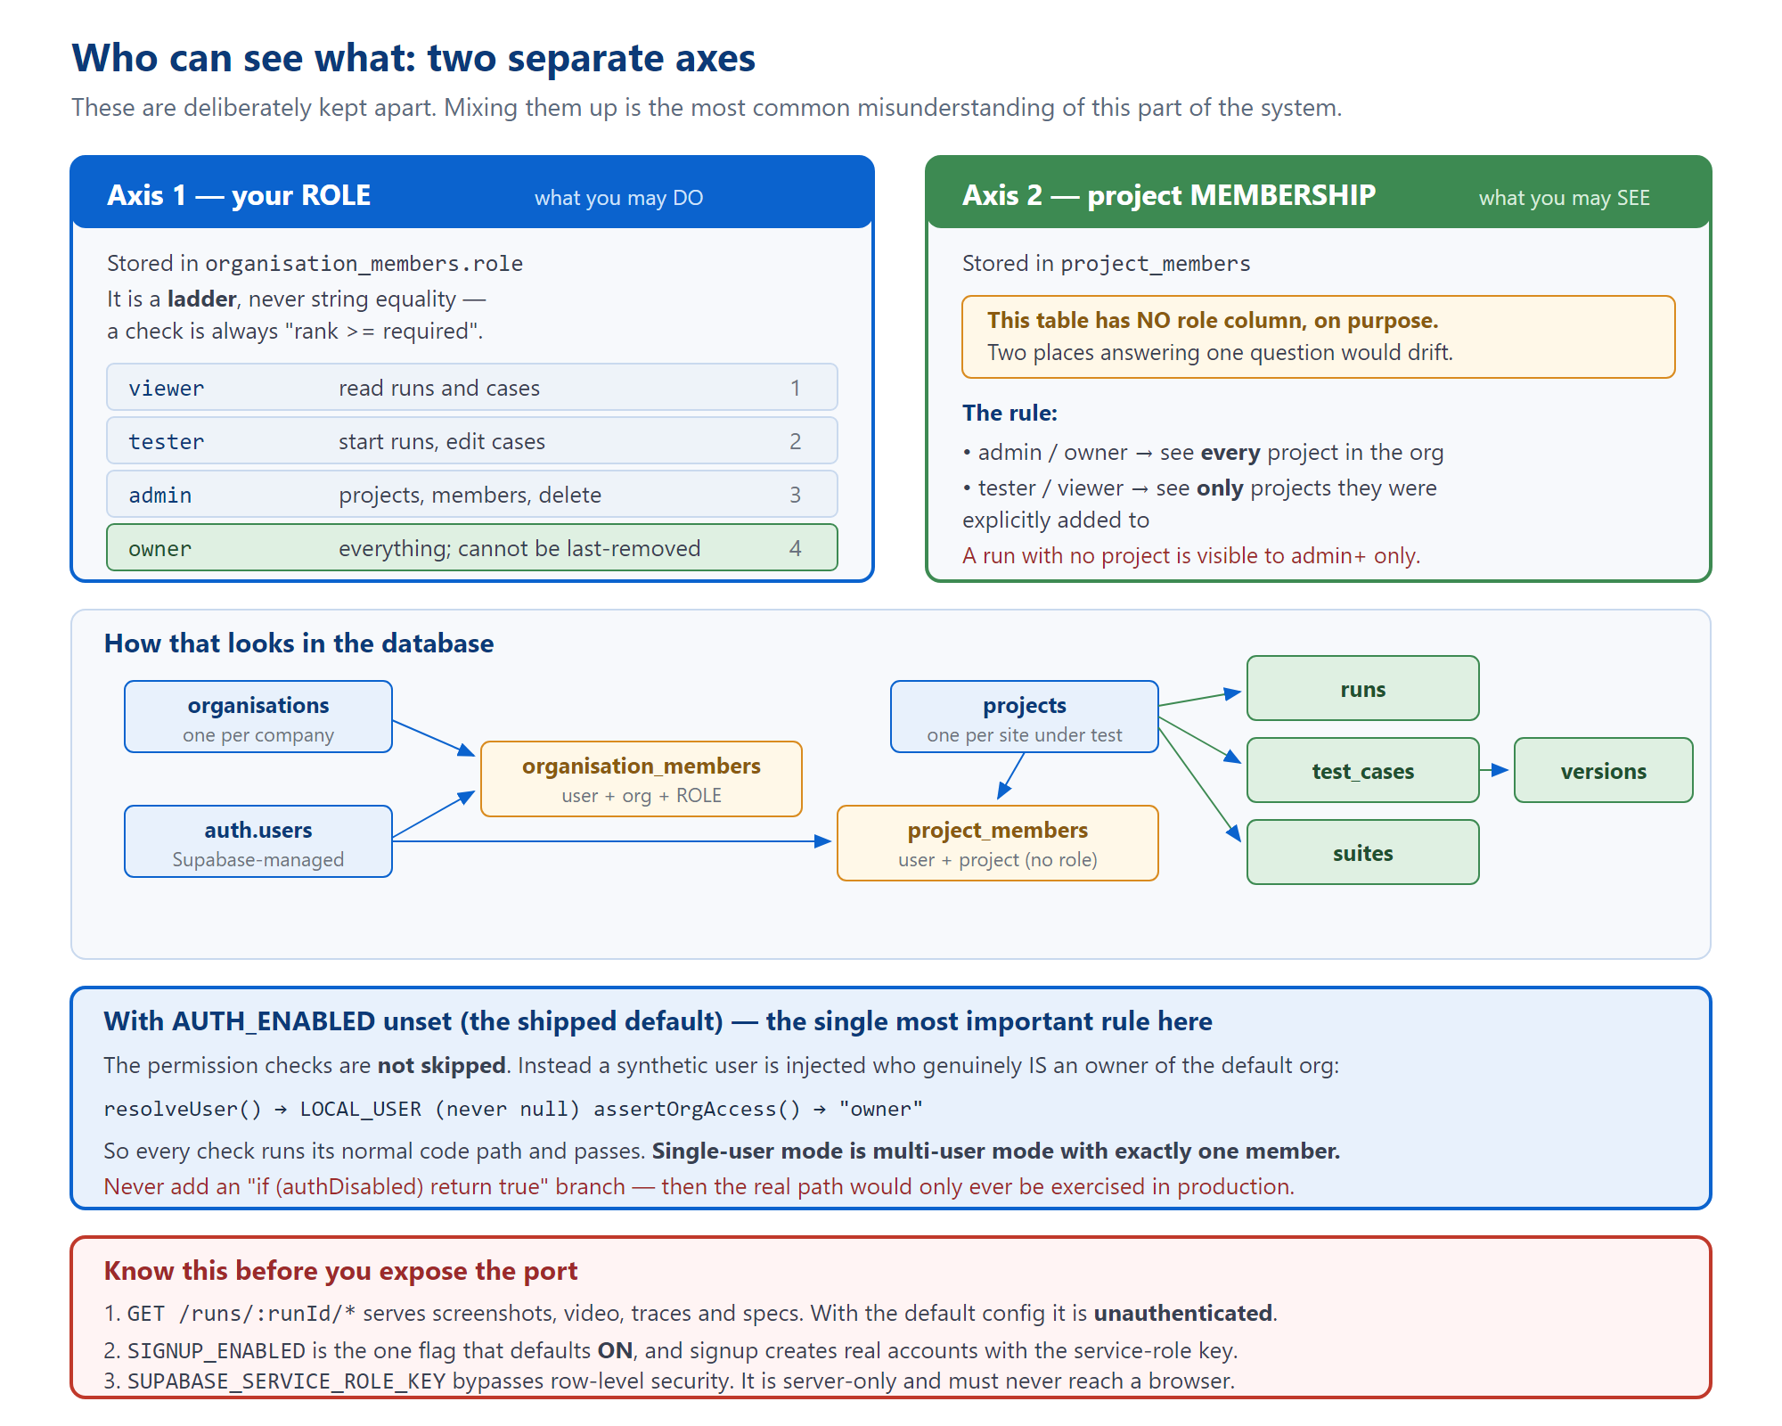
Figure 1 — the two axes, the tables behind them, and what changes when the flag is off.

Two axes, deliberately kept apart
- Organisation role — what you may DO. A ladder: viewer < tester < admin < owner. Checks are always rank >= required, never string equality, so an owner satisfies every lesser requirement automatically.
- Project membership — what you may SEE. A plain join table with no role column. Admins and owners see every project in their organisation by virtue of role; testers and viewers see only projects they were explicitly added to.
Why project_members has no role column. Duplicating the role ladder per project would put two places in charge of answering one question, and they would drift. Membership grants visibility, never entry — which is also why adding someone to a project requires that they already be an organisation member.
A brand-new account sees an empty history, and that is correct. Sign-up makes you a viewer in the default organisation with zero project assignments. It looks broken. It is the intended state — someone has to add you to a project.

The governing rule of authz.ts
Quoted from its own header, and worth memorising:
"Every read joins through membership. Never filter by an org id taken from the request body — take the user from the session, and let the join prove the org is theirs."
An organisation id appearing in a URL is only ever the subject of a check, never its authority.

What happens with AUTH_ENABLED unset
This is the single most important design rule in the server layer, and it is easy to get wrong when adding a feature.
// auth.ts
if (!isAuthEnabled()) return LOCAL_USER; // never null

// authz.ts
const LOCAL_MEMBERSHIPS = [{ organisationId: DEFAULT_ORG_ID, role: "owner" }];
if (!canEnforceTenancy()) return "owner";
The checks are not skipped. A synthetic user is injected who genuinely is an owner.
So every permission check runs its normal code path and passes. Single-user mode is multi-user mode with exactly one member.
Never add an if (authDisabled) return true branch. That is the documented failure mode: it means the real permission code is only ever exercised in production, where you find out it is wrong.

Everything fails closed
- An unreadable membership table returns [], not "everything".
- A run with no ownership row is visible to nobody.
- A run whose project_id is null is visible to admins and owners only — nobody can be assigned to "no project", so treating it as public would be a hole that widens as unfiled runs accumulate.
- "Not a member" and "insufficient role" both return 403, deliberately indistinguishable to someone probing.
Membership is cached for 5 seconds, because the UI polls. The staleness window is closed where it matters: every member-management route calls invalidateMemberships(userId) directly, so a demotion takes effect immediately.
And one subtle API detail: visibleProjectIds returns null to mean "no restriction" (admin/owner) and an empty Set to mean "nothing visible". Getting those two confused inverts the check.

Sign-up
src/server/signup.ts — 183 lines
Accounts are created server-side because Supabase's public sign-up hangs on this project's free-tier mailer. It uses two different keys on purpose:
- The service-role key creates the user with email_confirm: true, so no confirmation mail is ever attempted.
- A separate browser-style client with the publishable key then signs in to mint the session.
The reason for the second step: a session derived from the service-role key would not be a normal user session, and row-level security would not apply to it.
SIGNUP_ENABLED defaults to ON. It is the one documented exception to this project's "every flag defaults off" rule. The justification is that the sign-up screen only exists when AUTH_ENABLED=true, which is itself off — so the shipped default is still "no sign-up".
But this is an unauthenticated route that writes, using an admin key. The rate limit is 5 attempts per 15 minutes per IP, in-process — a speed bump, not access control, and a second instance has its own counter.
Set SIGNUP_ENABLED=false before this port is reachable by anyone else.

Organisation management
src/server/organisations.ts — 332 lines
Two invariants are enforced here rather than in routes, because they are properties of the data:
- Nobody grants above themselves. An admin cannot mint an owner, and cannot act on anyone above them — otherwise "demote the owner to viewer" is removal by another name.
- An organisation always has at least one owner. The last owner can be neither demoted nor removed.
Two limitations recorded in the source itself.
Single-company assumption: every sign-up joins DEFAULT_ORG_ID. This is wrong the moment two unrelated customers share an instance — it needs an invite token or a domain rule first.
listAddableUsers returns every registered email address to any admin. Fine for one company; a privacy leak in a multi-customer instance. It also pages the user directory at 1,000 accounts per call.

5. The database
src/db.ts — 350 lines
Supabase-hosted Postgres, accessed only through PostgREST calls — no SQL client, no ORM, and no .sql file anywhere in the repository. The schema lives in the Supabase project and is applied by migrations the code references by name. The table description below was reconstructed from the queries.

The tables
Table | Columns as queried | Notes
organisations | id, name | Seeded. Never created at runtime.
organisation_members | organisation_id, user_id, role, created_at | The join every authorization read goes through. Ordered by created_at for "primary org".
projects | id, organisation_id, name, base_url | name doubles as the URL key for auto-filed projects.
project_members | project_id, user_id | No role column, on purpose.
runs | id, organisation_id, project_id (nullable), started_by, prompt, url, status, started_at | id is the run-ID string, not a UUID.
suites | id, project_id, name, created_by
suite_cases | suite_id, test_case_id, position | Join table — a case can be in several suites. Cascades on suite delete; cases survive.
test_cases | id, project_id, title, feature, ir (jsonb), current_version, source_run_id, last_run_status, … | ir is validated by the real Zod schema on every read and write.
test_case_versions | test_case_id, version, ir, change_note, saved_by, saved_at | v1 is written with the case, or Compare has nothing to diff.
run_cases | run_id, test_case_id, case_index, status | A join table, not a column on runs — one replay runs many cases.
DB_ENABLED is not the switch it looks like.
It gates only five things: the four run-row writes and the shadow comparison. Everything else — the entire library, projects, and organisations surface — goes straight through the service client with no such check.
Practical consequence: those routes work whenever SUPABASE_URL and SUPABASE_SERVICE_ROLE_KEY are set, regardless of DB_ENABLED — and return 503 whenever they are not, regardless of any flag. So "local flag-off mode" means runs, artifacts and polling all work while roughly half the route table 503s. That is expected, not a bug.
And a genuinely dangerous combination: AUTH_ENABLED=true with DB_ENABLED=false and a service key present. Tenancy silently switches off (with a warning in the log) while the library keeps reading and writing real rows. The code calls this "a misconfiguration, not a supported mode."

Every database write is fire-and-forget
void (async () => { ... })(); // errors are console.error'd, never thrown
A run is long, expensive and user-visible. A database hiccup must never fail it, delay it, or lose it.
An ordering consequence. recordRunStarted fires before the concurrency semaphore. So a queued run has a database row and no directory on disk — invisible in history, and the shadow comparison would report it as "in the database but not on disk". Not a bug; worth recognising.

6. Run storage on disk
src/runStore.ts — 249 lines
Its own header calls it "the one seam that separates demo from product": the entire interface is append() and read(), so swapping the backing store later is a change to this file's body only.
export const store: RunStore; // append(event) / read(runId)
export function allRunIds(): string[];
export function summariseRun(runId: string): RunSummary;
export function listRuns(ids?: string[]): RunSummary[];
Volume 1, Figure 3 has the full folder map. Three behaviours worth knowing:
startedAt is the directory's filesystem creation time, not the timestamp in the run ID. Copying or moving a run directory changes where it appears in history.
Two synthetic events get invented on read. Legacy runs with no event log get a reconstructed stream. More usefully: a run with an event log but no terminal event, whose ID predates the current process start, gets a synthetic error reading "This run was interrupted — the server restarted before it finished." Without it, the UI would poll such a run forever.
History filters first, then caps at 20 — and the order is not cosmetic.
const visible = await filterRunsForUser(userId, allRunIds().map(runId => ({ runId })));
res.json(listRuns(visible.map(r => r.runId)));
Capping first let every unfiled directory on disk consume one of the twenty visible slots. History then shrank as those accumulated, and read from the outside as "no runs happened" — measured at 20 directories on disk yielding 2 visible rows. Filtering IDs is also the cheap half; summarising means parsing a full event log per run.

7. Concurrency
src/server/concurrency.ts — 36 lines
One module-level semaphore, default 3, shared by runs and replays. Each run launches Chromium; uncapped, one browser per request means running out of memory.
The subtle part is that a waiting caller inherits the finishing caller's permit rather than re-acquiring:
finally {
const next = this.waiters.shift();
if (next) next(); // hand the permit straight over — active is unchanged
else this.active--;
}
Incrementing after a release-and-reacquire would open a window where a fresh arrival steals the freed slot and concurrency exceeds the maximum.
Two environment-variable footguns, both silent.
MAX_CONCURRENT_RUNS= (empty) → ?? does not catch the empty string → Number("") is 0 → the constructor throws at module load and the server will not boot.
MAX_CONCURRENT_RUNS=abc → NaN → the < 1 check passes, so nothing throws, but active < max is never true → every run parks forever. Silent deadlock.
Re-ground jobs are not covered by the semaphore. Saving edited steps launches its own browser outside runLimit. N concurrent editors means N unbounded browsers.

8. How credentials stay off disk
The rule: real credentials never touch disk or the database. They live in process memory for the length of one walk, and stored steps keep an ${env:...} reference instead.
SOURCE (env first, then the browser prompt)
↓ in-memory Map only — never persisted
applyCredentials() writes "${env:TEST_PASSWORD}" → 04-ir.json holds the SENTINEL
generateSpec() emits process.env.TEST_PASSWORD ?? "" → the spec holds a REFERENCE
runSpec() injects the real value into the CHILD PROCESS ENV only
↓
scrubServedSecrets() cleans results.json, final-page.txt, and error attachments afterwards
The allowed environment variable names are a fixed pair — TEST_USERNAME and TEST_PASSWORD — never derived from model output or user text, so a crafted prompt cannot smuggle another variable into generated code.
What is deliberately never written: the request body is never logged; the credential event carries only {url, fields} and then {provided: true|false}, never a value; and 00-input.json stores the redacted prompt. That last one was a real bug — writing the prompt verbatim put plaintext passwords on a publicly served path.
Setting TEST_USERNAME / TEST_PASSWORD in the environment silently suppresses every credential prompt — in runs, in the case editor, and in replay. Convenient for an operator, confusing if you are sitting there waiting for a dialog that will never appear.
A replay bug worth learning from. runReplay accepted a credentials argument, but its only caller never passed one. So the spec's process.env.TEST_USERNAME ?? "" typed an empty string into the login form. The sign-in failed silently and the case died several steps later on a completely unrelated assertion. Confirmed on run 2026-08-31T06-30-26-597Z-1c2a719e.
The lesson: an unpassed optional argument plus a ?? "" fallback produces a wrong answer instead of an error.

9. The remaining server modules
File | Lines | Job, and what to know
runRegistry.ts | 37 | Live SSE fan-out. Holds only open sockets — nothing that matters is lost on restart. Durability is the orchestrator's job.
pendingCredentials.ts | 55 | Parks a promise until you answer. In memory on purpose — it holds a resolver and real credentials. Note run IDs and job IDs share one keyspace.
resolveCredentials.ts | 39 | The one place the "environment first, prompt second" policy lives. Its comment warns: the emit is not optional — without the event the UI never renders the form and the caller waits out the full timeout against a screen with nowhere to type.
pendingCaseSelection.ts | 62 | Same pattern for the review gate. 10-minute default.
caseAccumulator.ts | 86 | The accepted-case pool across gate rounds. MAX_ACCUMULATED_CASES is read at module load, unlike most flags — a test cannot flip it.
caseHistoryLedger.ts | 99 | Feeds the next round's prompt so it stops re-proposing rejected cases. Note normalizeTitle is duplicated here and in caseAccumulator; identical today, nothing pins them.
gateCaseEdits.ts | 126 | Folds your gate edits into the batch by position. Index stability is the invariant: edits address existing slots, additions append, nothing is ever spliced out — "remove this" arrives as "not selected", so the case still occupies its slot and is still recorded as rejected.
regroundJobs.ts | 120 | Background re-ground jobs. In memory, not on disk — writing them under runs/ would put them in run history and the shadow comparison. Jobs are personal: another account is refused even in the same organisation.
rewrite.ts | 421 | Three model proposers, none of which ever write. See below.
retention.ts | 73 | Optional pruning of old runs. Three guards: a hard 24-hour floor regardless of setting, older than the window, and the run must be terminal.
projects.ts | 354 | Project CRUD and auto-filing by URL. deleteProject refuses with 409 while it still holds runs rather than orphaning them.
library.ts | 747 | Suites, cases, versions, replay loading. See below.

The proposer rule
All three functions in rewrite.ts return step text, never IR. Approval therefore travels the ordinary parse → re-ground → version path. This is the project rule "a model proposes, it never writes" expressed in code.
They differ in what they can check, and the difference is principled.
Rewriting a saved case is constrained to the parser's vocabulary, and every proposed line is re-run through the real parser before you see it — the model cannot widen the accepted grammar.
Rewriting a case at the gate deliberately does neither, because gate steps read like "Type an invalid email into the Email field" and there is no IR yet. Imposing the executor's grammar there would reject the model's own valid output. The check still happens later, in toIR.

Two things in library.ts that will catch you
The IR schema is imported, never restated. parseIr runs the real Zod schema on every read and write. A hand-maintained copy would be documentation drift reappearing as code.
A line that looks like a bug and is not:
if (Object.keys(update).length === 2) { /* nothing to update */ }
updated_at and updated_by are always set, so two keys means no real change. Adding a third always-set column would silently break this check.
Optimistic concurrency is re-checked at write time. updateCase re-validates expectedVersion against the row it is about to write, closing the window between the initial check and the write — which can be sixty seconds later, after a browser walk.
A counting subtlety: countCasesByProject counts every case in the project, not the sum of its suites — a suite-less case must still appear. So a project's number can legitimately exceed the sum of its children's.

10. Ten things worth knowing on day one
- npm run serve has no watch. Editing src/ does nothing until you restart.
- Artifacts under runs/ are unauthenticated by default.
- DB_ENABLED does not gate the library. Half the route table 503s without a service-role key, whatever the flags say.
- AUTH_ENABLED=false runs the same permission code, satisfied by a synthetic owner. Never branch around it.
- Never change an existing route's request or response shape. public/app.js reads them in dozens of places. New capability → new route. Existing route → optional additive fields only.
- A model proposes, it never writes.
- Credentials never touch disk. Do not weaken the scrubbing functions.
- SSE exists but nothing uses it. The UI polls /state.
- A paused run holds its concurrency slot. Three abandoned prompts wedge the default cap.
- Two duplications pinned only by convention: normaliseUrlKey (server ↔ app.js) and formatIrStep (server ↔ app.js). Only the second has a test holding it in place.
Before calling anything done: npx tsc --noEmit must be clean, and npx vitest run must pass. No CI runs either of them for you — that is TECH_DEBT.md TD-20.

