Karnataka Law Society’s

GOGTE INSTITUTE OF TECHNOLOGY-590008

UDYAMBAG, BELAGAVI-59008

Department of Computer Science And Engineering



**PROJECT REPORT (Course Activity) 2019-20**

**Semester: V**

**Project Title**

**GIT OFFICE APPLICATION**

**Project done by:**

**Lakshya Tripathi 2GI17CS056**

|  |  |
| --- | --- |
|  |  |

**CERTIFICATE**



*This is to certify that the Seminar entitled “Education System” is a bona fide record of the Seminar work done by* **Lakshya Tripathi** *(2GI17CS056),* **Sucheta Kulkarni** *(2GI17C054),* **Prasanna Kusugal** *(2GI17CS055) and* **Kiran Hiremath** (2GI17CS052) *under my supervision and guidance, in partial fulfilment of the requirements for the Outcome Based Education Paradigm in Computer science and Engineering from Gogte Institute of Technology Belagavi for the academic year 2019-2020*

#### 

#### **Prof. V.S. Rajpurohit**

**V.S .Rajpurohit**

*Professor & Head*

*Dept. of computer science and Engineering*

Place: KLS Gogte Institute of Technology Belgaum.

**Problem Statement:**

The record of the college office management system must be open for input. Tap anywhere on the first screen , after which the student will see a log in , after entering all his credentials, the student will be redirected to a home page where the details about the app will displayed , on the left corner on the top of the page on clicking the button , a variety of options will be displayed , i.e. Notification , Scholarship, Accounts, Meet Principal , Get new id, bus info , departments , Know your campus , Visit office, Get bonafied certificate.

When you select Notification , you will be displayed about new government schemes, about the upcoming examinations , Plans about server , The timetables of everyday classes etc.

When you select scholarship , categories of different scholarships will be displayed , i.e. Academic scholarship , Sports Scholarship , Central Scholarship , PWD Scholarship , Defence Scholarship. On clicking on the scholarship , A form will be displayed. Where in the you will be able to enter the information required to avail scholarship.

When you select Accounts , two options will be displayed i.e. Admissions and Fine payment. On selecting admissions , you will have to fill a form pertaining to details required to take admission in the college , similarly for fine payment.

When you select meet principal , you will see the timings as to when the principal is available , and will be asked to fill a form which will ask you to enter details about when you want to meet the principal and why.

When you select Get new Id , you will have to pay the fine , the amount depends on if you have lost a faculty identity card or a student identity card. After that you will be directed to a payment gateway .

When you select Departments , you will see a list of departments , following which there is detailed information about the individual departments

When you select Know your campus , a visual map of the campus will be displayed.

When you select Bus info , you will be able to select between bus timetable or application bus pass , in bus pass you will have to fill a form which will ask for mandatory details.

When you select Visit office , you will have to fill a form which will ask for some necessary details like name , USN , etc. then you will be allotted a slot to visit office, and then you will be given a token which you will have to display for appointment in office.

When you select get bonafied certificate , user should get a form in which user should provide the related detail and the reason for which he/she wants the bonafied certificate.

**Objectives:**

**TASK : BUS INFORMATION PAGE**

When the student/professor heads to the bus information page he/she can see the bus timetable on different days and also about the location , on the same page the student can apply for bus pass as well. Just below the link to bus timetable , there is a link to apply for bus pass. on clicking that , he/she will fill a form to apply for the bus pass , after filling the form he/she will be directed to a payment gateway , where in he/she will see how much they have to pay and after that the user will receive a SMS as to when his/her bus pass will arrive.

**TASK : LOGIN**

After tapping on the first page that appears , the user is directed to a log in page ,where he/she will have to enter his login credentials. The login credentials includes the USN and the password , after the user entered his credentials , he/she will be directed to a intro page , where the basic information is displayed. The system will check with the database if the credentials are correct only then the user will be redirected to the next page.

**TASK: MEET THE PRINCIPAL**

When you click on the meet principal button , at first the timings as to when the principal is available will be shown. The timings will be displayed keeping in mind the personal and professional commitments of the principal. Once that is done the student or professor should click on the link just below the timings , this link will lead to a form which will ask the student/professor to fill mandatory details like his name, department , the reason why he/she wants to meet the principal. After filling the form, the student/professor will receive a confirmation about the meeting in 12 hours.

**TASK : GET NEW IDENTITY CARD**

When the user is directed to the page of get new identity card he/she will see a dialogue box , which tells the whole procedure of how to apply for a new id card. It also displaysthe amount to be paid for the id card. Later the user will be taken to a payment gateway. Later the user will be instructed when he./he will have to collect the id card from the office.

**Flow Chart:**

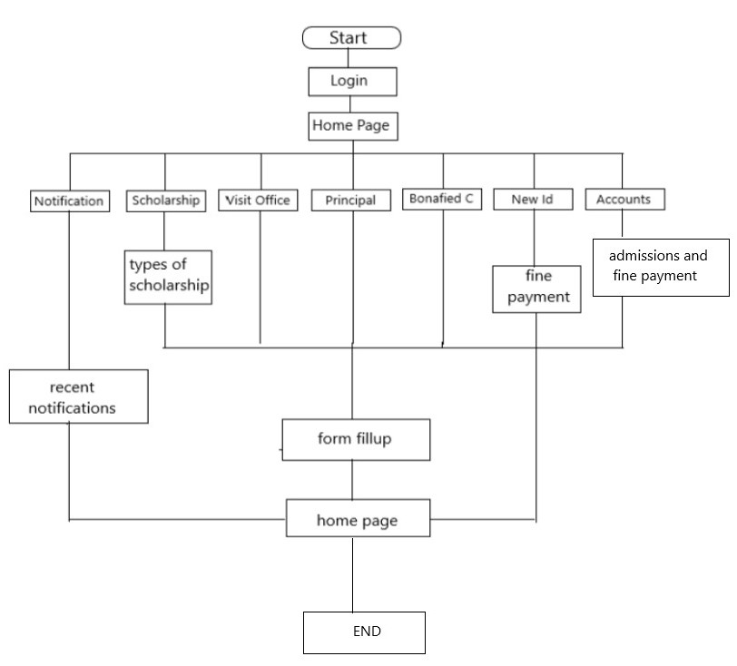

**Classes:**

1. **For visiting office:**

class visit_office{

private : char name[30];

int USN ;

char date[10] , time[10] ;

char reason_to_visit[50];

public : void dispense_token();

};

void dispense_token(){

char date1[10],time1[10];

// takes in account the date and time the user has entered and allots a specific time slot to the user and also dispenses a token number that the user has to show ohysically at the office.

}

1. **For Accounts department:**

class accounts{

private : char name , address;

int usn, phone;

int marks[];

public: void admission ( name, address , usn , phone , marks);

void fine_payment();

};

void admission(name, address , usn , phone , marks){

// this function makes use of name , address , phone , usn and marks for the student to take admission in the next academic year , using the user information it checks the fee payment the student has to make and informs the student what is the further procedure of making the fee payment like collecting the challan and submitting it at the bank ,etc.

}

void fine_payment(){

// this function takes in account the name of the user , phone and why he has to pay the fine, later he is taken to a payment gateway to pay the fine }

1. **For bona fide certificate**

class bonafied_certificate(){

private : char name ;

int USN , sem;

public : void getcertificate();

};

void getcertificate() {

// after the user enters his entire details , the database will fetch for the information required and issue the students bonafied certificate }

1. **For Accounts**

class accounts(){

private: char name,usn,fname,mname;

char branch;

int semestrer;

public: void admission(){

// this function will take all the inputs from the user in the form of a table and will direct the user to a payment gateway where the user can pay the fee and take admission.

}

Void fine_payment(){

**//** this function store the the fine details related to the logged in user and will direct the user to a payment gateway whenever he wishes to pay the fine.

**Outputs:**

