**SAVITRIBAI PHULE PUNE UNIVERSITY**

**A PRELIMINARY PROJECT REPORT ON**

**“Collaborative Online Tutorial System”**

**SUBMITTED TOWARDS THE PARTIAL FULFILMENT OF THE**

**REQUIREMENTS OF**

**BACHELOR OF ENGINEERING (TE COMPUTER ENGINEERING)**

**Academic Year: 2018-19**

**By:**

**Diksha Kalbhor TECOA145**

**Namrata Kamble TECOA148**

**Mansi Kasodekar TECOA155**

**Under The Guidance of**

**Prof. Rajesh Lomte**



**DEPARTMENT OFCOMPUTER ENGINEERING,**

**PIMPRI CHINCHWAD COLLEGE OF ENGINEERING**

**SECTOR 26, NIGDI, PRADHIKARAN**

**CERTIFICATE**

This is to certify that, the project entitled

**“Collaborative Online Tutorial System**”

successfully submitted by following students of “KLS Gogte Institute of Technology, Belagavi**”** as a part of mini project

**Under the guidance of Prof. M.M.Ramannavar**

In the partial fulfilment of the requirements for the Course Python Programming (Computer Engineering)

**Lakshya Tripathi 2GI17CS056**

**Sujeet Madihalli 2GI17CS143**

**Shreyas Gayakwad 2GI17CS127**

**Siddhant Samant 2GI17CS133**

**Mrs. M.M.Ramannavar**

**Project Guide**

**Abstract**

Now a days Tutorial Points are becoming useful to the students who are in the search of quality education. So, this application provides the support for both the tutors and students. The tutors who need to be registered and login and can select the course he would like teach by providing location and timings.

Students who also need to register and login into the application while registering student will give the location and after logging when he selects the course. The tutors available in that location and the course that tutor can teach both are matched and the request will be sent to admin. Admin will confirm the request then that tutor will be assign to student.

1. **Introduction**

This Part talks about the work involved in the project. The problem statement and project idea of the project are clearly stated as well as the motivation behind it.

1. **Problem Statement**

Find a tutor for student in his location for particular course for specific timing.

1. **Project Idea**

Now a days Tutorial Points are becoming useful to the students who are in the search of quality education. Also student finds tutors manually. The current system is time consuming and also it is very costly. But now a days, computerization made easy to work .The proposed system can increase efficiency with reduced cost. The proposed system is highly secured , because for login the system it requires the username & password which is different for each department like admin ,tutor & student. In this project the system is taking personal details of a student as well as a tutor and on the basis of their location it will assigning tutor to student for that particular course.

1. **Motivation**

In existing management system the work is time consuming and costly as students are not knowing tutors in their location. So to minimize the manual work and to increase efficiency we work on this project.

Minimizing efforts is the real motivation behind this project.

1. **Scope**

This system implement for collaboration between tutor and student. Similarly, some bit of change in it can manage the other services also, like coaching classes, marriage bureau.

1. **Project Design**

This Part talks about hardware and software requirements. The functional as well as non-functional requirements are also stated. The chapter will also take a look at schema of all tables.

1. **Hardware , Software , resources, requirements & their detail explanation**
2. **Hardware Requirement:**

Processor-Intel Core, RAM-8 Gb , Hard disk-1 Tb.

1. **Software Requirement:**

Operating System-Windows, Front End-Python, Back End- MySQL.

1. **Functional Requirements**

Functional requirements are the behaviours that the system must do based on input from the user. The system then performs operations or functions to give a required output i.e. functional requirements are the tasks the system must perform to complete the work. From the interview and data analysis the functional requirements of the new system are identified:

* Student can add his/her details on system and also can see his/her request status on system using unique id if his/her account is already present.
* Tutor can add his/her details on system and also can see the no. student he/she is teaching on system using unique id if his/her account is already present.
* System will check Location and course name of tutor and student.
* System will show student name, tutor name, course name in admin section.
* Finally admin will appoint a teacher to the student if all the criteria match.

1. **Non-Functional Requirements**

Non-functional requirements are those requirements that the user has no direct control over but are part of the system nonetheless. They are often regarded as the non-behavioural aspects of the system. The non-functional requirements are identified:

* The system needs to be secure due to the sensitive nature of the data.

The system will have:

* Backup and recovery capabilities.
* Reasonable performance.
* Quality assurance (notification of faults).
* Documentation (optional extra)

1. **Schema of all the tables**

Student table:

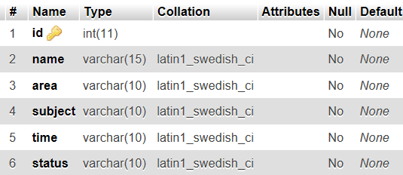

Teacher table:

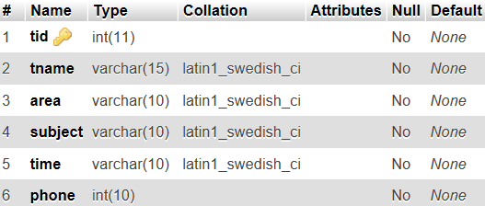

1. **Module Description**

This chapter talks about different modules present in project.

1. **Architecture Design**

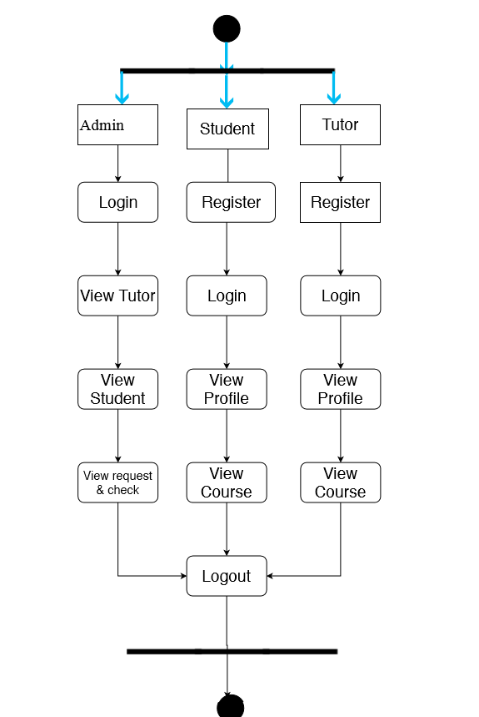

There are 3 Modules present in the application:

1. Admin
2. Tutor
3. Student

**Admin:**

Admin will login with the default username and password. Admin can view the registered tutors and students. He can also view the requests which he get from table and Admin will confirm the requests then the details of tutors are shown to student and the tutor will be assigned to student.

**Tutor:**

Tutor will login and register into the application by giving the username and password, after logging in tutor will select the course and location and the timings with his availability. If any student requests were there in that locality the tutor will be assigned to student .

**Student:**

Student will register and login into the application by giving username and password and student need to select the course and timings and if any tutors available in that area the request will be forwarded to admin, admin will confirm the request the tutor will be assigned to student.

**b. Packages:**

* pymysql
* pip

1. **Results & Discussion**

This chapter talks about actual work done. It includes screen shots. It also contains different test cases

**a. Screen shots.**

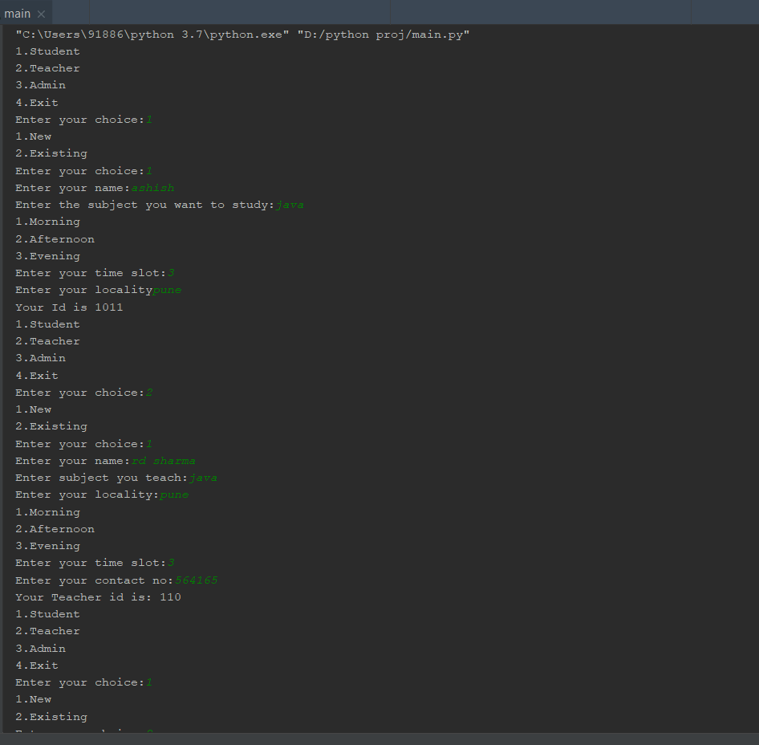

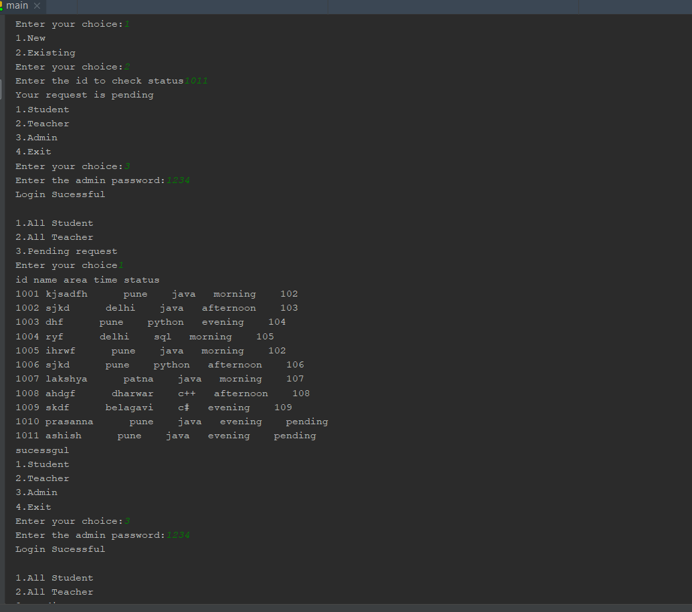

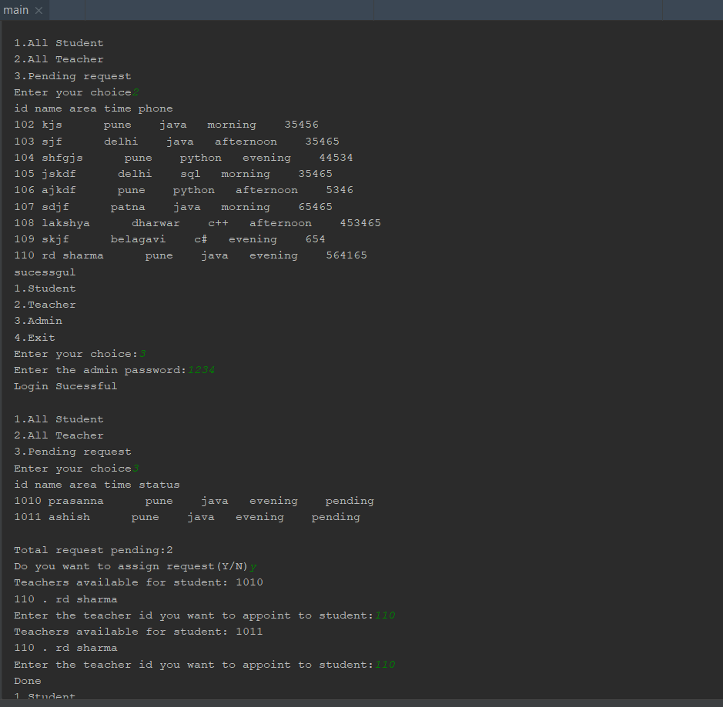

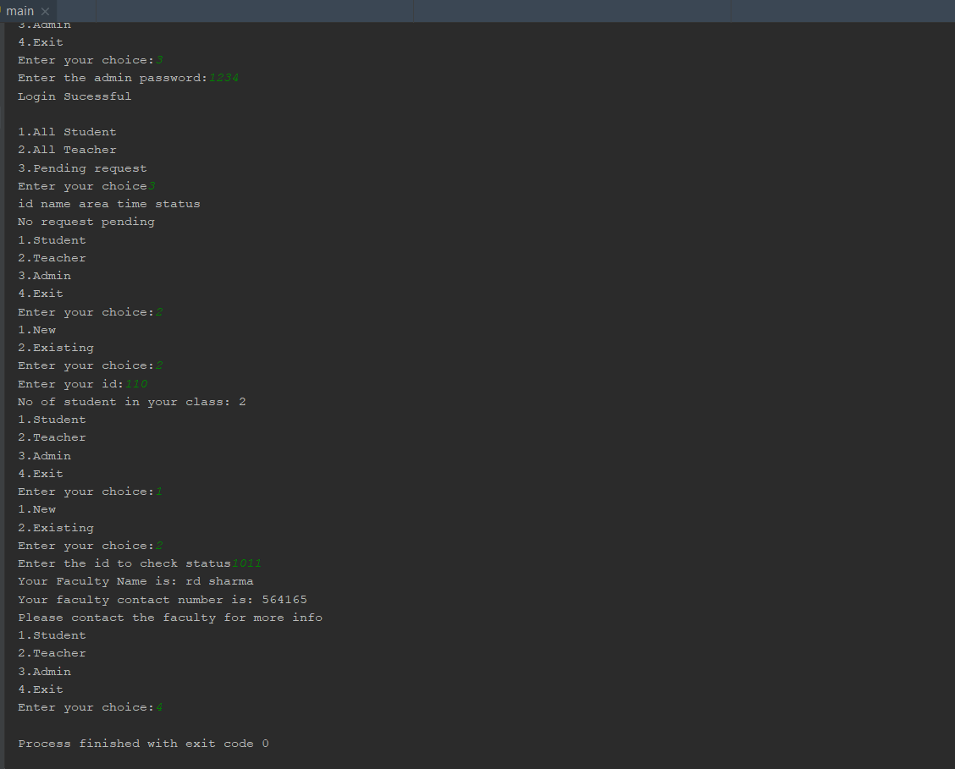

1. **Conclusion**