Dear Candidate,

The APIs given here may not work properly or many not have authentication. But still you can use these APIs & sample response to write your scriptings.

**API AUTOMATION**

1. Open the following link <https://www.monicahq.com/api/tasks>
2. You can see list of API document for Monicahq (CRM)
3. Please read the document and identify the API for getting lists of tasks.
4. Read the response.
5. Write a Groovy script to print total number of tasks
6. Write a groovy script to print all task names

Share the script in a text file named as ‘monicahq.txt’

**Selenium Automation**

Write automation script for following scenario

1. Open the following link: <https://www.programmableweb.com/category/open-data/api>
2. In the top right corner you can see search box. And you can see default text as ‘Search over XXXXX APIs and much more’
3. Write an automation script to read and print that default text
4. Also extract the number alone and print like this. ‘Programmableweb has XXXXX APIs’

Eg: Programmableweb has 21888 APIs

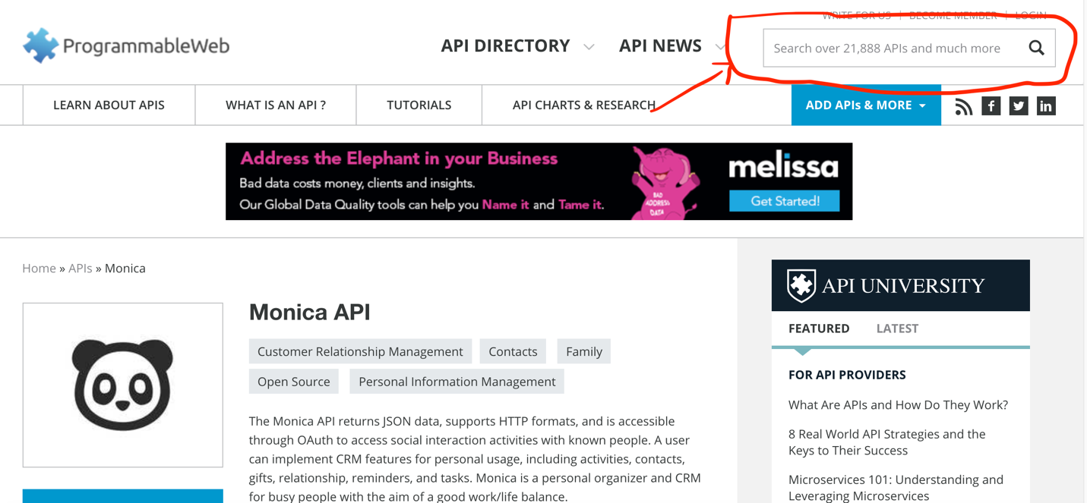

1. In the same page if you scroll down you can see some tabs.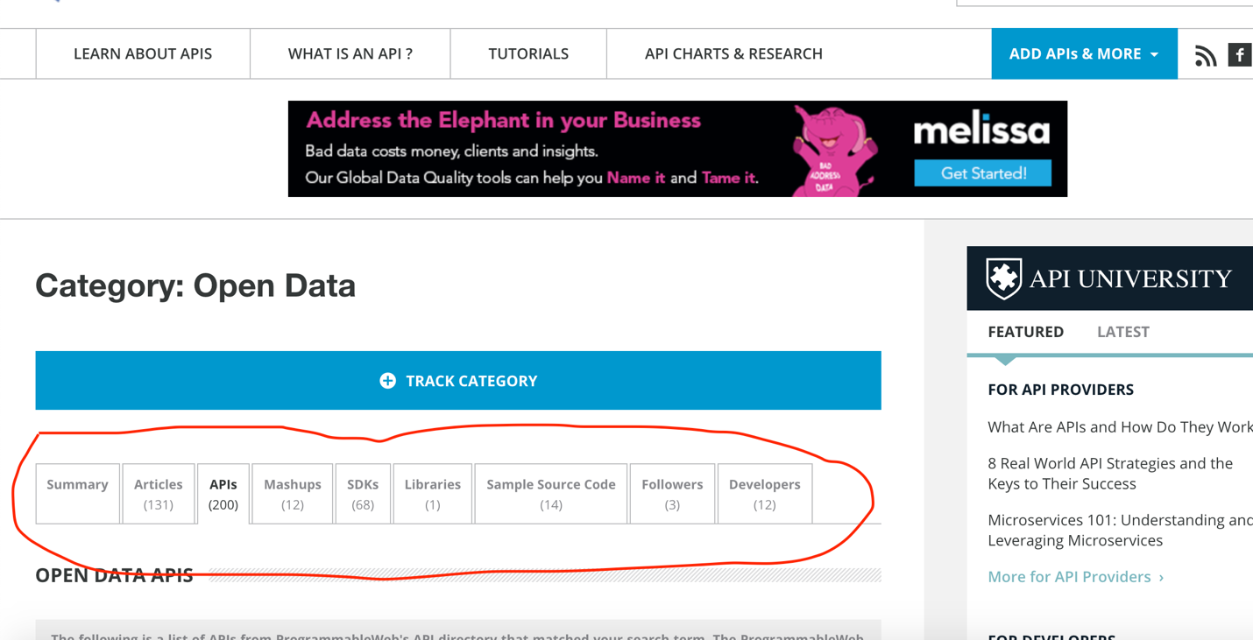
2. You need to print the tab texts as follows: (As per above screenshot)

There are 133 Articles in this page.

There are 200 APIs in this page

There are 112 Mashups in this page

(And so on…Print this for all tabs)

1. Print total number of resources by adding all these numbers you got in 4th step.

Submit the project file with ‘How to Execute instruction’.