Silver Bars Market Place

This program allows you do the below actions

1. Register a new order
2. Cancel an existing order
3. Summary Dashboard

**Design:**

Project SilverBarsMarketPlace consists of 4 packages and below are the details

1. src/default:

This package has the Main class which calls the Order method in LiveOrder class.

1. src/liveOrderExecption:

This package has a class LiveOrderException.java which is used to create user defined exception which is extending Exception class.

1. src/file:

This package has a class FileUtils.java which has all the constants used in the project.

1. src/model:

This package has 4 classes which are

1. Order.java which is a pojo which holds the user id, quantity, price and ordertype variables.
2. LiverOrder.java which has all the logic to register, cancel orders and to show the dashboard.
3. BuyOderComparator which implements Comparator interface and overrides compare method to arrange the buy orders in descending order.
4. SellOrderComparator which implements Comparator interface and overrides compare method to arrange the sell orders in ascending order.

**Running program**

Open a cmd and run the below command.

C:\Program Files\Java\jre1.8.0_202\bin>java.exe -jar <jarlocation>\SilverBarsLiveOrderexe.jar

**Input1:**

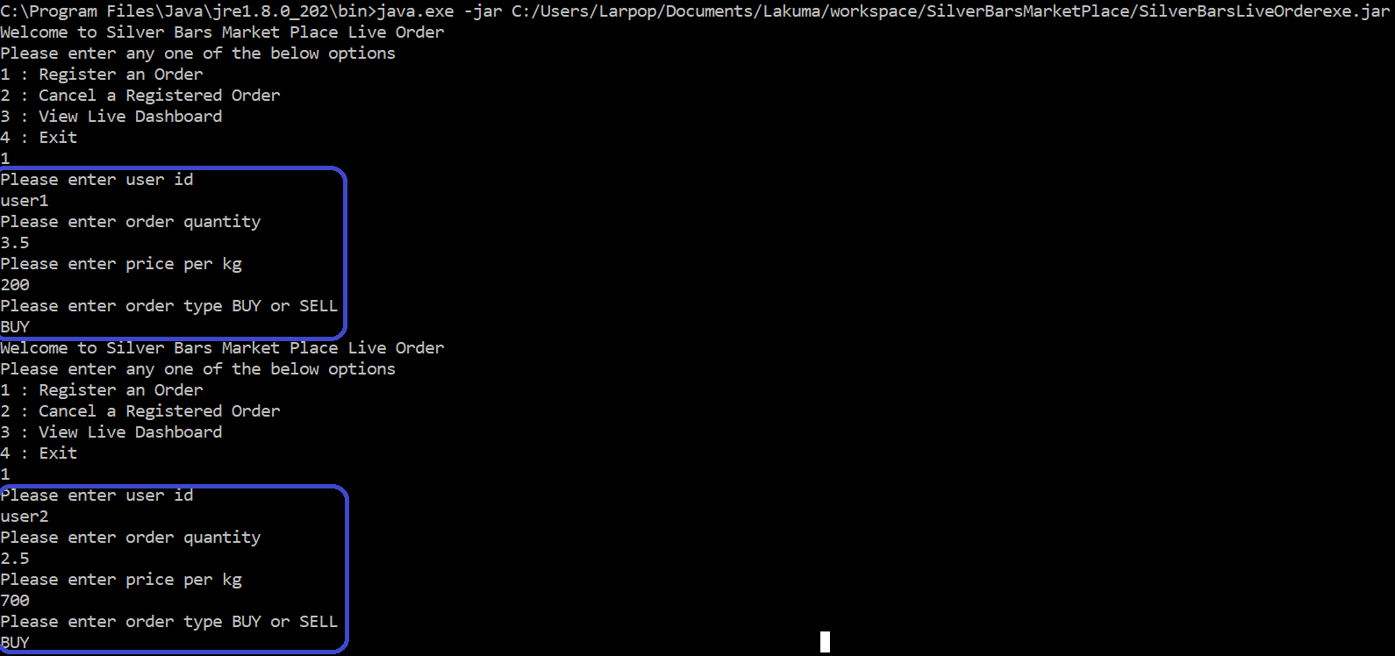

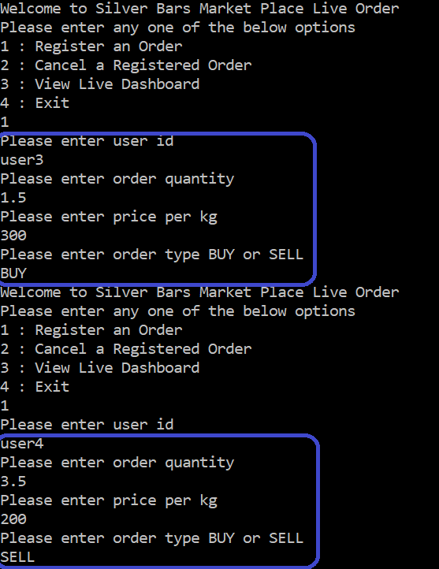

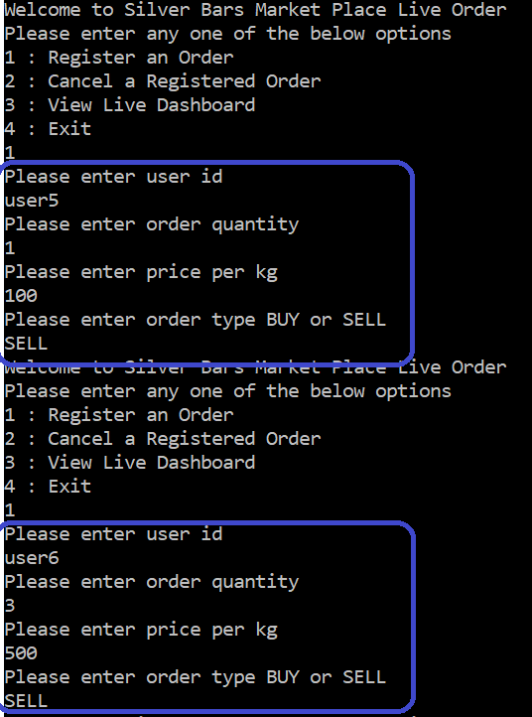

**Output1:**

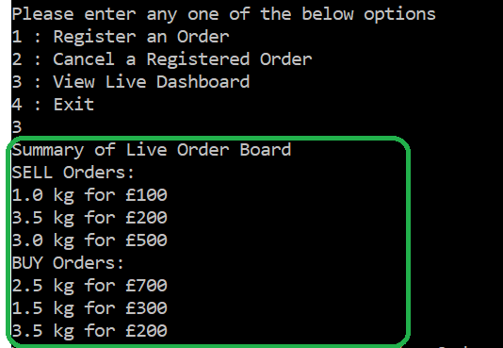

**Input2:**

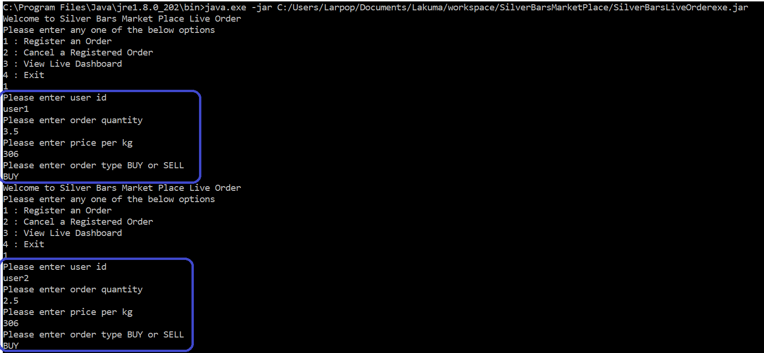

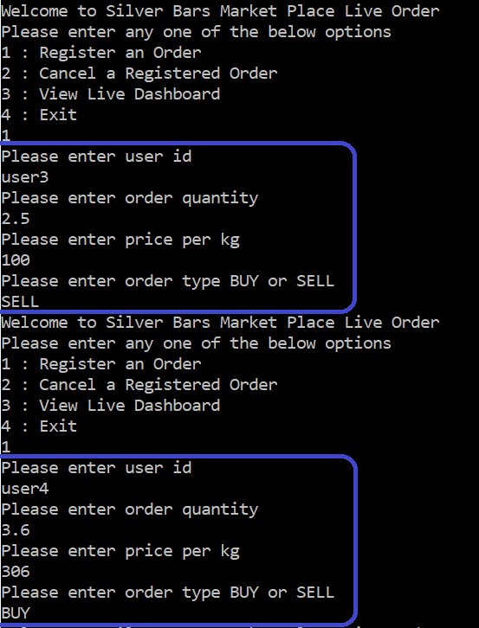

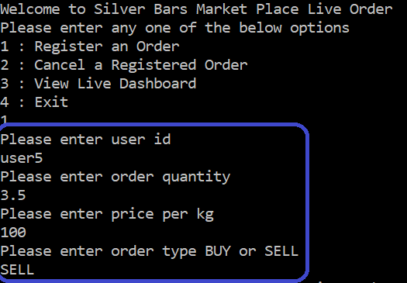

**Output2:**

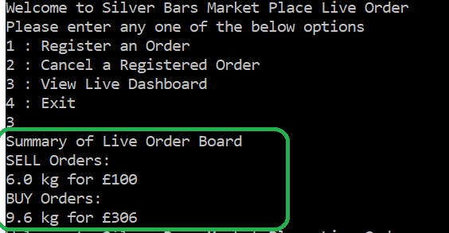

**Input3:**

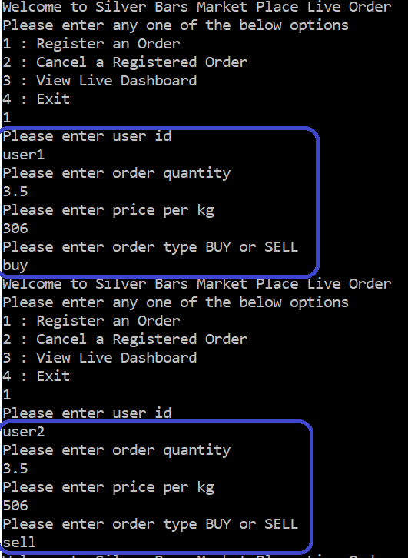

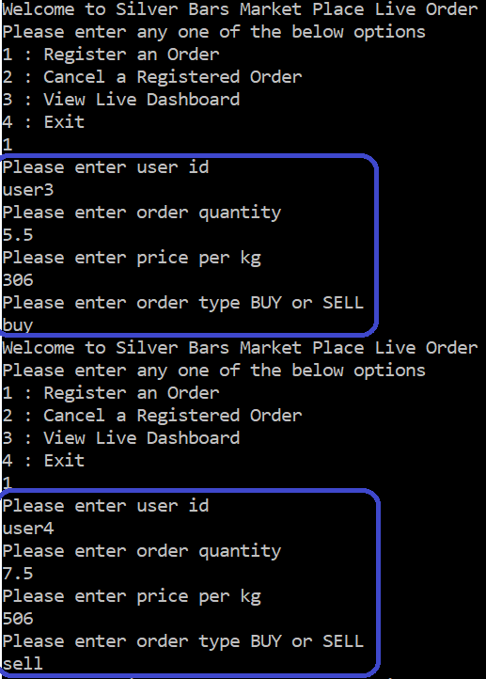

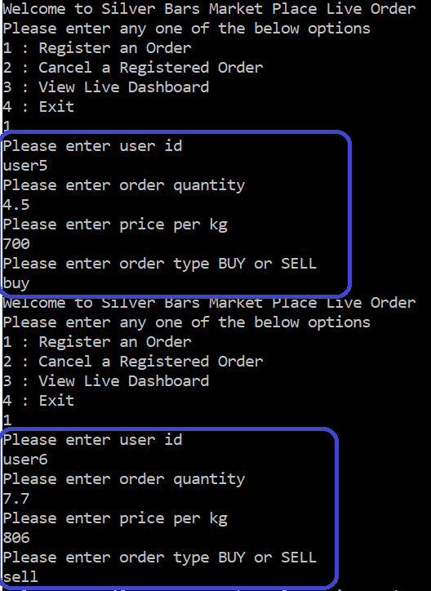

**Output3:**

