SMART STUDY
REPORT DIAGRAMS AND EXPLANATIONS
Prepared as supporting material for the Undergraduate Thesis Report

Use of this document: The diagrams can be copied into the recommended chapters of the final report. Figure numbers may be changed after the final report structure is confirmed. Each figure must be mentioned in the main text.

Diagram List
Figure | Diagram | Recommended chapter
3.1 | Use Case Diagram | Chapter 3 - Methodology and Artefact Design
3.2 | System Architecture Diagram | Chapter 3 - Methodology and Artefact Design
3.3 | Simplified Entity Relationship Diagram | Chapter 3 - Methodology and Artefact Design
3.4 | Application Navigation Flow | Chapter 3 - Methodology and Artefact Design
4.1 | AI Quiz Generation Sequence Diagram | Chapter 4 - Development and Testing
4.2 | Spaced-Repetition Flowchart | Chapter 4 - Development and Testing
4.3 | Collaborative Exam Sequence Diagram | Chapter 4 - Development and Testing
4.4 | Notification Delivery Diagram | Chapter 4 - Development and Testing
4.5 | Production Deployment Diagram | Chapter 4 - Development and Testing

3.1 Use Case Diagram
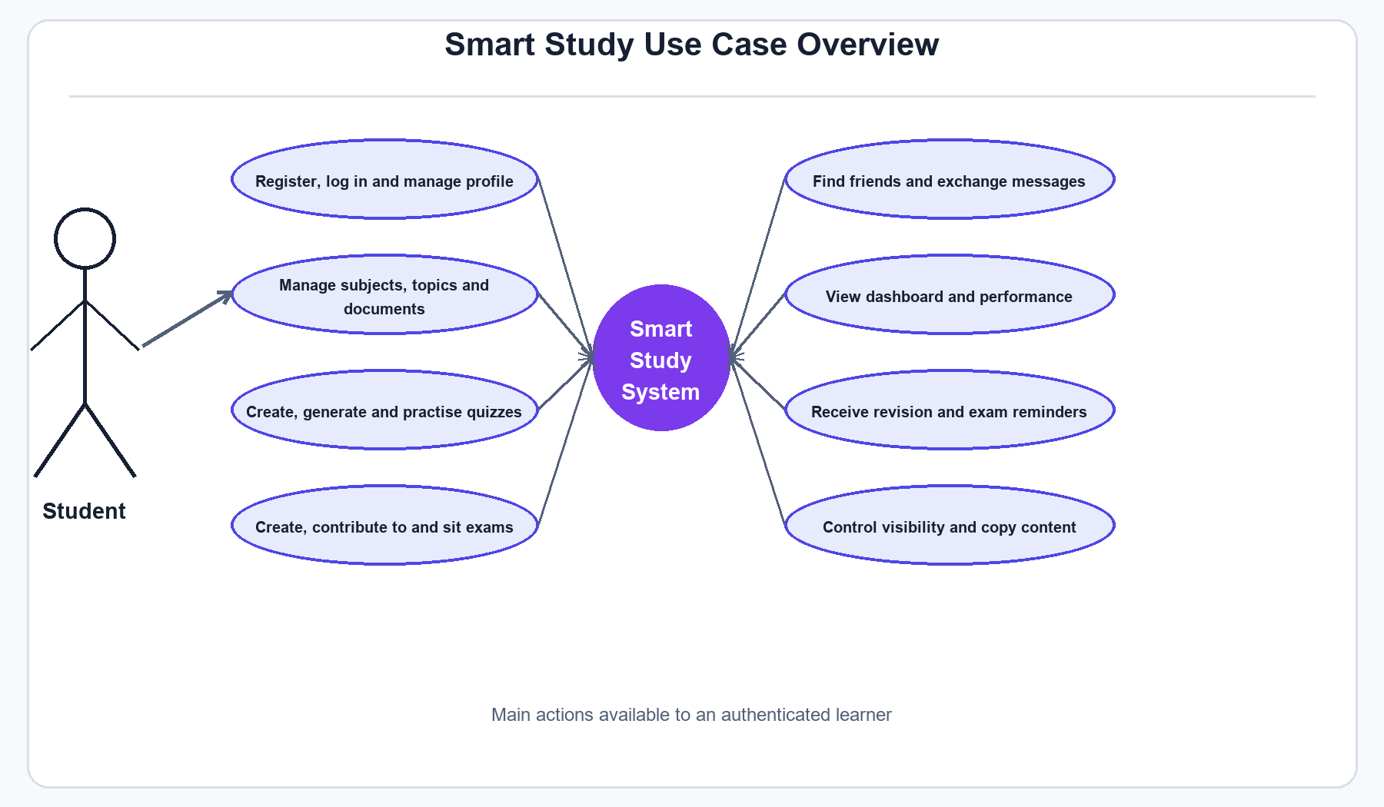
Figure 3.1: Use Case Diagram
Recommended report location: Chapter 3 - Methodology and Artefact Design, after the functional requirements.

Explanation
Figure 3.1 gives a summary of the main actions supported by the Smart Study application. The student is the main actor of the system. After authentication, the student can organise learning materials, create or generate quizzes, practise, take part in exams, manage friendships, exchange text messages and view learning progress. Visibility and copying are also included because the application allows private, friends-only and public study content. This diagram keeps the scope clear without showing the lower-level API operations.

Example sentence for the report
Figure 3.1 shows the main functions that are available to a student in the Smart Study application.

3.2 System Architecture Diagram
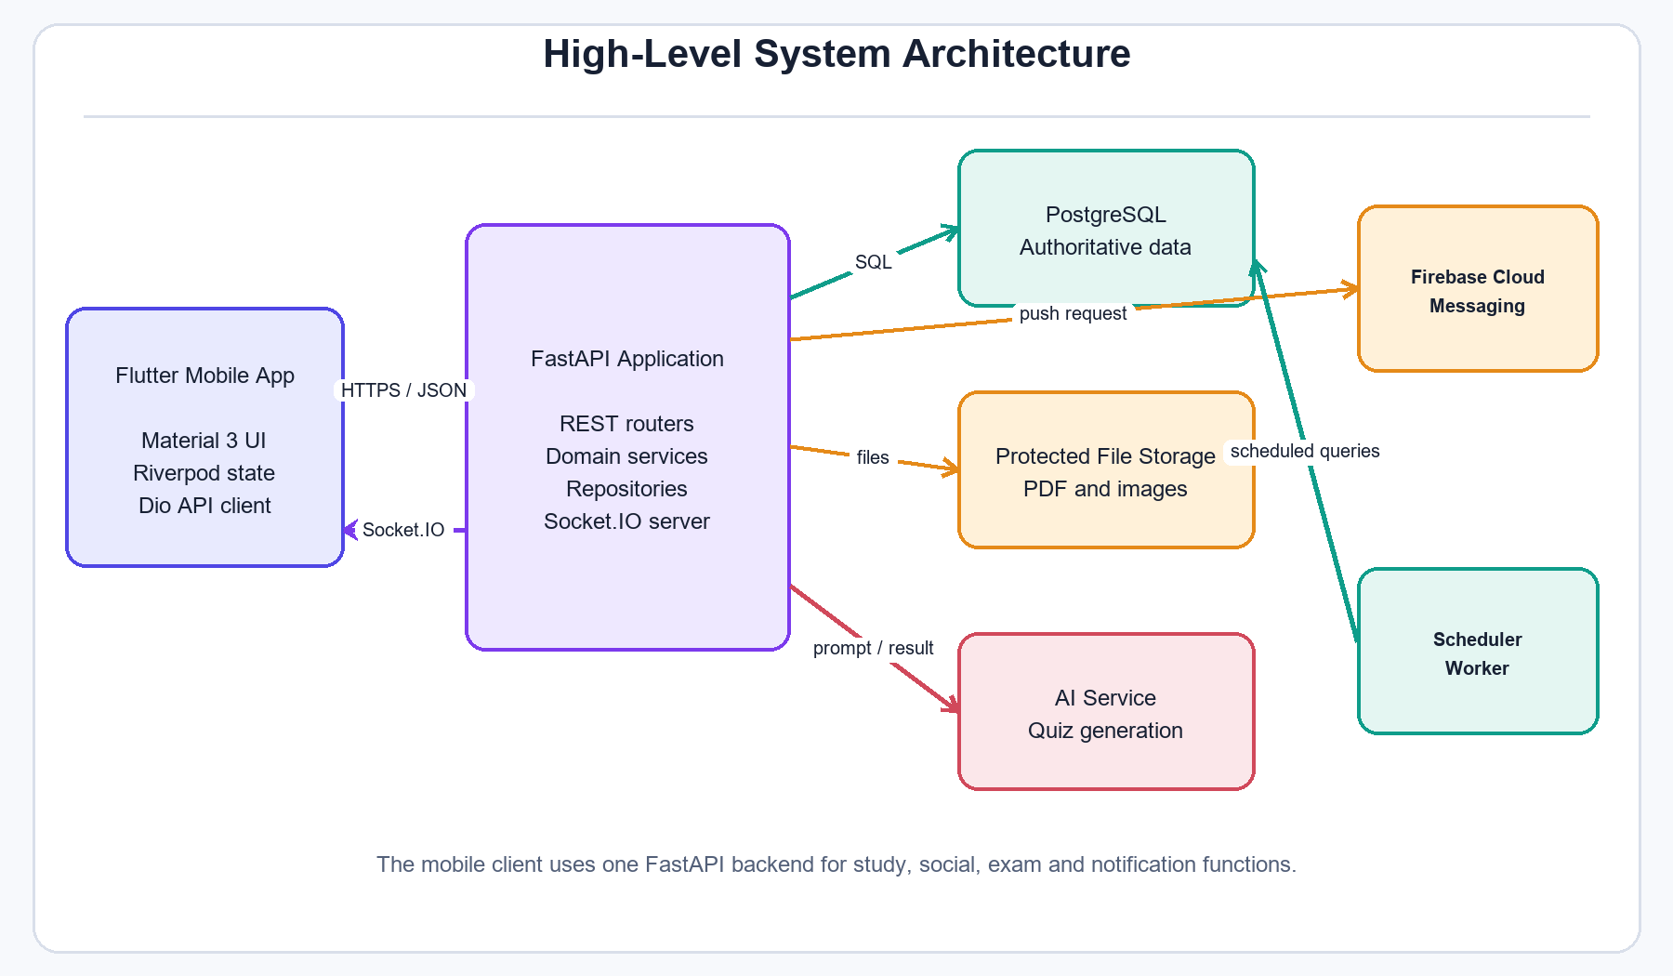
Figure 3.2: System Architecture Diagram
Recommended report location: Chapter 3 - Methodology and Artefact Design, in the system architecture section.

Explanation
Figure 3.2 presents the main technical parts of Smart Study. The Flutter mobile application handles the screens and local user interaction. It communicates with the FastAPI backend through HTTPS requests, while Socket.IO is used for immediate foreground events. The backend applies the application rules and uses PostgreSQL as the main data store. Uploaded PDF and image files are kept in protected storage. AI quiz generation, background scheduling and Firebase push delivery are connected to the backend as supporting services. This design keeps important rules on the server instead of trusting the mobile device.

Example sentence for the report
As shown in Figure 3.2, the mobile application uses one FastAPI backend to access the database and supporting services.

3.3 Simplified Entity Relationship Diagram
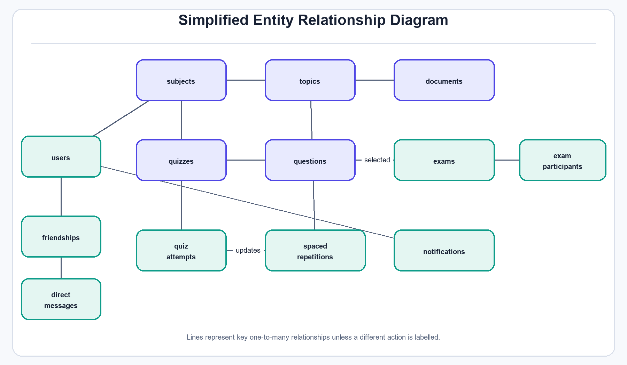
Figure 3.3: Simplified Entity Relationship Diagram
Recommended report location: Chapter 3 - Methodology and Artefact Design, in the database design section.

Explanation
Figure 3.3 shows the main data relationships used by the project. A user owns subjects, and each subject contains topics, documents and quizzes. Questions belong to quizzes and may also be included in exam papers. Quiz attempts store a learner's submitted work, and the result updates the spaced-repetition record. Exams are linked with participants, while friendships and direct messages connect users in the social part of the application. Notifications belong to individual users. The production database also includes supporting tables for sessions, refresh tokens, device tokens and collaborative contributions, but these were left out of the figure to keep it readable.

Example sentence for the report
The central relationships between the study, exam and social data are presented in Figure 3.3.

3.4 Application Navigation Flow
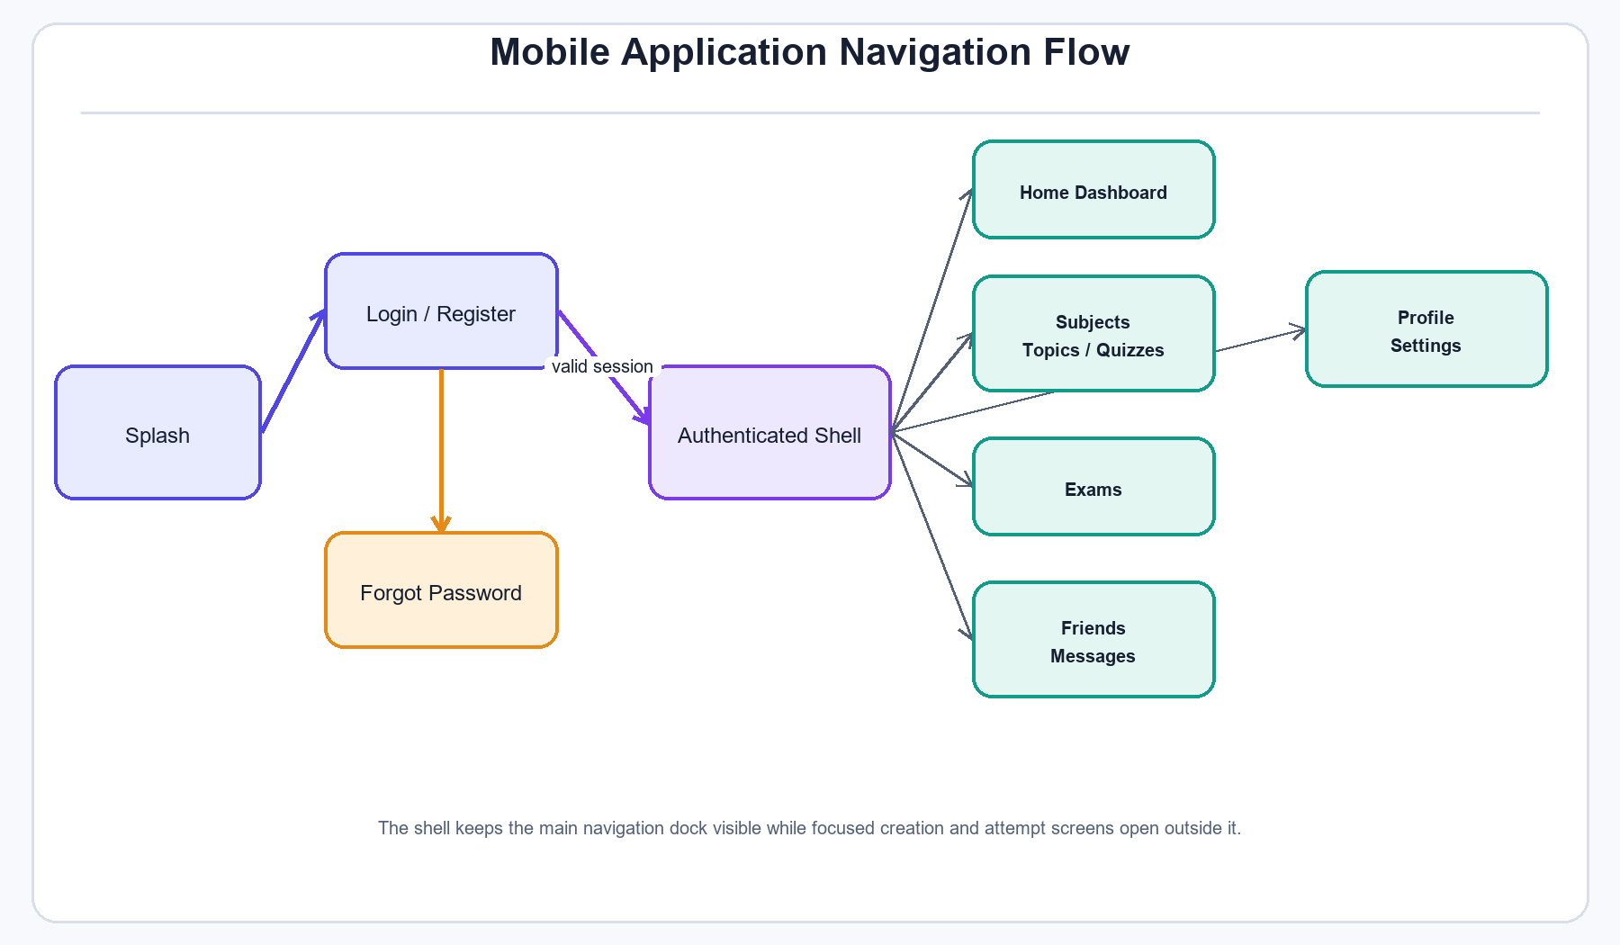
Figure 3.4: Application Navigation Flow
Recommended report location: Chapter 3 - Methodology and Artefact Design, after the user-interface design discussion.

Explanation
Figure 3.4 describes the high-level navigation of the Flutter application. A new or signed-out user moves from the splash screen to the authentication screens. A valid session opens the authenticated shell, which contains the Home, Subjects, Exams, Friends and Profile areas. The notification inbox and settings are reached from the relevant signed-in areas, although they are not separate bottom-navigation tabs. Detailed creation, contribution and active-attempt screens are opened as focused workflows, while normal detail and result pages keep the main navigation available where suitable.

Example sentence for the report
Figure 3.4 illustrates how authentication separates the public entry screens from the main application navigation.

4.1 AI Quiz Generation Sequence Diagram
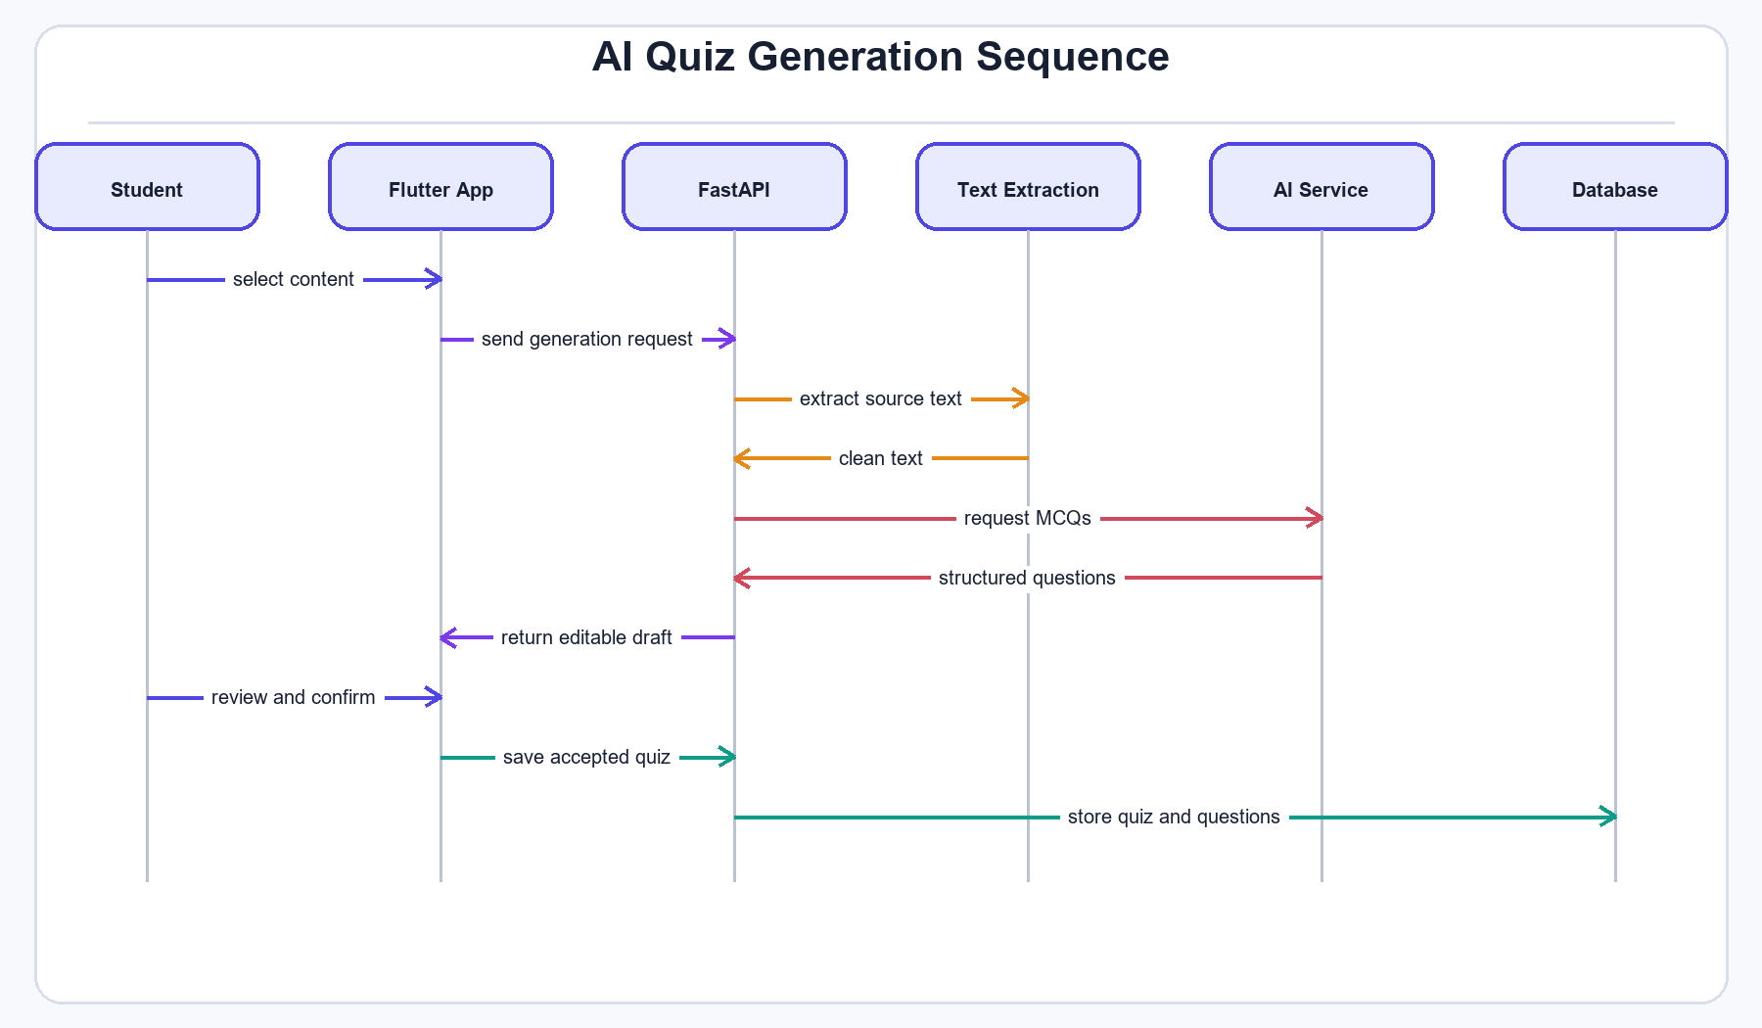
Figure 4.1: AI Quiz Generation Sequence Diagram
Recommended report location: Chapter 4 - Development and Testing, in the AI quiz-generation implementation section.

Explanation
Figure 4.1 explains the AI quiz-generation process. The student first chooses learning content in the Flutter application. The request is sent to FastAPI, where source text is extracted and prepared before the AI service is contacted. The generated multiple-choice questions are returned as an editable draft instead of being saved immediately. This gives the student a chance to review and correct the content. Only the accepted quiz and questions are stored in the database. The review stage is important because AI output may contain unsuitable or unclear questions.

Example sentence for the report
The sequence in Figure 4.1 keeps the student in control by returning an editable draft before the quiz is saved.

4.2 Spaced-Repetition Flowchart
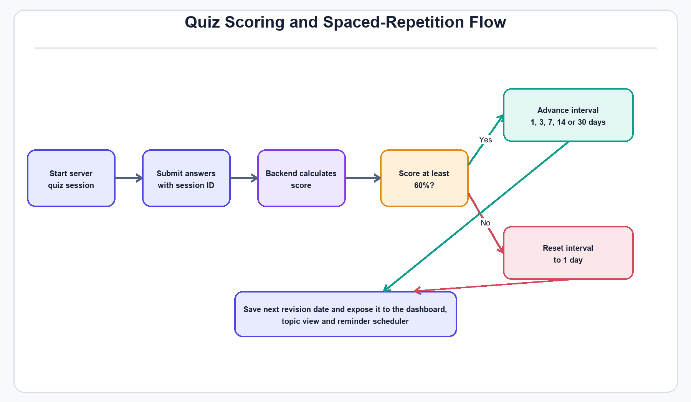
Figure 4.2: Spaced-Repetition Flowchart
Recommended report location: Chapter 4 - Development and Testing, in the quiz practice and memory scheduling section.

Explanation
Figure 4.2 shows how quiz results control the revision schedule. A practice attempt starts as a server-owned session, and the session identifier is sent back with the answers. The backend calculates the score instead of accepting a score from the mobile application. A score of 60 percent or more moves the learner to the next interval in the 1, 3, 7, 14 and 30-day sequence. A lower score resets the interval to one day. The calculated next revision date is stored and later shown in the dashboard, topic details and reminder process.

Example sentence for the report
As shown in Figure 4.2, the backend updates the revision interval using the result of the submitted quiz attempt.

4.3 Collaborative Exam Sequence Diagram
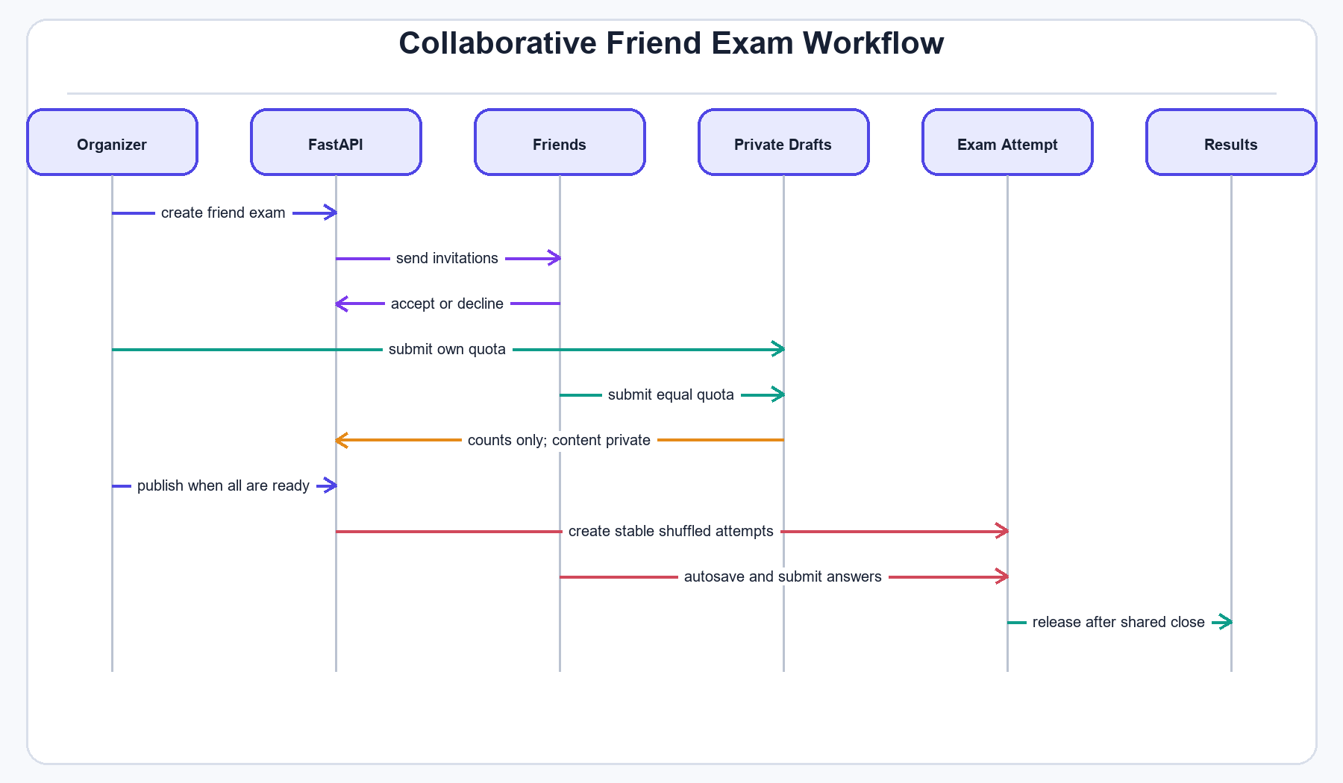
Figure 4.3: Collaborative Exam Sequence Diagram
Recommended report location: Chapter 4 - Development and Testing, in the collaborative exam implementation section.

Explanation
Figure 4.3 presents the workflow of a friend exam. The organiser creates the draft and invites friends. Every accepted participant, including the organiser, contributes the same required number of questions. Contributions remain private, and the lobby displays progress counts without showing another person's questions. The organiser can publish only after the invitation and contribution conditions are satisfied. The backend then creates stable shuffled attempts, autosaves answers and releases the shared results after the exam has closed. This process provides equal participation while protecting the private question drafts.

Example sentence for the report
Figure 4.3 demonstrates the equal contribution and private question rules used by collaborative exams.

4.4 Notification Delivery Diagram
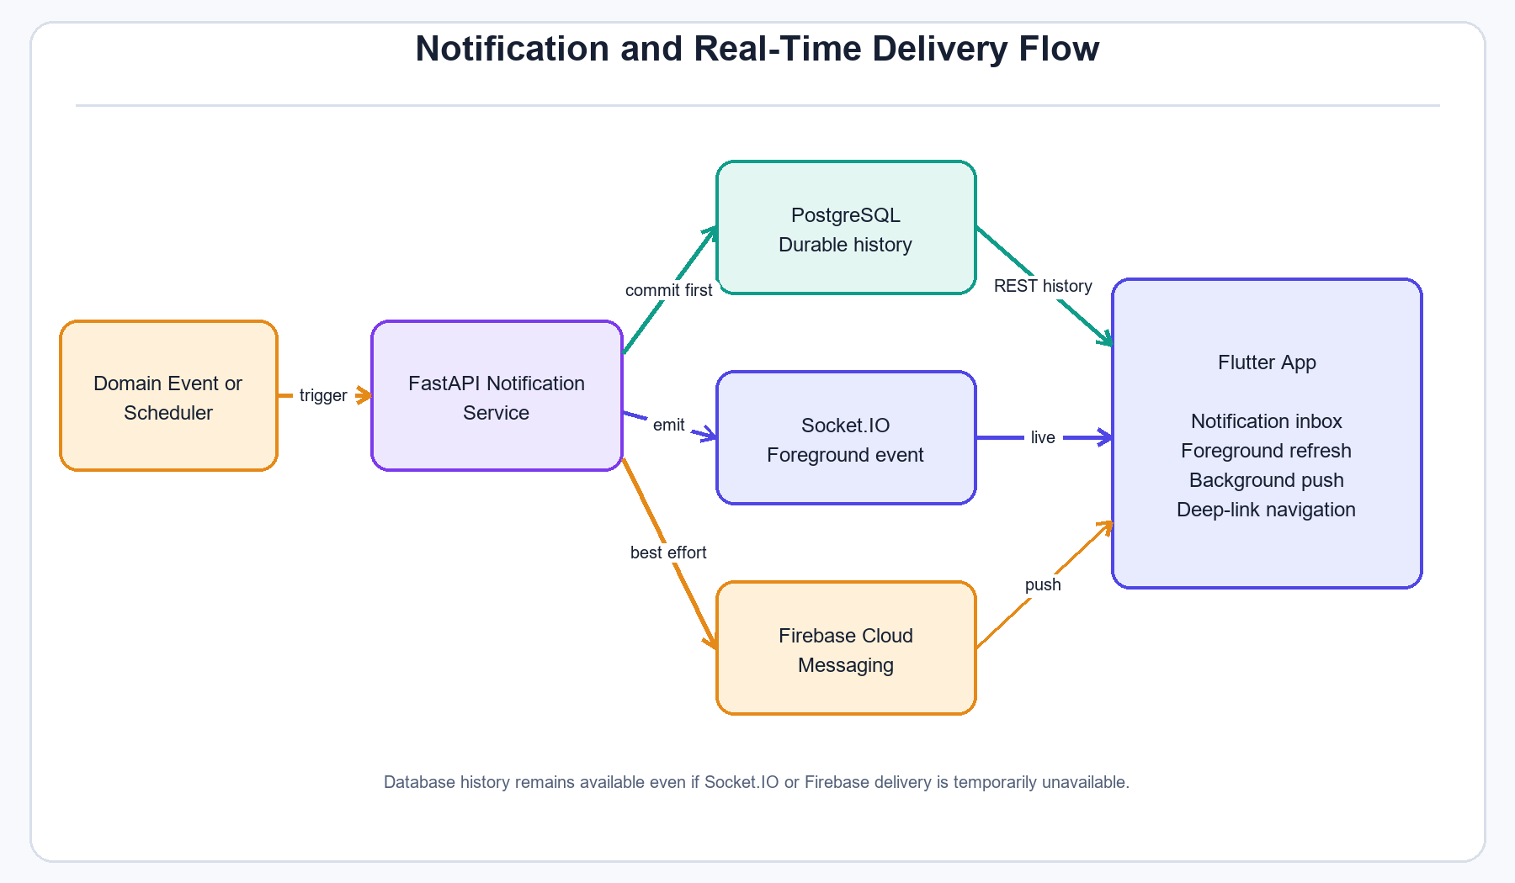
Figure 4.4: Notification Delivery Diagram
Recommended report location: Chapter 4 - Development and Testing, in the real-time and push-notification section.

Explanation
Figure 4.4 explains the three notification delivery paths. A feature event or scheduler task first creates a notification through the backend service. The record is committed to PostgreSQL, which remains the reliable notification history. Socket.IO provides an immediate update while the application is open, and Firebase Cloud Messaging provides best-effort delivery when the mobile app is in the background or closed. The Flutter application can still reload the notification inbox through the REST API if either live delivery method is unavailable.

Example sentence for the report
The layered delivery method in Figure 4.4 keeps PostgreSQL as the reliable history while Socket.IO and Firebase improve delivery speed.

4.5 Production Deployment Diagram
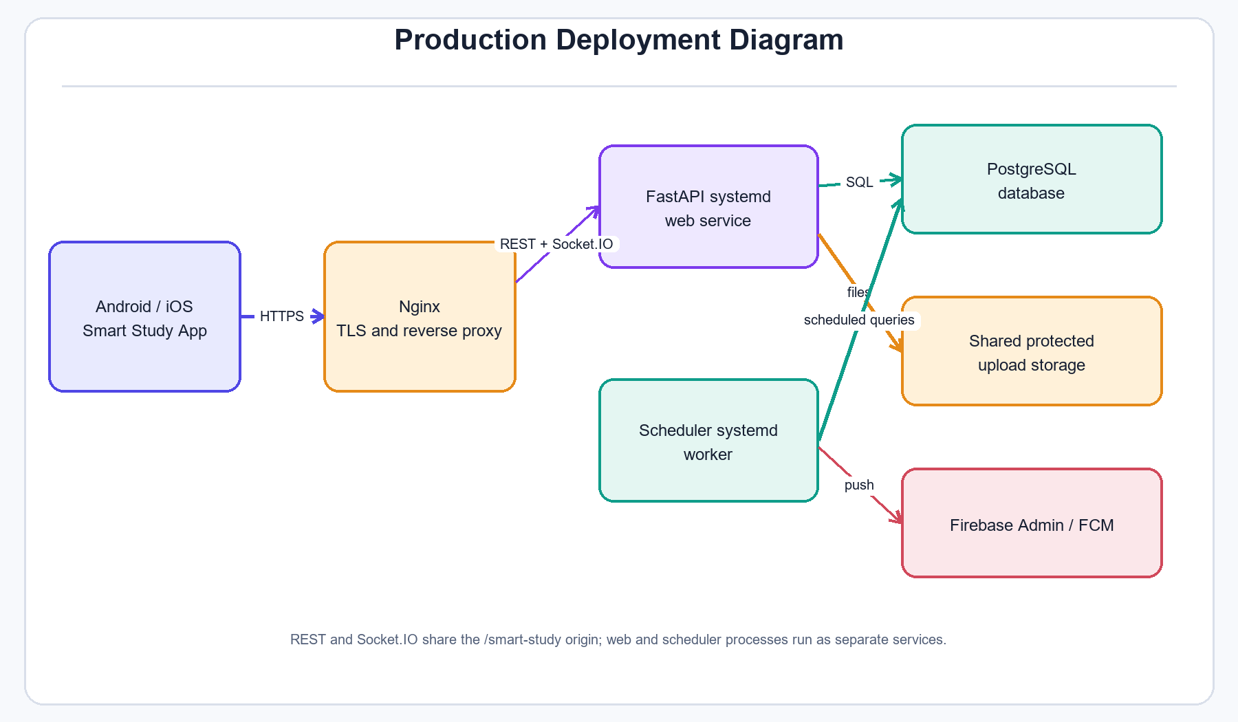
Figure 4.5: Production Deployment Diagram
Recommended report location: Chapter 4 - Development and Testing, near the deployment or implementation-environment section.

Explanation
Figure 4.5 gives an overview of the production deployment. Mobile clients connect through HTTPS to Nginx, which terminates TLS and forwards REST and Socket.IO traffic to the FastAPI web service. The web service uses PostgreSQL and protected shared upload storage. A separate scheduler service performs exam lifecycle and revision reminder work without blocking normal API requests. Firebase Admin is used for push delivery when it is enabled. Separating the web and scheduler services makes their responsibilities clearer and allows them to be monitored independently.

Example sentence for the report
Figure 4.5 shows how the public mobile application reaches the separate FastAPI web and scheduler services.

Evidence and Editing Notes
- These diagrams were prepared from the current Flutter routes, Riverpod architecture, FastAPI services, PostgreSQL migrations and project documentation.
- The ER diagram is intentionally simplified. Use the migration files when a complete table-level diagram is required.
- Do not claim that every external service was performance-tested only because it appears in an architecture diagram.
- Update figure numbers, captions and chapter references after the final thesis table of contents is fixed.
- Keep each diagram close to the paragraph that explains it. A figure should not be included without discussion in the main text.

