Logo Tiger 3 XML interface generation User Guide

# Background

Turkey office now has its own accounting system Logo Tiger 3 (hereinafter “LOGO”), all local transactions or expenses is required to go through this system. Therefore, all TEMS & Non-Trade expense transactions have to be extracted from current Epicor Accounting system to LOGO system.

ISAM system has been upgraded to let finance team to extract all Epicor posted journals which include TEMS & Non-Trade Expense transaction to LOGO system at once.

# How to use it?

A new function ***Logo XML Interfacing*** is located at Accounts module in ISAM system. User can submit their request by select Fiscal Year, Period and press [Submit] button. ISAM will extract the transactions from Epicor into interface file and upload into LOGO system directly.

Please note all transactions will include into this interface at once. Therefore, every time you request interface file will give you data that has **NOT** been extracted before. If you want to look for the previous data, please refer to the “Review previous interface file” section.

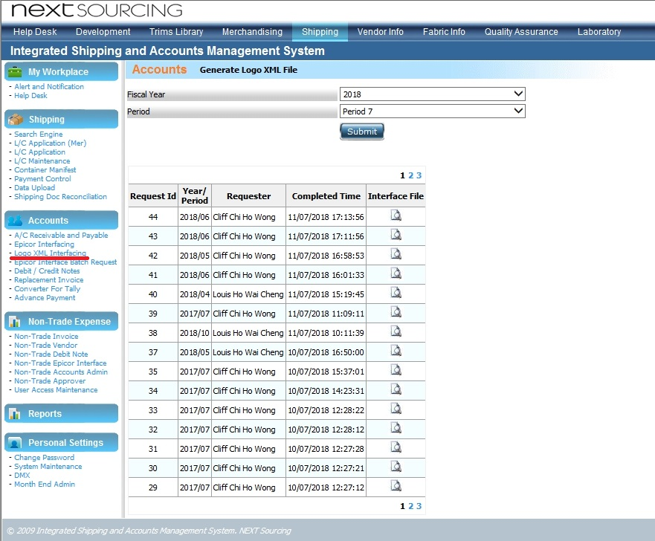

# Review previous interface file

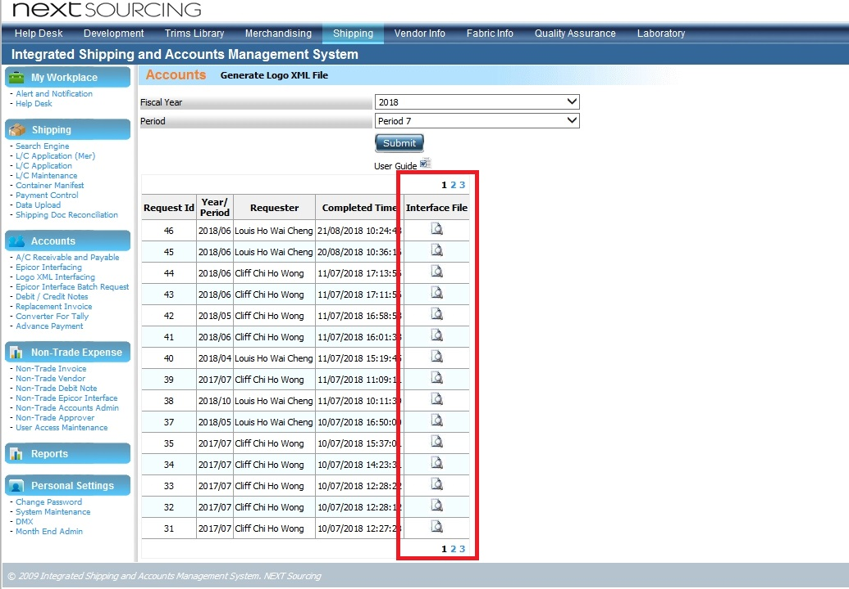

In the “Interface File” column, user can review the LOGO interface files which generated before by clicking the icon. Year/Period, requestor and completed time of previous file are also included for your reference.

Below is the interface file sample for your reference.

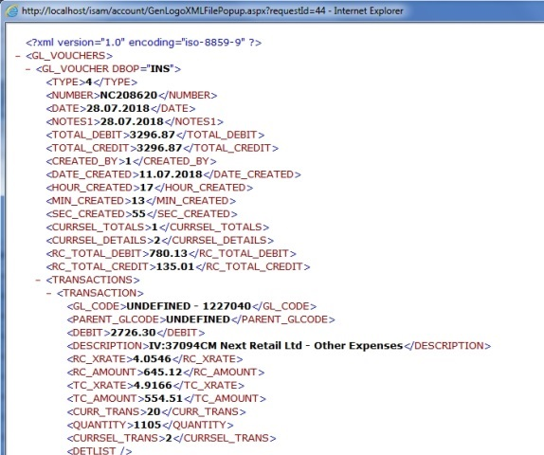

# Generate Logo XML File

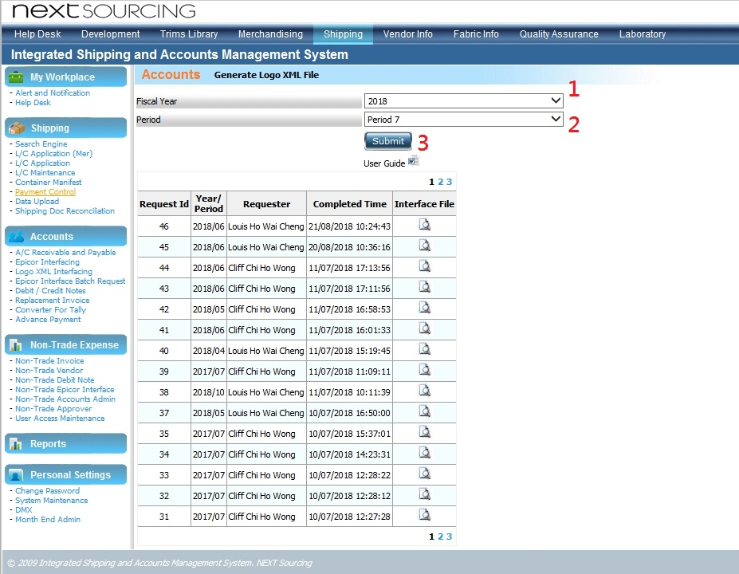

User is required to select br

1. Select “Fiscal Year”
2. Select “Period”
3. Press “Submit” button to submit their request.

4.1 If data extract success, below message will show

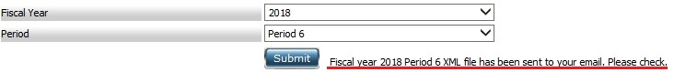

4.2 If data have been extract before, below message will show

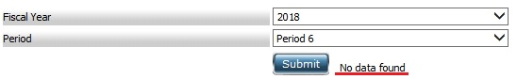

# Upload generated file to Logo

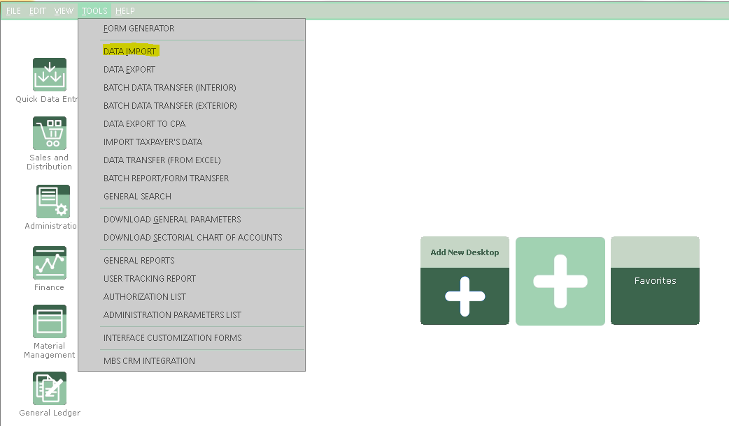

Once you’ve got the generated xml file from ISAM, you need to upload it to the Logo system as G/L Slip.

1. Login to LOGO Tiger 3 system
2. Select “TOOLS”
3. Select “DATA IMPORT”

In “DATA IMPORT” window

1. Expand “General Ledger”
2. Expand “Transactions”
3. Double click “G/L Slips”

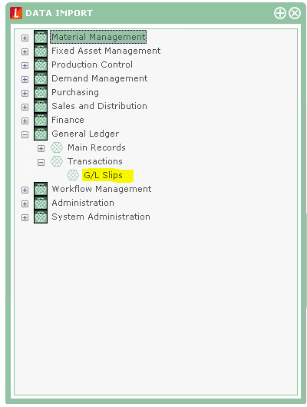

In “G/L SLIPS [IMPORT]” screen

1. Click “….” button to select the XML file generated from ISAM
2. Choose “USE XML TEMPLATE”
3. Select “GL Slip”
4. Click “START” button

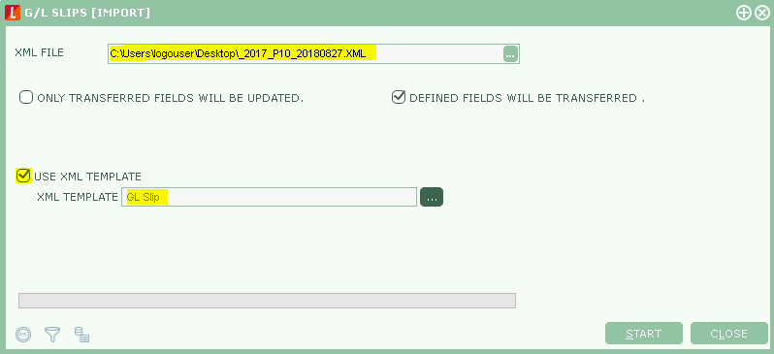

If data is uploaded, green bar will show

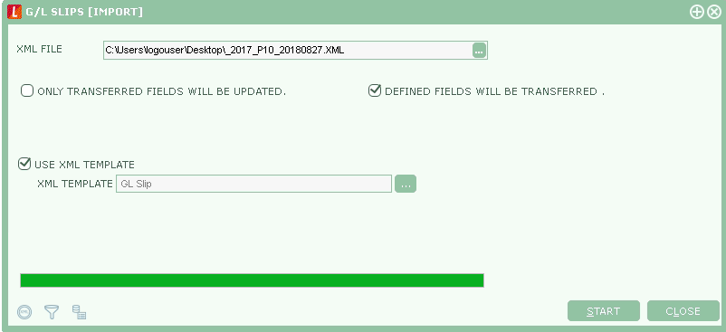

Click “Log file” button to check the data successfully uploaded or not

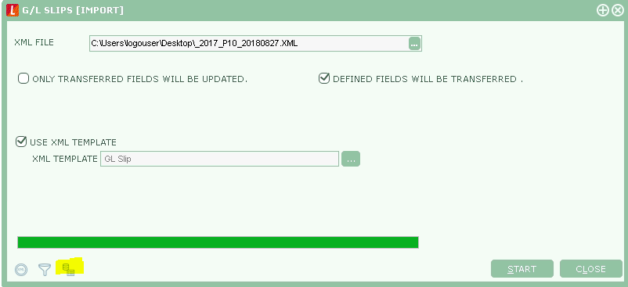

If data upload success, “Incorrect” should be show 0

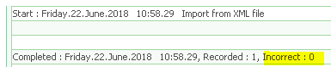

If data upload not success, error message will show

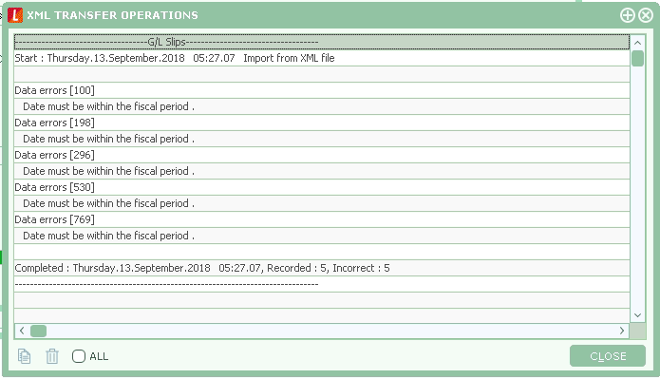

~~ End of Document ~~