Machine Learning and WGAN Augmentation for Noninvasive Gastric Cancer Detection
A repeated holdout evaluation using eight published clinical features
[Author names and affiliations to be added]

Abstract
Background: A published study reported a gradient boosting decision tree (GBDT) model for gastric cancer classification from eight noninvasive clinical features, with a test-set ROC-AUC of 0.91. This study compares that tree-based baseline with latent-variable models and TabPFN, and examines whether WGAN-GP synthetic augmentation improves holdout performance.
Methods: We analyzed the repository cohort of 709 patients (398 gastric cancer, 311 non-gastric cancer). The final predictors were gender, encoded age, neutrophil-to-lymphocyte ratio, hemoglobin, albumin, CEA, CA125, and CA199. Models were evaluated on 59 stratified 70/30 splits (seeds 42-100). Preprocessing and WGAN-GP fitting were confined to each training split. A default local TabPFNClassifier (package 9.2.0) was compared with paper-parameter GB. Paired AUC differences were assessed with the Nadeau-Bengio corrected resampled t-test and Holm adjustment across five comparisons.
Results: Real-only TabPFN achieved mean ROC-AUC 0.8901 (SD 0.0186), compared with 0.8661 (SD 0.0213) for paper-parameter GB. The paired difference was 0.0240 (corrected 95% CI 0.0077 to 0.0403; Holm-adjusted p=0.0231). WGAN augmentation changed mean AUC by +0.0051 for GB, +0.0017 for VAE+GB, +0.0026 for SS-VAE+GB, and -0.0057 for TabPFN; none was statistically reliable after Holm adjustment. Across 59 WGAN generations, mean class-conditional KS distance was 0.0811, normalized Wasserstein distance was 0.0866, and no exact duplicates of training rows were found; the mean near-duplicate fraction was 4.25%.
Conclusions: Default TabPFN had the highest mean holdout AUC among evaluated real-only models on this cohort. We found no statistically reliable evidence that WGAN augmentation improved any of the four tested model families. These repeated splits do not provide external validation, and the findings do not establish clinical utility or cancer-stage prediction.
Keywords: gastric cancer; noninvasive biomarkers; gradient boosting; variational autoencoder; WGAN-GP; TabPFN; repeated holdout

Introduction
Gastric cancer diagnosis commonly relies on endoscopy and histopathology. Routine blood counts, biochemical measurements, and serum tumor markers are easier to obtain, but their performance as a stand-alone diagnostic screen is limited. Machine learning offers a way to combine these measurements, although small clinical cohorts can produce unstable estimates when a model is evaluated on a single random split.
Zhu and colleagues studied 709 patients and selected eight noninvasive characteristics by univariate and multivariable analysis: gender, age, neutrophil-to-lymphocyte ratio (NLR), hemoglobin, albumin, CEA, CA125, and CA199. Their GBDT model used a 70/30 train/test split and reported a test-set AUC of 0.91, sensitivity of 87.0%, specificity of 84.1%, and accuracy of 83.0% at a threshold of 0.56. Their five-fold tuning reported an AUC of 0.86 for 70 trees and learning rate 0.12; the final tree settings included maximum depth 5 and minimum leaf size 10 [1].
The repository project explored whether representation learning or synthetic augmentation could improve on a tree model that uses the same published feature set. Unsupervised VAE compression and semi-supervised VAE (SS-VAE) compression were paired with gradient boosting. WGAN-GP was then trained within each training split to generate an additional eight-feature dataset. Finally, default local TabPFN was evaluated with and without the saved synthetic rows.
The prespecified questions were: (1) does real-only TabPFN have higher holdout AUC than the paper-parameter GB baseline; and (2) does WGAN-GP augmentation provide a statistically reliable AUC improvement for GB, VAE+GB, SS-VAE+GB, or TabPFN? This is a secondary analysis of one cohort, not an external validation study or a stage-prediction study.

Methods

Study cohort and outcome
The project CSV contains 709 patient records and 24 columns, including a patient identifier, a binary diagnosis label, and clinical variables. There were 398 gastric cancer cases (label 1) and 311 non-gastric-cancer controls (label 0). The source publication describes the non-cancer group as 202 patients with benign gastric disease and 109 healthy participants [1]. The binary outcome in the repository does not encode cancer stage.
The repository-coded age variable takes integer values from 2 to 9 and is treated as an encoded age category, rather than a continuous age in years. Gender is encoded 0 for female and 1 for male. The eight model inputs are listed in Table 1. Descriptive summaries below use the raw cohort values and are not estimates from a separate population sample.
Table 1. Cohort counts and selected-feature summaries by outcome.
Characteristic | Non-cancer, n=311 | Gastric cancer, n=398 | Description
Patients | 311 | 398 | Total N=709
Male sex | 103 (33.1%) | 252 (63.3%) | Gender code 1
Age category | 5 [5-6] | 7 [6-7] | Repository code; not years
NLR (neu_lym) | 1.71 [1.38-2.30] | 2.34 [1.70-3.57] | Ratio
Hemoglobin (hb) | 137 [128-150] | 127 [106-141] | g/L in project file
Albumin (alb) | 42.9 [40.3-45.5] | 38.2 [34.3-41.9] | g/L in project file
CEA | 1.60 [1.10-2.50] | 2.40 [1.50-4.50] | Marked right skew
CA125 | 11.20 [8.15-14.75] | 12.45 [8.62-21.09] | U/mL
CA199 | 9.65 [6.70-14.35] | 11.05 [6.10-25.93] | U/mL
Note. Continuous values are median [interquartile range] transcribed from the repository EDA report; categorical values are count (percentage). NLR is the repository variable neu_lym. The age field is encoded categorically in this dataset and should not be interpreted as age in years.

Predictors and preprocessing
The final eight predictors were fixed to the features reported in the source paper: gender, age, neu_lym, hb, alb, cea, ca125, and ca199. Feature screening was not repeated independently within each random split. The repository EDA reports no missing cells in the supplied raw cohort. The project preprocessor nevertheless flags extreme entries (hb greater than 300, alb greater than 100, or rdw greater than 40) as missing and imputes them using the nearest fitted K-means centroid. The imputer and its StandardScaler are fitted using the current training partition only; the fitted transform is then applied to the held-out test partition. The source paper does not report the exact outlier cutoffs or K-means settings; the project used five clusters [1].
For the VAE and SS-VAE models, the eight selected features were standardized using a scaler fitted to the training partition. Synthetic rows and test rows used the same fitted scaler. TabPFN received the eight processed features in clinical units without project-level feature scaling; its built-in default preprocessing remained enabled.

Repeated train/test evaluation
Each run used stratified random 70/30 train/test splits with integer seeds 42 through 100, yielding 59 holdout evaluations. Every split contained 496 training and 213 test patients; the typical stratified class counts were 218 controls and 278 cases in training, and 93 controls and 120 cases in test. For each seed, preprocessing, generator fitting, model fitting, and any model-specific training used only the 70% training partition. The 30% holdout was used only for that seed’s final evaluation. Patient membership overlaps across different seeds, so the 59 results are paired repeated resamples, not 59 independent cohorts.

Classification models
The raw-feature GB baseline used the paper-reported settings: 70 estimators, learning rate 0.12, maximum depth 5, minimum samples per leaf 10, minimum samples to split 2, and no feature subsampling. This is a project reimplementation using the reported settings; it is not an exact reproduction of the source pipeline because some preprocessing details and the project age encoding differ or are not fully documented in the paper.
The unsupervised VAE mapped the eight standardized predictors to a four-dimensional latent representation. Its encoder/decoder used hidden layers of 128 and 64 units, dropout 0.1, learning rate 0.001, weight decay 0.00001, 100 epochs, and batch size 64. Gradient boosting was then fitted to the latent features with the project settings (200 estimators, learning rate 0.1, depth 4, minimum split 4, minimum leaf 2, and square-root feature subsampling). The beta coefficient was evaluated at 0.0005, 0.005, 0.05, 0.5, and 1.0 [2,3].
The SS-VAE used the same four-dimensional latent space and optimization settings, with a supervised classification head (32 hidden units) and classification-loss weight alpha=10. Its beta coefficient was evaluated at the same five values. The primary direct comparisons with WGAN augmentation used beta=0.0005 for both VAE families.
TabPFN was run as the local default TabPFNClassifier from package version 9.2.0, without constructor overrides, AutoTabPFN, or a hosted client. The saved estimator configuration records automatic device and model-path selection and default estimator settings. The package resolved its local TabPFN-3.5 checkpoint in this installation [5,6].

WGAN-GP generation and augmentation
For each split, a class-conditional WGAN-GP was fitted only on that split’s real training rows and the eight selected features. neu_lym, CEA, CA125, and CA199 received log1p transforms; a StandardScaler was fitted on the transformed training data. The generator used latent dimension 16, hidden dimension 128, layer normalization, learning rates of 0.0001 for generator and critic, Adam betas (0.5, 0.9), gradient-penalty weight 10, five critic steps per generator step, 5,000 generator steps, and batch size 64 [4].
Each split generated 496 synthetic rows. Their class counts were chosen to reverse the real training counts: 278 synthetic controls and 218 synthetic cases were added to 218 real controls and 278 real cases. The resulting combined training set contained 992 rows with 496 examples in each class. Postprocessing enforced binary gender, integer age codes from 2 to 9, and nonnegative laboratory values. Consequently, the augmented comparison evaluates WGAN generation together with training-set class balancing and increased training-set size; it does not isolate the effect of synthetic rows from the effect of rebalancing.

Synthetic data quality checks
Synthetic rows were compared with the corresponding real training partition within each seed and class. Diagnostics included mean class-conditional Kolmogorov-Smirnov (KS) distance, Wasserstein distance normalized by the real training feature standard deviation, Frobenius distance between Spearman correlation matrices, invalid-value counts, exact duplicate counts, and near-duplicate fraction. A synthetic row was counted as near-duplicate when its standardized distance to a real training row was at or below the fifth percentile of real-to-real nearest-neighbor distances. These are descriptive fidelity and novelty checks; they do not establish clinical validity or privacy.

Outcomes and statistical analysis
The primary metric was ROC-AUC. Secondary metrics were average precision (reported as PR-AUC), accuracy, F1 score, sensitivity, specificity, and Brier score. Split-level classification metrics were averaged across 59 seeds; AUC standard deviations describe between-split variability. For classification outputs, model default prediction labels were used; no threshold was tuned on the held-out test data.
Five paired AUC comparisons were prespecified in Experiment 12: real-only TabPFN versus paper-config real-only GB; real+WGAN versus real-only GB; real+WGAN versus real-only VAE+GB at beta 0.0005; real+WGAN versus real-only SS-VAE+GB at beta 0.0005; and real+WGAN versus real-only TabPFN. For each seed, the AUC difference was calculated using the same holdout patients. We applied a two-sided Nadeau-Bengio corrected resampled t-test to account approximately for dependence from overlapping repeated splits, using 1/n + n_test/n_train as the variance factor and 58 degrees of freedom [7]. Holm’s step-down procedure adjusted the five p-values as one family, with family-wise alpha=0.05. Reported corrected 95% confidence intervals are nominal per comparison, not simultaneous family-wise intervals.

Results

Predictive performance
Table 2 reports the primary model comparisons at beta=0.0005 for the latent models. Real-only TabPFN had the highest mean AUC (0.8901, SD 0.0186), followed by TabPFN with WGAN augmentation (0.8844, SD 0.0202). The paper-config GB model averaged 0.8661 (SD 0.0213). VAE+GB and SS-VAE+GB latent models were below the raw-feature GB and TabPFN averages. The single highest split was not used as the main performance estimate.
Table 2. Primary 59-split holdout performance for real-only and WGAN-augmented models.
Model and training data | ROC-AUC mean +/- SD | PR-AUC | Accuracy | F1 | Sensitivity | Specificity | Brier
Paper-config GB, real only | 0.8661 +/- 0.0213 | 0.9017 | 0.7852 | 0.8080 | 0.8044 | 0.7603 | 0.1543
VAE + GB, beta 0.0005, real only | 0.8528 +/- 0.0214 | 0.8856 | 0.7703 | 0.7947 | 0.7908 | 0.7438 | 0.1720
SS-VAE + GB, beta 0.0005, real only | 0.8561 +/- 0.0231 | 0.8919 | 0.7762 | 0.7992 | 0.7912 | 0.7567 | 0.1801
TabPFN default, real only | 0.8901 +/- 0.0186 | 0.9220 | 0.7972 | 0.8171 | 0.8048 | 0.7875 | 0.1341
Paper-config GB, real + WGAN | 0.8712 +/- 0.0212 | 0.9060 | 0.7894 | 0.8070 | 0.7828 | 0.7979 | 0.1501
VAE + GB, beta 0.0005, real + WGAN | 0.8545 +/- 0.0219 | 0.8867 | 0.7701 | 0.7884 | 0.7616 | 0.7811 | 0.1649
SS-VAE + GB, beta 0.0005, real + WGAN | 0.8587 +/- 0.0241 | 0.8954 | 0.7787 | 0.7955 | 0.7664 | 0.7946 | 0.1688
TabPFN default, real + WGAN | 0.8844 +/- 0.0202 | 0.9177 | 0.7926 | 0.8096 | 0.7836 | 0.8043 | 0.1390
Note. Each mean is calculated over the same 59 stratified 70/30 seed splits. AUC SD is the between-split standard deviation. Lower Brier score is better. WGAN conditions contain the same number of synthetic rows as real training rows and produce a balanced combined training set.
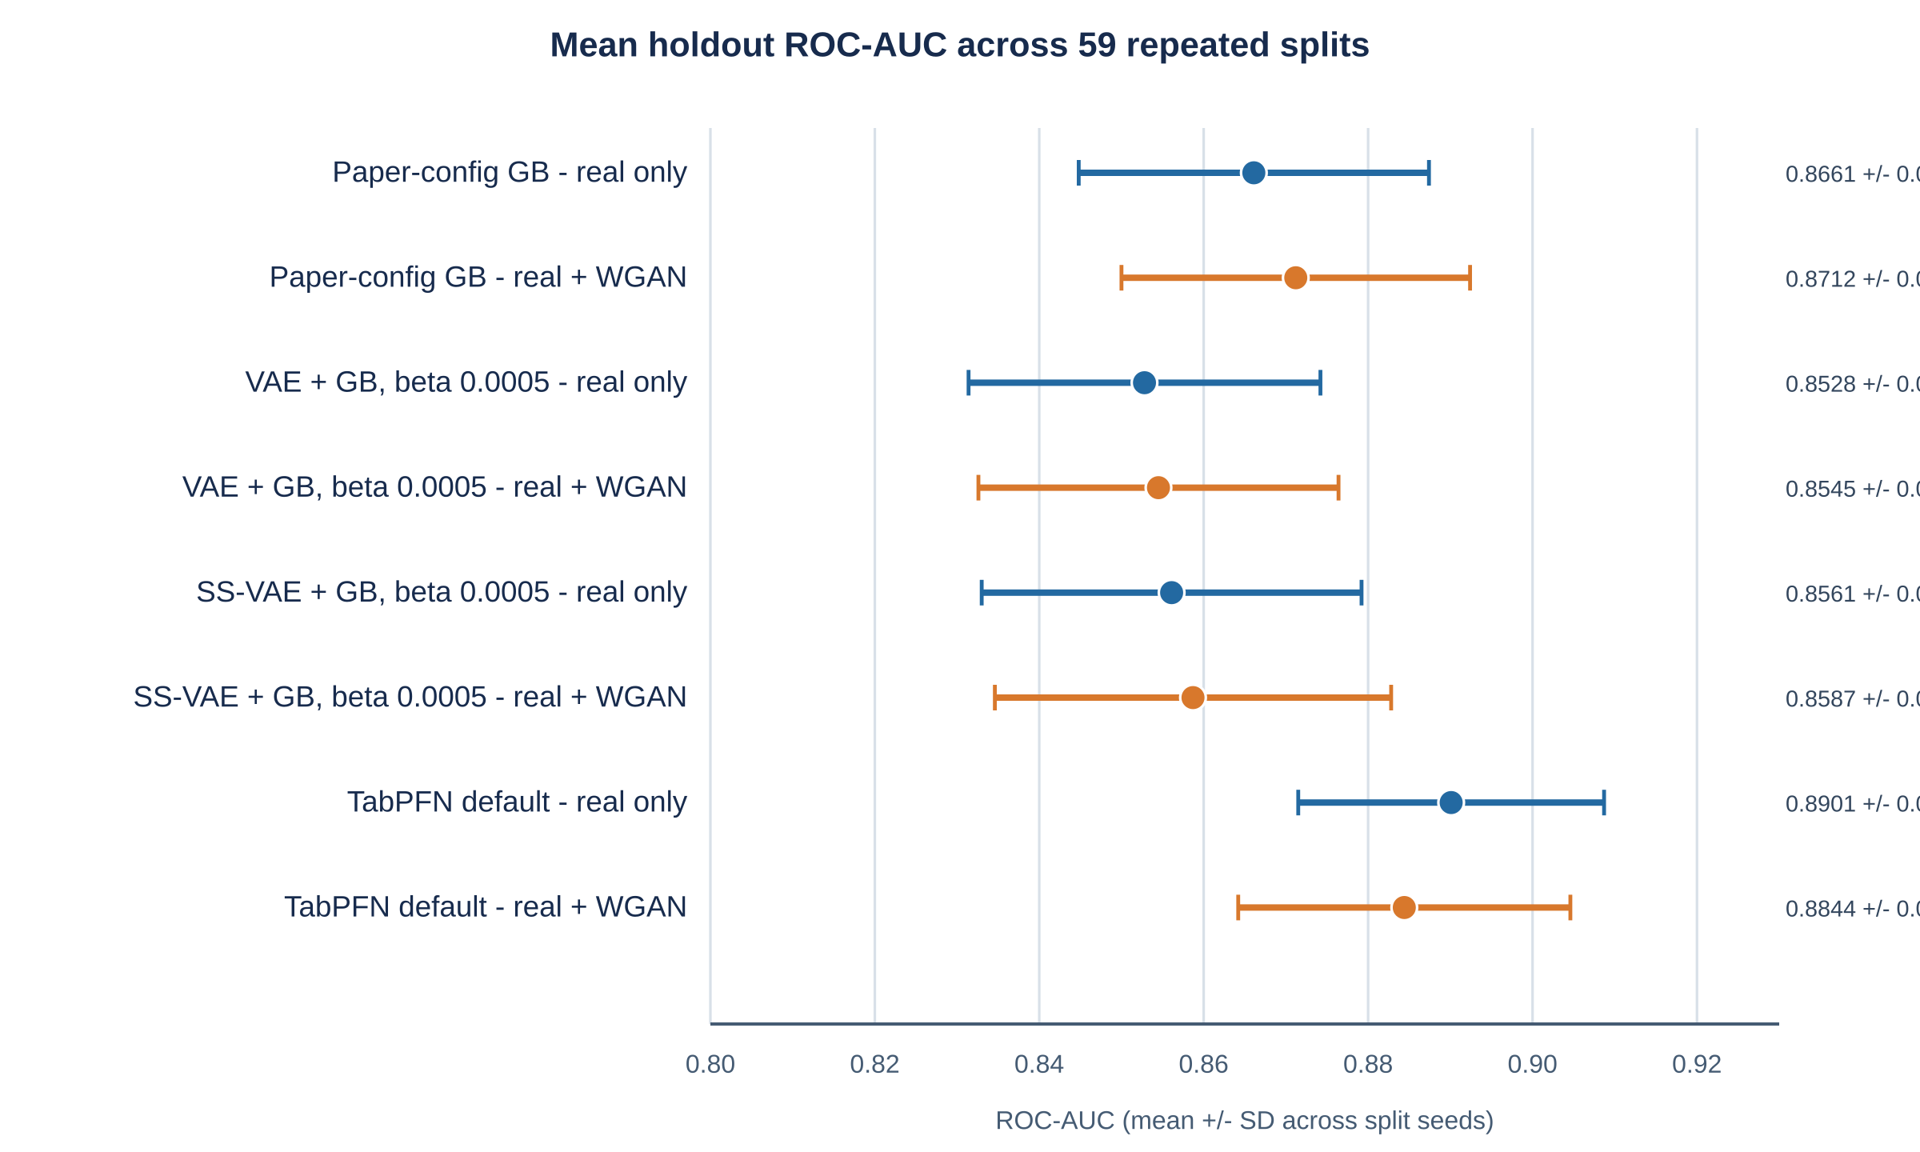
Figure 1. Mean holdout ROC-AUC and between-split standard deviation for the primary real-only and real+WGAN model comparisons. Error bars show plus/minus one standard deviation across 59 splits.

Beta sensitivity of VAE models
The beta sweeps showed modest AUC variation for SS-VAE+GB across beta values 0.0005 to 1.0. SS-VAE+GB had its highest mean AUC at beta=0.005 (0.8570). The unsupervised VAE+GB mean AUC declined as beta increased in these runs, from 0.8528 at beta=0.0005 to 0.8211 at beta=1.0. These are descriptive beta comparisons; Experiment 12 did not test every beta pair statistically.
Table 3. Real-only VAE and SS-VAE beta sweep across 59 holdout splits.
Model | Beta | ROC-AUC mean +/- SD | PR-AUC | Accuracy | F1 | Sensitivity | Specificity | Brier
VAE + GB | 0.0005 | 0.8528 +/- 0.0214 | 0.8856 | 0.7703 | 0.7947 | 0.7908 | 0.7438 | 0.1720
VAE + GB | 0.005 | 0.8509 +/- 0.0220 | 0.8847 | 0.7707 | 0.7952 | 0.7914 | 0.7439 | 0.1722
VAE + GB | 0.05 | 0.8469 +/- 0.0222 | 0.8805 | 0.7693 | 0.7950 | 0.7955 | 0.7356 | 0.1750
VAE + GB | 0.5 | 0.8438 +/- 0.0253 | 0.8759 | 0.7657 | 0.7920 | 0.7931 | 0.7305 | 0.1767
VAE + GB | 1.0 | 0.8211 +/- 0.0309 | 0.8577 | 0.7470 | 0.7751 | 0.7751 | 0.7108 | 0.1895
SS-VAE + GB | 0.0005 | 0.8561 +/- 0.0231 | 0.8919 | 0.7762 | 0.7992 | 0.7912 | 0.7567 | 0.1801
SS-VAE + GB | 0.005 | 0.8570 +/- 0.0230 | 0.8922 | 0.7784 | 0.8011 | 0.7931 | 0.7594 | 0.1792
SS-VAE + GB | 0.05 | 0.8558 +/- 0.0223 | 0.8894 | 0.7779 | 0.8003 | 0.7917 | 0.7602 | 0.1783
SS-VAE + GB | 0.5 | 0.8548 +/- 0.0213 | 0.8870 | 0.7776 | 0.8005 | 0.7927 | 0.7582 | 0.1794
SS-VAE + GB | 1.0 | 0.8547 +/- 0.0207 | 0.8869 | 0.7739 | 0.7965 | 0.7871 | 0.7567 | 0.1804
Note. The raw-feature GB comparator in Experiment 5 averaged ROC-AUC 0.8661 +/- 0.0213. It is reported in Table 2 rather than repeated for each beta because the raw GB model does not use a beta parameter.

Paired significance tests
On the matched per-seed results, real-only TabPFN exceeded paper-config real-only GB by a mean 0.0240 AUC (corrected 95% CI 0.0077 to 0.0403; raw p=0.0046; Holm-adjusted p=0.0231). TabPFN had higher AUC on 58 of 59 seeds. This supports a difference on the current cohort under the stated resampling design; it does not establish generalization to other hospitals.
None of the four WGAN augmentation comparisons had a Holm-adjusted p-value below 0.05. The point estimates were positive for GB, VAE+GB, and SS-VAE+GB, and negative for TabPFN. The results support the cautious conclusion that there was no statistically reliable evidence of an AUC improvement from WGAN augmentation in these comparisons; they do not prove an exactly zero effect.
Table 4. Nadeau-Bengio corrected paired AUC tests with Holm adjustment across five comparisons.
Comparison (A - B) | Mean delta AUC | Corrected 95% CI | Raw p | Holm p | A higher / tie / B higher
TabPFN real-only - paper GB real-only | +0.0240 | [+0.0077, +0.0403] | 0.0046 | 0.0231 | 58 / 0 / 1
GB + WGAN - GB real-only | +0.0051 | [-0.0132, +0.0233] | 0.5807 | 1.0000 | 37 / 0 / 22
VAE + GB + WGAN - VAE + GB | +0.0017 | [-0.0275, +0.0309] | 0.9088 | 1.0000 | 31 / 0 / 28
SS-VAE + GB + WGAN - SS-VAE + GB | +0.0026 | [-0.0183, +0.0235] | 0.8026 | 1.0000 | 35 / 0 / 24
TabPFN real + WGAN - TabPFN real-only | -0.0057 | [-0.0155, +0.0040] | 0.2452 | 0.9807 | 12 / 0 / 47
Note. Variance factor was 1/59 + 213/496 = 0.4464, with 58 degrees of freedom. Confidence intervals are nominal per comparison; p-values are Holm-adjusted across the five planned tests.
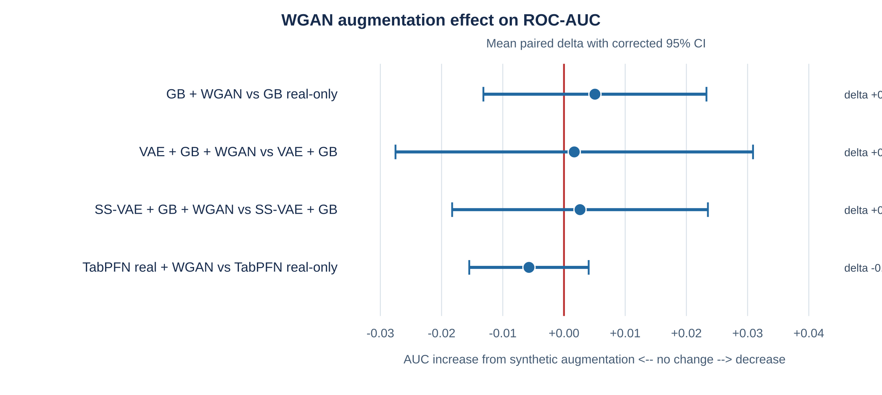
Figure 2. WGAN augmentation paired AUC differences. Intervals are Nadeau-Bengio corrected 95% confidence intervals; none of the four WGAN comparisons was significant after Holm adjustment.

Synthetic data quality
Across the 59 per-seed WGAN datasets, mean class-conditional KS distance was 0.0811 (SD 0.0143), and mean Wasserstein distance normalized by training-set feature SD was 0.0866 (SD 0.0165). Mean Spearman correlation-matrix Frobenius distance was 0.5716 (SD 0.0570). No invalid gender or age codes, negative biomarker values, exact real-training duplicates, or exact duplicate pairs within synthetic data were recorded. The mean near-duplicate fraction was 4.25% (SD 1.34%) under the project’s nearest-neighbor threshold. Similarity metrics indicate distributional resemblance on the evaluated training splits, but do not establish clinical plausibility, privacy, or downstream utility.
Table 5. Per-seed WGAN-GP fidelity, validity, and novelty diagnostics (n=59).
Diagnostic | Mean +/- SD or count | Interpretation
Class-conditional KS distance | 0.0811 +/- 0.0143 | Lower indicates closer marginal distributions
Wasserstein distance / training SD | 0.0866 +/- 0.0165 | Lower indicates closer marginal distributions
Spearman correlation Frobenius distance | 0.5716 +/- 0.0570 | Lower indicates closer rank-correlation matrices
Near-duplicate fraction | 0.0425 +/- 0.0134 | Nearest neighbor within real-training 5th percentile
Exact duplicate rows vs training | 0 of 59 runs | No exact matches recorded
Invalid gender / age / negative biomarkers | 0 rows in all runs | After generator postprocessing
Note. Wasserstein distances are normalized by the real training feature standard deviation. These checks compare synthetic and real training rows within each seed and class. No held-out test rows were used to fit the WGAN-GP generators or compute Experiment 10 quality metrics.
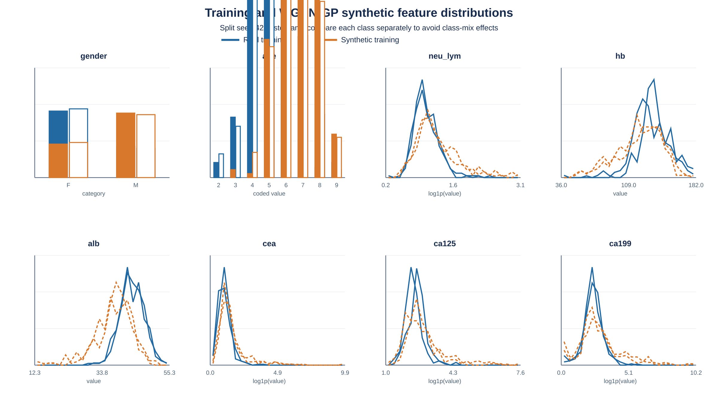
Figure 3. Class-conditional feature distributions for the seed-42 real training partition and its balanced WGAN-GP synthetic dataset. Heavy-tailed variables neu_lym, CEA, CA125, and CA199 are displayed after log1p transformation. This is an illustrative split; the 59-seed quality summaries are reported in Table 5.

Discussion
In this repeated holdout analysis, default local TabPFN trained on real data had the highest mean ROC-AUC among the evaluated real-only models. The corrected paired comparison with paper-config GB was statistically significant after Holm adjustment, with a mean difference of 0.0240. This result is stronger evidence than selecting the best single random split, but it remains an internal resampling result from one cohort.
The VAE and SS-VAE representations did not surpass the raw-feature GB baseline on average. For SS-VAE, mean AUC varied little across beta values 0.0005 to 1.0, whereas the unsupervised VAE results were lower at larger beta values, especially beta=1. The experiments do not establish that latent compression is intrinsically unsuitable; they show that these four-dimensional representations and training settings did not improve average holdout AUC in this dataset.
The WGAN-GP generated feature distributions that were broadly similar to their split-specific real training references, with no exact duplicates found and a modest but nonzero near-duplicate fraction. Yet the downstream paired tests did not show statistically reliable AUC gains for any of the four model families after multiple-comparison adjustment. The raw GB point estimate increased by 0.0051, while TabPFN decreased by 0.0057. Synthetic-data similarity and prediction utility are distinct: acceptable feature-level fidelity does not guarantee improved classification.
The source paper’s 0.91 test AUC came from one 70/30 split and a separately described parameter-tuning workflow [1]. Our paper-config GB average over 59 repeated splits was 0.8661, with between-split SD 0.0213. An earlier fixed processed-data holdout run in the repository produced AUC 0.8550; it is not pooled with the 59-split results. The comparison should not be interpreted as a contradiction or a direct replication failure: the split identities and certain preprocessing details are not identical, and the repository stores age as category codes rather than the age-in-years representation described in the publication.

Limitations
Single-cohort evaluation. All resamples reuse patients from one 709-record cohort. The Nadeau-Bengio correction addresses dependence approximately, but it does not provide external validation or establish performance at another institution.
Published feature set. The eight predictors were fixed from the source study and not reselected inside each split. The source paper reports screening predictors before the 70/30 split. If the repository data are the same patient-level cohort, this creates a risk that feature selection used outcome information from records later assigned to holdout sets. A future analysis should use nested feature selection or an independent cohort.
Age representation. The repository age feature is encoded from 2 to 9, while the source paper describes age in years. This coding difference limits exact replication and should be clarified from the data dictionary before publication.
Augmentation and class balance are combined. WGAN-generated rows both increase training-set size and bring the combined labels to 50/50. The current design therefore cannot attribute an effect solely to synthetic observations rather than class balancing.
No stage or prospective outcomes. The target is binary cancer versus non-cancer. The dataset does not provide a stage target for this experiment, and no prospective screening pathway, calibration threshold, decision-curve benefit, or clinical impact was evaluated.
Synthetic quality is descriptive. Feature-level distances and nearest-neighbor checks are not clinical validation and do not constitute a formal privacy guarantee. The nonzero near-duplicate fraction warrants caution.
Multiplicity and model scope. Holm adjustment was applied to five AUC comparisons. Other beta-level and secondary-metric comparisons are descriptive and should not be interpreted as inferential tests.

Conclusion
Across 59 stratified 70/30 resamples of the available cohort, real-only default TabPFN achieved the highest mean holdout AUC and exceeded the paper-config GB baseline in a corrected paired comparison. WGAN-GP produced synthetic rows with measurable similarity to training data, but we found no statistically reliable evidence that adding them improved AUC for GB, VAE+GB, SS-VAE+GB, or TabPFN. Independent external validation and careful confirmation of the age coding and feature-selection history are required before drawing conclusions about clinical screening performance.

Declarations

Ethics approval and consent
The source publication reports approval by the Zhejiang Provincial People’s Hospital institutional review board (approval 220QT111) and a waiver of written informed consent for its retrospective analysis [1]. This manuscript analyzes an anonymized secondary dataset. Confirm applicable data-use permissions and local secondary-analysis requirements before submission.

Data availability
The analytical data and experiment outputs are maintained in the project repository. Public redistribution of patient-level data is subject to the source data-use terms; the authors should provide the approved access statement before submission.

Funding, conflicts, and author contributions
Funding, competing-interest disclosures, author contributions, and corresponding-author details should be completed by the authors before submission.

References
1. Zhu SL, Dong J, Zhang C, Huang YB, Pan W. Application of machine learning in the diagnosis of gastric cancer based on noninvasive characteristics. PLoS One. 2020;15(12):e0244869. doi:10.1371/journal.pone.0244869.
2. Friedman JH. Greedy function approximation: a gradient boosting machine. Ann Stat. 2001;29(5):1189-1232. doi:10.1214/aos/1013203451.
3. Kingma DP, Welling M. Auto-Encoding Variational Bayes. In: International Conference on Learning Representations; 2014. arXiv:1312.6114.
4. Gulrajani I, Ahmed F, Arjovsky M, Dumoulin V, Courville A. Improved training of Wasserstein GANs. In: Advances in Neural Information Processing Systems. 2017;30:5767-5777.
5. Hollmann N, Muller S, Purucker L, et al. Accurate predictions on small data with a tabular foundation model. Nature. 2025;637:319-326. doi:10.1038/s41586-024-08328-6.
6. Jager B, Erickson N, Grinsztajn L, et al. TabPFN-3.5: Technical Report. arXiv:2609.17895. 2026.
7. Nadeau C, Bengio Y. Inference for the generalization error. Mach Learn. 2003;52(3):239-281. doi:10.1023/A:1024068626366.

