Deep learning – Personal course report

Note: this report is not an exam, and the answers do not directly affect your exercise points. Answer all questions in your own words, there are no wrong or right answers!
This personal report is required for passing this course!
The idea in this report is to answer each question in your own words, which means using an AI is not beneficial in this report.
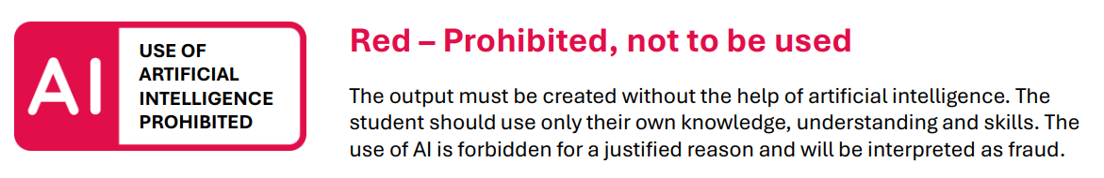

What are your thoughts about deep learning in general?
Do you think deep learning tasks are interesting, difficult or something else? Think about also what is possibly the reason for your opinion.
Deep Learning is a useful tool for a lot of applications, e.g. Data Science (forecasting), Image Recognition, Automation etc. But it is also important to know the downsides and costs of deep learning and to recognize when relying on DL is overkill for the application requirements.

What is easy in deep learning, what is difficult or complex?
If you want, you can think about this question from different point of views, for example: certain algorithms or neural network types, data preparation, neural network optimization, error metrics, TensorFlow, PyTorch, compare to scikit-learn / Classic ML etc.
Its difficult to properly prepare the data for a decent NN-Performance. Once you have a decent dataset with good preparation it is easy to create a suitable NN and adjust it to your needs. It is like a pyramid where the very bottom is the quality of the dataset. Using Keras is quite simple for beginners but once you actually start creating NNs from scratch it gets difficult really quick. Tinkering with TensorFlow etc. therefore has a lot of challenges. Also doing DL/ML on a Laptop without a dedicated GPU does not make a lot of sense. In the simple exercise projects we had in this coure it took me up to 20-50 minutes to train the NN. On my Computer at home in Germany it would take a fraction of that time.

What would you like to learn next in machine learning?
Actual practical applications and not only neural networks. So basically integrating the NN into a proper application in any shape or form e.g. Image Recognition. A personal fun project I want to build using a Jetson Nano I have at home is a beerpong shot prediction and tracker. In my home university we already built something similar to this: In a project work we used 6 Jetson Nanos and deployed them in a football cage to analyze player posture with the aim to detect unhealthy habits in order to prevent injuries.

Can you use your deep learning skills in your current activities and/or hobbies? Or even in your work? Would you like to work as a professional machine learning engineer in the future?
I think its a fun part of Computer Science but I would not want to work in this field. I have some personal projects I want to try out (see above) but my main focus is on Embedded Systems based on microcontrollers like esp32.

How do you understand the following concepts and/or technologies? In your own words, write about what you can do with them while creating deep learning applications, and where they are useful.

- Keras / TensorFlow (and PyTorch)
With Keras you can create a NN really quick without a lot of code. With Tensorflow you have a lot more control over everything but it gets more complicated.

- Encoders (LabelEncoder, OneHotEncoder etc.)
With encoders you can change nominal variables (like CarModel, color etc in my case) into binary boolean flags. So you change color (1-10) into color1 (0/1) color2 (0/1) etc.

- Normalization, standardization and regularization
Without looking it up and reading about it again I wouldnt be able to explain these concepts so I wont do it here since I believe it would go against the goal of this template and questions. In my home university I was already familiar with these concepts when I wrote a small paper in preparation for my bachelors thesis about “usage of deep learning and neural networks in order to improve diagnostic accuracy in medical image analysis”. In this short “paper” I also analyzed the basics of deep learning and neural networks.

- Deep learning application optimization (both dataset and algorithm optimization)
Im not really that familiar with this topic since I didn’t put in the required time and effort. Dataset optimization is really important and includes things like removing outliers, removing duplicates, removing unimportant columns etc.
- The role of data analytics in deep learning
Data Analytics is a big part of DL since you have to understand the data before you feed it into a NN. Also you need to know which variables you want to analyze, the impact of variables towards the target variable etc. So Data analytics and DL are very important to each other.
- Essential phases needed to produce a complete deep learning application, from raw data to a user application with user interface?
Collect data / search dataset from sources like kaggle, prepare dataset, create NN, optimize NN, create UI and other parts of application, repeat optimizations.

If you participated in the semester project this semester, describe your personal deep learning –related tasks in the project

I did not participate in the semester project.

Any other feedback considering the course itself or deep learning in general? Both positive and negative feedback is welcome!
I would have really enjoyed this course in my home university but as an exchange student it was too much work and it was hard to motivate myself to do really well in this course while also enjoying my limited time in Finland.

