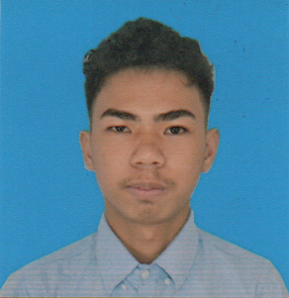

**LANCE LEMUEL Z. MOROÑA**

**348 Damka St. Old Sta. Mesa, Manila**

**09471813827**

**lancelemuel.morona@gmail.com**



**OBJECTIVE:**

To acquire valuable knowledge and skills to complement those that I have learned from school in an actual job environment. In return, I offer my service and determination to be an asset to your company throughout the duration of my training period.

**EDUCATIONAL ATTAINMENT:**

**COLLEGE** Polytechnic University of the Philippines  
 *SY: 2018 - present*

**SECONDARY LEVEL Senior High-** AMA Computer College, Manila

*SY: 2016 - 2018*

**Junior High-** Victorino Mapa High School *SY: 2012 – 2016*

**PRIMARY LEVEL** San Juan Elementary School *SY: 2006 – 2012*

**COMPETENCIES:**

- Can work under pressure

- Highly systematic and organize

- Positive attitude

- MS word - MS Power point

- MS Excel - Communication

- Computer Literate - SQL

- Java

- HTML

- CSS

# **AWARDS & ACKNOWLEDGEMENTS:**

* Grade 10 Completer
* NC II Achiever (Programming Java)
* NC III Achiever (Programming Oracle Database)

**PERSONAL INFORMATION:**

**Age:**  21years old

**Civil Status:** Single

**Gender:**  Male **Religion:**  Catholic **Citizenship:** Filipino **Date of Birth:** November 14, 1999

**Mother:** Ma. Liza Z. Moroña **Father:** Arnold C. Moroña

**Language/s:** Tagalog, English

**CHARACTER REFERENCES:**

* Herbert Kin Lebrero Instructor; 09499734457
* Reiner Angelo B. Mercado Instructor; 09066168943
* Kathleen Charmaine Gogo Instructor; 0926496072

*I hereby certify that the above information are true and correct on the extent of my knowledge and belief.*

Lance Lemuel Z. Moroña

**APPLICANT**