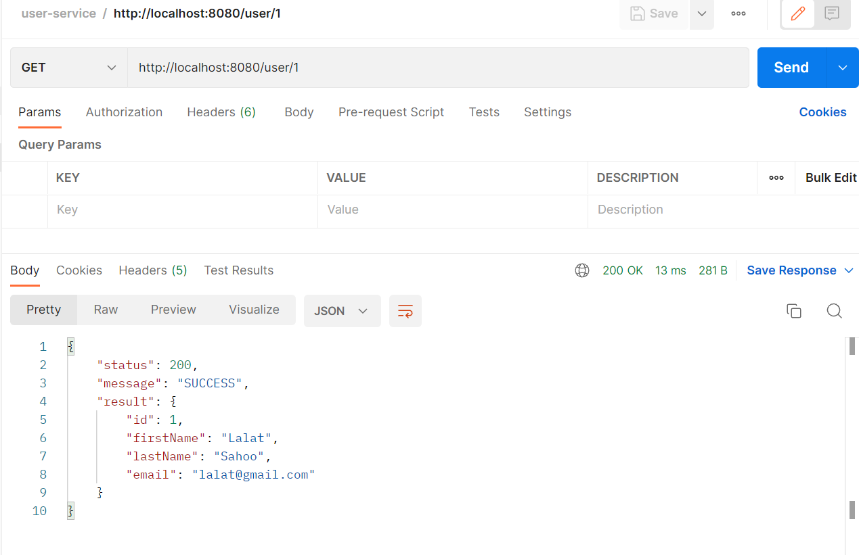

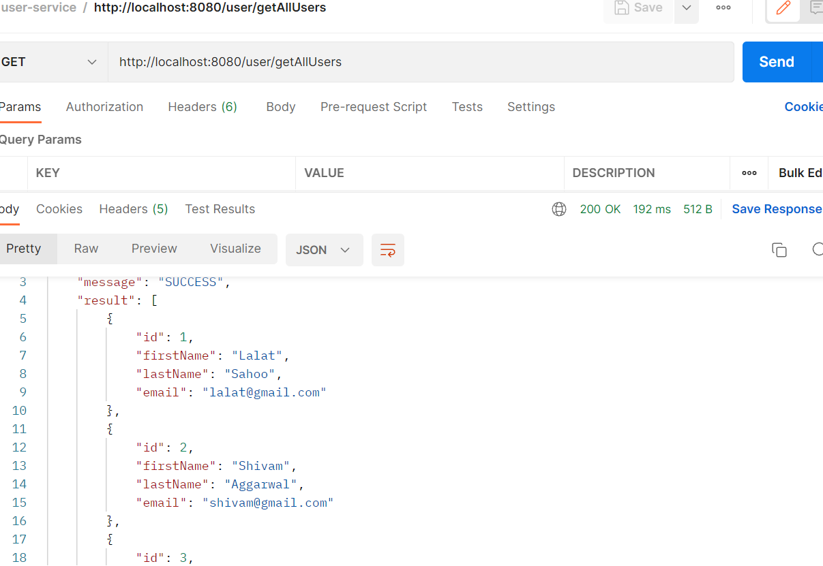

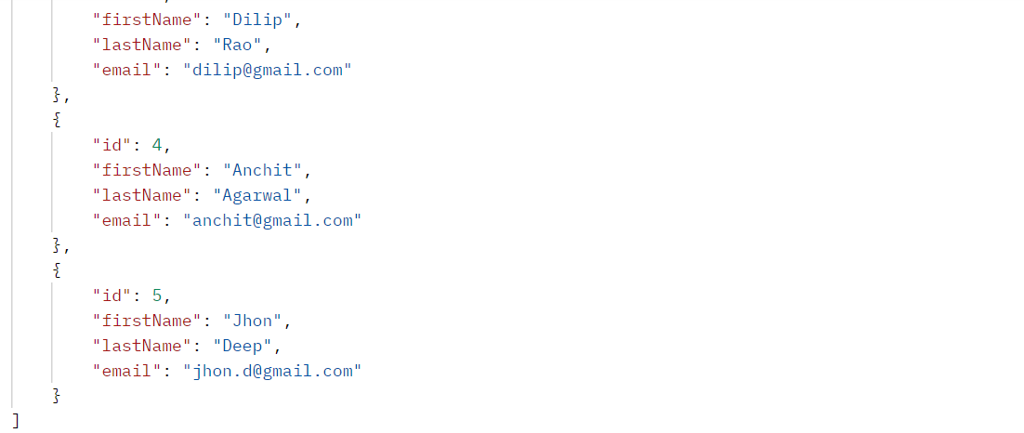

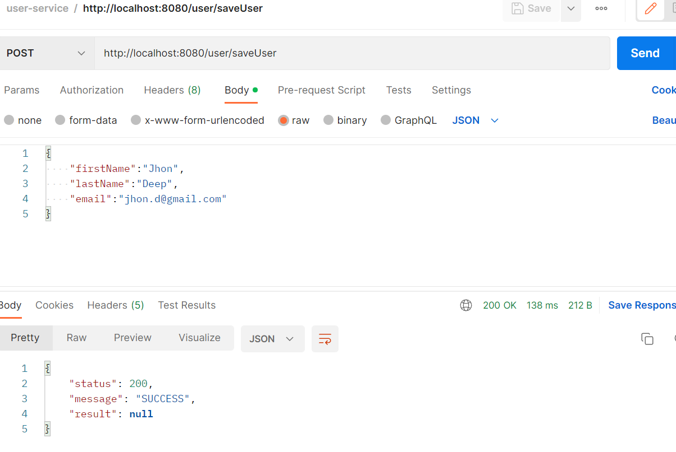

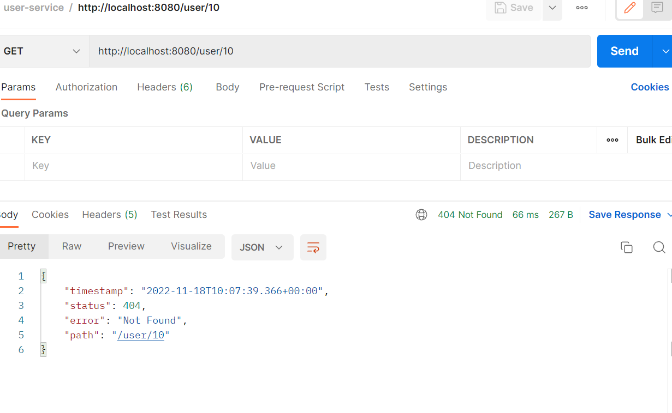

GET: http://localhost:8080/user/getAllUsers

{

    "status": 200,

    "message": "SUCCESS",

    "result": [

        {

            "id": 1,

            "firstName": "Lalat",

            "lastName": "Sahoo",

            "email": "lalat@gmail.com"

        },

        {

            "id": 2,

            "firstName": "Shivam",

            "lastName": "Aggarwal",

            "email": "shivam@gmail.com"

        },

        {

            "id": 3,

            "firstName": "Dilip",

            "lastName": "Rao",

            "email": "dilip@gmail.com"

        },

        {

            "id": 4,

            "firstName": "Anchit",

            "lastName": "Agarwal",

            "email": "anchit@gmail.com"

        },

        {

            "id": 5,

            "firstName": "Jhon",

            "lastName": "Deep",

            "email": "jhon.d@gmail.com"

        }

    ]

}