Lesson 02

Overview
In this worksheet, we review some basic JavaScript concepts and walkthrough the PetCareApp.
Before you attempt the questions in this worksheet, you should go through the respective topics in your notes:
Worksheet | Notes
Section A | Web Application Revision
Section B | PetCareApp Walkthrough
Section C | Submissions

Materials
There is one problem statement for each learning package. A learning package is made up of a few lessons. In each lesson in the learning package, you will generally find a set of slides that serves as your notes, and a worksheet. As you go through the day with your lecturer, there will be activities for you to work on. Some activities are meant to help you take notes, while others are for you to delve deeper into the topics.
These activities will be mapped in both the slides and worksheet. You should put your answers in the worksheet. Below are some icons to guide you on what an activity will require you to do.
 Answer some questions on your own as you watch a video or listen to your lecturer.
 Team discussions
 This is a lecturer-led activity. Your lecturer will guide you through an activity step-by-step. Pay attention!

Do seek your lecturer’s advice when in doubt

Section A – Web Application Revision
Exercise 1
- In the Revision folder, create a file named ex01.js. In ex01.js, type the following code below to calculate the pet grooming fee.
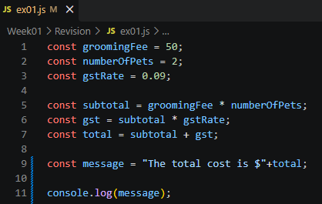
- Ensure that you are in the right folder in the console(You should be in the Revision folder.)
- Run the JS file: node ex01.js
- What is the output?
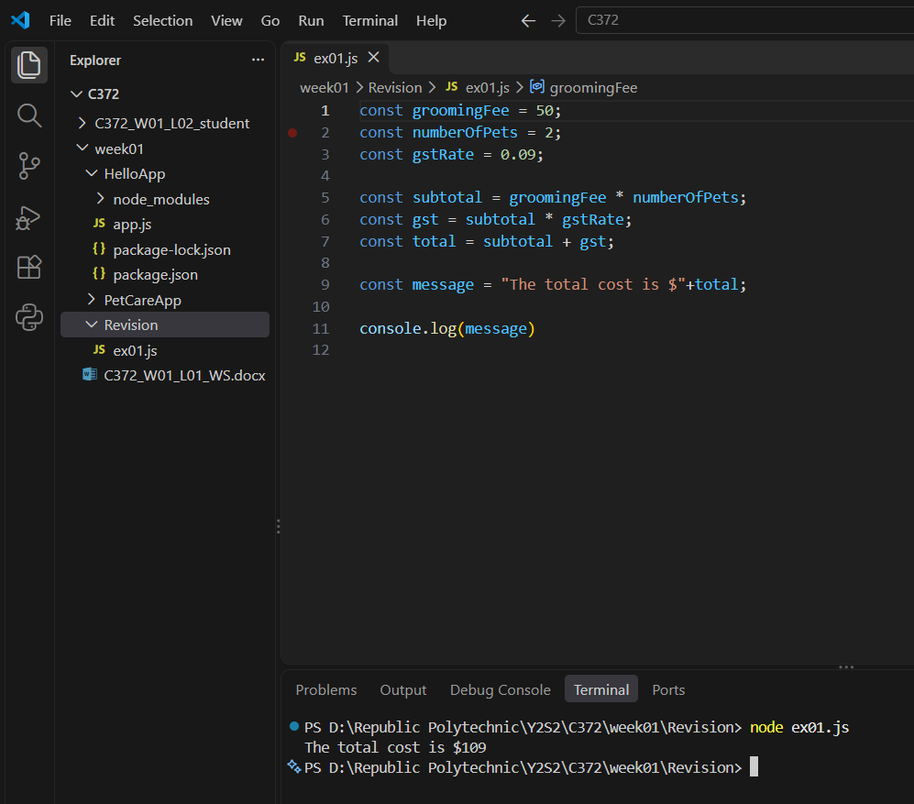

- What are the datatypes of the variables?
Variable | Data Type
groomingFee | Number
numberofPets | Number
gstRate | Number
subtotal | Number
gst | Number
message | String

- What is the difference between const and let?
Const declares variable that cnt be reassigned while let allows it to

Exercise 2
In the Revision folder, create a file named ex02.js. In ex02.js, implement the logic shown in the table below to process a grooming fee payment status. (Use conditional logic to decide what users see.)

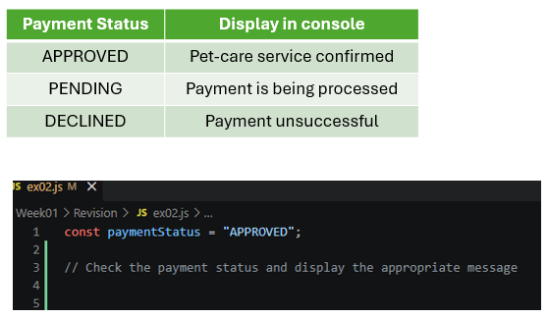

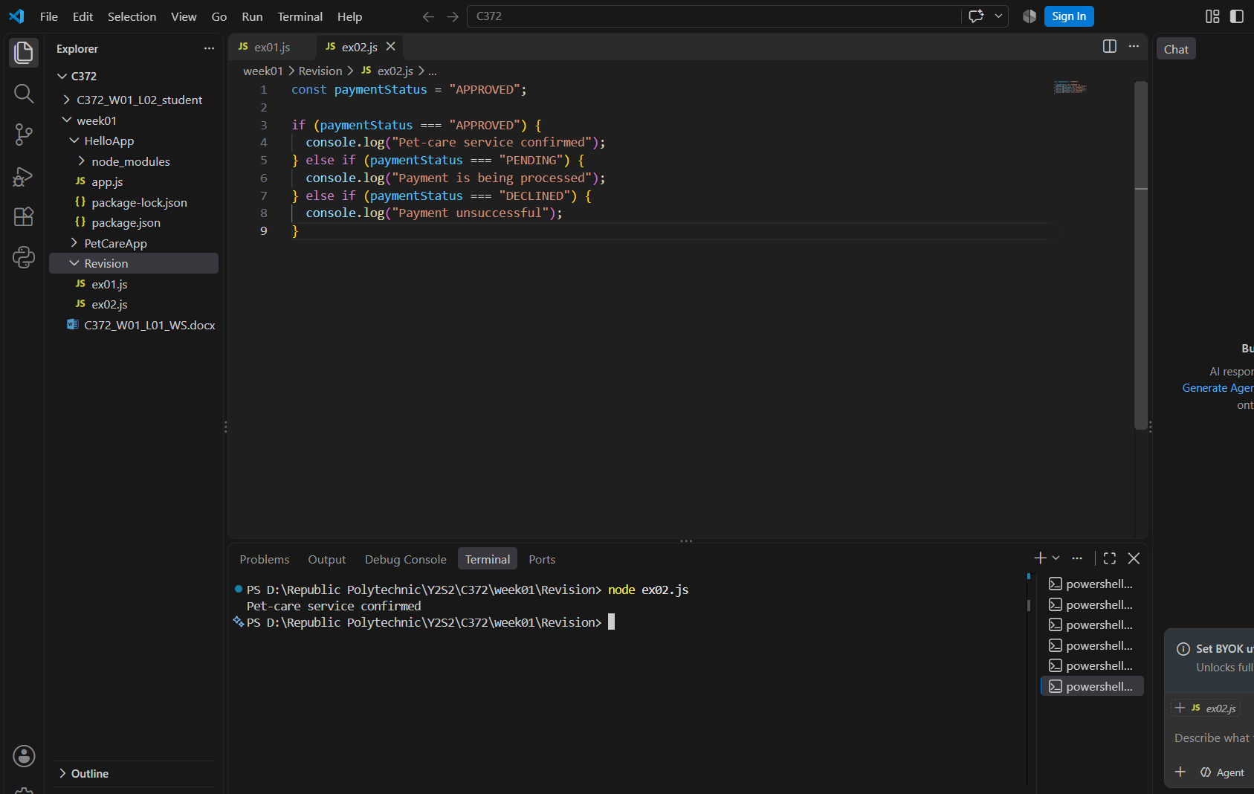

Exercise 3
In the Revision folder, create a file named ex03.js.
Given the payments array as shown:
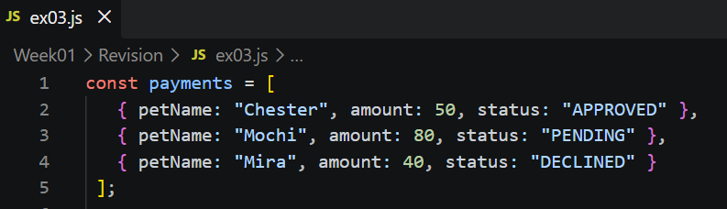

In ex03.js,
- Write the code to display Mochi’s payment status
- Use a loop to display the payment details for each pet.
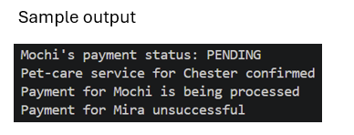
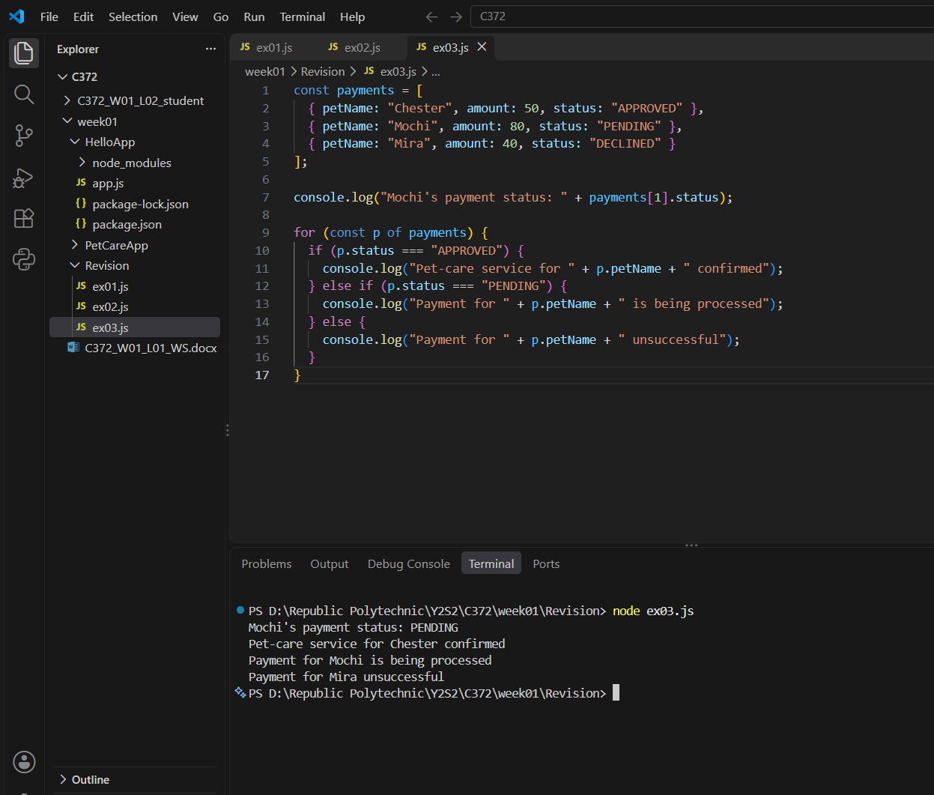

Section B – PetCareApp Walkthrough
Exercise 4
Given the page shown, trace the request.
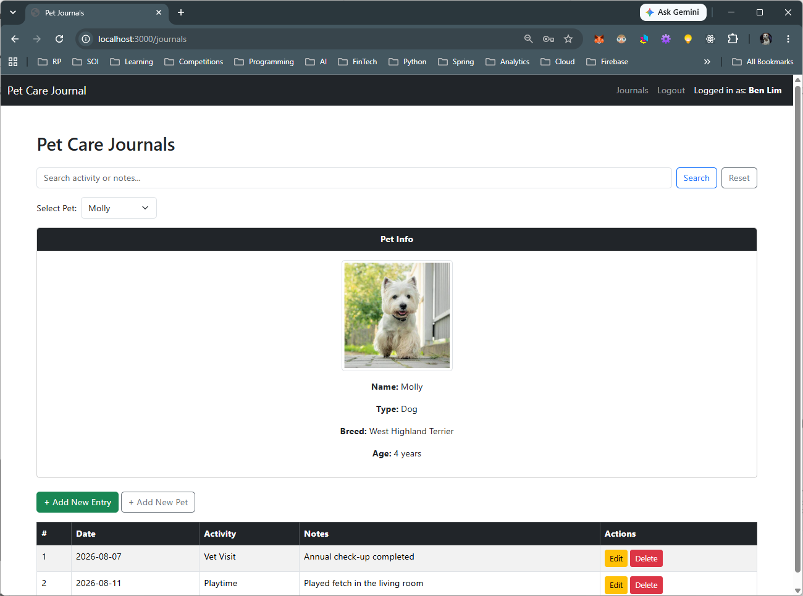

Step | Question | Answer
Browser action | Which link did you click? What URL was requested? | Clicked the “View” link on a pet. URL requested: /pets/3
Route handler | What HTTP method and route pattern handle this request? | GET, route pattern /pets/:id
Input | What value does the handler read, and where does it come from—for example, req.params? | The pet id, read from the URL with req.params.id (value “3”)
Database operation | Which SQL query runs? Which table and record does it access? | SELECT * FROM pets WHERE petId = ? with [id]. Table: pets, record: the row where petId is 3
View | Which EJS template is rendered? What data is passed into it? | pet.ejs, with { pet: results[0] } passed in
Output | Where does the template display that data? | Inside pet.ejs, where tags like <%= pet.petName %> print the pet’s details

Exercise 5
Given the page shown, trace the request.
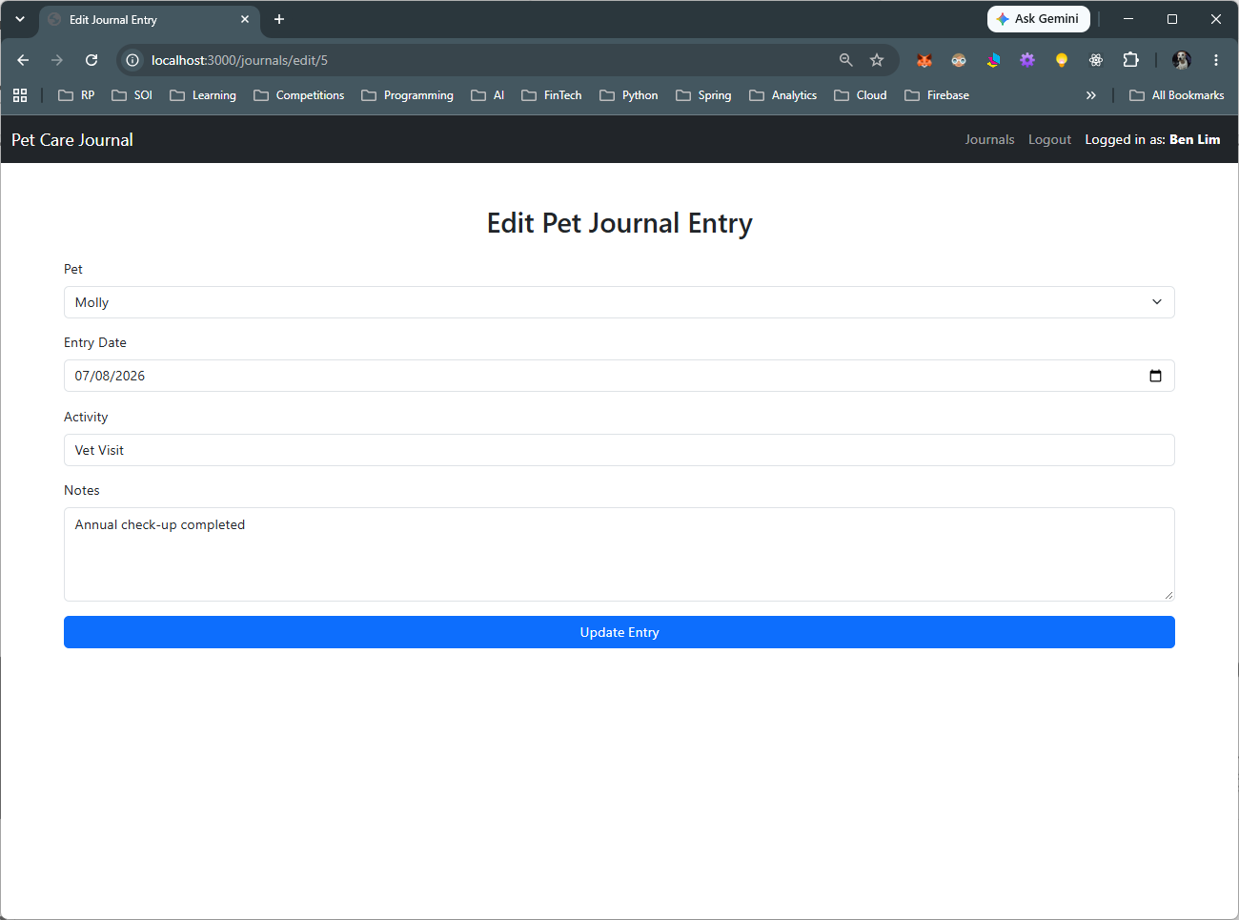

Step | Question | Answer
Browser action | Which link did you click? What URL was requested? | Clicked the “View” link on a pet. URL: /pets/3
Route handler | What HTTP method and route pattern handle this request? | GET /pets/:id
Input | What value does the handler read, and where does it come from—for example, req.params? | Pet id from the URL, read using req.params.id
Database operation | Which SQL query runs? Which table and record does it access? | SELECT * FROM pets WHERE petId = ? on the pets table, gets the row with that id
View | Which EJS template is rendered? What data is passed into it? | pet.ejs, passed the pet data from the query result
Output | Where does the template display that data? | Shown in the page where <%= pet.petName %> and the other fields are printed

Section C – Submissions
Deliverables for today
- Worksheet (Individual)
- Upload your deliverables to POLITEMALL even if it is incomplete before the next session.
- You can resubmit by 2359 if there are updates.

