Lesson 01

Overview
In this worksheet, we discuss some basic concepts about payment systems and how play a crucial role in the functioning of the economy by enabling the exchange of goods and services.
Before you attempt the questions in this worksheet, you should go through the respective topics in your notes:
Worksheet | Notes
Section A | Payments Ecosystem
Section B | Installations and Setup
Section C | Submissions

Materials
There is one problem statement for each learning package. A learning package is made up of a few lessons. In each lesson in the learning package, you will generally find a set of slides that serves as your notes, and a worksheet. As you go through the day with your lecturer, there will be activities for you to work on. Some activities are meant to help you take notes, while others are for you to delve deeper into the topics.
These activities will be mapped in both the slides and worksheet. You should put your answers in the worksheet. Below are some icons to guide you on what an activity will require you to do.
 Answer some questions on your own as you watch a video or listen to your lecturer.
 Team discussions
 This is a lecturer-led activity. Your lecturer will guide you through an activity step-by-step. Pay attention!

Do seek your lecturer’s advice when in doubt

Section A – Payments Ecosystem

Exercise 1
Scenario:
You receive a digital payment request. Before approving it, what could go wrong?
In your teams, identify three risks and suggest one safeguard for each.
Risks | Safeguards
Fraud | Use a strong password and enable two-factor authentication to prevent unauthorized access.
Human Error | Double check the receipt’s name and payment amount before approving the transaction.
Scam | Verify the payment purpose and the sender through a trusted channel and avoid clicking on suspicious links or approving unexpected payment requests..

Exercise 2
What are some of the payment methods or technologies you have used personally? (e.g. Used YouTrip when I went Japan, PayNow at hawker stall)
Share and discuss with your team. Note down in your worksheet, what your teammates used.
Member | Payment method/App used | Card, A2A or wallet? | Payer | Payee | Other participant or provider
Dayana | Paynow | A2A | Me | My friend | OCBC
 | youtrip | wallet | me | Jb cafe | apple
  Joscelyn
Damien | Ocbc digital | A2A | Me | Caifan auntie | OCBC,paynow
Jincheng | Youtrip | Card | Me | dewu merchant | Apple
Elton | Localpay | A2A | Me | Vietnam local stores | VietQR

Exercise 3
Scenario: A student buys a concert ticket online using a DBS Visa card.

- Identify the various players
Player | Answer
Customer | The student initiates the payment
Merchant | The concert ticket seller or the ticket platform receiving the payment.
Issuer | DBS Bank issued the student’s Visa card and approves or decline the transaction.
Gateway | Transmits payment information securely from the merchant’s website to the payment processing system.
Acquirer | The merchant’s acquiring bank or payment institution that processes card payments on the merchant’s behalf.
Card Network | Visa routes payment messages between the issuer and acquirer.

- What should the payment flow look like?
My work: Customer → Merchant → Gateway → Acquirer → Visa → DBS (Issuer)

Section B – Installations and Setup
Exercise 1
- Paste a screenshot of your VS Code HelloApp project structure in your worksheet.
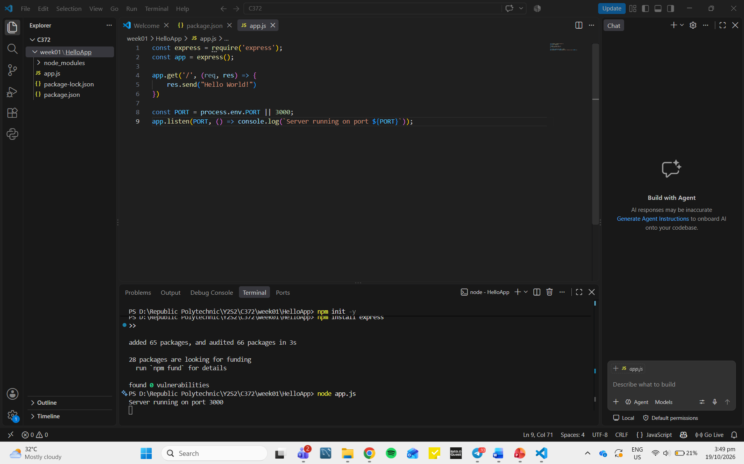

- Modify app.js so that the greeting changes to “Hello RP!”
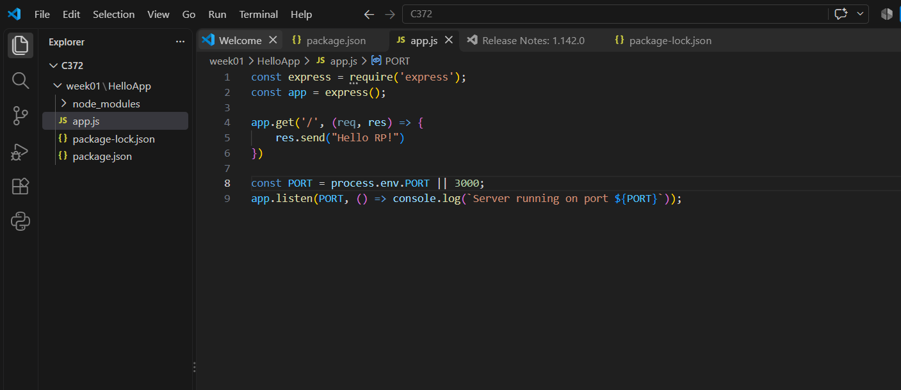

- Paste a screenshot of your web browser displaying the new greeting from HelloApp in your worksheet.
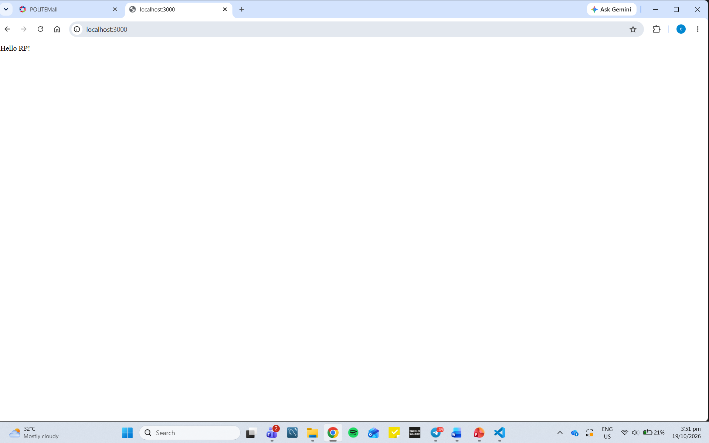

Exercise 2
- Paste a screenshot of your VS Code PetCareApp project structure in your worksheet.
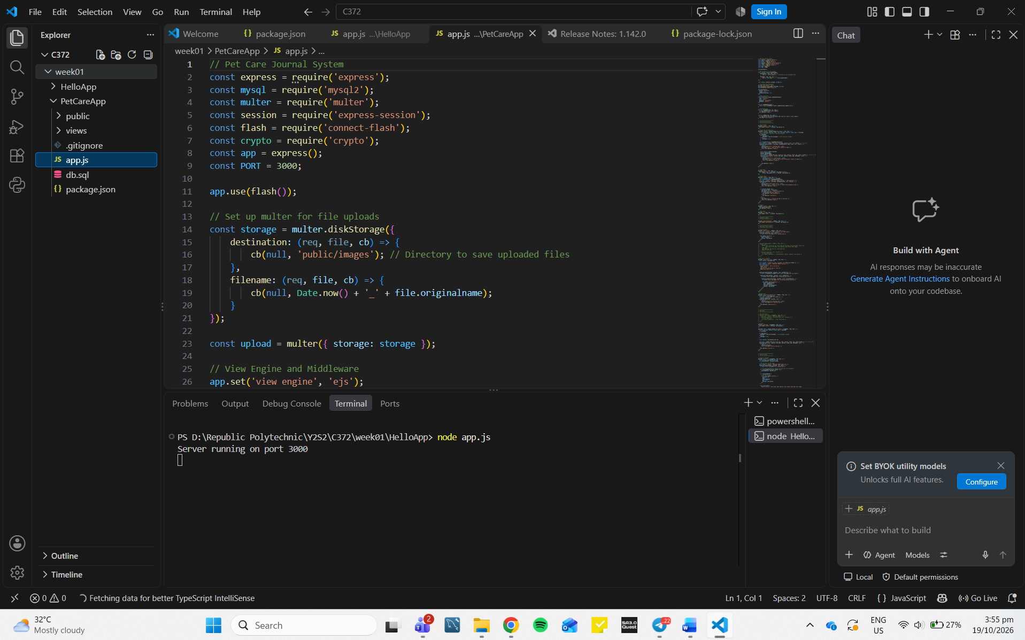

- Paste a screenshot of your web browser displaying the list of users from PetCareApp in your worksheet.
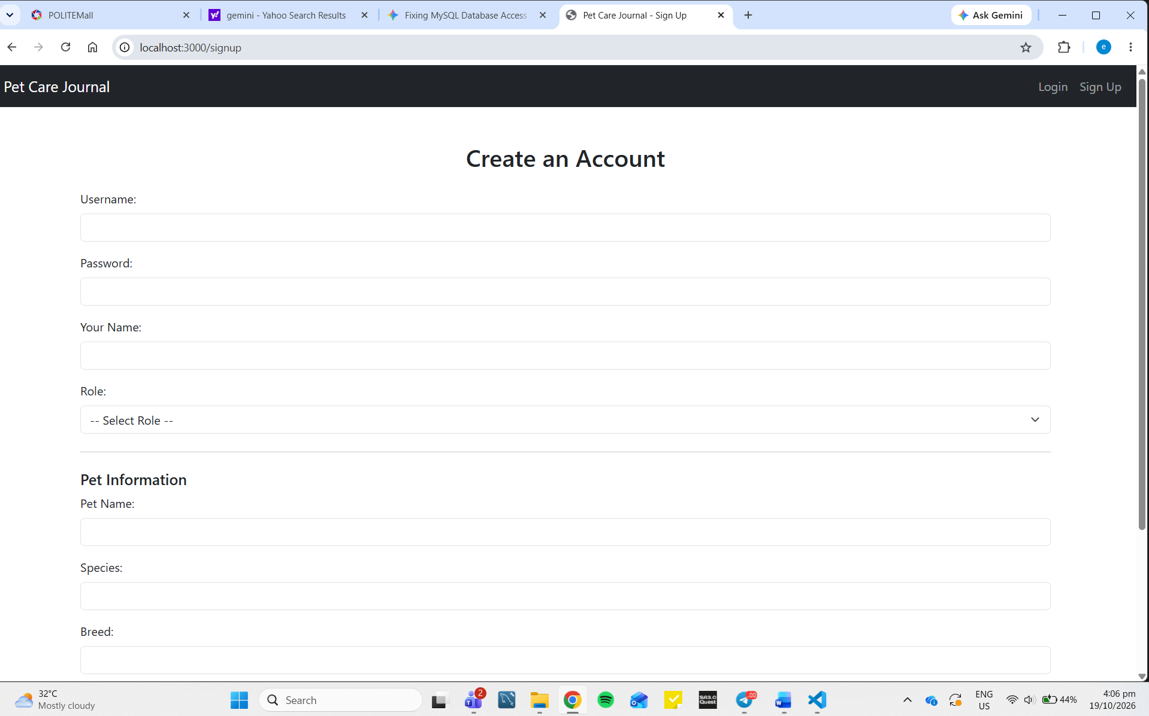

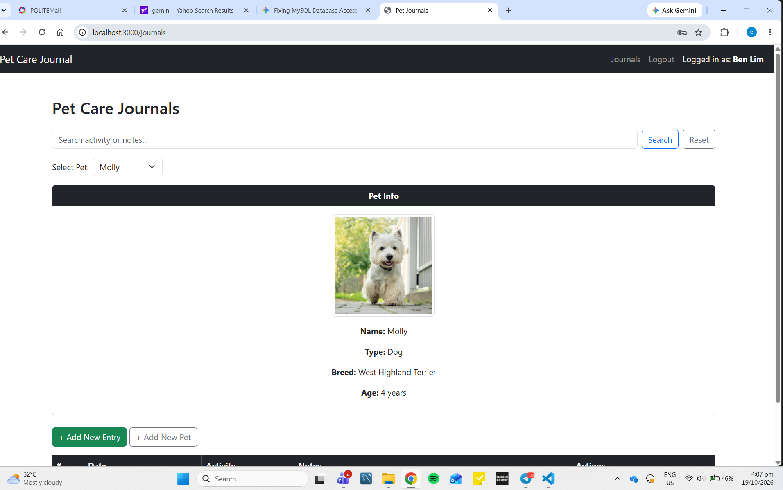

Section C – Submissions
Deliverables for today
- Worksheet (Individual)
- Upload your deliverables to POLITEMALL even if it is incomplete before the next session.
- You can resubmit by 2359 if there are updates.

